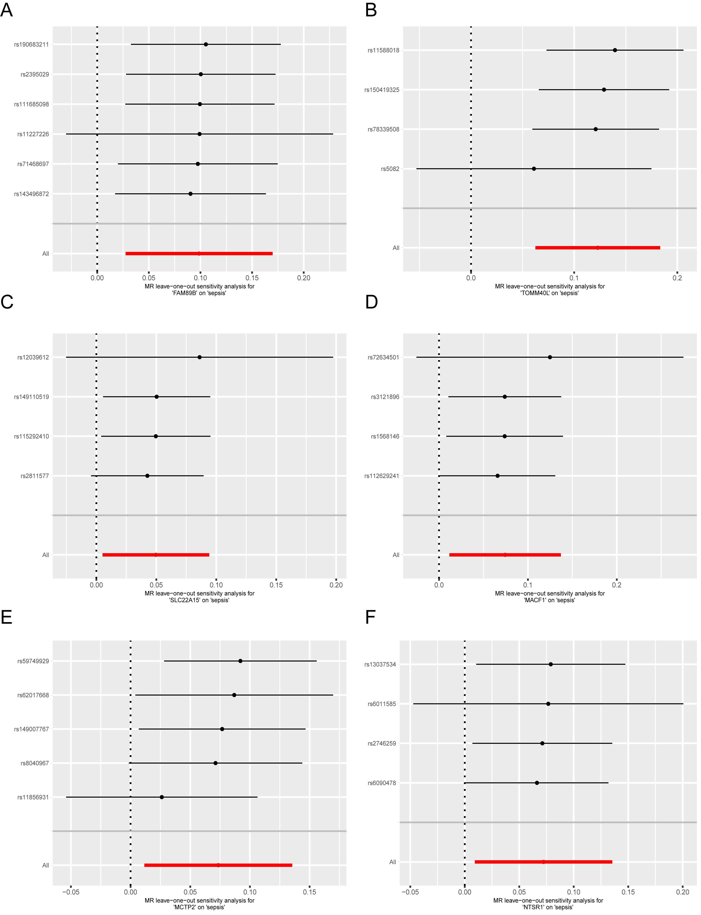

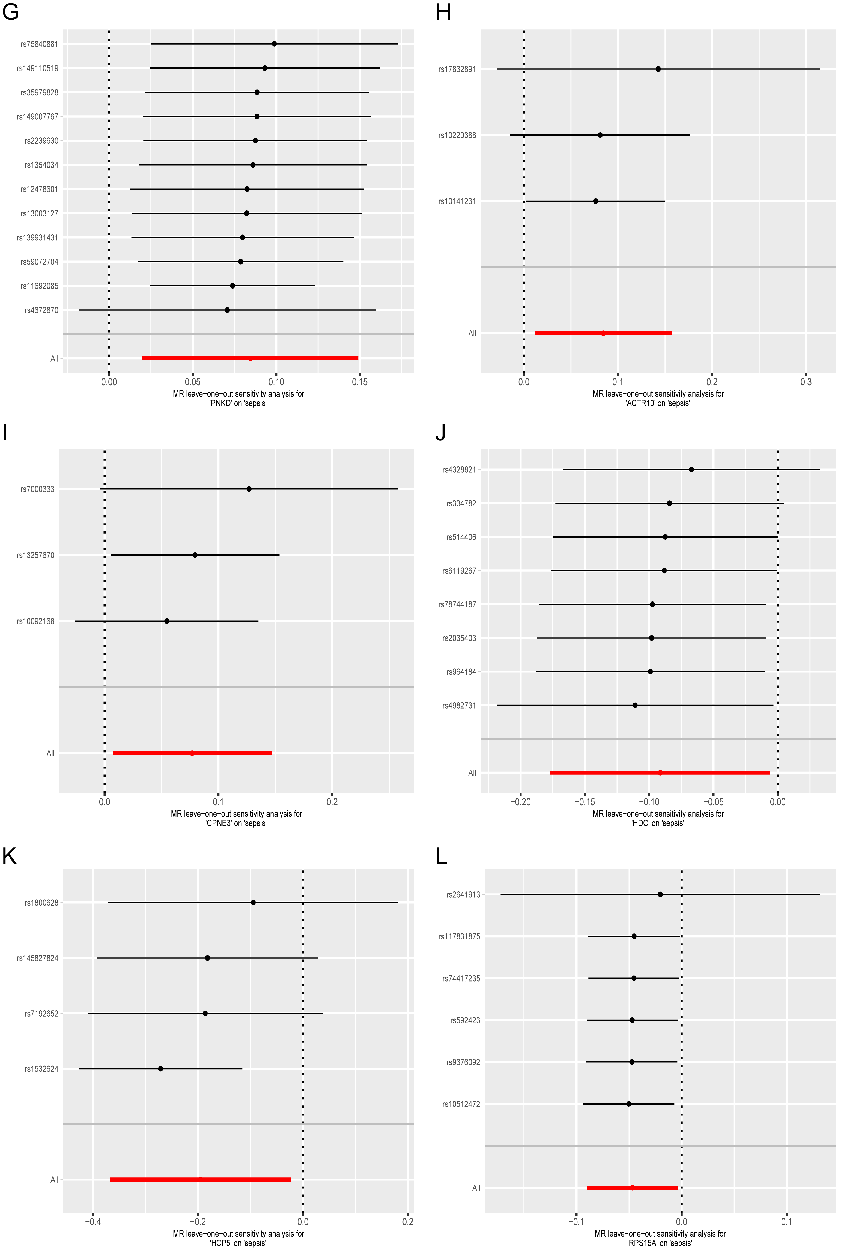
Supplementary Figure 2 (A) FAM89B; (B) TOMM40L; (C) SLC22A15; (D) MACF1; (E) MCTP2; (F) NTSR1; (G) PNKD; (H) ACTR10; (I) CPNE3; (J) HDC; (K) HCP5; (L) RPS15A

