Supplementary figures

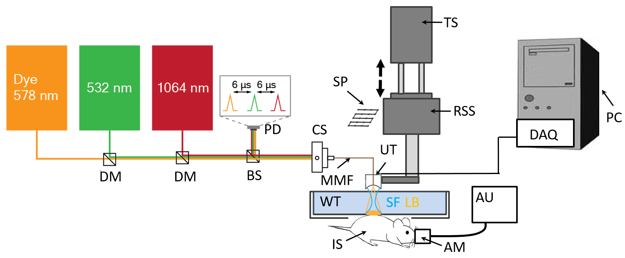
Suppl. Fig. 1. AR-OAM system. Lay-out of the experiment system. DM – dichroic mirror, BS – beam splitter, PD – photodiode, CS – coupling stage, MMF – multi-mode fiber, TS – translation stage, RSS - raster-scanning stages, SP – scanning pattern, UT – ultrasound transducer, WT – water tank, SF – sensitivity field, LB – light beam, IS – imaging sample, AU – anesthesia unit, AM – anesthesia mask, DAQ – data acquisition system, PC – personal computer.

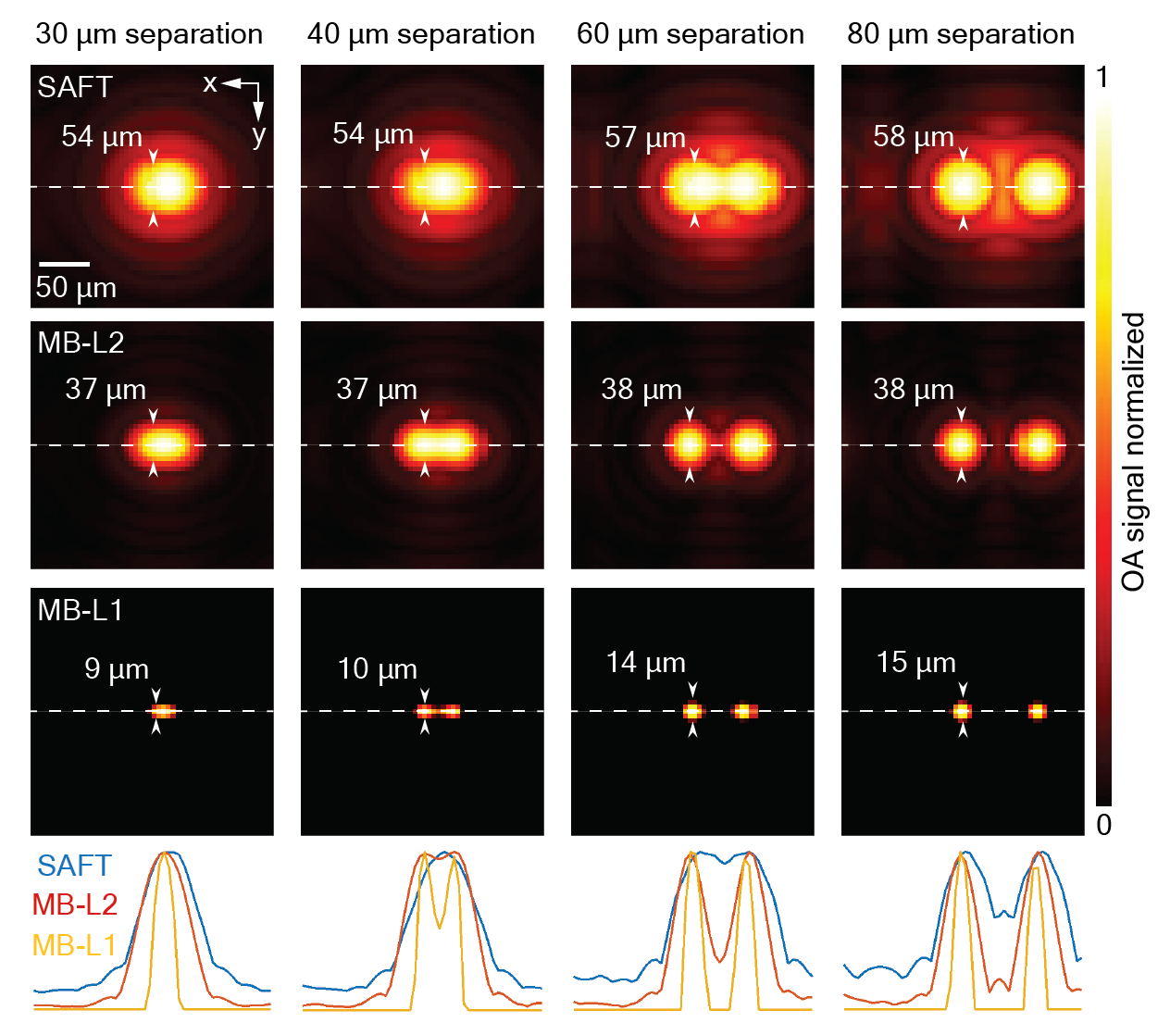
Suppl. Fig. 2. Super-resolution imaging with MB-L1. Maximum intensity projections (MIPs) along the depth direction of the AR-OAM images reconstructed with the SAFT (top), MB-L2 (middle) and MB-L1 (bottom) methods from simulated data corresponding to two 20 μm absorbers with separations ranging from 30 to 80 μm. Full width at half maxima (FWHM) and central image profiles are shown.

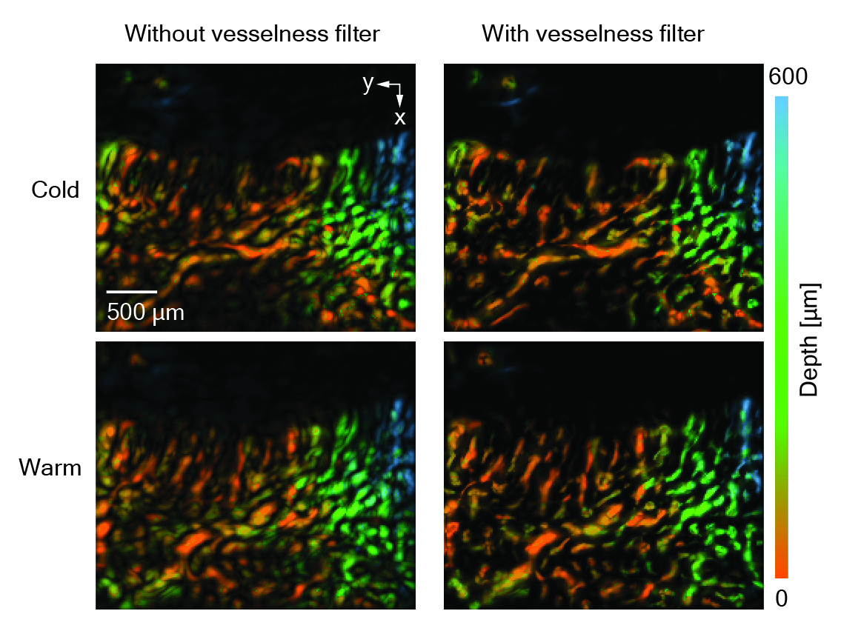
Suppl. Fig. 3. Frangi vesselness filtering. Left - Maximum intensity projections (MIPs) along the depth direction of nailfold images reconstructed with MB-L2. Right – Equivalent images after application of a Frangi vesselness filter. Images obtained immediately after immersion in cold and warm water, respectively, are shown. All images are color-coded for depth.

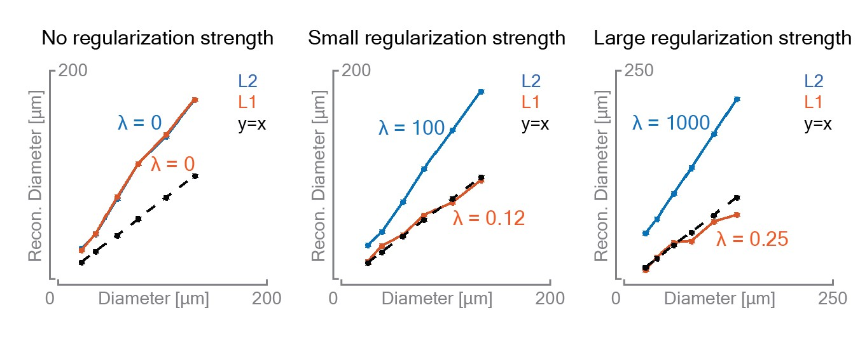
Suppl. Fig. 4. Effects on regularization on reconstructed dimensions. Reconstructed diameter of a simulated sphere as a function of the actual diameter for the MB-L1 and MB-L2 and methods. A comparison is shown for different regularization intensities. Regularization parameters are indicated.

