SUPPORTING INFORMATION

Cell membrane mechanics using a simple-to-fabricate microwell chip and deep learning-assisted automated AFM analysis

Nicholas Hallfors^{1,2#,} Charalampos Lamprou^{1#}, Shaohong Luo¹, Sara Awni Alkhatib^{1,3}, Jiranuwat Sapudom⁴, Cyril Aubry⁵, Jawaher Alhammadi¹, Vincent Chan^{1,2}, Cesare Stefanini⁶, Jeremy Teo⁴, Leontios Hadjileontiadis^{1,2,7*,} Anna-Maria Pappa^{1,2,3,4*}

1 Department of Biomedical Engineering and Biotechnology, Khalifa University, Abu Dhabi, P.O. Box 127788, UAE
2 Healthcare Engineering Innovation Group, Khalifa University, Abu Dhabi, P.O. Box 127788, UAE
3 Center for Catalysis and Separations, Khalifa University, Abu Dhabi, P.O. Box 127788, UAE
4 Division of Engineering, New York University Abu Dhabi, Abu Dhabi, UAE
5 Research Laboratories, Khalifa University, Abu Dhabi, P.O. Box 127788, UAE
UAE
6 Biorobotics Institute, Scuola Superiore Sant'Anna, Pisa, Italy
7 Department of Department of Electrical and Computer Engineering, Aristotle University of Thessaloniki, Thessaloniki, Greece,

* Corresponding Author(s): leontios.hadjileontiadis@ku.ac.ae, anna.pappa@ku.ac.ae
# equal contribution

Keywords: Cell stiffness, membrane stiffness, AFM, drug screening, machine learning, young’s modulus, microwell array

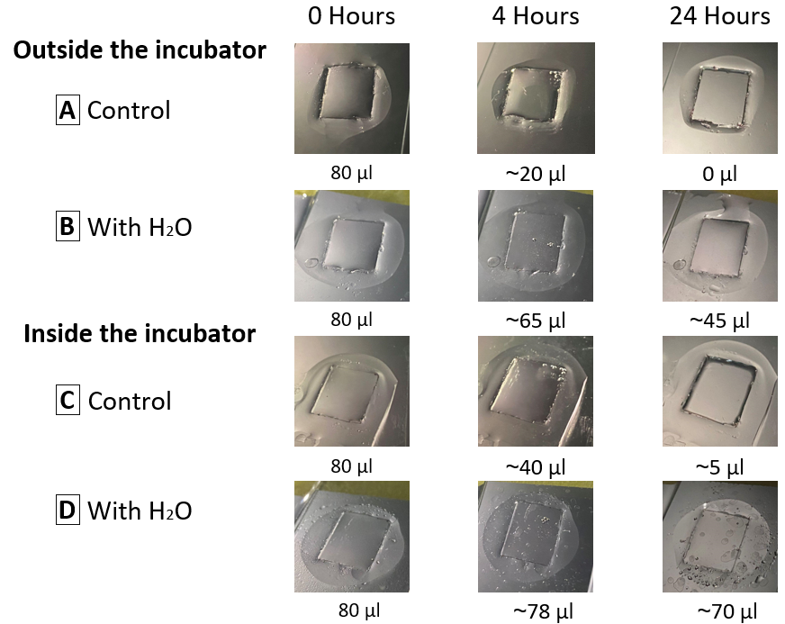
Figure S1: Testing the media evaporation in the cell trap’s device over 24 hours. Two conditions were considered, outside the incubator at room temperature, and inside the incubator, at 37 °C and 5% CO2. In each condition, two setups were prepared: 1) a control, which consisted of the PDMS chip placed inside a 100mm petri dish, 2) with H2O, which consisted of two plain glass slides secured inside a 100mm petri dish, the PDMS chip was placed on the plain glass slides, then 5 ml of water was added to the area surrounding the glass slides. Equal volumes of media were added to the PDMS chips and it was observed and measured after 4 hours and 24 hours. Without the addition of water inside the petri dish, the media’s evaporation rate was high, and it almost fully evaporated within 24 hours. The addition of water inside the petri dish helped in maintaining the media for a longer period of time, whether the petri dish was placed inside or outside the incubator. This is due to the humidity caused inside the petri dish that reduced the media’s evaporation rate.

Machine Learning Model
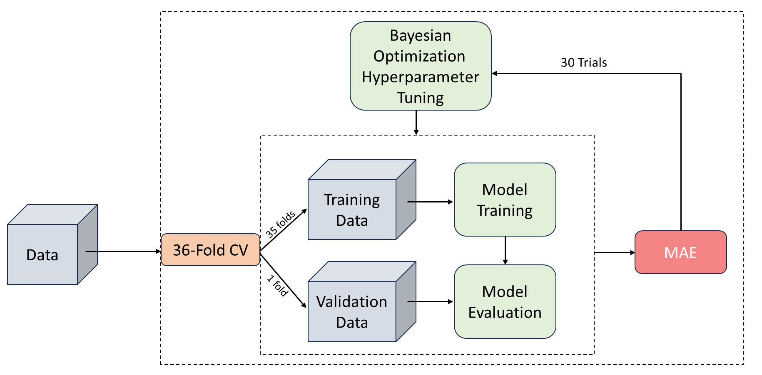
Figure S2. Block diagram of the Bayesian optimization procedure. First, a 36-Fold cross-validation is applied to the data. In each fold of the 36-Fold cross-validation, a model is trained, using the hyperparameters proposed by the Bayesian optimizer. After the the iteration over all 36 folds is complete, the average validation Mean Absolute Error (MAE) is used to assess the performance of the examined combination of hyperparameters. This procedure is repeated 20 times and, in the end, the set of hyperparameters that yielded the lower average MAE score is returned.

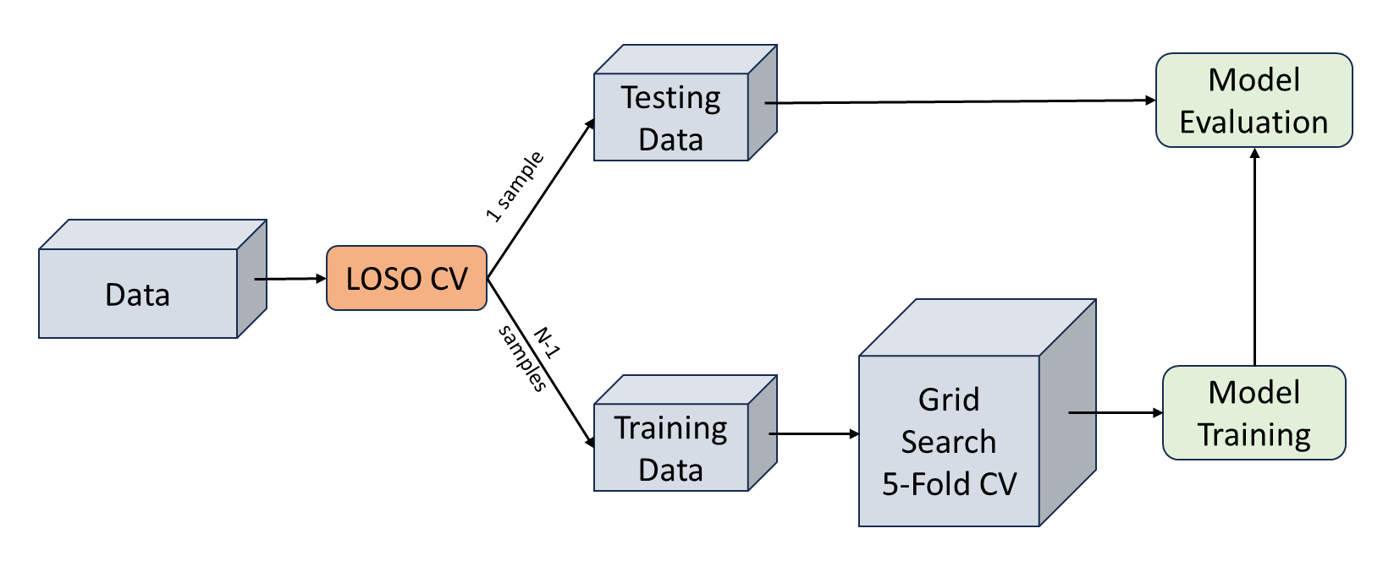
Figure S3. Schematic presentation of the nested LOSO cross validation. The figure illustrates a robust technique for model evaluation and hyperparameter tuning. The outer loop of LOSO cross-validation splits the dataset into subsets, with each subset serving as the testing set once. Within each outer iteration, the inner loop performs 5-fold cross-validation for hyperparameter optimization using grid search. The training set is divided into 5 folds, and multiple hyperparameter combinations are evaluated. The best-performing hyperparameters, determined by the average performance across the folds, are selected. This nested approach provides an unbiased estimate of model performance and effectively tunes hyperparameters.

Table S1. True Positive Rate (TPR) scores for the multiclass classification problem, with respect to each class. 95% confidence interval is given.
Model | TPR  Control | TPR  Cytochalasin B | TPR  Blebbistatin | TPR  Y-27632
SVM | 0.79 ± 0.014 | 0.94 ± 0.013 | 0.75 ± 0.03 | 0.93 ± 0.03
RF | 0.79 ± 0.004 | 0.96 ± 0.011 | 0.97 ± 0.011 | 0.79 ± 0.012

Table S2. True Negative Rate (TNR) scores for the multiclass classification problem, with respect to each class. 95% confidence interval is given.
Model | TNR  Control | TNR  Cytochalasin B | TNR  Blebbistatin | TNR  Y-27632
SVM | 0.99 ± 0.005 | 0.91 ± 0.008 | 0.98 ± 0.004 | 0.93 ± 0.008
RF | 0.99 ± 0.005 | 0.89 ± 0.006 | 0.96 ± 0.004 | 0.99 ± 0.002

Table S3. False Positive Rate (FPR) scores for the multiclass classification problem, with respect to each class. 95% confidence interval is given.
Model | FPR  Control | FPR  Cytochalasin B | FPR  Blebbistatin | FPR  Y-27632
SVM | 0.07 ± 0.005 | 0.09 ± 0.008 | 0.02 ± 0.003 | 0.07 ± 0.009
RF | 0.015 ± 0.006 | 0.11 ± 0.006 | 0.04 ± 0.004 | 0.0007 ± 0.0015

Table S4. False Negative Rate (FNR) scores for the multiclass classification problem, with respect to each class. 95% confidence interval is given.
Model | FNR  Control | FNR  Cytochalasin B | FNR  Blebbistatin | FNR  Y-27632
SVM | 0.21 ± 0.04 | 0.06 ± 0.013 | 0.24 ± 0.03 | 0.07 ± 0.03
RF | 0.21 ± 0.004 | 0.04 ± 0.011 | 0.03 ± 0.01 | 0.21 ± 0.012

