Supplementary Information for
A B-integral managing strategy with multi-stage SCF amplifier: towards direct power scaling of femtosecond sources near 2 μm
Jianlei Wang¹, Yongguang Zhao^{1,*}, Ning Zhang², Wenlong Wei², Haohai Yu^{1,**}, Valentin Petrov³ and Huaijin Zhang¹
¹State Key Laboratory of Crystal Materials and Institute of Crystal Materials, Shandong University, Jinan, 250100, China.
²Jiangsu Key Laboratory of Advanced Laser Materials and Devices, School of Physics and Electronic Engineering, Jiangsu Normal University, Xuzhou 221116, China.
³Max Born Institute for Nonlinear Optics and Short Pulse Spectroscopy, Max-Born-Str. 2a, 12489 Berlin, Germany.
*Corresponding authors:
Yongguang Zhao, Email: yongguangzhao@yeah.net
Haohai Yu, Email: haohaiyu@sdu.edu.cn

Section I: Direct fs amplification in single Ho:YAG-SCF amplifier
- Power scaling performance
At first, we investigated the power scalability of the direct amplification system employing a single Ho:YAG-SCF (Φ 1 mm × 50 mm, 0.5 at.% Ho³⁺) as gain medium. Figure S1(a) shows the experimental setup where the laser power after the pre-amplifier was 0.8 W. After passing through a variable attenuator the power could be continuously adjusted and thereafter was injected into the main amplifier with a beam diameter of ~ 450 μm. The laser beam was free-space propagation in the SCF and well mode-matched with the pump light emitting from a Tm-fiber laser at 1907 nm. Figure S1(b) shows the power scaling performances seeding by 0.1, 0.5, and 0.8-W laser pulses, giving the amplified powers of 0.55, 2.5, and 4.6 W for these three cases. Further power scaling in such single SCF amplifier was limited by the gain saturable effects, and the highest extraction efficiency was ~ 15%.
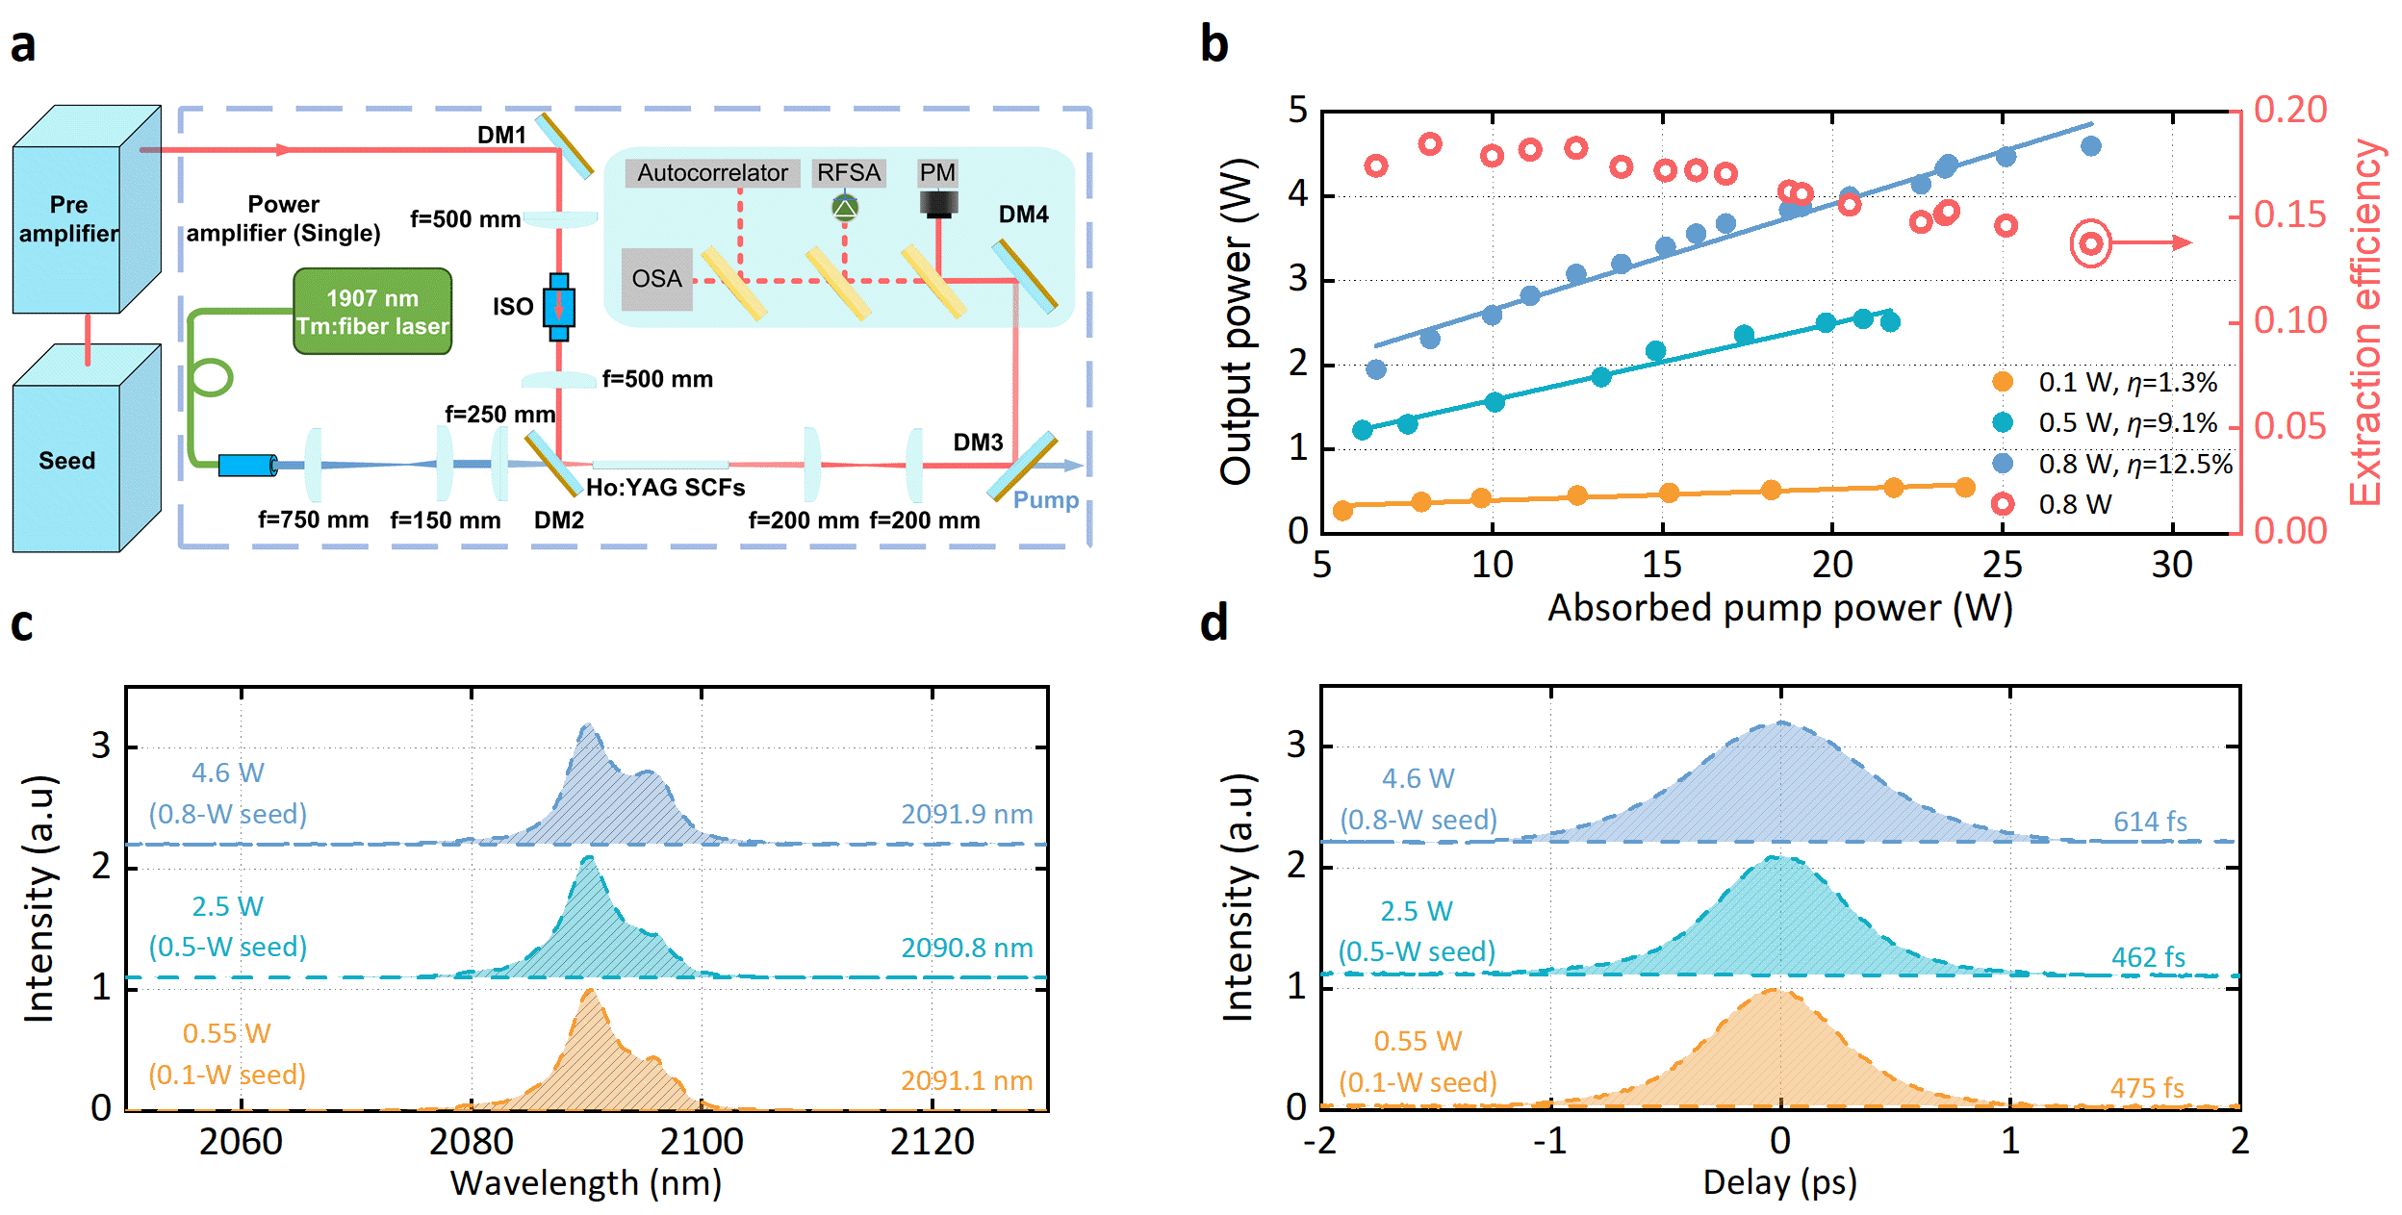
Fig. S1 Performance of the single Ho:YAG-SCF amplifier. a Schema of the experiment setup, b amplified laser power and extraction efficiency with respective the absorbed pump power, c and d, the corresponding optical spectra and autocorrelation traces of the amplified pulses at the highest power levels in the cases of 0.1, 0.5, and 0.8-W seed powers.
Figure S1(c) shows the optical spectra of the amplified pules at the highest output powers, the spectral profiles in particular for the case of 4.6 W output power (0.8-W seed), were different from the pre-amplified pulse (see Fig. 3a in the main text) due to the gain modulation in the Ho:YAG-SCF. The appeared second peak at 2096 nm was obviously the other emission peak of the Ho:YAG, as can be seen in the main text Fig. 5a the emission cross-sections of the transition ⁵I₇ → ⁵I₈. The corresponding autocorrelation traces for the three cases are shown in Fig. S1(d), the pulse durations have broadened to ~ 500 fs and even 614 fs at 4.6 W. Since the total material dispersion (Group Delay Dispersion, GDD of ~ 12000 fs² including the used SCF in the pre-amplifier) can result in only ~ 10 fs broadening of a near Fourier-transform-limited 360-fs pulse, the main reason here was attributed to the gain narrowing effect. In all the cases the pulses were stable single-pulse operation without breakup.
- Dynamic evolution of the optical spectra and temporal properties
For the 0.8-W seed laser (after the pre-amplifier), evolution of the optical spectra and temporal properties with respective to the amplified laser power is shown in Fig. S2. It clearly shows that splitting of the spectrum became apparent and a weak peak located exactly at 2096-nm fluorescence peak of the Ho:YAG SCF was appeared [see Fig. S2(a)], which indicates that the optical spectrum during amplification process was seriously affected by the gain profile. The spectral FWHM at the highest power was decreased from 10.5 nm [see Fig. 3(a) in the main text] to 8.7 nm, showing an obvious gain narrowing effect as improving the average power. Such gain narrowing effect further led to pulse broadening from 410 fs [see the main text Fig. 3(b)] to 614 fs, as can be seen from the measured autocorrelation traces in Fig. S2(b).
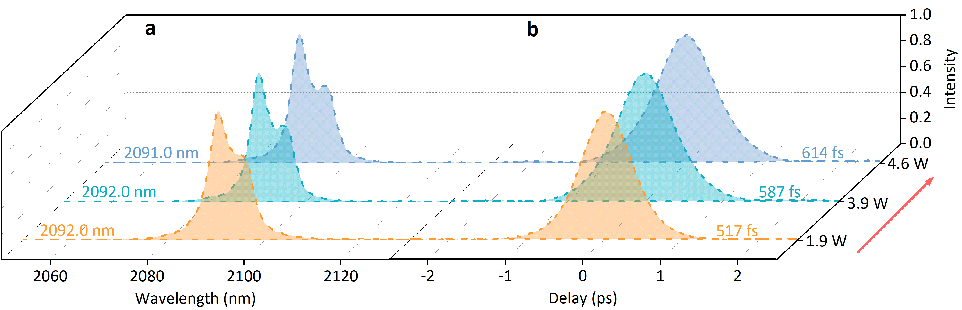
Fig. S2 Evolution of the optical spectra and temporal properties. a Measured optical spectra and b autocorrelation traces of the amplified pulses from the single-stage SCF amplifier at different average powers.
Section Ⅱ: Direct fs amplification system using two discrete SCFs
- Power scaling performance
Power scalability of the direct amplification system was thereafter investigated by employing two identical Ho:YAG SCFs (Φ 1 mm × 50 mm, 0.5 at.% Ho³⁺). As shown in Fig. S3(a), the two SCFs were discretely placed with a separation of 4 mm and both of them were directly water-cooled at 13 ℃. Similarly, the seed laser after the pre-amplifier was free-space propagation in the SCFs and the power was set to 0.1, 0.5, and 0.8 W, respectively. The output power and the corresponding extraction efficiency with respective to the absorbed pump power, are shown in Fig. S3(b). For the three different seeding power, the amplified laser powers were 3.4, 13.1, and 20.4 W, giving a highest slope efficiency of 44.3% at a 0.8-W seed, corresponding to an extraction efficiency of ~ 40%, much higher than that in the single-stage SCF amplifier.
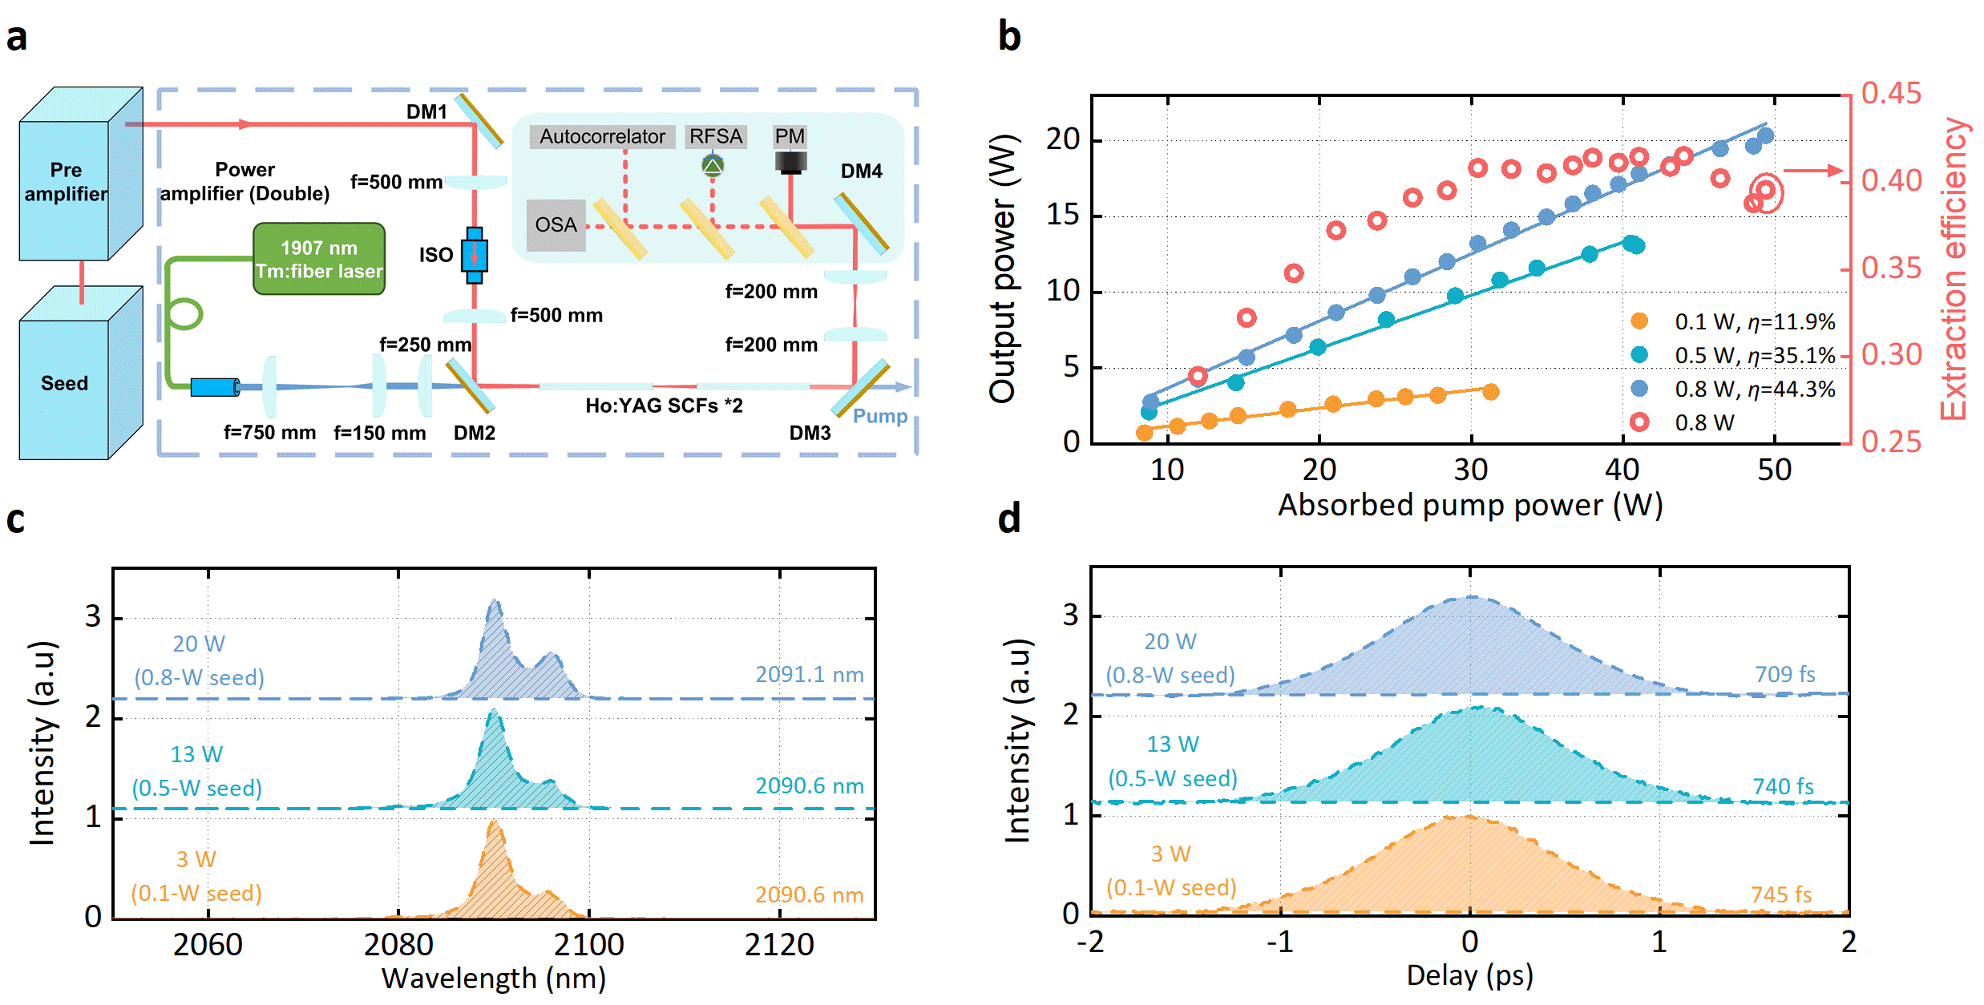
Fig. S3 Performance of the direct amplification system employing two discrete SCFs. a Schema of the experiment setup, b amplified laser power and extraction efficiency with respective the absorbed pump power, c and d, the corresponding optical spectra and autocorrelation traces of the amplified pulses at the highest power levels in the cases of 0.1, 0.5, and 0.8-W seed powers.
The optical spectra of the amplified pules are shown in Fig. S3(c), splitting of the spectrum were more obvious in comparison with the case [see Fig. S1(c)] in the single-stage SCF amplifier, meanwhile the spectral FWHM was narrower due to the stronger gain narrowing effect. Figure S3(d) shows the corresponding autocorrelation traces, the pulse duration at the highest power of 20 W was further broadened to 709 fs, but still a stable sing-pulse operation without distortions. It seems that with a lower seeding power the broadening of the amplified pulses was more obvious since the small signal is easier affected by the gain profile of the SCF.
- Evolution of the optical spectra and temporal properties
Dynamic evolution of the optical spectra and temporal properties of the amplified pulses in such two-SCF amplification system was also investigated. Seeding by a 0.8-W laser (after the pre-amplifier), the measured experimental results at different output powers are shown in Figure S4. Similar to that in the single-stage SCF amplifier, splitting of the spectrum was more visible and spectral FWHM was narrower as improving the output power. Nevertheless, no ASE and obvious spectral distortion were observed which is an indication of the suppressed nonlinear effects. In this case, the pulse duration was gradually broadened from 410 fs [see the main text Fig. 3(b)] to 709 fs [see Fig. S4(b)] at the highest power, indicating the stronger gain narrowing effect.
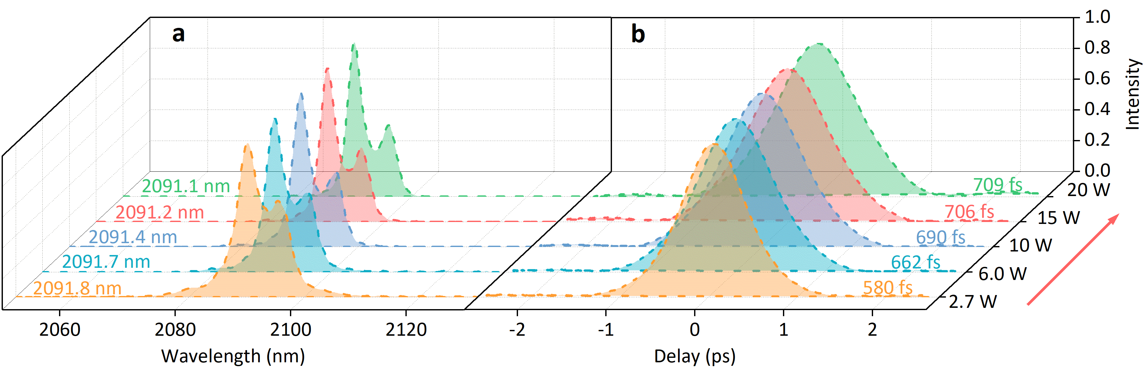
Fig. S4 Optical spectra and temporal properties of the amplified pulses. a optical spectra and b the corresponding autocorrelation traces of the amplified pulses at different output power with a seeding power of 0.8-W.

