Supplementary Information
Enhanced brightness and photostability dye-sensitized Nd-doped rare earth nanocomplex for in vivo NIR-IIb vascular and orthotopic tumor imaging
Syue-Liang Lin¹, Shih-Po Su^{1,2}, Yuan-Zhen Yang², Hsin-Yu Chi², Cheng Allen Chang¹, Tse-Ying Liu²*, Huihua Kenny Chiang^{1,2}*
¹Biomedical Engineering Research and Development Center;
²Department of Biomedical Engineering, National Yang Ming Chiao Tung University, 112 Taipei, Taiwan.
*Correspondence:
Huihua Kenny Chiang chiang@nycu.edu.tw; Tse-Ying Liu tyliu5@nycu.edu.tw

Materials and methods
Materials
For this study, analytical or high-performance liquid chromatography grade substances were acquired from Sigma-Aldrich in St. Louis, MO, including a range of rare-earth acetate hydrates (specifically yttrium, ytterbium, erbium, cerium, and neodymium), along with other organic and inorganic reagents such as OA (oleic acid), ODE (1-octadecene), NaOH (sodium hydroxide), NH₄F (ammounium fluoride), and (Na-TFA) sodium trifluoroacetate. Additional solvents such as n-hexane, chloroform, ethanol were procured from Thermo Fisher Scientific in Waltham, MA. The 1,2-distearoyl-sn-glycero-3-phosphoethanolamine-N-[methoxy(polyethyl-ene glycol)-3400] (DSPE-PEG3.4K) were purchased from Avanti Polar Lipids. All these materials were used directly as supplied, with no additional purification.
Characterization
The structural characterization of the nanoparticles was conducted using a JEM-2000EX II transmission electron microscope (TEM) set to an acceleration voltage of 100 kV for morphology imaging. The photoluminescence properties were evaluated using an FSP-920 spectrometer, which is equipped with a 40W 793 nm laser, operating at a power density safe for this study (1W/cm2). Ultraviolet-visible light absorption spectra were collected using a Hewlett-Packard/Agilent 8453 spectrophotometer, with samples placed in 1 cm quartz cuvettes. The hydrodynamic size distribution and zeta potential of the synthesized nanomaterials were measured using a dynamic scattering analyzer (Malvern, Zetasizer nano ZS90) in triplicate. X-ray diffraction (XRD) patterns were recorded using a Cu Kα radiation source with the 2θ range of 10−70° by powder X-ray diffractometer (Bruker, D2 PHASER). The preparation and analysis of the nanoparticles were executed following the established standard operating procedures, which include rigorous calibration steps.
Core RENPs synthesis
The creation of rare-earth-doped nanoparticles was based on a previously published method, with slight adaptations. The process started by blending 1 mmol of rare-earth acetate precursors with a specific molar ratio in 10 mL OA (oleic acid) and 15 mL ODE (octadecene). This mixture was then uniformly heated to 160°C under argon to obtain a well-mixed solution. After being allowed to cool, a methanol-based solution with 4 mmol ammonium fluoride and 2.5 mmol sodium hydroxide was introduced gradually while maintaining a steady temperature to ensure the evaporation of methanol. The mixture was then subjected to 300°C for 1.5 hr and after cooling, the nanoparticles were isolated through several ethanol washes, centrifugation, and finally dispersed in n-hexane.
Fabrication of onion-like Nd-RENPs
The multilayered nanoparticles were synthesized using a modified version of the Successive Layer-by-Layer Strategy (SLBL)[46]. Initially, A stock solution of sodium trifluoroacetate (Na-TFA) with a concentration of 0.4 M was prepared by dissolving it in 10 mL of OA under vacuum conditions. This was done while stirring continuously to remove dissolved oxygen and water, continuing until the solution turned clear at room temperature. Simultaneously, a homogeneous precursor solution of 0.1 M RE-OA was prepared by dissolving 2.5 mmol of RE(CH3COO)₃ (where RE stands for Y, Nd, Yb, Er, Ce) in a mixture of 10 mL of octyl alcohol (OA) and 15 mL of 1-octadecene (ODE). This mixture was heated to 160 °C and maintained at this temperature for 1 hour before being allowed to cool to room temperature. The previous synthesized core was blended with 6 mL OA and 15 mL ODE, and the solution was uniformly heated to create a homogenous mixture of rare-earth -oleate at 65°C for 30 mins, facilitating the evaporation of n-hexane. Subsequently, the temperature was increased to 290°C under a stream of argon gas. At this temperature, 1 mL of 0.1 M RE-OA and 0.5 mL of 0.4 M Na-TFA-OA stock solutions were introduced sequentially, each addition lasting for a duration of 10 minutes. Repeat the process to accommodate the desired number of shell layers. Adjust the volumes of rare-earth salt stock solutions as necessary to attain the targeted molar ratios. Once the mixture was allowed to cool to room temperature, the onion-like Nd-RENPs were precipitated. These were then washed with ethanol for several times, isolated by centrifugation, and redispersed in 10 mL of n-hexane.
Surface modification and dye-encapsulation onto onion-like Nd-RENPs
The preparation began by mixing 10 mg of onion-like Nd-RENPs in 2 mL of hexane, which was subsequently precipitated using an equivalent volume of ethanol. The formed pellet was then redissolved in 2 mL of chloroform (CHCl₃). To this solution, 1 mL of CHCl₃ containing 15 mg DSPE-mPEG3.4K was added, followed by an addition of 8 mL CHCl₃. The mixture was then transferred to a 20 mL sample bottle and mixed in darkness. Sonication was applied for 30 minutes to ensure thorough mixing. The solution was left to evaporate under a fume hood for 24-48 hours and subsequently placed under vacuum for 1 hour to remove any residual solvent. For redispersion, the PEGylated onion-like Nd-RENPs (CS3-PEG) was dispersed in 10 mL deionized water (ddH2O) and through sonication for 30 minutes and filtered using a 0.22 µm PES syringe filter to ensure purity. Dye encapsulation was achieved by sonicating CS3-PEG with 35 nmol of IR783 to ensure thorough mixing and integration. Finally, the CS3-PEG/IR783 was further concentrated using ultrafiltration procedure (100 kDa MWCO, Sartorius Vivaspin® 20), collected, and sonicated in water for further use, ensuring a high concentration of the nanocomplex for subsequent applications.
Penetration depth test
The ability of the onion-like Nd-RENP nanocomplex to penetrate was evaluated using an Intralipid® Phantom. A 1% Intralipid® solution was prepared by diluting a 20% Intralipid® stock solution (obtained from Sigma-Aldrich, St. Louis, MO, USA) with deionized water. A black box created via 3D printing, which was filled with this 1% Intralipid® solution, was positioned on a stable plate. Glass capillary tubes with an outer diameter of 1.5 mm and an inner diameter of 1.1 mm, containing the 1 mg/mL nanocomplex, were then submerged into the Intralipid® at incremental depths ranging from 1 mm to 6 mm from the surface. A 793 nm near-infrared (NIR) laser emitting a power density of 100 mW/cm², paired with a 1400 nm longpass filter, was applied during the testing procedures.
Photostability test
To assess photostability, the nanocomplexes were subjected to prolonged exposure times while maintaining a constant concentration of the IR783 dye. The vial filled with IR783 dye aqueous solution underwent analysis using an 1100 longpass filter, while the vial with the CS3-PEG/IR783 nanocomplex were examined with a 1400 longpass filter. Both groups, each having an IR783 concentration of approximately 3 ppm, were exposed to a 793 nm laser with a power density of 100 mW/cm² during the imaging process. This enabled a comparative analysis of the dye's stability over time when bound within the nanocomplex versus when it was free in solution.
In vivo Near-Infrared imaging
The animal study protocol was approved by the Institutional Animal Care and Use Committee of the National Yang Ming Chiao Tung University (1100509n, approved date Aug 1, 2021). BALB/c nude female mice (5 to 6 weeks, 18 to 22 g) were purchased from the National Laboratory Animal Center, Taipei, Taiwan. The mice were housed under normal laboratory conditions (22±2°C) and a regular 12 h light/dark cycle with free access to food and water. The tumor murine model was established by orthotopically injecting 4T1 cells into the mammary gland of female BALB/c nude mice. The experimental procedures were in strict adherence to the National Animal Protection Law and the care and use guidelines stipulated by the IACUC of National Yang Ming Chiao Tung University. The in vivo NIR-II imaging was conducted using custom-built apparatus equipped with an InGaAs CCD camera (NIRvana 640 Camera from Princeton Instruments). For excitation, a 793 nm wavelength laser from Changchun New Industries Optoelectronics Tech Co., Ltd., with an intensity of 100 mW/cm² and coupled with a diffuser, was used. The emitted light from the subjects was filtered through a 1400 nm longpass filter to record the photon emissions. For imaging purposes, a 200 μL volume of CS3-PEG/IR783 solution at a concentration of 2 mg/mL was intravenously injected into mice, in line with a previously documented imaging protocol. Binocular stereo vision operates on the concept of dual cameras simultaneously focusing on a single object, offering the advantages of rapid imaging speed and cost-efficiency. The technique employs a stereo algorithm to align patterns from the left-view image with markers in the right-view image, thereby deriving depth information from the disparity of matching points between the two perspectives. The detailed specifications of the 3D reconstruction imaging technology have been referenced from our past publications[11, 12].

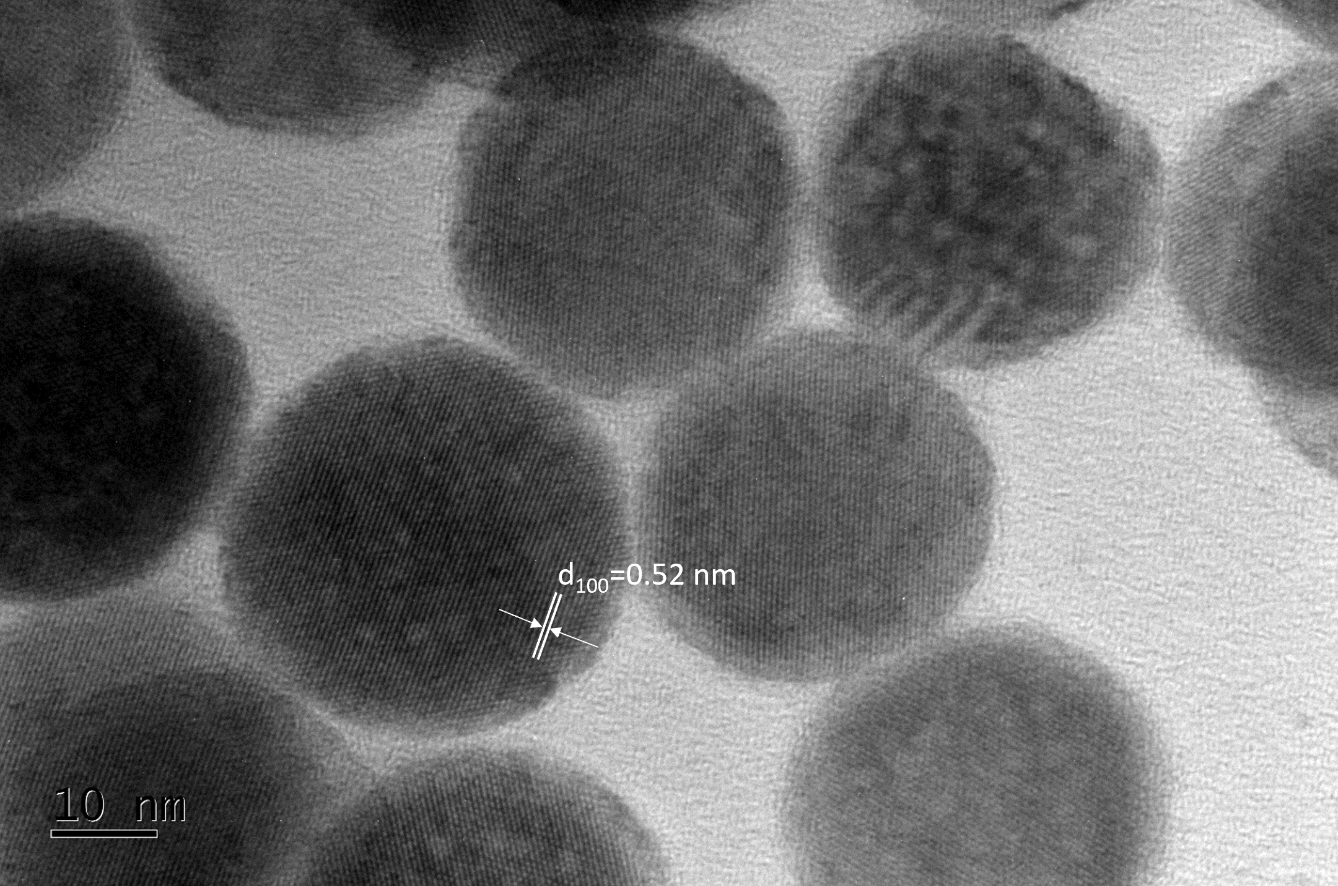
Fig. S1 High-resolution TEM (HRTEM) image showing the single-crystalline nature of the CS3 architecture, characterized by well-defined lattice fringes and uniform spherical particle morphology. The scale bar represents 10 nm.

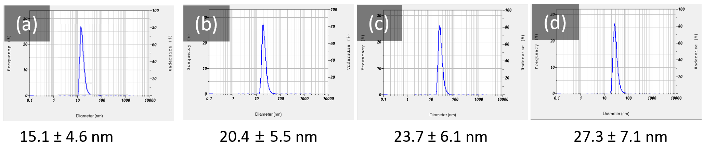
Fig. S2 Dynamic Light Scattering (DLS) analysis of nanoparticle size distribution. The graphs of (a) core (C), (b) core-shell (CS), (c) core-double shell (CS2), and (d) core-triple shell (CS3) represent the size distribution profiles of nanoparticles with varying average diameters. Each graph shows a single peak, indicating a relatively narrow size distribution, with the x-axis representing the diameter (nm) and the y-axis displaying the frequency (%) of occurrence. The measurements reflect the precision and consistency of the nanoparticle synthesis process, with the mean diameter increasing progressively from (a) to (d).

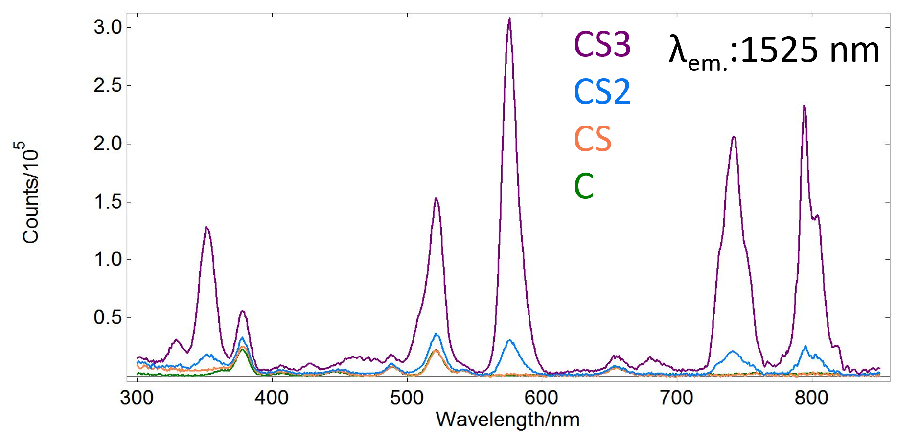
Fig. S3 Excitation spectra of the onion-like Nd-RENPs with varying shell structures under excitation, highlighting the progressive increase in photoluminescent intensity at 1525 nm from the core (C), core-shell (CS), core-double shell (CS2), to the core-triple shell (CS3), indicating enhanced upconversion efficiency.

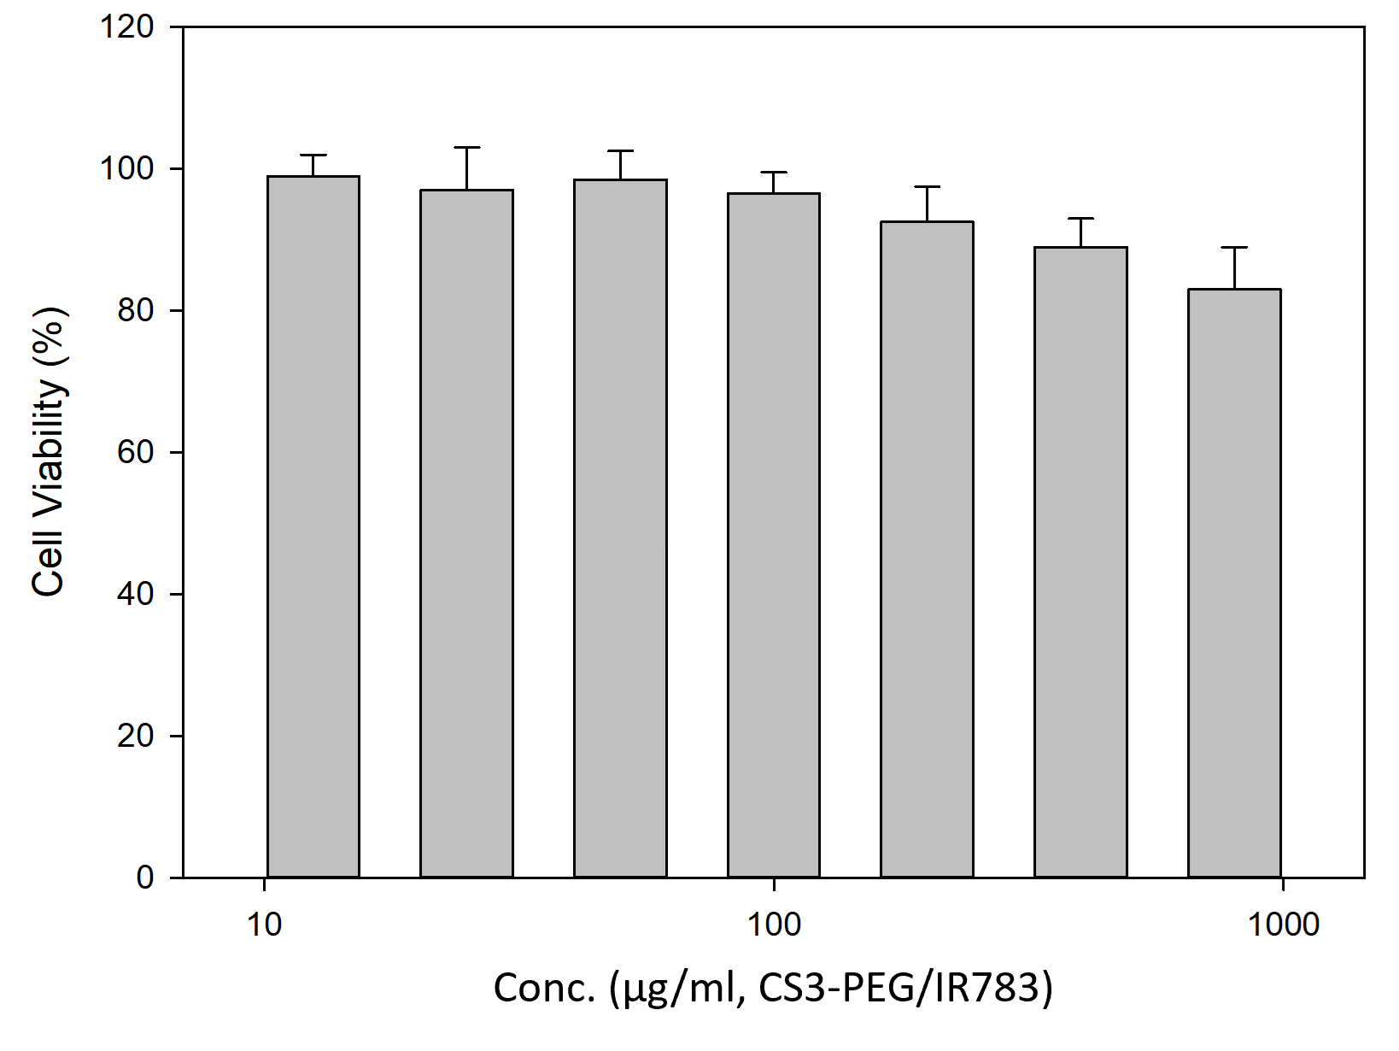
Fig. S4 Cell viability assessment of different concentrations of CS3-PEG/IR783 ranging from 12.5 to 800 μg/ml (12.5, 25, 50, 100, 200, 400, 800 800 μg/ml), as determined by CCK-8 assay, showing high cell viability across all tested concentrations and indicating low cytotoxicity of the nanocomplex.

