Supplementary file
Table S1: Comparative studies on the adsorption capacities of other reported adsorbents.
Adsorbent | pH | q_{max} (mg/g) | Reference
Graphene Oxide | 3 | 313 mg/g | (Gao et al., 2012)
Cu-immobilized alginate adsorbent | 3 | 58 mg/g | (Zhang et al., 2019)
Porous adsorbent | Natural pH | 330.59 mg/g | (Yu et al., 2021)
nano-zero valent iron (nZVI | 6 | 72.64 mg/g | (Abdelfatah et al., 2021)
Cu/β-CD/rGO | 7.8 | 403.2 mg/g | (Yakout et al., 2021)
Fe3O4/Clinoptilolite nanocomposite | 8 | 180 mg/g | (Rouhani et al., 2022)
CuFe2O4@PVP@GO | 6 | 193.8 mg/g | (Ahmed et al., 2023)
CuO@GO@IR | 3 | 769.23 mg/g | Present study

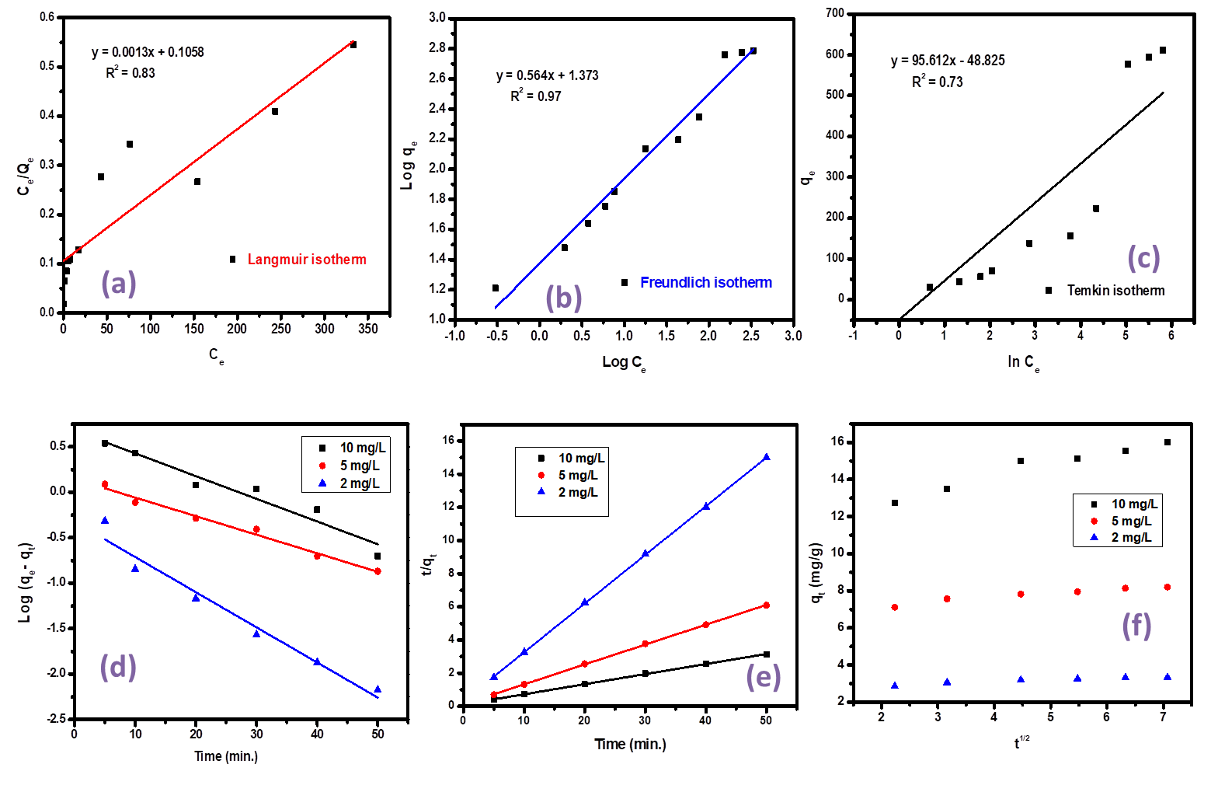

Fig. S1 Adsorption isotherm models (a) Langmuir isotherm (b) Freundlich isotherm (c) Temkin isotherm, Kinetic plots (d) Pseudo First Order (e) Pseudo second order (f) Intraparticle diffusion model

