Hydroxyethylamine-based analog targets microtubule assembly: An in silico study for anti-cancerous drug development

Pawan Kumar¹, Rajni Khan², Basant Narain Singh³, Anisha Kumari⁴, Ankit Rai^{5*}, Anil Kumar Singh^{6*}, Amresh Prakash^{7*} and Shashikant Ray^{4*}
¹National Institute of Immunology, New Delhi, India.
²Department of Pharmacology and Toxicology, National Institute of Pharmaceutical Education and Research, Hajipur, 844102, India.
³Gorakshpithadhishwar Mahant Awedyanath Mahavidyalaya, Chowk Bazar, Maharajganj, Affiliated unit of Siddharth University, Kapilvastu, Siddharth Nagar, (U.P.), 272202, India
⁴Department of Biotechnology, Mahatma Gandhi Central University, Motihari, 845401, India.
⁵Department of Medical Biotechnology, Gujrat Biotechnology University Gandhinagar- 382355, Gujarat, India
⁶Department of Chemistry, Mahatma Gandhi Central University, Motihari, 845401, India.
⁷Amity Institute of Integrative Sciences and Health, Amity University Haryana, Gurgaon, India.

* Corresponding author:
ankit.rai@gbu.edu.in (Ankit Rai)
anilkumarsingh@mgcub.ac.in (Anil Kumar Singh)
amreshprakash@jnu.ac.in (Amresh Prakash)
shashikantray@mgcub.ac.in (Shashikant Ray)

S. No. | Ligand Code |  | Ligand Structure | IUPAC Name | Molecular Weight (g/mol)
1 | BKS2001 |  |  | 3,5-di((E)-benzylidene)-4-oxo-N-phenylpiperidine-1-carboxamide | 394.47
2 | BKS2002 |  |  | 3,5-bis((E)-4-chlorobenzylidene)-4-oxo-N-phenylpiperidine-1-carboxamide | 463.36
3 | BKS2003 |  |  | 3,5-bis((E)-4-bromobenzylidene)-4-oxo-N-phenylpiperidine-1-carboxamide | 552.27
4 | BKS2004 |  |  | 3,5-bis((E)-4-fluorobenzylidene)-4-oxo-N-phenylpiperidine-1-carboxamide | 430.45
5 | BKS2005 |  |  | 4-oxo-N-phenyl-3,5-bis((E)-4-(trifluoromethyl)benzylidene)piperidine-1-carboxamide | 530.47
6 | BKS2006 |  |  | 3,5-bis((E)-4-methylbenzylidene)-4-oxo-N-phenylpiperidine-1-carboxamide | 422.53
7 | BKS2007 |  |  | 3,5-bis((E)-3,4-dichlorobenzylidene)-4-oxo-N-phenylpiperidine-1-carboxamide | 532.24
8 | BKS2008 |  |  | 3,5-bis((E)-3,4-difluorobenzylidene)-4-oxo-N-phenylpiperidine-1-carboxamide | 466.44
9 | BKS2009 |  |  | 3,5-bis((E)-2,5-dimethoxybenzylidene)-4-oxo-N-phenylpiperidine-1-carboxamide | 514.58
10 | BKS2010 |  |  | 4-oxo-N-phenyl-3,5-bis((E)-3,4,5-trimethoxybenzylidene)piperidine-1-carboxamide | 574.63
11 | BKS2011 |  |  | 3,5-bis((E)-4-methoxybenzylidene)-4-oxo-N-phenylpiperidine-1-carboxamide | 454.53
12 | BKS2012 |  |  | 3,5-bis((E)-3,4-dimethoxybenzylidene)-4-oxo-N-phenylpiperidine-1-carboxamide | 514.58
13 | BKS2013 |  |  | 3,5-bis((E)-4-(dimethylamino)benzylidene)-4-oxo-N-phenylpiperidine-1-carboxamide | 480.61
14 | BKS2014 |  |  | 3,5-di((E)-benzylidene)-N-(4-fluorophenyl)-4-oxopiperidine-1-carboxamide | 412.46
15 | BKS2015 |  |  | 3,5-bis((E)-4-chlorobenzylidene)-N-(4-fluorophenyl)-4-oxopiperidine-1-carboxamide | 481.35
16 | BKS2016 |  |  | 3,5-bis((E)-4-bromobenzylidene)-N-(4-fluorophenyl)-4-oxopiperidine-1-carboxamide | 570.26
17 | BKS2017 |  |  | 3,5-bis((E)-4-fluorobenzylidene)-N-(4-fluorophenyl)-4-oxopiperidine-1-carboxamide | 448.45
18 | BKS2018 |  |  | N-(4-fluorophenyl)-4-oxo-3,5-bis((E)-4-(trifluoromethyl)benzylidene)piperidine-1-carboxamide | 548.46
19 | BKS2019 |  |  | N-(4-fluorophenyl)-3,5-bis((E)-4-methylbenzylidene)-4-oxopiperidine-1-carboxamide | 440.52
20 | BKS2020 |  |  | 3,5-bis((E)-3,4-dichlorobenzylidene)-N-(4-fluorophenyl)-4-oxopiperidine-1-carboxamide | 550.23
21 | BKS2021 |  |  | 3,5-bis((E)-3,4-difluorobenzylidene)-N-(4-fluorophenyl)-4-oxopiperidine-1-carboxamide | 484.43
22 | BKS2022 |  |  | 3,5-bis((E)-2,5-dimethoxybenzylidene)-N-(4-fluorophenyl)-4-oxopiperidine-1-carboxamide | 532.57
23 | BKS2023 |  |  | N-(4-fluorophenyl)-4-oxo-3,5-bis((E)-3,4,5-trimethoxybenzylidene)piperidine-1-carboxamide | 592.62
24 | BKS2024 |  |  | N-(4-fluorophenyl)-3,5-bis((E)-4-methoxybenzylidene)-4-oxopiperidine-1-carboxamide | 472.52
25 | BKS2025 |  |  | 3,5-bis((E)-3,4-dimethoxybenzylidene)-N-(4-fluorophenyl)-4-oxopiperidine-1-carboxamide | 532.57
26 | BKS2026 |  |  | 3,5-bis((E)-4-(dimethylamino)benzylidene)-N-(4-fluorophenyl)-4-oxopiperidine-1-carboxamide | 498.60
27 | BKS2027 |  |  | 3,5-di((E)-benzylidene)-N-(4-chlorophenyl)-4-oxopiperidine-1-carboxamide | 428.92
28 | BKS2028 |  |  | 3,5-bis((E)-4-chlorobenzylidene)-N-(4-chlorophenyl)-4-oxopiperidine-1-carboxamide | 497.80
29 | BKS2029 |  |  | 3,5-bis((E)-4-bromobenzylidene)-N-(4-chlorophenyl)-4-oxopiperidine-1-carboxamide | 586.71
30 | BKS2030 |  |  | N-(4-chlorophenyl)-3,5-bis((E)-4-fluorobenzylidene)-4-oxopiperidine-1-carboxamide | 464.90
31 | BKS2031 |  |  | N-(4-chlorophenyl)-4-oxo-3,5-bis((E)-4-(trifluoromethyl)benzylidene)piperidine-1-carboxamide | 564.91
32 | BKS2032 |  |  | N-(4-chlorophenyl)-3,5-bis((E)-4-methylbenzylidene)-4-oxopiperidine-1-carboxamide | 456.97
33 | BKS2033 |  |  | N-(4-chlorophenyl)-3,5-bis((E)-3,4-dichlorobenzylidene)-4-oxopiperidine-1-carboxamide | 566.68
34 | BKS3001 |  |  | 2-(4-methyl-1-oxo-1-(pyrrolidin-1-yl)pentan-2-yl)isoindoline-1,3-dione | 314.39
35 | BKS3002 |  |  | 2-(1-oxo-3-phenyl-1-(pyrrolidin-1-yl)propan-2-yl)isoindoline-1,3-dione | 348.40
36 | BKS3003 |  |  | 2-(3-methyl-1-oxo-1-(pyrrolidin-1-yl)butan-2-yl)isoindoline-1,3-dione | 300.36
37 | BKS3004 |  |  | 2-(3-methyl-1-oxo-1-(pyrrolidin-1-yl)pentan-2-yl)isoindoline-1,3-dione | 314.39
38 | BKS3005 |  |  | 2-(4-methyl-1-oxo-1-(piperidin-1-yl)pentan-2-yl)isoindoline-1,3-dione | 328.41
39 | BKS3006 |  |  | 2-(1-oxo-3-phenyl-1-(piperidin-1-yl)propan-2-yl)isoindoline-1,3-dione | 362.43
40 | BKS3007 |  |  | 2-(3-methyl-1-oxo-1-(piperidin-1-yl)butan-2-yl)isoindoline-1,3-dione | 314.39
41 | BKS3008 |  |  | 2-(3-methyl-1-oxo-1-(piperidin-1-yl)pentan-2-yl)isoindoline-1,3-dione | 328.41
42 | BKS3009 |  |  | 2-(1-(4-benzylpiperidin-1-yl)-4-methyl-1-oxopentan-2-yl)isoindoline-1,3-dione | 418.54
43 | BKS3010 |  |  | 2-(1-(4-benzylpiperidin-1-yl)-1-oxo-3-phenylpropan-2-yl)isoindoline-1,3-dione | 452.55
44 | BKS3011 |  |  | 2-(1-(4-benzylpiperidin-1-yl)-3-methyl-1-oxobutan-2-yl)isoindoline-1,3-dione | 404.51
45 | BKS3012 |  |  | 2-(1-(4-benzylpiperidin-1-yl)-3-methyl-1-oxopentan-2-yl)isoindoline-1,3-dione | 418.54
46 | BKS3013 |  |  | 2,2'-(piperazine-1,4-diylbis(4-methyl-1-oxopentane-1,2-diyl))bis(isoindoline-1,3-dione) | 572.66
47 | BKS3014 |  |  | 2,2'-(piperazine-1,4-diylbis(1-oxo-3-phenylpropane-1,2-diyl))bis(isoindoline-1,3-dione) | 640.70
48 | BKS3015 |  |  | 2,2'-(piperazine-1,4-diylbis(3-methyl-1-oxobutane-1,2-diyl))bis(isoindoline-1,3-dione) | 544.61
49 | BKS3016 |  |  | 2,2'-(piperazine-1,4-diylbis(3-methyl-1-oxopentane-1,2-diyl))bis(isoindoline-1,3-dione) | 572.66
50 | BKS3017 |  |  | 2-(4-methyl-1-morpholino-1-oxopentan-2-yl)isoindoline-1,3-dione | 330.38
51 | BKS3018 |  |  | 2-(1-morpholino-1-oxo-3-phenylpropan-2-yl)isoindoline-1,3-dione | 364.40
52 | BKS3019 |  |  | 2-(3-methyl-1-morpholino-1-oxobutan-2-yl)isoindoline-1,3-dione | 316.36
53 | BKS3020 |  |  | 2-(3-methyl-1-morpholino-1-oxopentan-2-yl)isoindoline-1,3-dione | 330.38
54 | BKS3021 |  |  | tert-butyl (3-hydroxy-4-(4-methylpiperazin-1-yl)-1-phenylbutan-2-yl)carbamate | 363.50
55 | BKS3022 |  |  | 2-(1,3-dioxoisoindolin-2-yl)-N-(3-hydroxy-4-(4-methylpiperazin-1-yl)-1-phenylbutan-2-yl)-4-methylpentanamide | 506.65
56 | BKS3023 |  |  | 2-(1,3-dioxoisoindolin-2-yl)-N-(3-hydroxy-4-(4-methylpiperazin-1-yl)-1-phenylbutan-2-yl)-3-phenylpropanamide | 540.66
57 | BKS3024 |  |  | 2-(1,3-dioxoisoindolin-2-yl)-N-(3-hydroxy-4-(4-methylpiperazin-1-yl)-1-phenylbutan-2-yl)-3-methylbutanamide | 492.62
58 | BKS3025 |  |  | 2-(1,3-dioxoisoindolin-2-yl)-N-(3-hydroxy-4-(4-methylpiperazin-1-yl)-1-phenylbutan-2-yl)-3-methylpentanamide | 506.65
59 | BKS3026 |  |  | tert-butyl (4-(4-ethylpiperazin-1-yl)-3-hydroxy-1-phenylbutan-2-yl)carbamate | 377.53
60 | BKS3027 |  |  | 2-(1,3-dioxoisoindolin-2-yl)-N-(4-(4-ethylpiperazin-1-yl)-3-hydroxy-1-phenylbutan-2-yl)-4-methylpentanamide | 520.67
61 | BKS3028 |  |  | 2-(1,3-dioxoisoindolin-2-yl)-N-(4-(4-ethylpiperazin-1-yl)-3-hydroxy-1-phenylbutan-2-yl)-3-phenylpropanamide | 554.69
62 | BKS3029 |  |  | 2-(1,3-dioxoisoindolin-2-yl)-N-(4-(4-ethylpiperazin-1-yl)-3-hydroxy-1-phenylbutan-2-yl)-3-methylbutanamide | 506.65
63 | BKS3030 |  |  | 2-(1,3-dioxoisoindolin-2-yl)-N-(4-(4-ethylpiperazin-1-yl)-3-hydroxy-1-phenylbutan-2-yl)-3-methylpentanamide | 520.67
64 | BKS3031 |  |  | di-tert-butyl (piperazine-1,4-diylbis(3-hydroxy-1-phenylbutane-4,2-diyl))dicarbamate | 612.81
65 | BKS3032 |  |  | N,N'-(piperazine-1,4-diylbis(3-hydroxy-1-phenylbutane-4,2-diyl))bis(2-(1,3-dioxoisoindolin-2-yl)-4-methylpentanamide) | 899.10
66 | BKS3033 |  |  | N,N'-(piperazine-1,4-diylbis(3-hydroxy-1-phenylbutane-4,2-diyl))bis(2-(1,3-dioxoisoindolin-2-yl)-3-phenylpropanamide) | 967.14
67 | BKS3034 |  |  | N,N'-(piperazine-1,4-diylbis(3-hydroxy-1-phenylbutane-4,2-diyl))bis(2-(1,3-dioxoisoindolin-2-yl)-3-methylbutanamide) | 871.05
68 | BKS3035 |  |  | N,N'-(piperazine-1,4-diylbis(3-hydroxy-1-phenylbutane-4,2-diyl))bis(2-(1,3-dioxoisoindolin-2-yl)-3-methylpentanamide) | 899.10
69 | BKS3036 |  |  | tert-butyl (4-([1,4'-bipiperidin]-1'-yl)-3-hydroxy-1-phenylbutan-2-yl)carbamate | 431.62
70 | BKS3037 |  |  | N-(4-([1,4'-bipiperidin]-1'-yl)-3-hydroxy-1-phenylbutan-2-yl)-2-(1,3-dioxoisoindolin-2-yl)-3-phenylpropanamide | 608.78
71 | BKS3038 |  |  | tert-butyl (4-(4-(4-fluorobenzyl)piperazin-1-yl)-3-hydroxy-1-phenylbutan-2-yl)carbamate | 457.59
72 | BKS3039 |  |  | 2-(1,3-dioxoisoindolin-2-yl)-N-(4-(4-(4-fluorobenzyl)piperazin-1-yl)-3-hydroxy-1-phenylbutan-2-yl)-4-methylpentanamide | 600.74
73 | BKS3040 |  |  | 2-(1,3-dioxoisoindolin-2-yl)-N-(4-(4-(4-fluorobenzyl)piperazin-1-yl)-3-hydroxy-1-phenylbutan-2-yl)-3-phenylpropanamide | 634.75
74 | BKS3041 |  |  | 2-(1,3-dioxoisoindolin-2-yl)-N-(4-(4-(4-fluorobenzyl)piperazin-1-yl)-3-hydroxy-1-phenylbutan-2-yl)-3-methylbutanamide | 586.71
75 | BKS3042 |  |  | 2-(1,3-dioxoisoindolin-2-yl)-N-(4-(4-(4-fluorobenzyl)piperazin-1-yl)-3-hydroxy-1-phenylbutan-2-yl)-3-methylpentanamide | 600.74
76 | BKS3043 |  |  | tert-butyl (4-(4-(4-bromobenzyl)piperazin-1-yl)-3-hydroxy-1-phenylbutan-2-yl)carbamate | 518.50
77 | BKS3044 |  |  | N-(4-(4-(4-bromobenzyl)piperazin-1-yl)-3-hydroxy-1-phenylbutan-2-yl)-2-(1,3-dioxoisoindolin-2-yl)-4-methylpentanamide | 661.64
78 | BKS3045 |  |  | N-(4-(4-(4-bromobenzyl)piperazin-1-yl)-3-hydroxy-1-phenylbutan-2-yl)-2-(1,3-dioxoisoindolin-2-yl)-3-phenylpropanamide | 695.66
79 | BKS3046 |  |  | N-(4-(4-(4-bromobenzyl)piperazin-1-yl)-3-hydroxy-1-phenylbutan-2-yl)-2-(1,3-dioxoisoindolin-2-yl)-3-methylbutanamide | 647.61
80 | BKS3047 |  |  | N-(4-(4-(4-bromobenzyl)piperazin-1-yl)-3-hydroxy-1-phenylbutan-2-yl)-2-(1,3-dioxoisoindolin-2-yl)-3-methylpentanamide | 661.64
81 | BKS3048 |  |  | 2-(1-(4-(4-bromobenzyl)piperazin-1-yl)-4-methyl-1-oxopentan-2-yl)isoindoline-1,3-dione | 498.40
82 | BKS3049 |  |  | 2-(1-(4-(4-bromobenzyl)piperazin-1-yl)-1-oxo-3-phenylpropan-2-yl)isoindoline-1,3-dione | 532.44
83 | BKS3050 |  |  | 2-(1-(4-(4-bromobenzyl)piperazin-1-yl)-3-methyl-1-oxobutan-2-yl)isoindoline-1,3-dione | 484.39
84 | BKS3051 |  |  | 2-(1-(4-(4-bromobenzyl)piperazin-1-yl)-3-methyl-1-oxopentan-2-yl)isoindoline-1,3-dione | 498.42
85 | BKS3052 |  |  | 2-(1-(4-(4-fluorobenzyl)piperazin-1-yl)-4-methyl-1-oxopentan-2-yl)isoindoline-1,3-dione | 437.52
86 | BKS3053 |  |  | 2-(1-(4-(4-fluorobenzyl)piperazin-1-yl)-1-oxo-3-phenylpropan-2-yl)isoindoline-1,3-dione | 471.53
87 | BKS3054 |  |  | 2-(1-(4-(4-fluorobenzyl)piperazin-1-yl)-3-methyl-1-oxobutan-2-yl)isoindoline-1,3-dione | 423.49
88 | BKS3055 |  |  | 2-(1-(4-(4-fluorobenzyl)piperazin-1-yl)-3-methyl-1-oxopentan-2-yl)isoindoline-1,3-dione | 437.52
89 | BKS3056 |  |  | 2-(4-methyl-1-oxo-1-(4-(4-(trifluoromethyl)benzyl)piperazin-1-yl)pentan-2-yl)isoindoline-1,3-dione | 487.52
90 | BKS3057 |  |  | 2-(1-oxo-3-phenyl-1-(4-(4-(trifluoromethyl)benzyl)piperazin-1-yl)propan-2-yl)isoindoline-1,3-dione | 521.54
91 | BKS3058 |  |  | 2-(3-methyl-1-oxo-1-(4-(4-(trifluoromethyl)benzyl)piperazin-1-yl)butan-2-yl)isoindoline-1,3-dione | 473.50
92 | BKS3059 |  |  | 2-(3-methyl-1-oxo-1-(4-(4-(trifluoromethyl)benzyl)piperazin-1-yl)pentan-2-yl)isoindoline-1,3-dione | 487.52
93 | BKS3060 |  |  | 2-(1-(4-(4-(tert-butyl)benzyl)piperazin-1-yl)-4-methyl-1-oxopentan-2-yl)isoindoline-1,3-dione | 475.63
94 | BKS3061 |  |  | 2-(1-(4-(4-(tert-butyl)benzyl)piperazin-1-yl)-1-oxo-3-phenylpropan-2-yl)isoindoline-1,3-dione | 509.65
95 | BKS3062 |  |  | 2-(1-(4-(4-(tert-butyl)benzyl)piperazin-1-yl)-3-methyl-1-oxobutan-2-yl)isoindoline-1,3-dione | 461.61
96 | BKS3063 |  |  | 2-(1-(4-(4-(tert-butyl)benzyl)piperazin-1-yl)-3-methyl-1-oxopentan-2-yl)isoindoline-1,3-dione | 475.63
97 | BKS3064 |  |  | 2-(4-methyl-1-oxo-1-(4-phenethylpiperazin-1-yl)pentan-2-yl)isoindoline-1,3-dione | 433.55
98 | BKS3065 |  |  | 2-(1-oxo-1-(4-phenethylpiperazin-1-yl)-3-phenylpropan-2-yl)isoindoline-1,3-dione | 467.57
99 | BKS3066 |  |  | 2-(3-methyl-1-oxo-1-(4-phenethylpiperazin-1-yl)butan-2-yl)isoindoline-1,3-dione | 419.53
100 | BKS3067 |  |  | 2-(3-methyl-1-oxo-1-(4-phenethylpiperazin-1-yl)pentan-2-yl)isoindoline-1,3-dione | 433.55
101 | BKS3046A |  |  | (S)-2-amino-N-((2R,3S)-4-(4-(4-bromobenzyl)piperazin-1-yl)-3-hydroxy-1-phenylbutan-2-yl)-3-methylbutanamide | 516.51
102 | BKS3031A |  |  | (2S,2'S,3R,3'R)-1,1'-(piperazine-1,4-diyl)bis(3-amino-4-phenylbutan-2-ol) | 412.58
103 | BKS3045A |  |  | (S)-2-amino-N-((2R,3S)-4-(4-(4-bromobenzyl)piperazin-1-yl)-3-hydroxy-1-phenylbutan-2-yl)-3-phenylpropanamide | 565.56
104 | BKS3023A |  |  | (S)-2-amino-N-((2R,3S)-3-hydroxy-4-(4-methylpiperazin-1-yl)-1-phenylbutan-2-yl)-3-phenylpropanamide | 410.56
105 | BKS3047A |  |  | (2S,3R)-2-amino-N-((2R,3S)-4-(4-(4-bromobenzyl)piperazin-1-yl)-3-hydroxy-1-phenylbutan-2-yl)-3-methylpentanamide | 531.54
106 | BKS3040A |  |  | (S)-2-amino-N-((2R,3S)-4-(4-(4-fluorobenzyl)piperazin-1-yl)-3-hydroxy-1-phenylbutan-2-yl)-3-phenylpropanamide | 504.65

Supplementary Table 1. Ligand Structure, IUPAC name and Molecular Weight

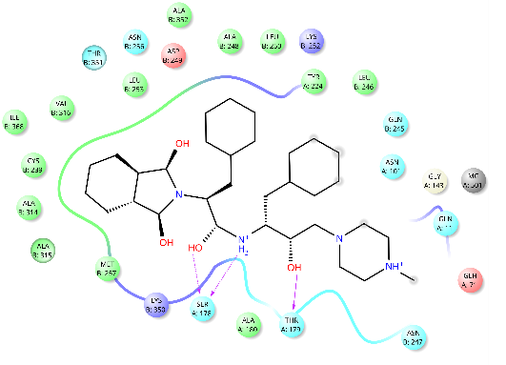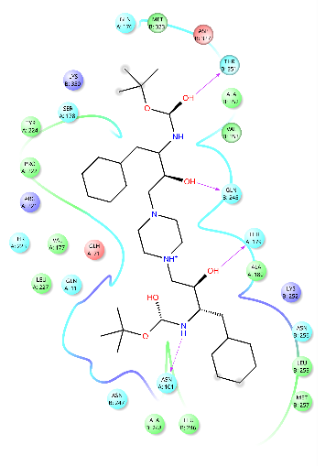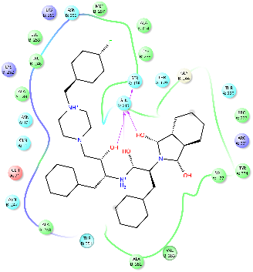
BKS3023 BKS3031 BKS3040
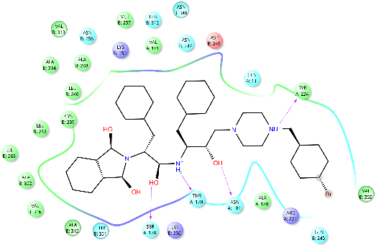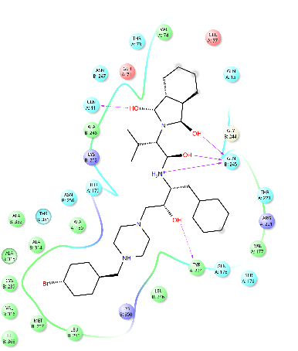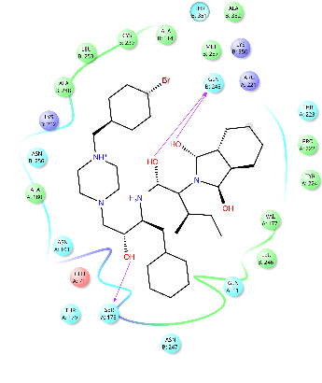
BKS3045 BKS3046 BKS3047

Supplementary Figure S1. The two-dimensional view of molecular binding interaction of BKS compounds at the colchicine binding pocket of ɑ-β tubulin.

