- Sound recording in Phase I and Phase II
A total of 16285 sound records were collected during the study using 6 Sound Monitoring stations (SMS) (Table1). This amounts to 271.42h of sound recording. In Phase I, which is 12h operation of MPC, 11266 sound records have been collected over 3 months. Similarly, 5019 sound records have been collected in Phase II, which is 20h MPC operations. In Phase II, due to a technical snag in the recording device, sound recorded in SMS3 and SMS5 were not used for analysis.
A total of 16285 sound records were collected during the study using 6 SMS (Table 1). This amounts to 271.42h of sound recording. In Phase I, which is 12h operation of Main Pipe Conveyor (MPC) operations, 11266 sound records have been collected over 3 months. Similarly, 5019 sound records have been collected in Phase II, which is 20h MPC. In Phase II, due to a technical snag in the recording device, sound recorded in SMS3 and SMS5 were not used for any analysis.
Table 1: Sound Monitoring Stations with the number of sound records
SMS # | Land-use | Begin Date | End Date | Total Records | Phase
06 | Control | 03 July 21 | 13 July 21 | 1336 | Phase I
01 | Grassland | 15 July 21 | 25 July 21 | 1359 | Phase I
02 | Agriculture | 15 July 21 | 25 July 21 | 1433 | Phase I
03 | Water | 19 June 21 | 09 July 21 | 2775 | Phase I
04 | Forest | 19 June 21 | 10 July 21 | 2633 | Phase I
05 | Builtup | 25 July 21 | 06 August 21 | 1730 | Phase I
01 | Grassland | 13 August 21 | 24 August 21 | 814 | Phase II
02 | Agriculture | 13 August 21 | 24 August 21 | 517 | Phase II
03 | Water | 13 August 21 | 24 August 21 | 1220 | Phase II
04 | Forest | 13 August 21 | 24 August 21 | 1090 | Phase II
05 | Builtup* | 13 August 21 | 13 August 21 | 1293 | Phase II

Visualizing sound records
An audio file consisting of the audio signals can be used viewed using specific software. Raven Pro 1.6, SigView, Audacity® and see wave plugin in R is used in the present study. Here a 60 second sound record is viewed using Raven Pro 1.6. In this study, sounds of the arthropods, amphibians, birds and mammals (bats) are recorded, either in the sound monitoring stations or using specific devices (eg., echo meter for bats, Zoom H1n for amphibians and so on). Each group of the animals and their acoustical characteristic features are discussed separately in the respective chapters. However, all the sound representation follows a similar method and annotations discussed below. Figure 1 demonstrates the waveform (longitudinal waves) of the sound recorded on 29th June 2021 from the control region. Much hidden information within waveform can be viewed if a Fourier transformation is applied to sound. Figure 2.5 illustrates the spectrogram of the above-mentioned sound file. A select spectrum view provides the amplitude within a part of the spectrogram Figure 2. Annotation and spectrum slice is illustrated in Figure 2.7. Waveform and spectrogram of MPC running at 8:10 am recorded in SMS is given in Figure 2.7a. Due to the Nyquist frequency given for sound recording at 44.1 kHz, some ultrasounds emitted from MPC are not recorded in the SMS.
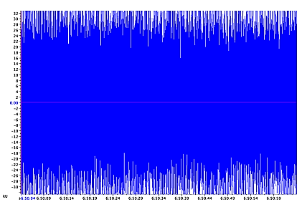

Figure 1. Waveform representation of sound recording.
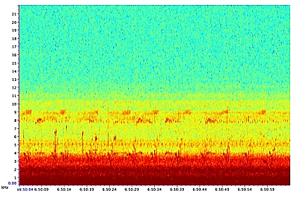
Figure 2. Spectrogram view of the sound.
Ultrasonic Sound emission from MPC
The MPC during its operations does emit sound due to the movement of its Steel and HDPE idlers and the belt. The frequency emitted by the MPC varies depending on the speed at which the MPC system is running, and the type of idlers used at the specific section. The average frequency of the sound emitted from the MPC recorded during its regular operational time (06:00 to 18:00 hrs) was up to 25 kHz (Figure 3 b). The highest frequency from the MPC has been up to 45 kHz when the speed of MPC is at its peak speed. Such high frequency has been documented even at lower speeds wherever the steel idlers are used.
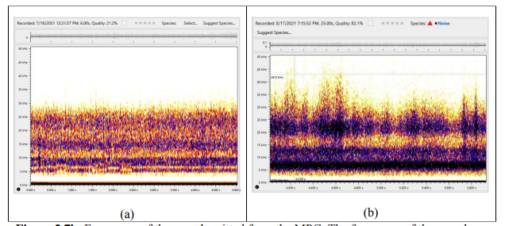
Figure 3. Frequency of the sound emitted from the MPC. The frequency of the sound was recorded close to 30kHz (a); The frequency of the sound was recorded close to 45kHz, during 20 hours operation (b)
Noise scape Map
Introduction
Sound is a vibration that propagates as an acoustic wave, through a medium such as a gas, liquid or solid. Sound emission is a spatial phenomenon and maps are used to represent noise with appropriate colour coding, resulting in noise maps (Weninger, 2015). Noise mapping is used in modelling noise generating from landscapes, traffic, industries and cities. Similarly, noise maps are used for planning purposes, for setting up noise reduction measures and for long term monitoring in environmental noise (Manwar et al 2015; Knauss, 2020). The primary aims of noisescape map were (i) to determine and map noise along MPC, (ii) to predict noise attenuation with distance and, (iii) to predict noise attenuation in various landuses in the study area.
Materials and Methods :
Instrument and measurements: Calibrated sound measuring instruments (1. 3M Sound Detector SD-200, 2. Sound Lever Meter S12, and 3. SL-4023SD) are used to record sound pressure levels (dBA). Sound measurements were made near Main Pipe Conveyor Belt (MPC) and at different distance intervals randomly moving away from the MPC during the operational time between 6am to 6pm. Sound pressure measurements were recorded for about 30sec. Maximum dBA values were noted along with Longitude, Latitude and predominant land use of the place of recording.
QGIS 3.20.2 with plugin v.distance and contour are used for mapping and creating sound scape. PAST® and MS Excel are used for regression analysis. Colour coding for the noise contours are based on Weninger (2015).
Result Sound measurements:
A total of 1587 sound (dB) measurements were collected from 7th July 2021 to 22nd August 2021 during the day time operation of MPC (6am to 6pm). Among 1587 sound measurements, 1378 unique data are used for analysis, which falls within 250m on either sides of MPC Figure 4. Minimum sound measured was 34.9dB, while the maximum was 89.77. In various land-uses, agriculture fields had 685 points, while grassland had 25 data points.
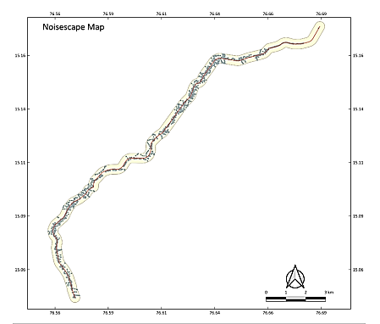
Figure 4 Sound measurement points along MPC
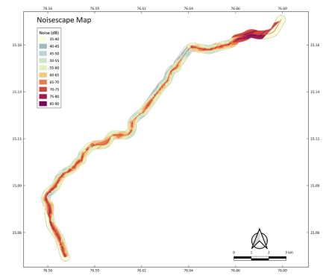
Figure 5. Noise scape Map with MPC
Discussion and suggestions:
This is the first-ever noisescape map of an active main pipe conveyor belt in India. This map visually represents the noise levels coming from the MPC along its length as well as at places with HDPE idlers. Karakula et al. (2007) and Parajuli (2018) indicate that the quality of a noise model can be improved with a high density of observation points. The present research had a large number of observation points (1378), the maps are of good accuracy as indicated by the statistical significance of regression analysis. Suggestions: Planting a double row of trees along and on both sides of MPC can reduce the noise immission and propagation (Aksu and Yilmaz, 2021). In addition, HDPE idlers that reduce noise (by 10-50dB), can be used as alternatives to steel idlers along with the MPC. Limitations: The inconsistent noise levels variations in the study could be due to a. Varied speed of the MPC, b. variation in the load inside MPC and c. variation in the sound meters used. The variation in the sound meters is at the level of 1 to 2 dB, while the variation due to speed and load of MPC is at the level of 20-40dB

