International Journal of Biometeorology
Supplementary Information
Study on the Characteristics of Flash Drought and the Response Regularity of Photosynthesis to Flash Drought in Different Vegetation Ecosystems in the Middle and Lower Reaches of the Yangtze River Basin.
Yunjun Zhan¹, Chuanqi Ma¹, Yan Yan^{2*}, Yongsi Luo¹, Xueting Wang¹, Senrong Wang¹,Yuejing Rong²

¹School of Resources and Environmental Engineering, Wuhan University of Technology, Wuhan 430070, China
²State Key Laboratory of Urban and Regional Ecology, Research Center for Eco-Environmental Sciences, Chinese Academy of Sciences, Beijing 100089, China
*Correspondence: State Key Laboratory of Urban and Regional Ecology, Research Center for Eco-Environmental Sciences, Chinese Academy of Sciences, Beijing 100089, China, e-mail: yyan@rcees.ac.cn

Corresponding author
Correspondence to Yan Yan.
*Correspondence: State Key Laboratory of Urban and Regional Ecology, Research Center for Eco-Environmental Sciences, Chinese Academy of Sciences, Beijing, 100089, China, e-mail: yyan@rcees.ac.cn
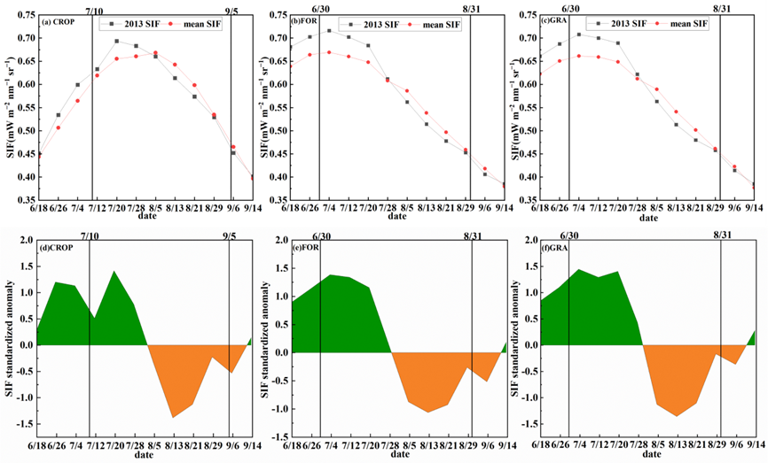
Fig. S1 Characteristics and standardized anomalies of SIF variations for different vegetation types during the 2013 flash drought in the middle and lower Yangtze River basin: (a) Cropland SIF, (b) Forest SIF, (c) Grassland SIF, (d) Cropland SIF standardized anomaly, (e) Forest SIF standardized anomaly, (f) Grassland SIF standardized anomaly. (Red curves indicate multi-year average SIF values, while black curves represent 2013 SIF values. Black bars denote the duration of flash drought for each vegetation type)
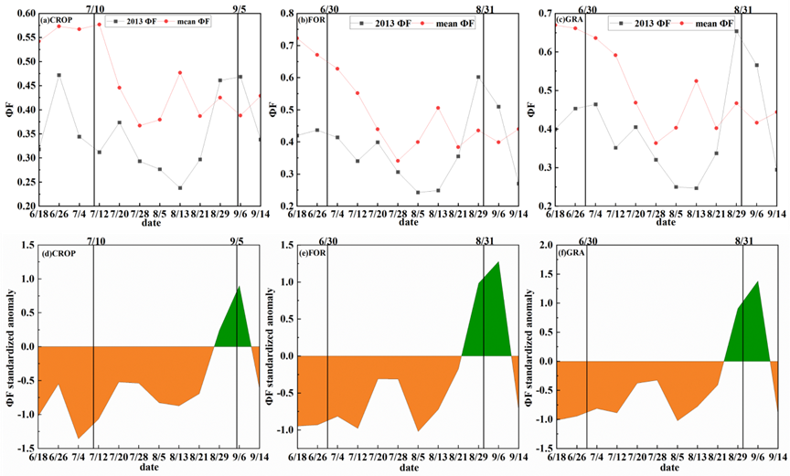
Fig. S2 Characteristics and standardized anomalies of $ϕ_{F}$ variations for different vegetation types during the 2013 flash drought in the middle and lower Yangtze River basin: (a) Cropland $ϕ_{F}$, (b) Forest $ϕ_{F}$, (c) Grassland $ϕ_{F}$, (d) Cropland $ϕ_{F}$ standardized anomaly, (e) Forest $ϕ_{F}$ standardized anomaly, (f) Grassland $ϕ_{F}$ standardized anomaly. (Red curves indicate multi-year average $ϕ_{F}$ values, while black curves represent 2013 $ϕ_{F}$ values. The black lines represent the onset and end times of flash drought for each vegetation type)

