Title
Mesoporous SiO₂-chitin/MoO₃ Nanocomposite: Synthesis, Surface Investigation, Uptake Potential for Pb(II) and Cu(II), and Future Outlook
Authors:
Hany Fathy Heiba ^{[1]*}, Asia A. Taha ^{[2]}, Alaa R. Mostafa ^{[3]}, Abeer Elsaharty ^{[1]}, Manal Gomaa ^{[1]}, Laila A. Mohamed ^{[1]}.
[1] National Institute of Oceanography and Fisheries, NIOF, Egypt.
[2] Alexandria University, Faculty of science, Department of Chemistry, Alexandria, Egypt.
[3] Alexandria University, Faculty of science, Department of Environmental Sciences, Alexandria, Egypt.
* Corresponding author:
Hany Fathy Heiba: hanyheiba@gmail.com;hf.heiba@niof.sci.eg (https://orcid.org/0000-0001-5253-5670)

SUPPLEMENTARY MATERIAL

Table S1 Experimental conditions during studying different adsorption parameters.
Parameter | pH | Time (min) | C₀  (mg/L) | Adsorbent mass (g) | Temperature (K) | Agitation speed (rpm)
pH | 2-7 | 60 | 40 | 0.25 | RT*** | 100
Time (min) | 5*, 6** | 1-60 | 40 | 0.25 | RT | 100
Concentration, C₀ (mg/L) | 5*, 6** | 60 | 10 - 60 | 0.25 | RT | 100
Adsorbent mass (g) | 5*, 6** | 60 | 40 | 0.05 - 0.5 | RT | 100
Temperature (K) | 5*, 6** | 60 | 40 | 0.25 | 293 - 318 | 100
* in Cu(II) adsorption, ** in Pb(II) adsorption, *** RT = Room Temperature

Table S2. List of chemicals used during the study
Chemical | Company Name | Purity (Assay)
Hydrochloric Acid | SIGMA ALDRICH | 36.5 % - 38.0 %
Sodium Hydroxide | SIGMA ALDRICH | ≥98.0 %
Acetone | SIGMA ALDRICH | ≥99.5 %
Acetic Acid | LOBA CHEMIE | >99 %
Ammonium heptamolybdate tetrahydrate | SIGMA ALDRICH | > 99.3 %
SiO₂ | SIGMA ALDRICH | 99.5% trace metals basis
Cu(NO₃)₂ | Merk | 1000 mg/l (>99.9%)
Pb(NO₃)₂ | Merk | 1000 mg/l (>99.9%)

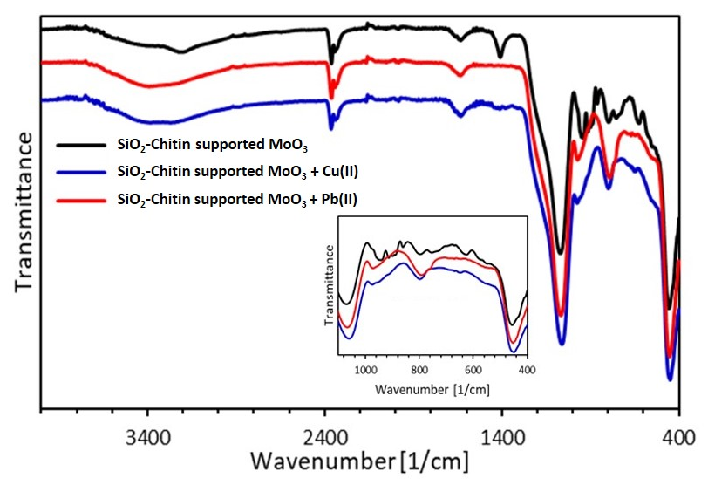
Fig. S1 FTIR showing SiO₂-Chitin supported MoO₃ before and after the Cu(II) and Pb(II) loading

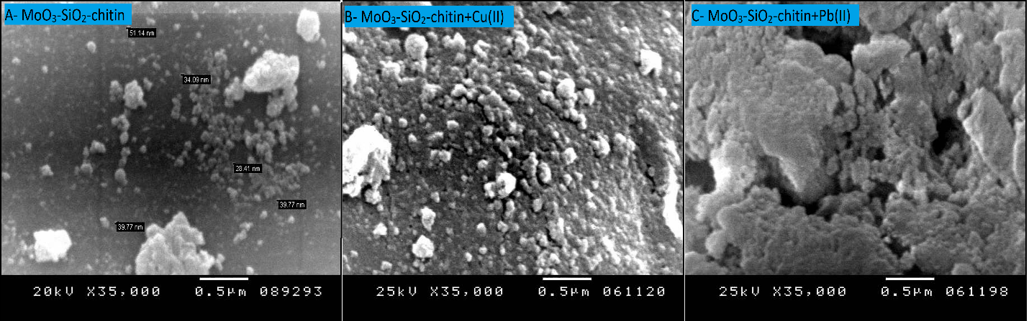
Fig. S2 SEM images of A- SiO₂-Chitin supported MoO₃, B- SiO₂-Chitin supported MoO₃ + Cu(II), C- SiO₂-Chitin supported MoO₃ + Pb(II).

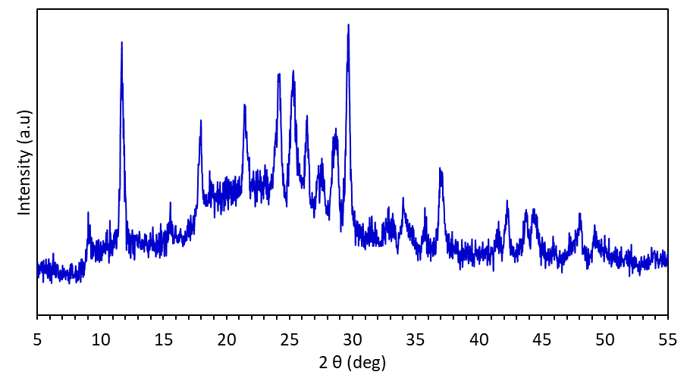
Fig. S3 XRD patterns of SiO₂-chitin supported MoO₃.
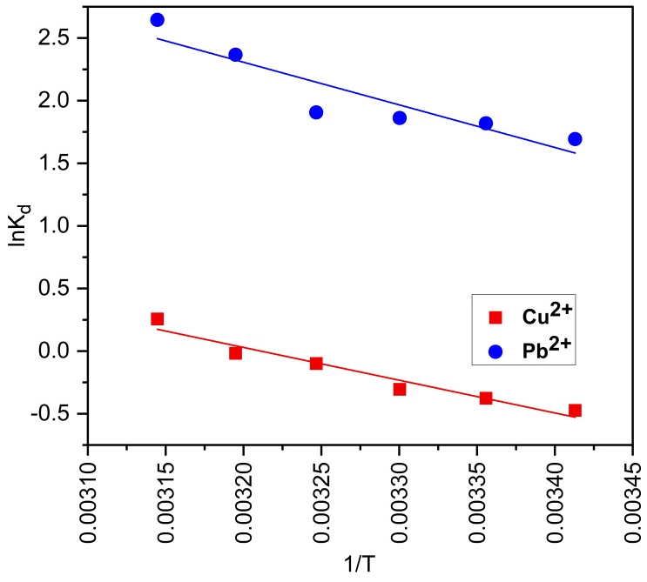
Fig. S4 Van't Hoff plot for Cu(II) and Pb(II) adsorption onto SiO₂-Chitin supported MoO₃.

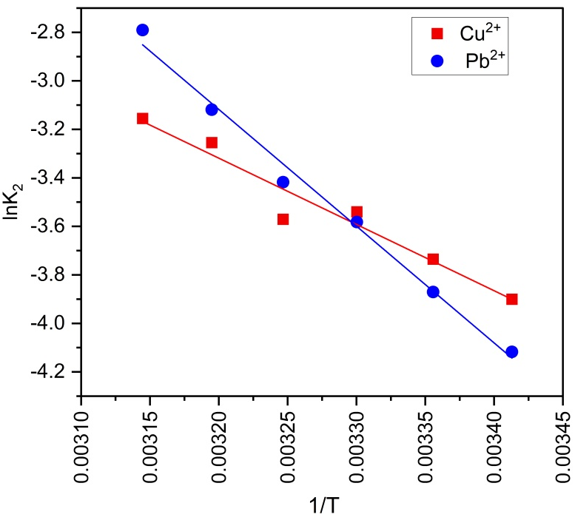
Fig. S5 Arrhenius plot for Cu(II) and Pb(II) adsorption onto SiO₂-Chitin supported MoO₃ .

