Impact of Mining Tailings on Soil Decomposition and Carbon Stabilisation in a Riparian Atlantic Forest

Milton Barbosa^{1*}, João Carlos Gomes Figueiredo¹, Daniel Negreiros^{1,2}, Renata Maia¹, Yumi Oki¹, Lucas Rodrigues de Souza³, Marcos Paulo dos Santos¹, Rebeca Ferreira Reis¹, Quezia Emanuelle Ferreira Rocha¹, ​​Yule Roberta Ferreira Nunes³, Maria das Dores Magalhães Veloso³, Geraldo Wilson Fernandes^{1,2,*}

¹Department of Genetics, Ecology and Evolution, Federal University of Minas Gerais, 31270-901, Belo Horizonte, Brazil.

²Knowledge Center for Biodiversity, 31270-901, Belo Horizonte, Brazil.
³Department of General Biology, Montes Claros State University, 39401-089, Montes Claros, Minas Gerais, Brazil.
* Corresponding authors: miltonbsjunior@gmail.com; gw.fernandes@gmail.com

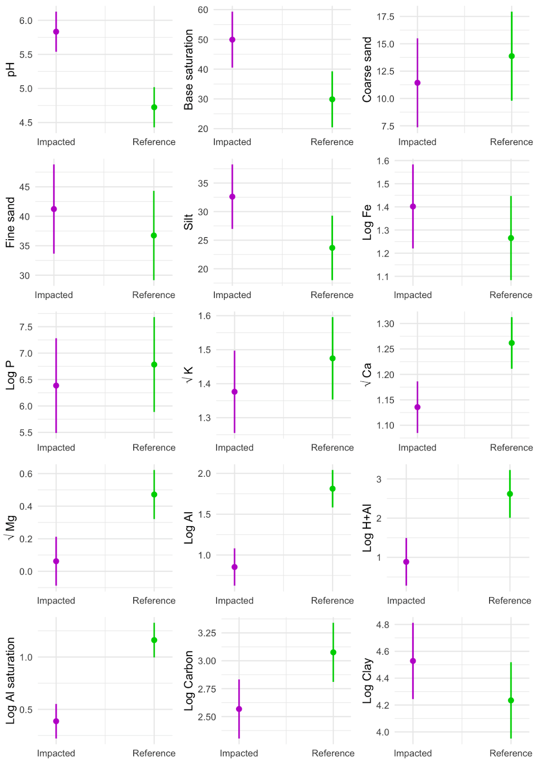Fig. S1 Variation in soil physical and chemical parameters between reference soil and soil impacted by mining tailing from the Samarco’s dam breach in Mariana, MG, Brazil
a)
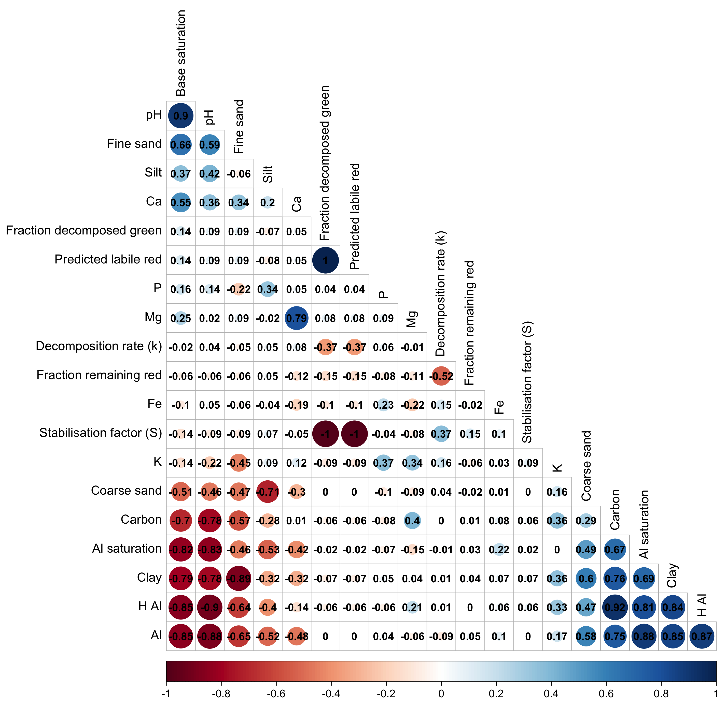

b)
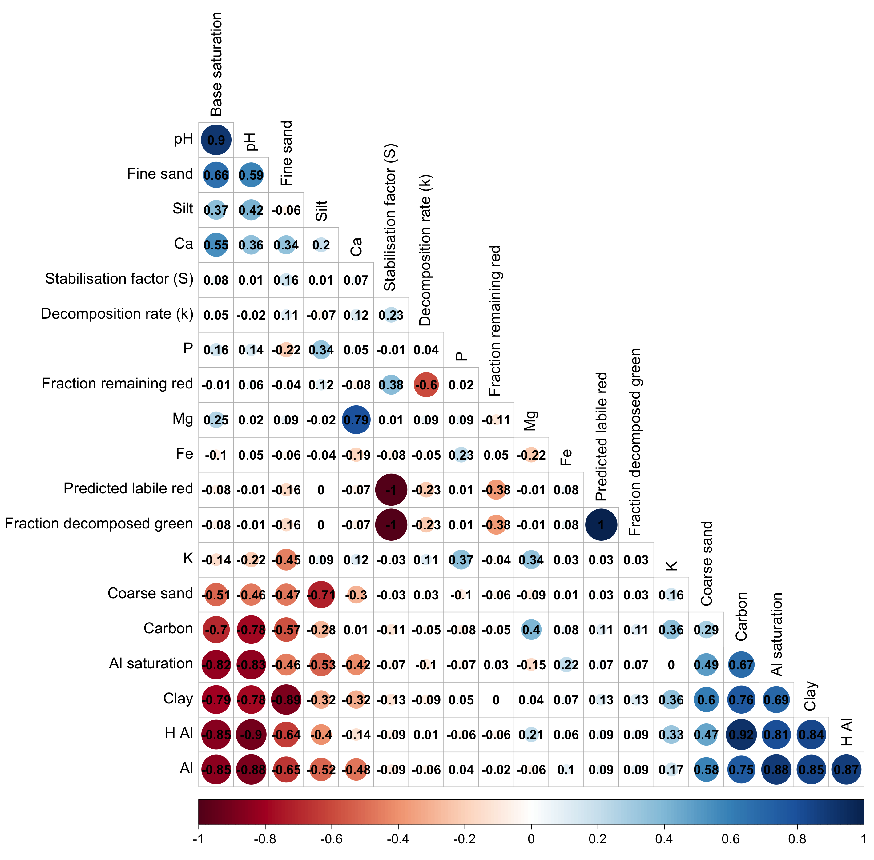
Fig. S2 Pearson Correlation coefficients among the soil physical and chemical variables and decomposition variables from reference soil and soil impacted by mining tailings from the Samarco’s dam breach in Mariana, MG, Brazil in the (a) dry and (b) wet season. The size of each circle indicates the magnitude of the correlation, with larger circles representing stronger correlations. The colour gradient extends from deep blue (strong positive correlation) to deep red (strong negative correlation), illustrating the degree of linear association between pairs of variables. Only the lower triangle of the matrix is shown, organised according to the first principal component to highlight potential clustering patterns among the variables. k = decomposition rate; S = stabilisation factor
Table S1 Stepwise model selection results. The first four best-fitting model candidates are ranked based on their optimal balance between explanatory power and complexity (lower AIC). The global models are the full models subjected to stepwise selection. The positive sign (+) indicates the covariates included in the respective model. Only terms that appear in at least one of the top four models are displayed. Delta is the AIC difference between models
GLOBAL MODEL: Decomposition Rate (k): k ~ treatment : time : season + PC1 : time : season + PC2 : time : season + S : time : season + (1 | sample ID)
Model | Intercept | PC2 | S | season | time | treatment | season : time | season : treatment | time : treatment | season : time : treatment | df | logLik | AIC | delta | weight
290877 | -6.09E-05 |  | 0.1038 | + | + | + | + | + | + | + | 15 | 544.184 | -1058.4 | 0 | 0.077
20541 | 1.30E-03 |  | 0.1026 | + | + | + | + |  | + |  | 12 | 540.943 | -1057.9 | 0.48 | 0.06
290879 | 6.58E-04 | 0.001521 | 0.1042 | + | + | + | + | + | + | + | 16 | 544.914 | -1057.8 | 0.54 | 0.059
20543 | 2.03E-03 | 0.001517 | 0.103 | + | + | + | + |  | + |  | 13 | 541.669 | -1057.3 | 1.03 | 0.046
GLOBAL MODEL: Stabilisation Factor (S): S ~ treatment : time : season + PC1 : time : season + PC2 : time : season + (1 | sample ID)
Model | Intercept | PC1 | PC2 | season | time | treatment | PC1 : season | season : treatment | time : treatment | df | logLik | AIC | delta | weight
2110 | -0.9682 | -0.02028 |  | + | + | + | + |  | + | 11 | 227.563 | -433.1 | 0 | 0.206
2112 | -0.9892 | -0.016 | -0.02352 | + | + | + | + |  | + | 12 | 227.848 | -431.7 | 1.43 | 0.101
3134 | -0.937 | -0.02709 |  | + | + | + | + | + | + | 12 | 227.798 | -431.6 | 1.53 | 0.096
46 | -0.96 | -0.02784 |  | + | + |  | + |  |  | 8 | 223.547 | -431.1 | 2.03 | 0.075

