Table 3 : Results and complications of AAU and ntAAU series

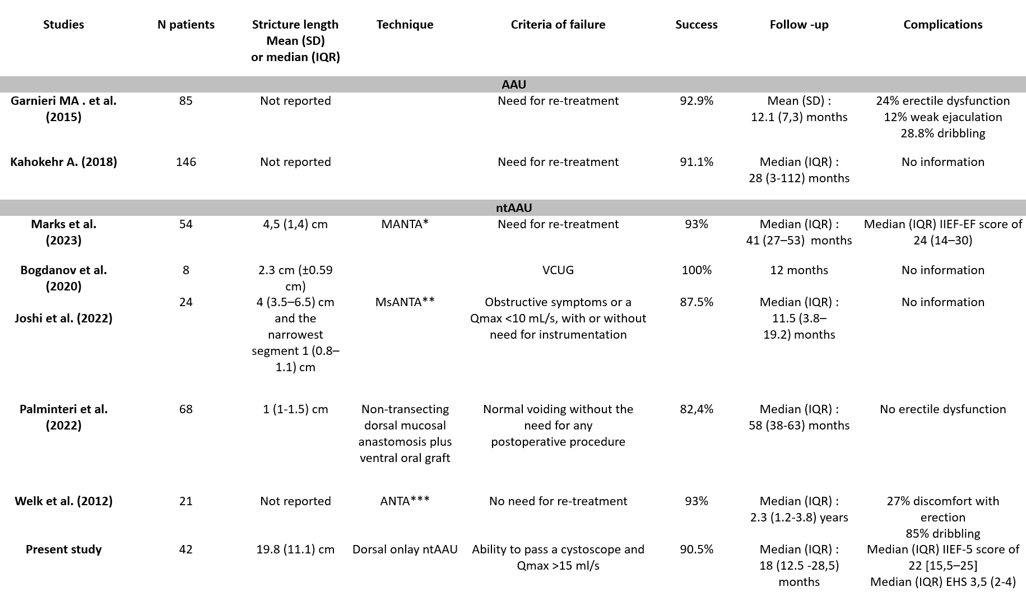

*MANTA : Mucomucosal anastomotic non‐transecting augmentation
**MsANTA : Mucosal-sparing augmented non-transected anastomotic
***ANTA : nontransected anastomotic urethroplasty

