Tables
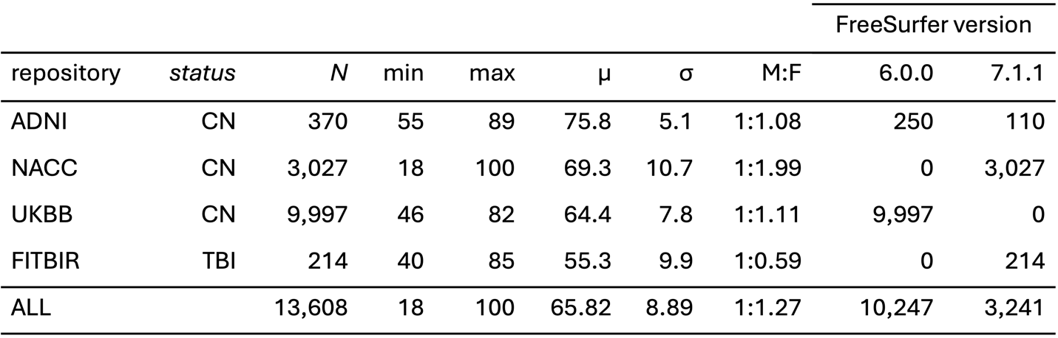
Table 1: Participant demographics according to repository. Sample size (N), minimum (min), maximum (max), mean (μ), standard deviation (σ) and the male-to-female (M:F) ratio of participant CAs are shown.

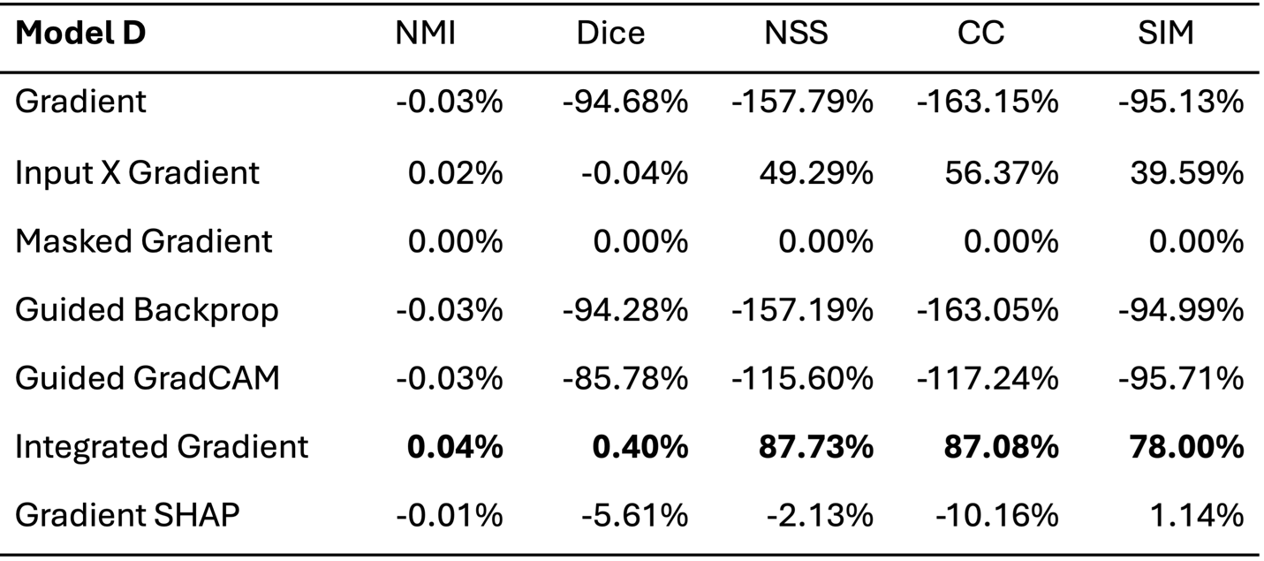
Table 2: $M_{D}$ percentage differences between each saliency map and the masked gradient saliency map. Masked gradient is used as a baseline for comparing saliency methods. The largest percentage improvement according to each measure is shown in bold.

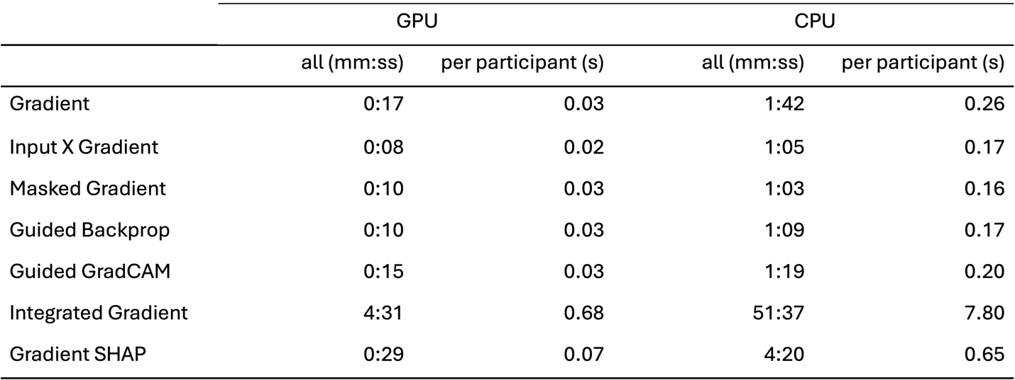
Table 3: Computation time to calculate 128³ saliency maps per participant and across 370 participants in the data perturbation test set. Results are reported for the GPUs and CPUs listed in section 2.3.

