Synthesis, Biological Properties, and Molecular Docking Studies of Pyrazolopyridine and Isoxazolopyridine Derivatives

Umut Çelikoglu^{1,2}, Melek Gul¹, Emel Pelit^{3,*}
¹Department of Chemistry, Faculty of Art and Sciences, Amasya University, 05100, Amasya, Turkiye
²Central Research and Application Laboratory, Amasya University, 05100 Amasya, Turkiye
³Department of Chemistry, Faculty of Art and Sciences, Kirklareli University, 39100, Kirklareli, Turkiye
Supplementary Materials

Table S1. Molecular electrostatic potential (MEP) map and frontier molecular orbitals of the compounds 4a-4g.
Compound | MEP | HOMO | LUMO
4a | 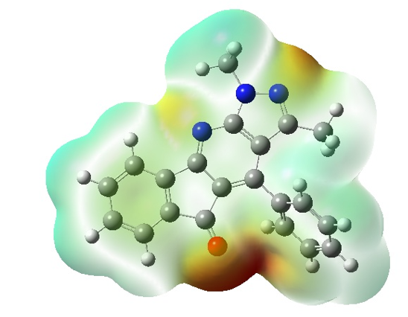 | 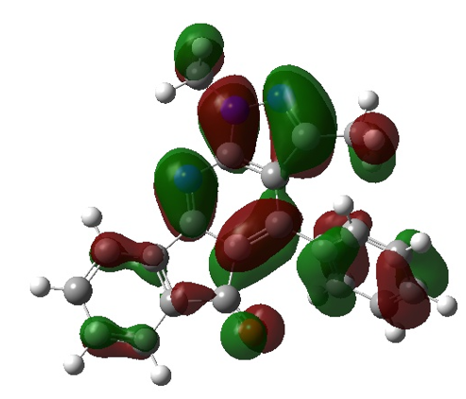 | 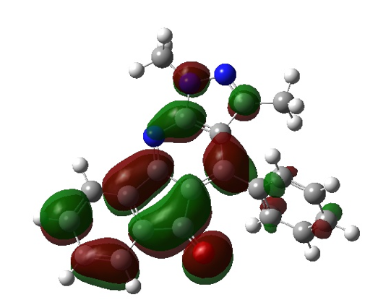
4b | 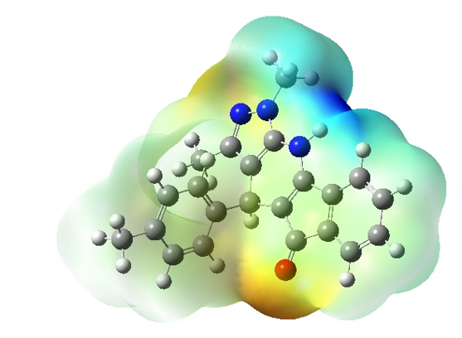 | 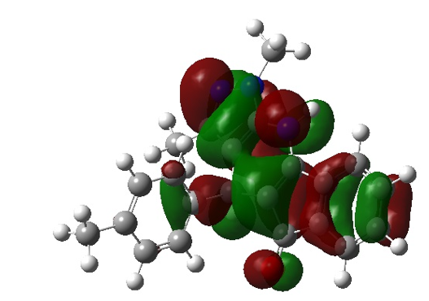 | 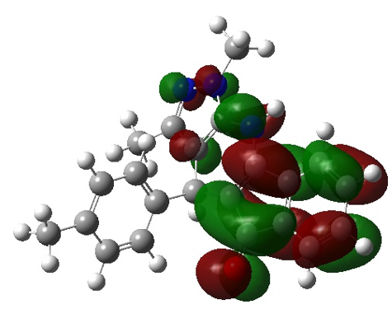
4c | 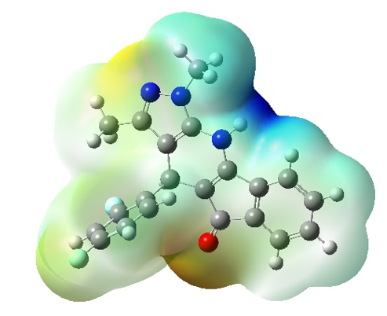 | 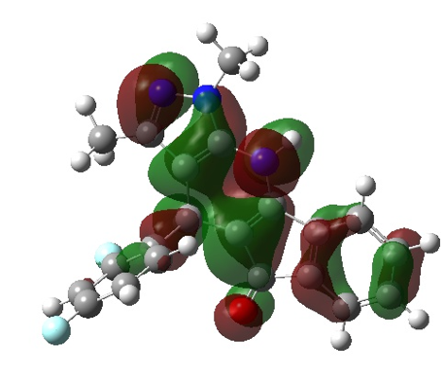 | 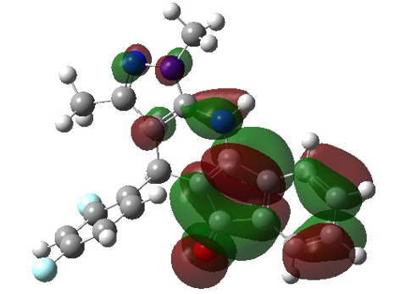
4d | 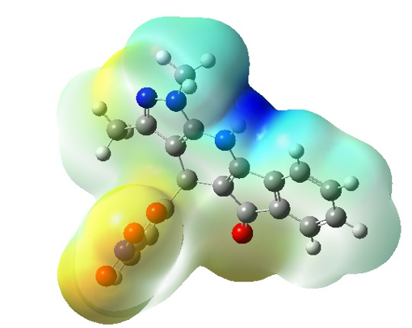 | 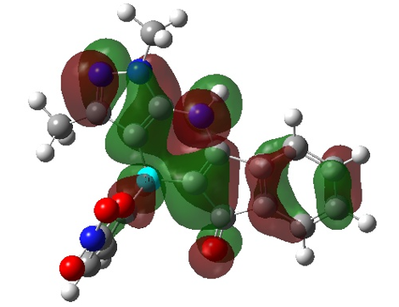 | 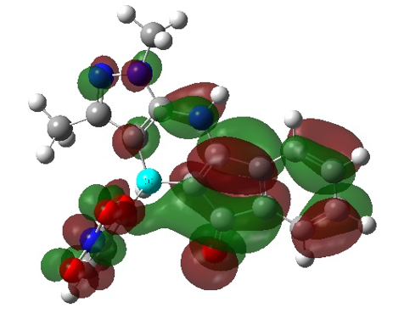
4e | 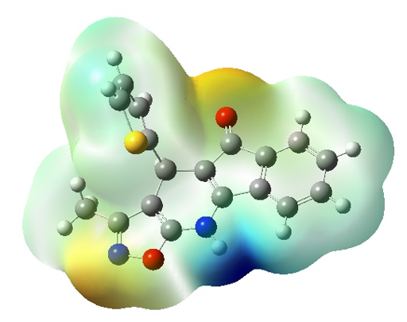 | 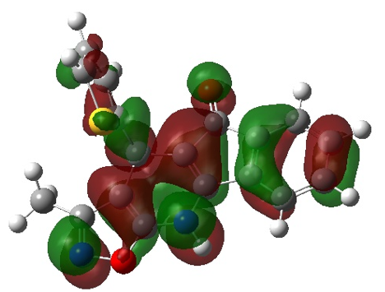 | 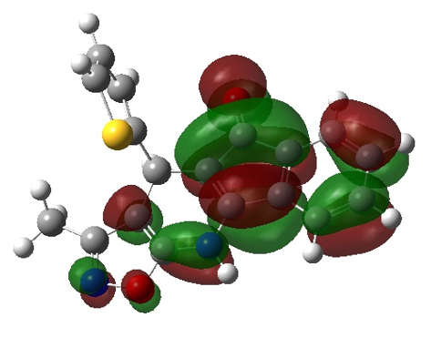
4f | 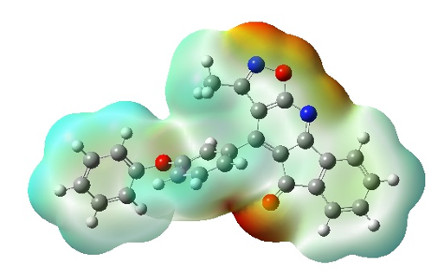 | 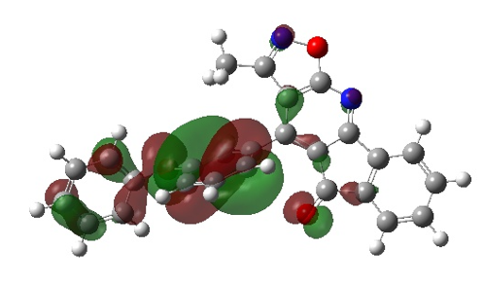 | 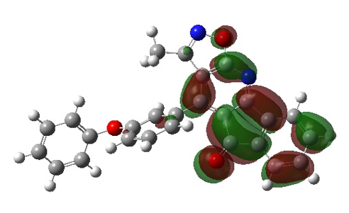
4g | 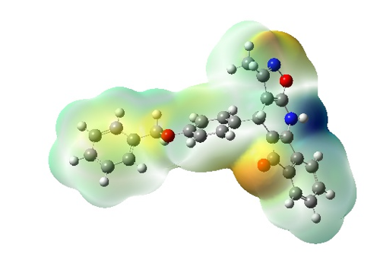 | 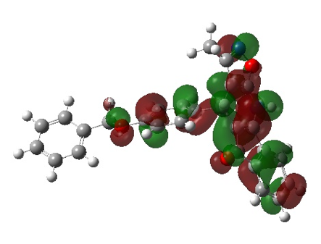 | 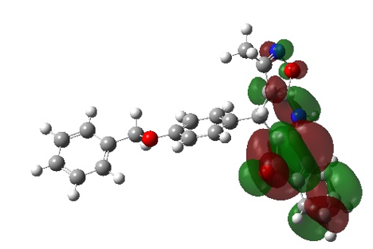

Table S2. Some global reactivity parameters of the compounds 4a-4g.
Compound | HOMO (eV) | LUMO (eV) | Ionization Potential | Electron Affinity | Chemical Hardness | Chemical Softness
4a | -6,415 | -2,389 | 6,415 | 2,389 | 2,013 | 0,248
4b | -5,648 | -2,301 | 5,648 | 2,301 | 1,674 | 0,299
4c | -5,794 | -2,416 | 5,794 | 2,416 | 1,689 | 0,296
4d | -5,972 | -2,576 | 5,972 | 2,576 | 1,698 | 0,294
4e | -6,037 | -2,568 | 6,037 | 2,568 | 1,734 | 0,288
4f | -6,470 | -2,640 | 6,470 | 2,640 | 1,915 | 0,261
4g | -5,929 | -2,524 | 5,929 | 2,524 | 1,703 | 0,294

4a: CC1=NN(C)C2=C1C(C3=CC=CC=C3)=C4C(C(C=CC=C5)=C5C4=O)=N2
4b: CC1=NN(C)C2=C1C(C3=CC=C(C)C=C3)C4=C(C(C=CC=C5)=C5C4=O)N2
4c: CC1=NN(C)C2=C1C(C3=C(F)C=C(F)C=C3)C4=C(C(C=CC=C5)=C5C4=O)N2
4d CC1=NN(C)C2=C1C(C3=CC=C([N+]([O-])=O)O3)C4=C(C(C=CC=C5)=C5C4=O)N2
4e: CC1=NOC2=C1C(C3=CC=CS3)C4=C(C(C=CC=C5)=C5C4=O)N2
4f: CC1=NOC2=C1C(C3=CC(OC4=CC=CC=C4)=CC=C3)=C5C(C(C=CC=C6)=C6C5=O)=N2
4g: CC1=NOC2=C1C(C3=CC=C(OCC4=CC=CC=C4)C=C3)C5=C(C(C=CC=C6)=C6C5=O)N2

Table S3. Counter map of the compounds 4a-4g.
Compound | COUNTER MAP
4a | 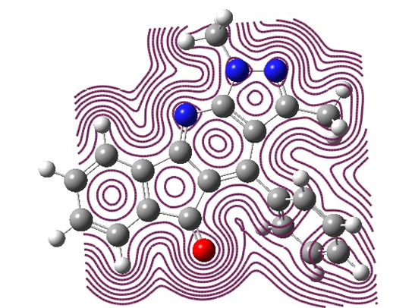
4b | 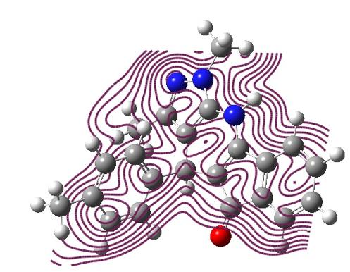
4c | 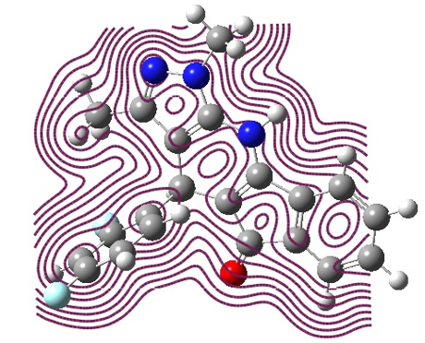
4d | 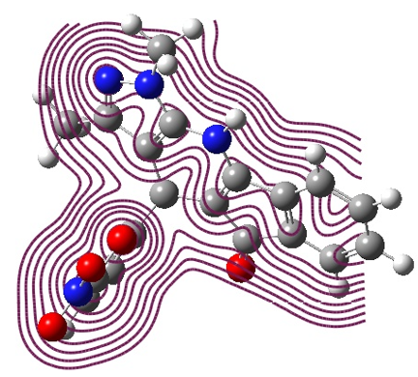
4e | 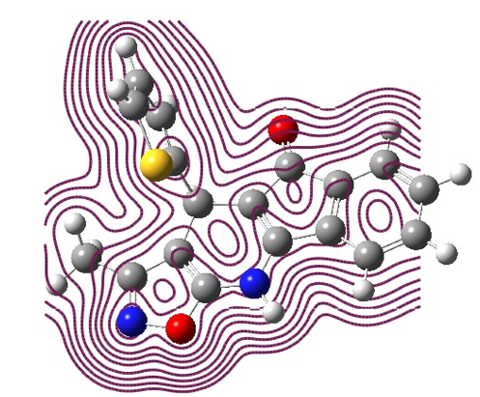
4f | 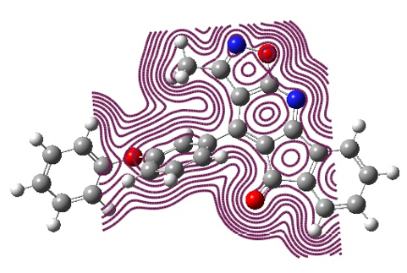
4g | 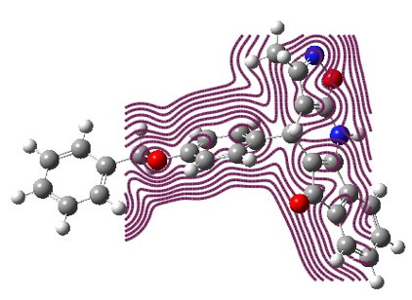
Table S4. In silico some pharmacokinetic properties and toxicity prediction for the compounds 4a-4g.
Compound | 4a | 4b | 4c | 4d | 4e | 4f | 4g
Number of hydrogen bond acceptors | 3 | 3 | 3 | 4 | 3 | 4 | 4
Number of hydrogen bond donors | 0 | 1 | 1 | 1 | 1 | 0 | 1
Number of atoms | 25 | 26 | 27 | 27 | 23 | 31 | 32
Number of bonds | 29 | 30 | 31 | 31 | 27 | 36 | 37
Number of rotable bonds | 1 | 1 | 1 | 2 | 1 | 3 | 4
Molecular refractivity | 98.06 | 105.89 | 100.84 | 102.01 | 91.81 | 117.59 | 124.91
Topological Polar Surface Area | 47.78 | 46.92 | 46.92 | 105.88 | 83.37 | 65.22 | 64.36
octanol/water partition coefficient(logP) | 4.16 | 4.34 | 4.31 | 4.06 | 320.37 | 6.2 | 5.87
 | 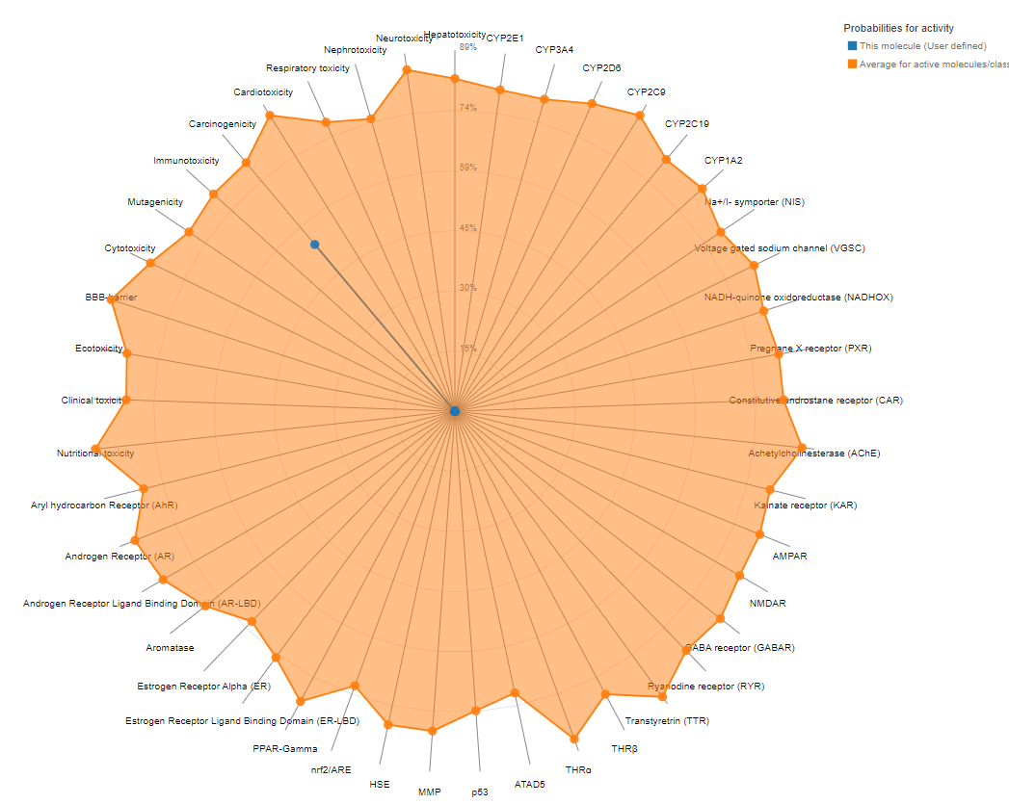 | 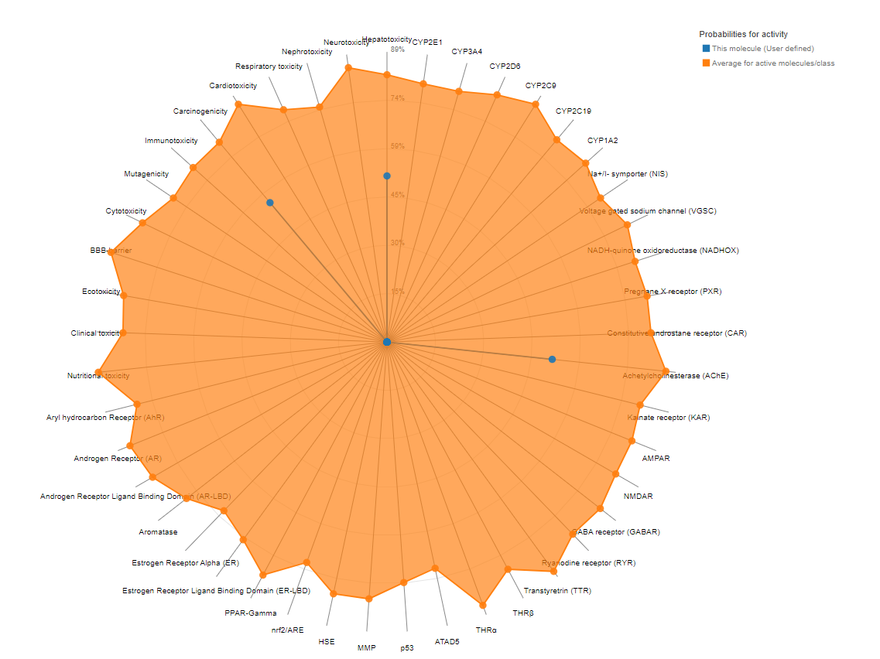 | 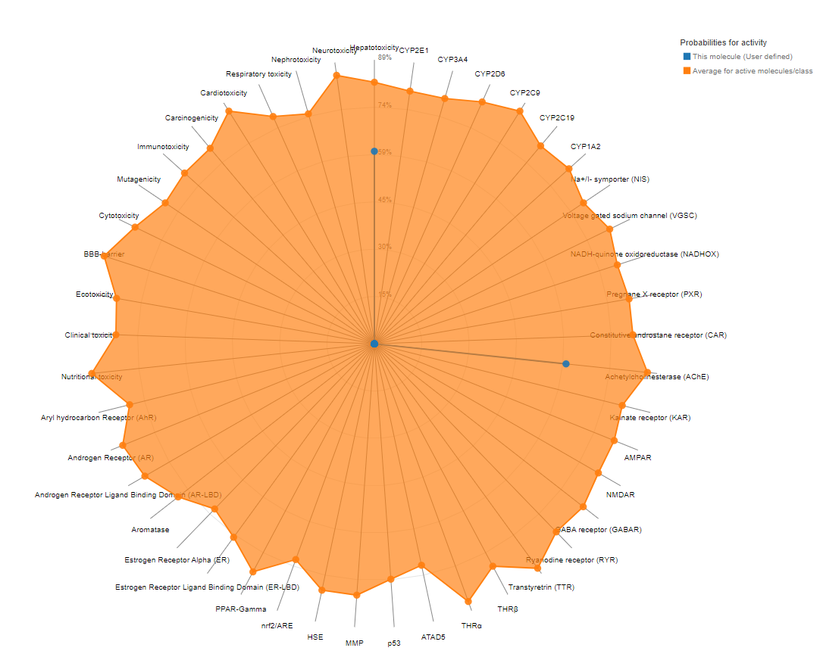 | 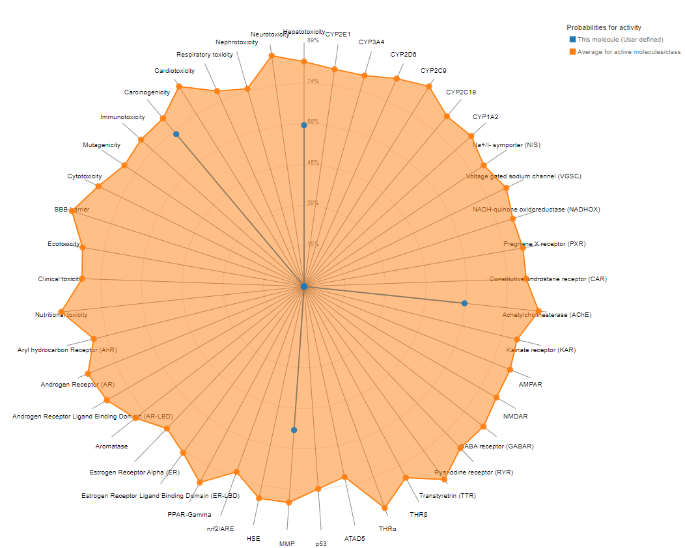 | 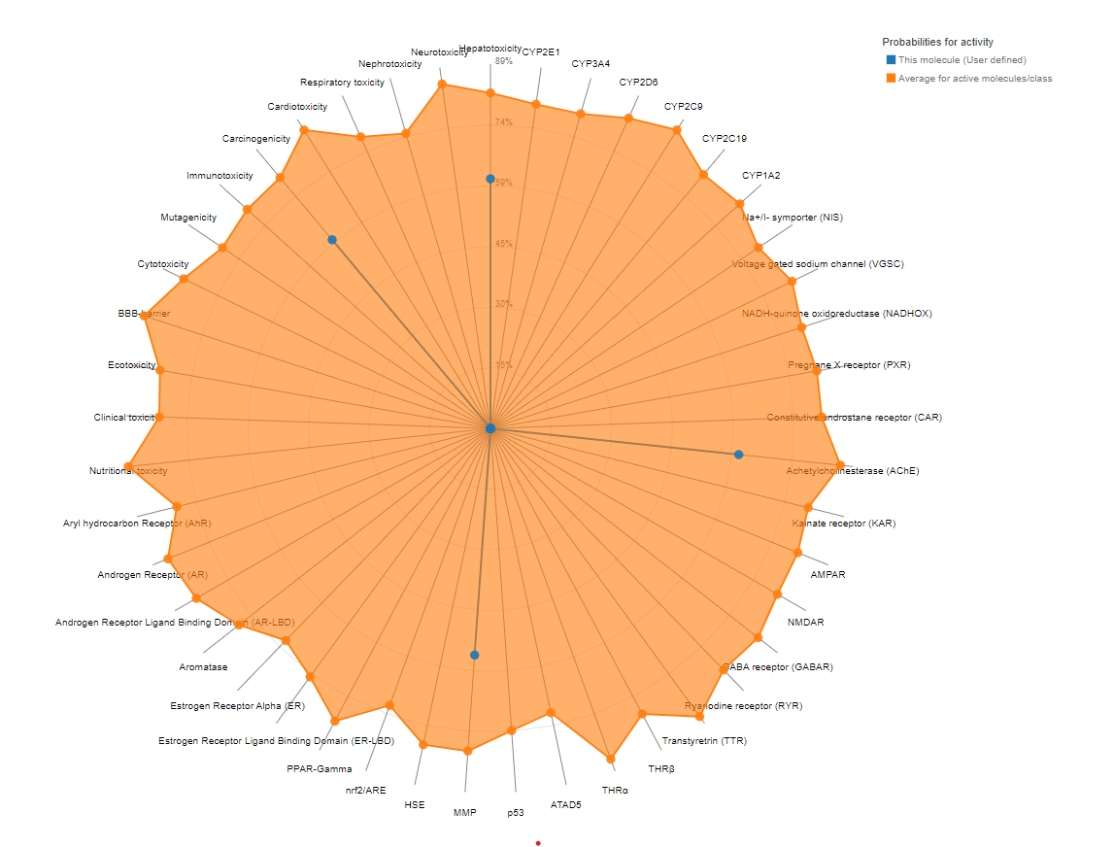 | 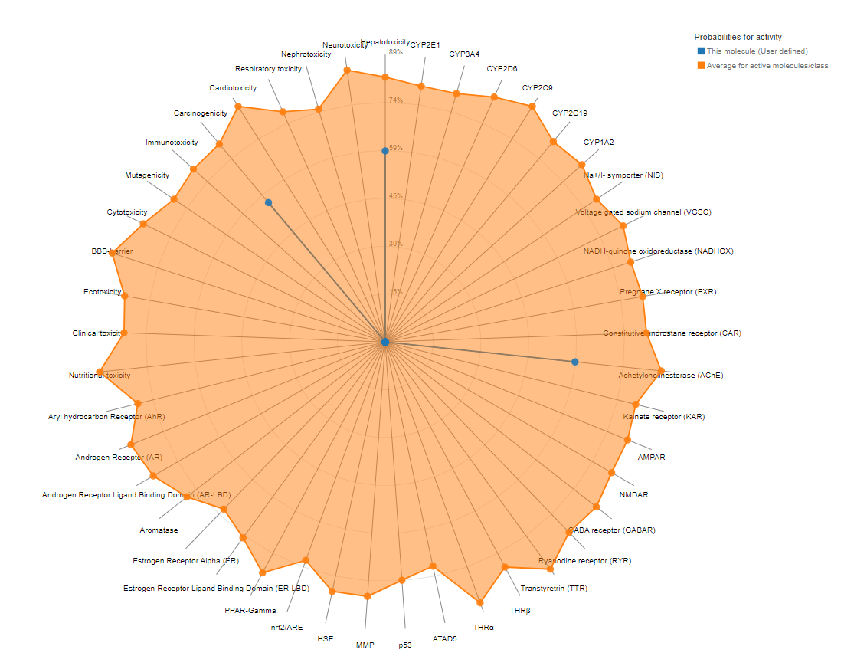 | 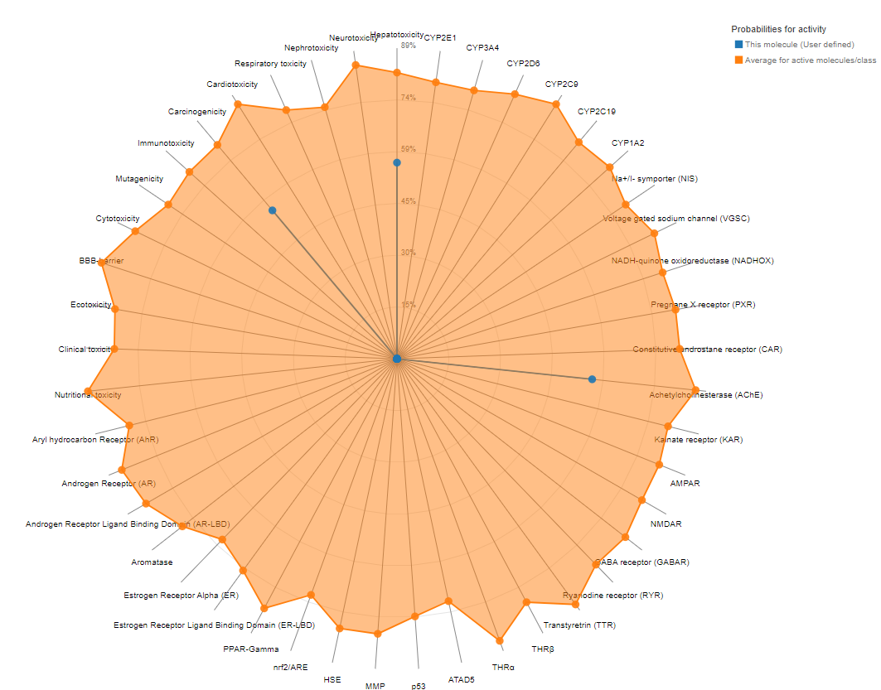
Class I: fatal if swallowed (LD50 ≤ 5)  Class II: fatal if swallowed (5 < LD50 ≤ 50)  Class III: toxic if swallowed (50 < LD50 ≤ 300)  Class IV: harmful if swallowed (300 < LD50 ≤ 2000)  Class V: may be harmful if swallowed (2000 < LD50 ≤ 5000)  Class VI: non-toxic (LD50 > 5000) | 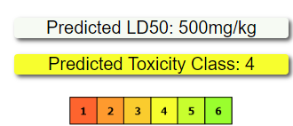 | 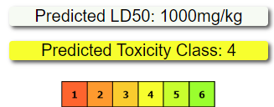 | 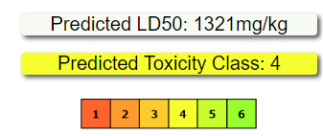 | 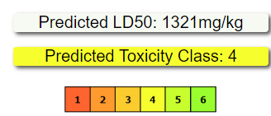 | 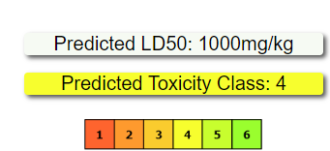 | 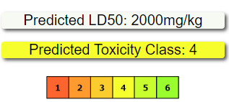 | 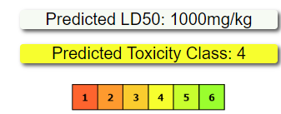

Table S5. Toxicity prediction for the compounds 4a-4g.
Compound |  | 4a | 4b | 4c | 4d | 4e | 4f | 4g
Classification | Target | Prediction | Prediction | Prediction | Prediction | Prediction | Prediction | Prediction
Organ toxicity | Hepatotoxicity | IA | A | A | A | A | A | A
Organ toxicity | Cardiotoxicity | IA | IA | IA | IA | IA | IA | IA
Toxicity end points | Carcinogenicity | A | A | IA | A | A | A | A
Toxicity end points | Cytotoxicity | IA | IA | IA | IA | IA | IA | IA
Tox21-Nuclear receptor signalling pathways | Estrogen Receptor Alpha (ER) | IA | IA | IA | IA | IA | IA | IA
Tox21-Nuclear receptor signalling pathways | Peroxisome Proliferator Activated Receptor Gamma (PPAR-Gamma) | IA | IA | IA | IA | IA | IA | IA
Tox21-Stress response pathways | Nuclear factor (erythroid-derived 2)-like 2/antioxidant responsive element (nrf2/ARE) | IA | IA | IA | IA | IA | IA | IA
Tox21-Stress response pathways | Heat shock factor response element (HSE) | IA | IA | IA | IA | IA | IA | IA
Tox21-Stress response pathways | Mitochondrial Membrane Potential (MMP) | IA | IA | IA | A | A | IA | IA
Molecular Initiating Events | GABA receptor (GABAR) | IA | IA | IA | IA | IA | IA | IA
Molecular Initiating Events | Achetylcholinesterase (AChE) | IA | A | A | A | A | A | A
Molecular Initiating Events | NADH-quinone oxidoreductase (NADHOX) | IA | IA | IA | IA | IA | IA | IA
Class I: fatal if swallowed (LD50 ≤ 5)
Class II: fatal if swallowed (5 < LD50 ≤ 50)
Class III: toxic if swallowed (50 < LD50 ≤ 300)
Class IV: harmful if swallowed (300 < LD50 ≤ 2000)
Class V: may be harmful if swallowed (2000 < LD50 ≤ 5000)
Class VI: non-toxic (LD50 > 5000)

Table S6. Autodock grid box and root mean square deviation (RMSD) score
Proteins | Dimension Grid Box | Grid Box | Native Ligand RMSD Score
4OR0-Chain A | -0.1 x 19.0 x 107.0 | 40*40*40 | 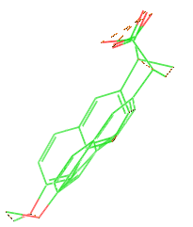  1.19224Å
4OR0-Chain B | 68.4 x 24.4 x 95.0 | 40*40*40 | 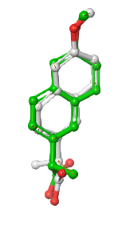  1.13119Å
3V03-Chain A | 10.1 x 20.4 x 40.7 | 40*40*40 | -
3V03-Chain B | 106.6 x 33.4 x 41.1 | 40*40*40 | -
8EC1 | 12.5 x 22.5 x 87.0 | 40*40*40 | 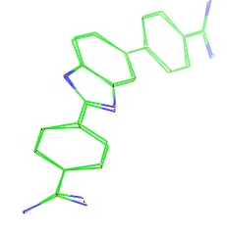  0.1523Å

Table S7. Docking pose of the compounds 4a-4g interaction with selected proteins 4ORO, 3V03, and 8EC1.

 | 4OR0_a | 4OR0_b | 3V03_a | 3V03_b | 8EC1
4a | 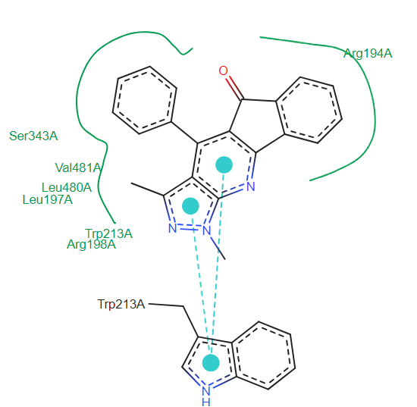-7.61/2.63 µM | 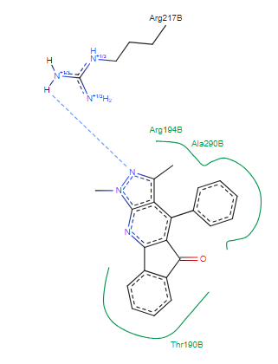 -5.66/71.54µM | 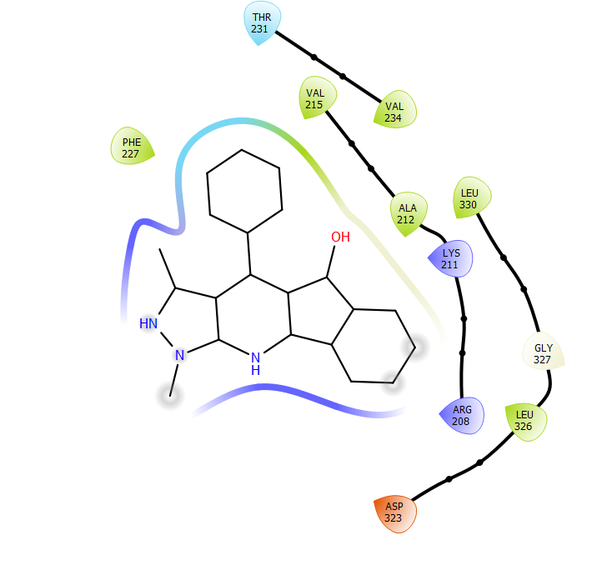 | 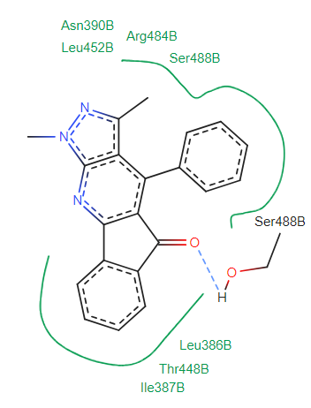 | 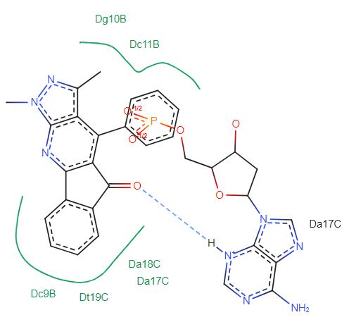
4b | 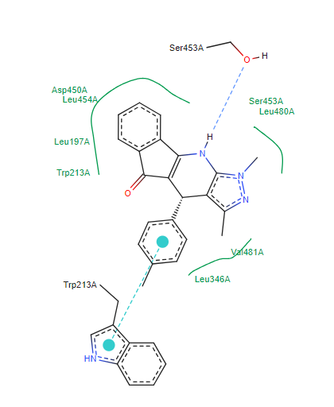-3.88/1.43 µM | 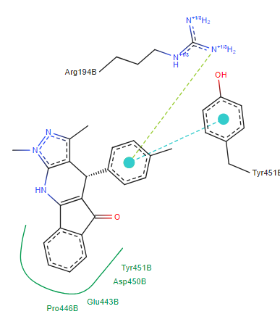 -4.67/380.17µM | 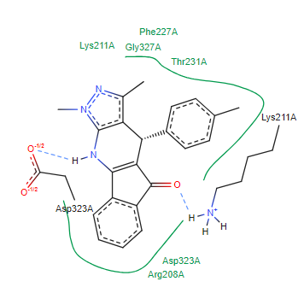 | 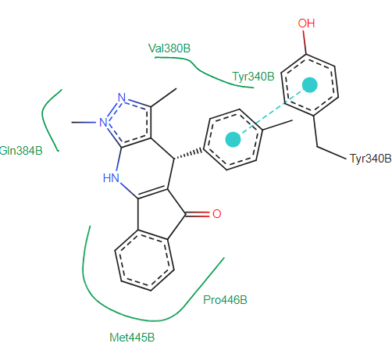 | 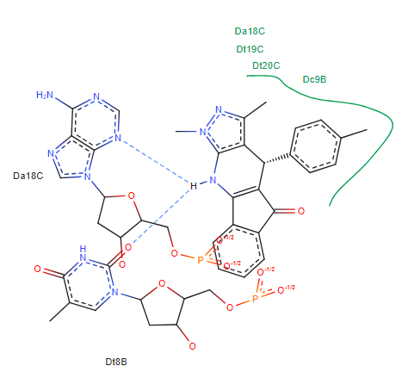
4c | 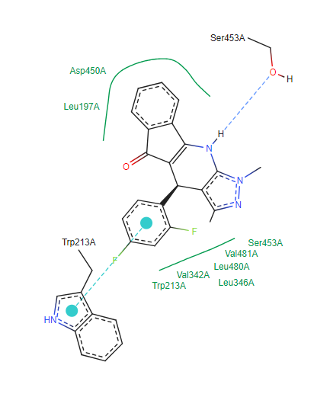-3.57/3.84 µM | 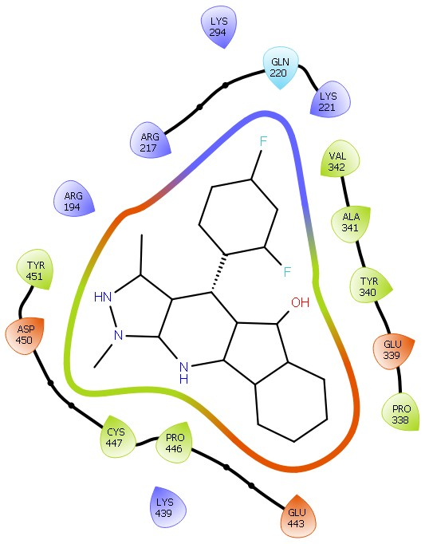  -4.66/385.09µM | 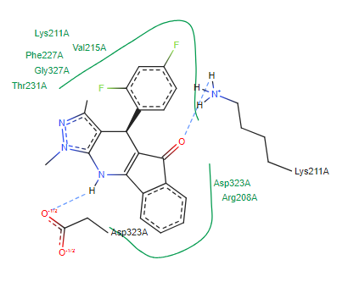 | 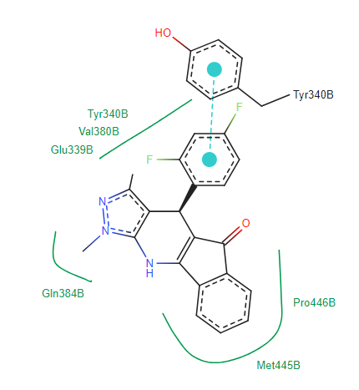 | 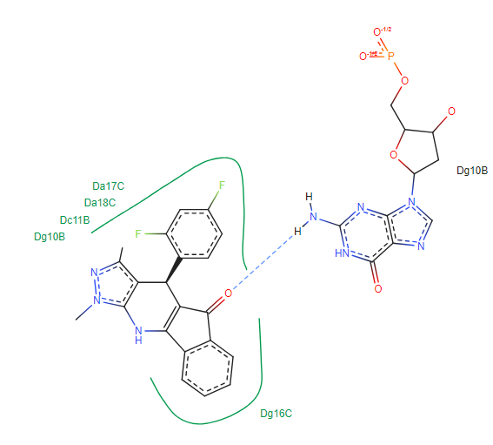
4d | 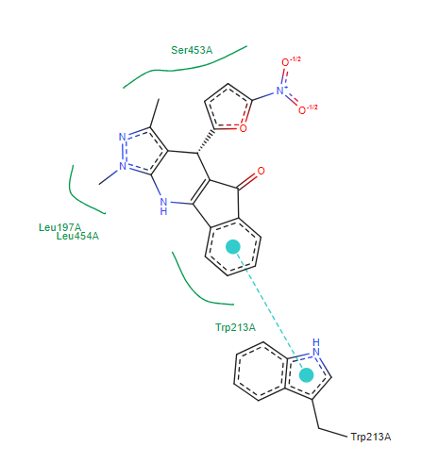-7.83/1.83 µM | 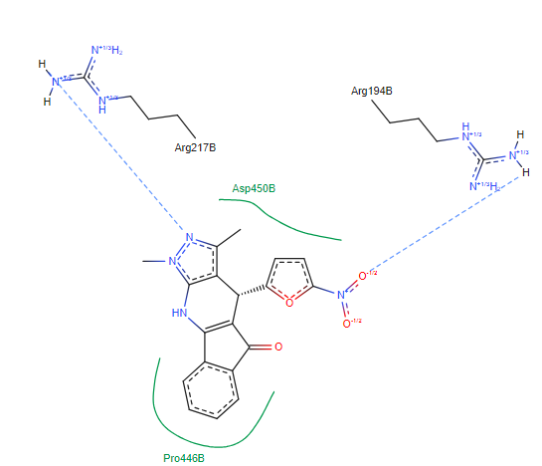  -6.52/16.64µM | 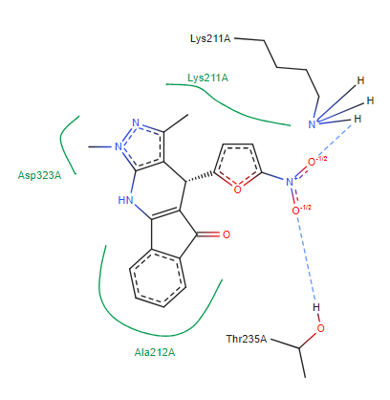 | 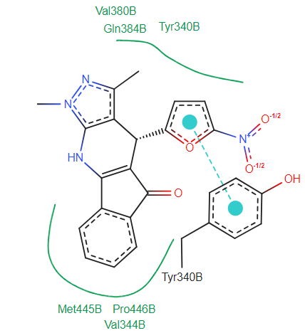 | 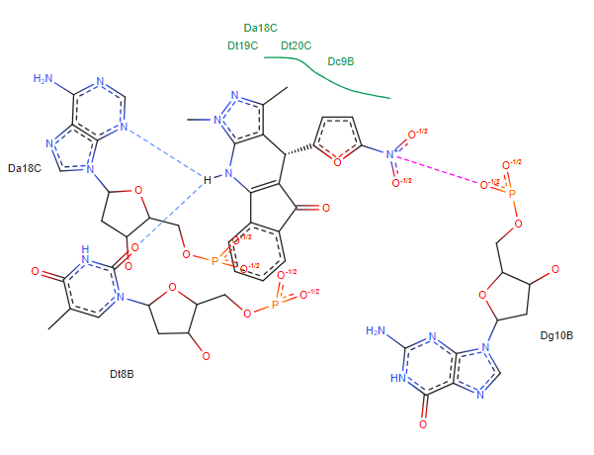
4e | 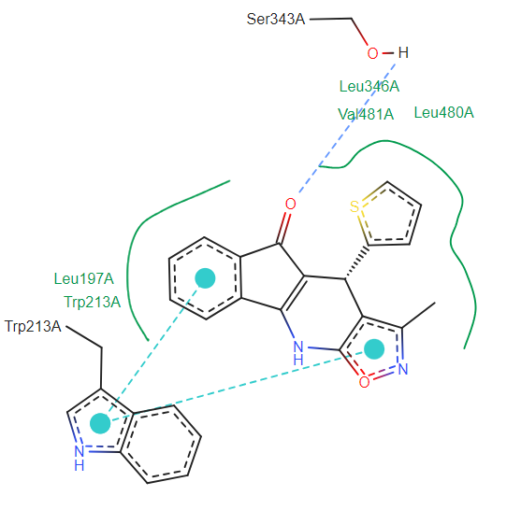  -9.06/227.23nM | 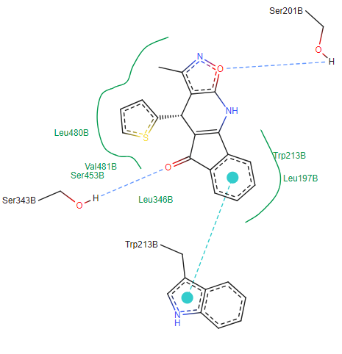  -9.03 /240.34nM | 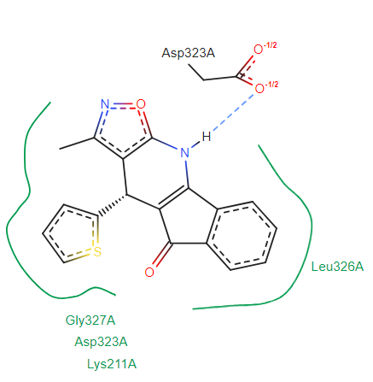 | 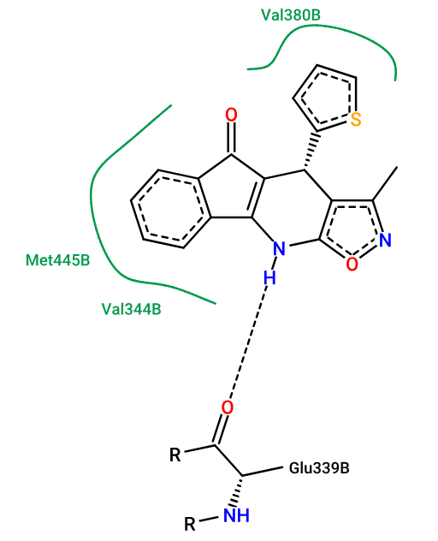 | 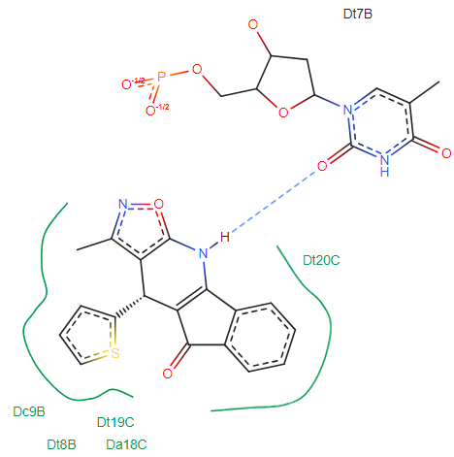
4f | 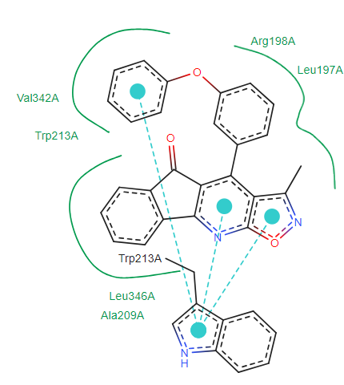-10.15/36.47nM | 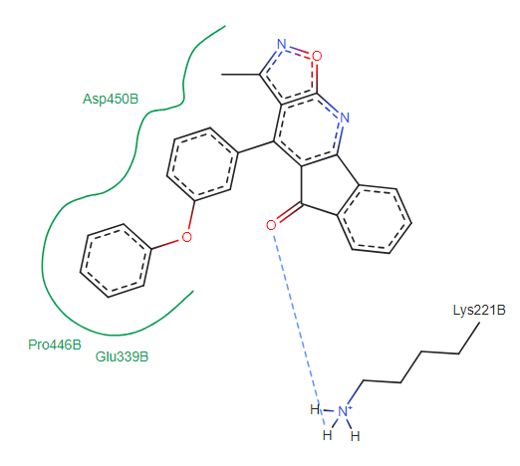  -7.5/ 3.8 µM | 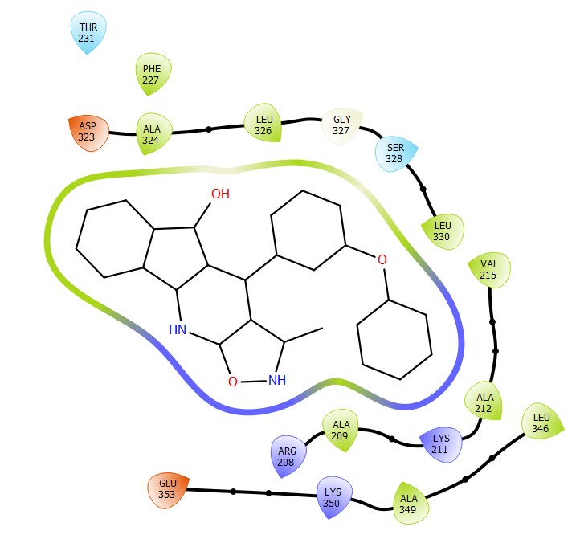 | 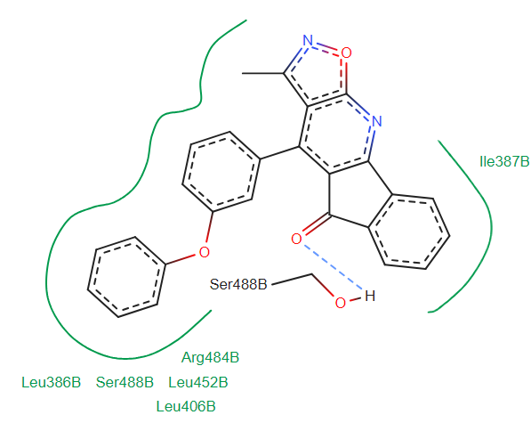 | 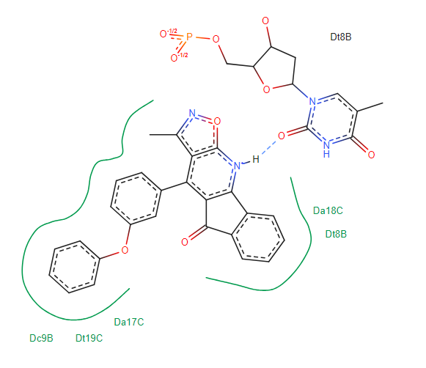
4g | 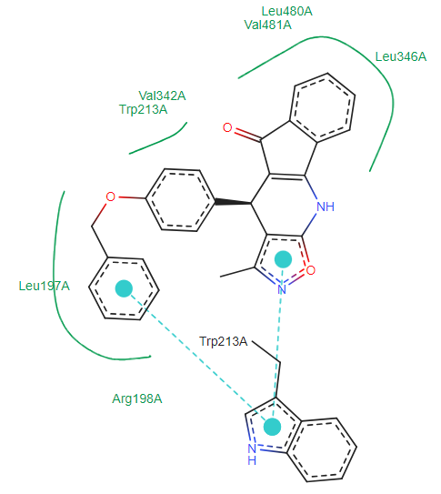  -9.56//97.97 nM | 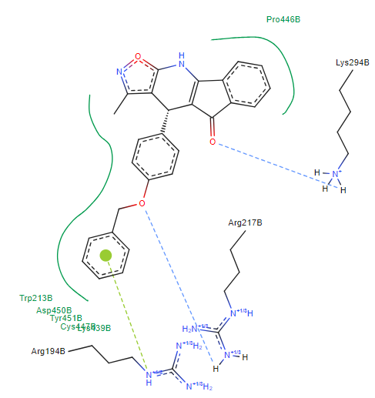  -6.36/21.69 µM | 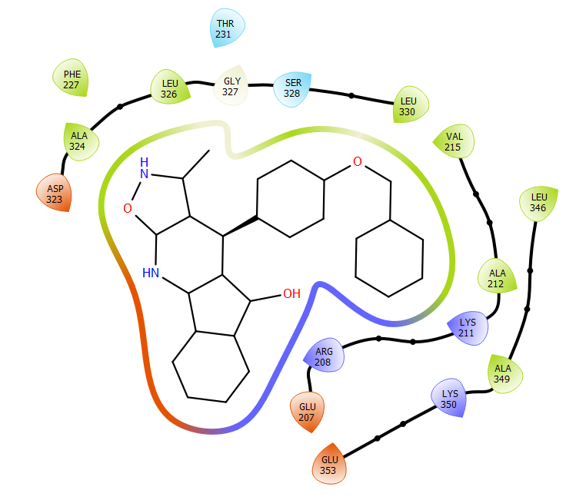 | 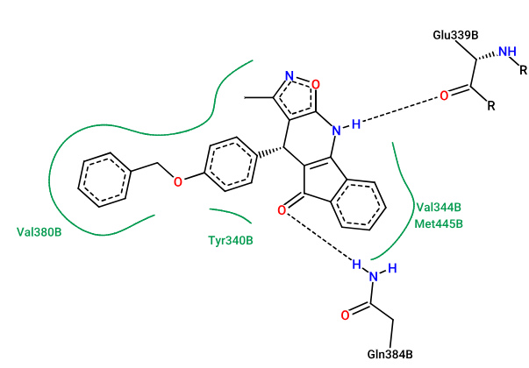 | 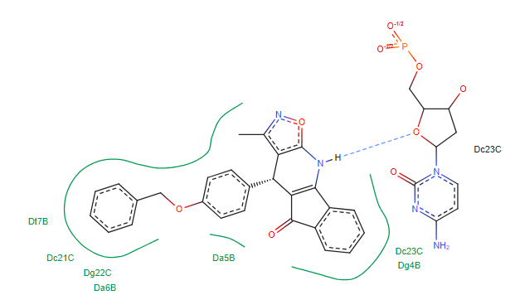

Table S8. Docking binding energies (Kcal/mol) of best active posess of the compounds 4a-4g along with the reference compound Diclofenac (DIC).
 | 4OR0_a | 4OR0_b | 3V03_a | 3V03_b | 8EC1
4a | -7.61//2.63 µM | -5.66//71.54 µM | -7.65//2.49 µM | -7.98//1.41 µM | -9.08//222.23 nM
4b | -3.88//1.43 µM | -4.67//380.17 µM | -6.91//8.74 µM | -7.45//3.48 µM | -8.74//389.74 nM
4c | -3.57//3.84 µM | -4.66//385.09 µM | -6.66//13.24 µM | -7.23//5.0 µM | -8.39//704.29 nM
4d | -7.83//1.83 µM | -6.52//16.64 µM | -8.53//556.08 nM | -8.45//610.05 nM | -10.82//11.64 nM
4e | -9.06//227.23nM | -9.03//240.34 nM | -7.44//3.54 µM | -7.54//2.96 µM | -8.17//1.02 µM
4f | -10.15/36.47 nM | -7.5//3.18 µM | -8.45//638.92 nM | -8.34//770.11 nM | -9.77//69.38 nM
4g | -9.56//97.97 nM | -6.36//21.69 µM | -8.97//264.62 nM | -8.5//584.05 nM | -10.28//29.23 nM
DIC | -9.17//190.07 nM | -9.26/163.13 nM | -6.07/35.31 µM | -8.07/1.21 µM | -6.69/12.42 µM

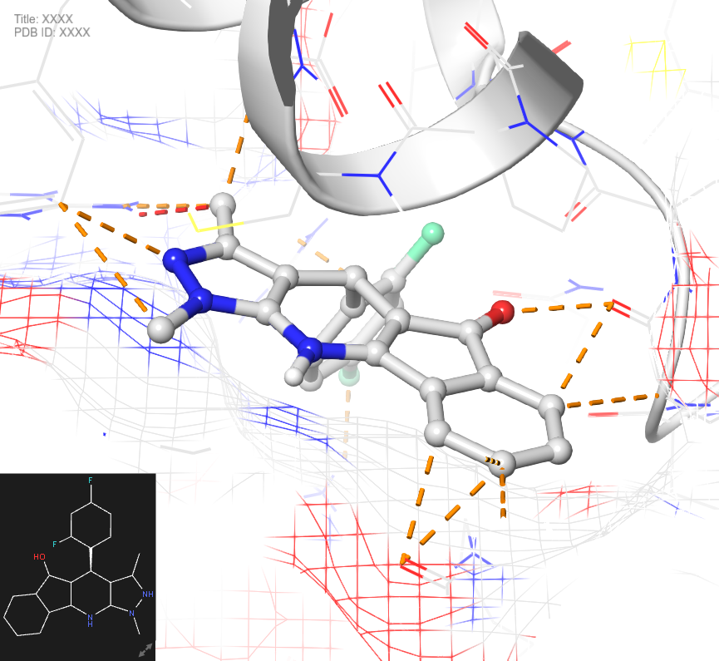

Figure S1. Structure of compound 4c
3v03_b_4g: 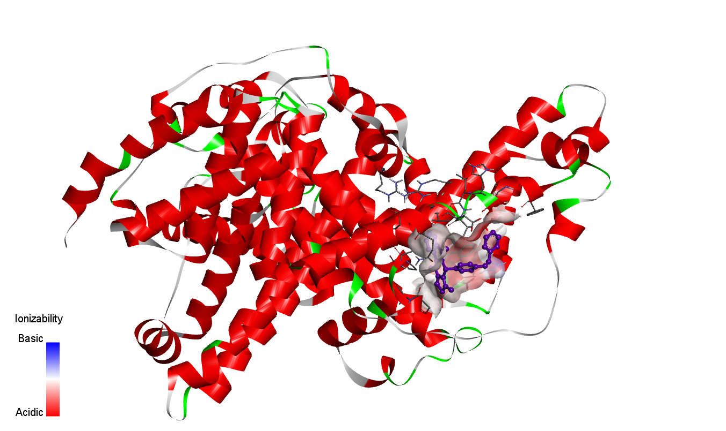
3v03_a_4g

Figure S2. Compound 4g interaction with 3V03
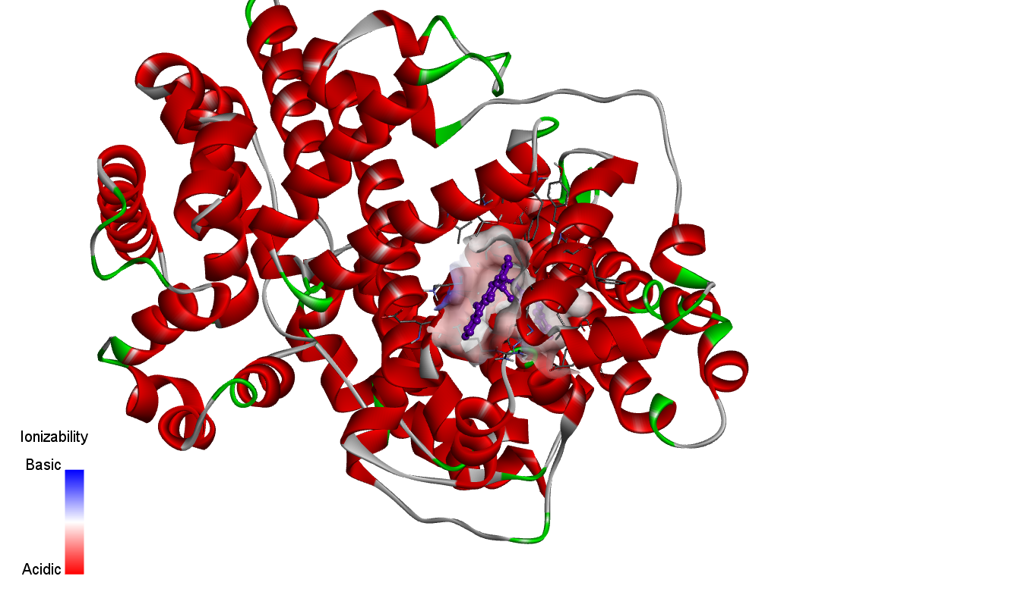

4OR0_b-4g
Figure S3. Compound 4g interaction with 4ORO_b
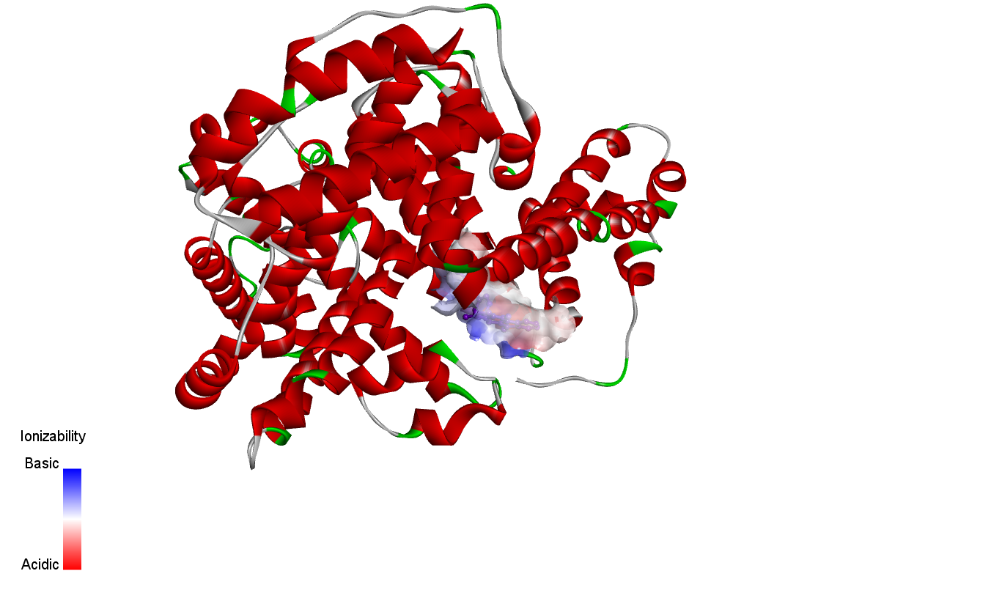
4OR0_a-4g

Figure S4. Compound 4g interaction with 4ORO_a

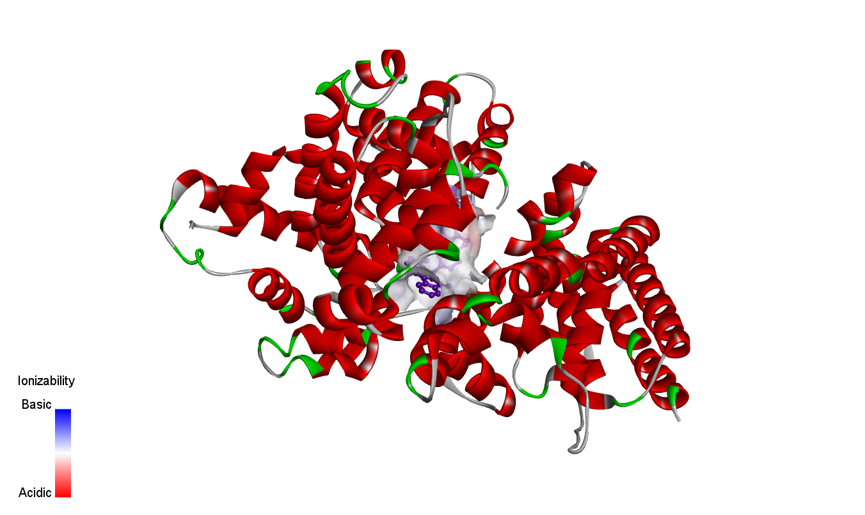

8ec1_4g

Figure S5. Compound 4g interaction with 8EC1
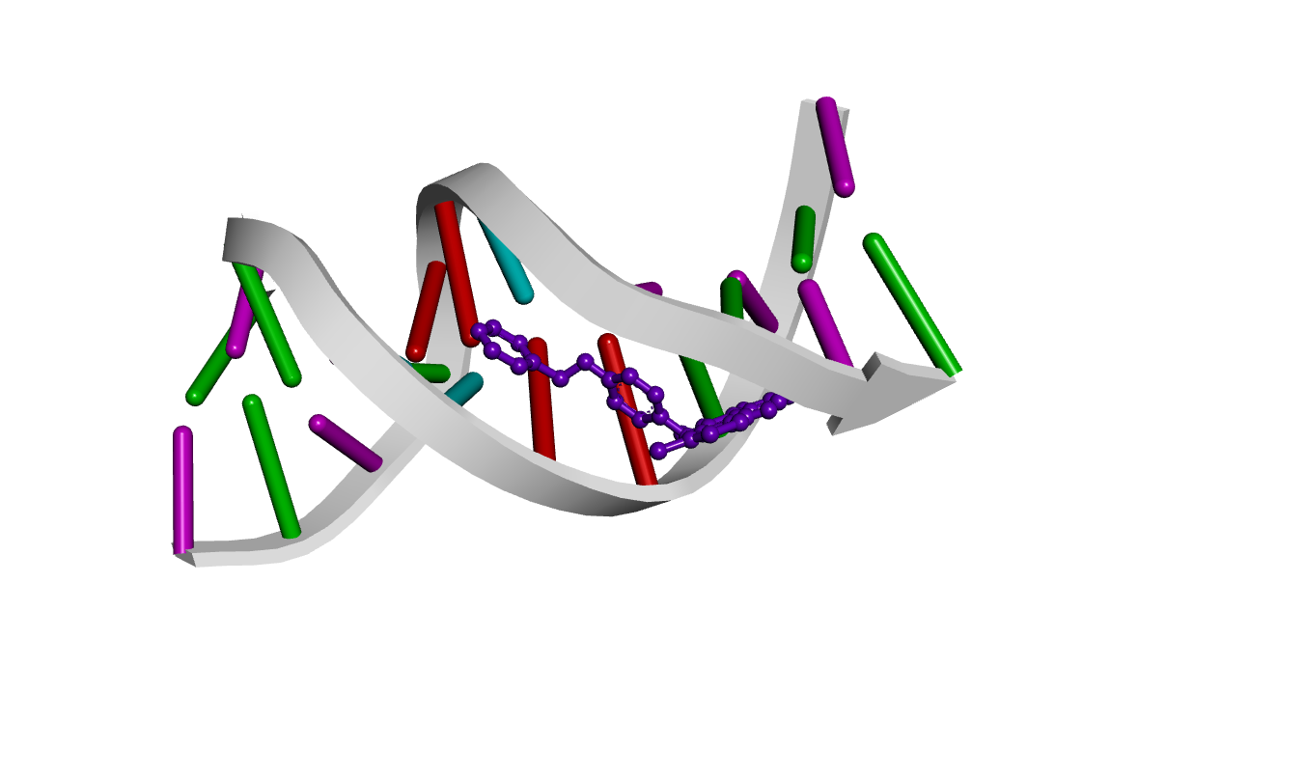

Figure S6. Compound 4g interaction with DNA

NMR SPECTRA OF COMPOUNDS 4a-4g
4a
¹H NMR
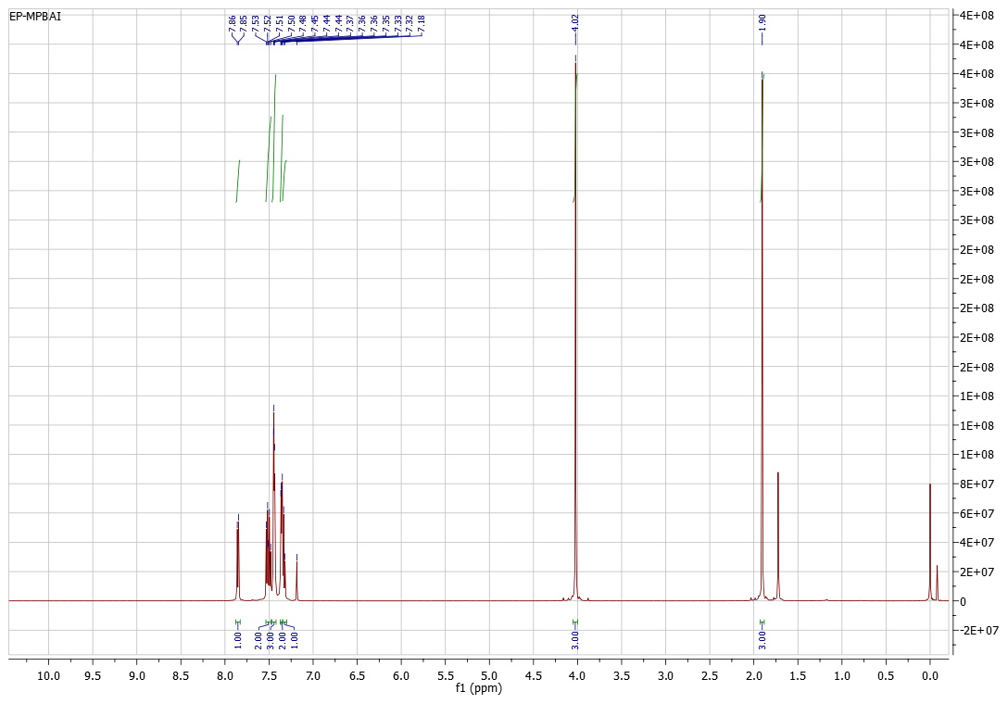

¹³C NMR
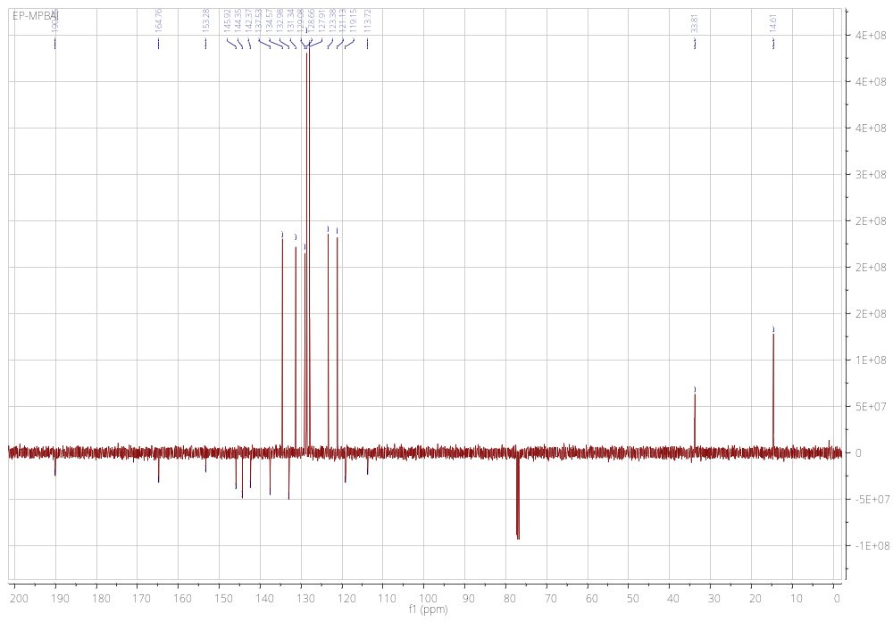

4b
¹H NMR
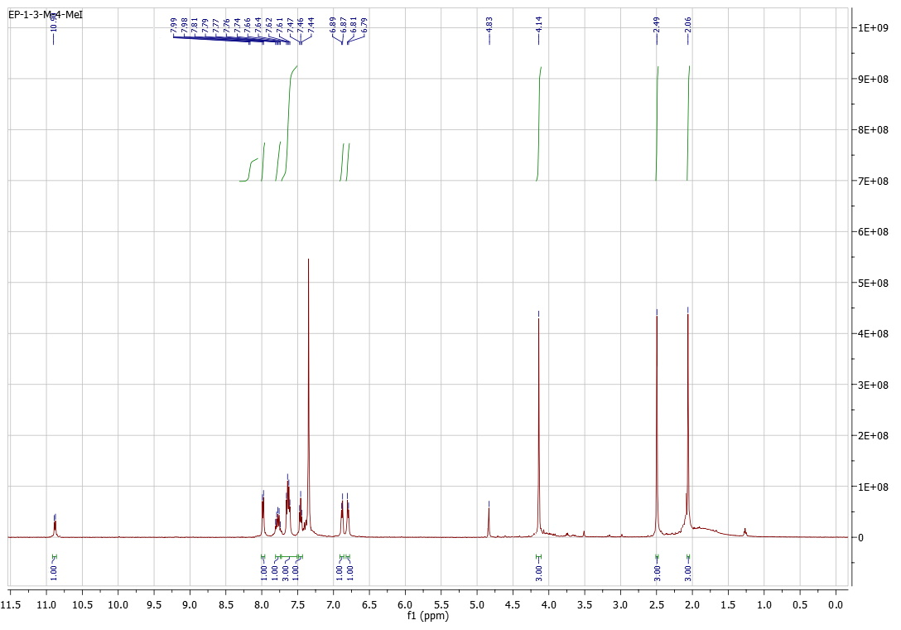
¹³C NMR
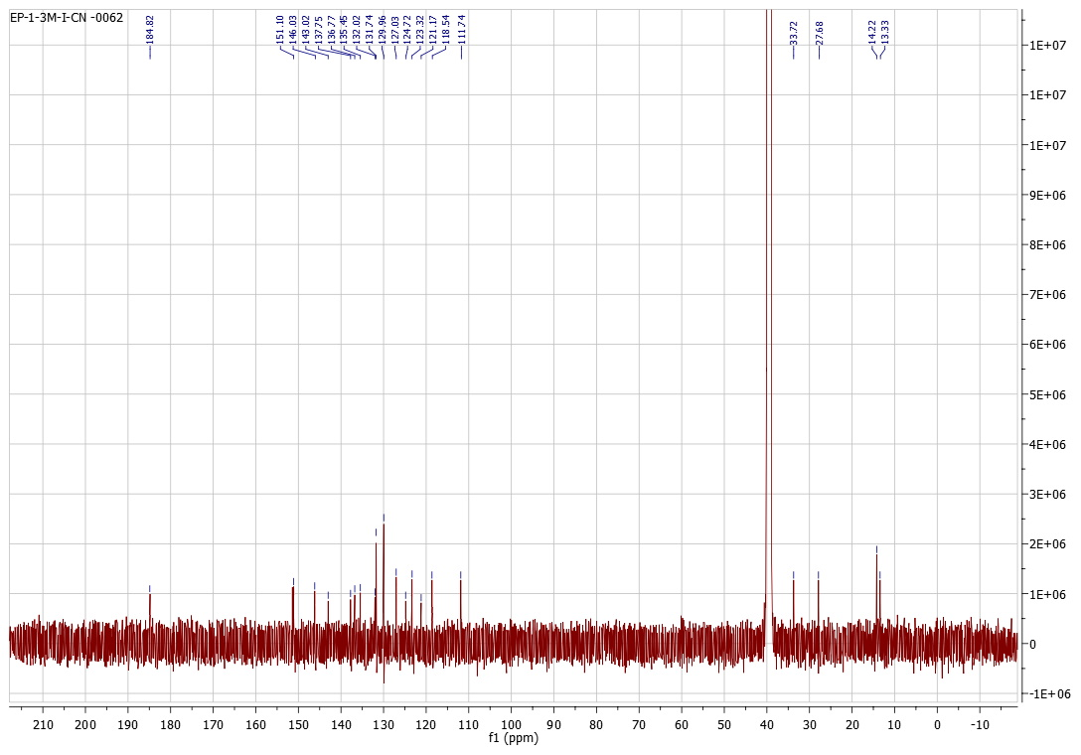

4c
¹H NMR
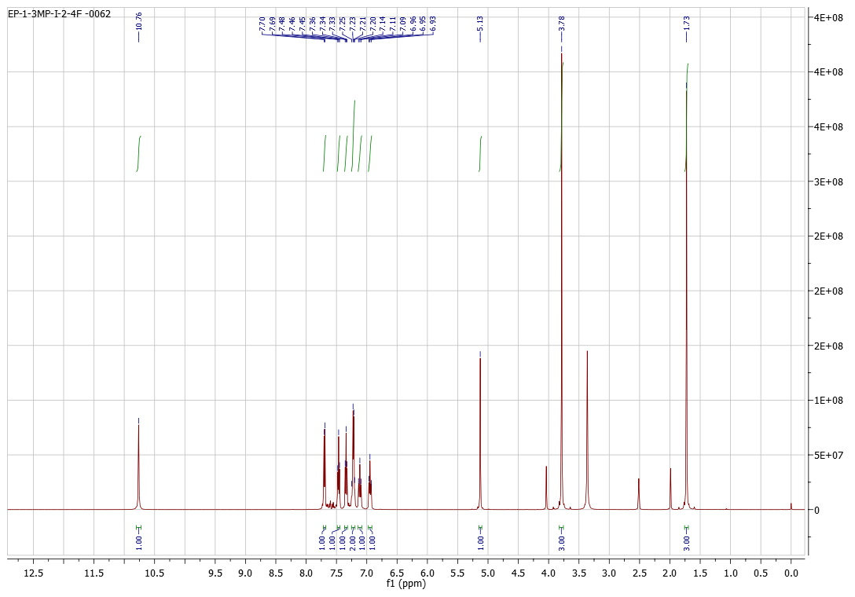

¹³C NMR
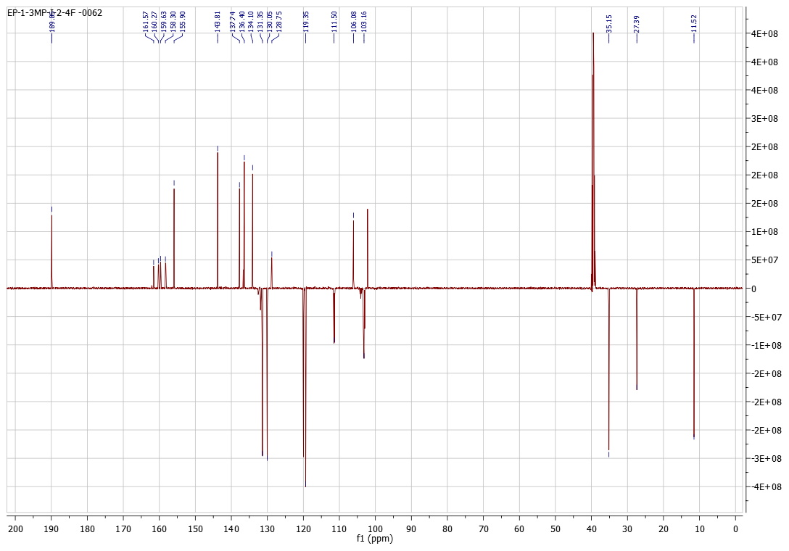

4d
¹H NMR
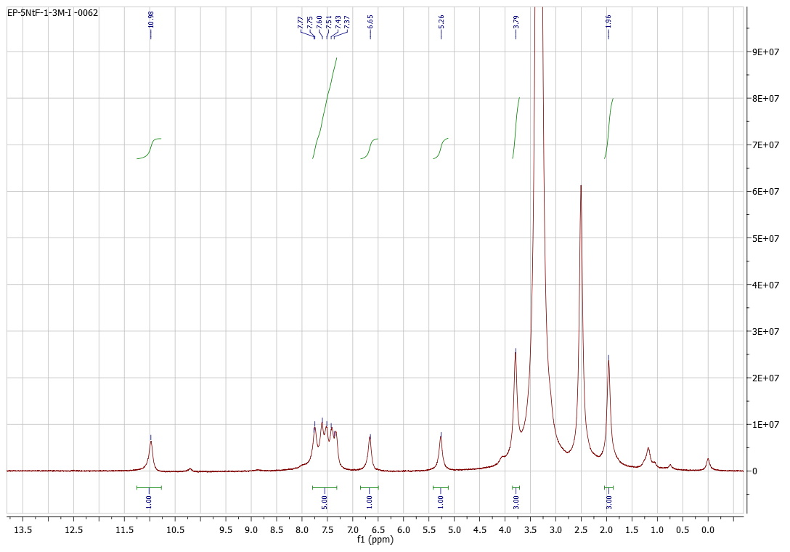

¹³C NMR
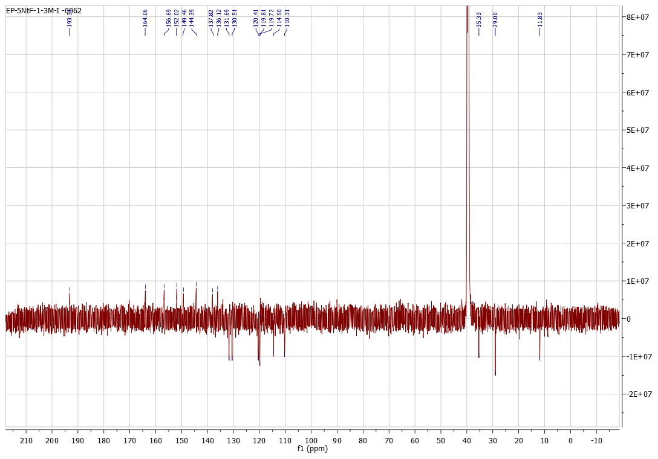

4e
¹H NMR
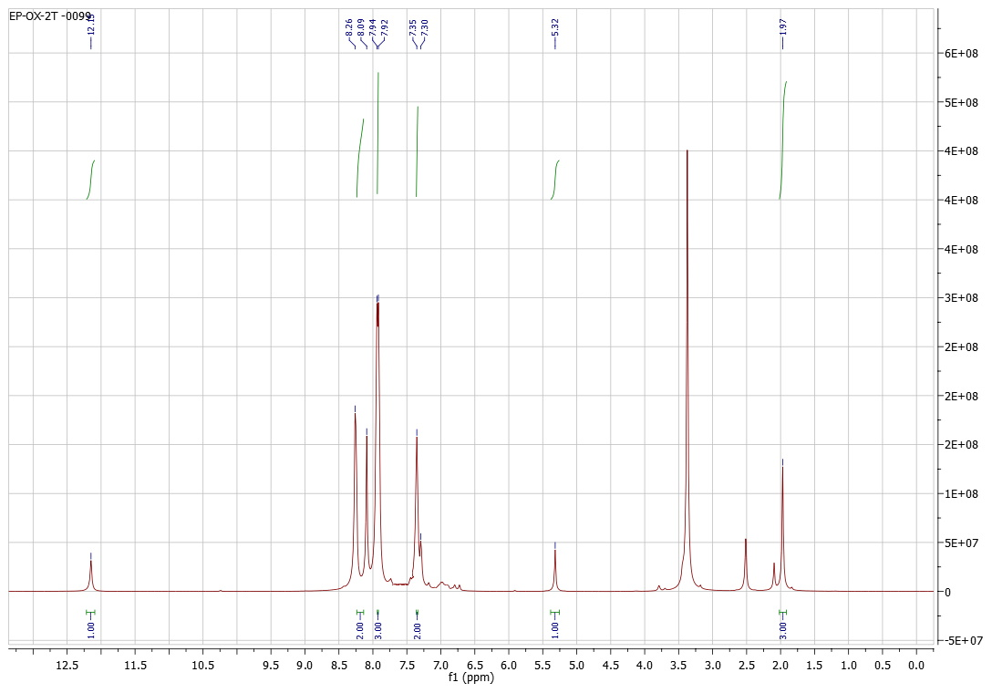

¹³C NMR
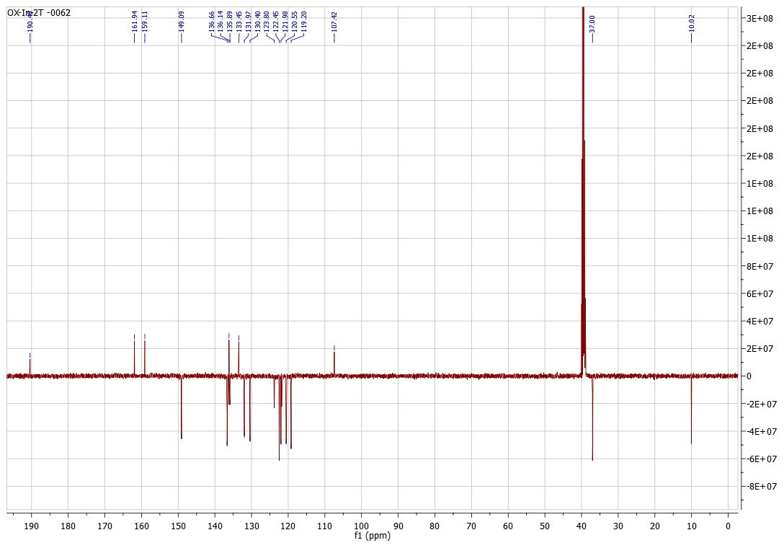

4f
¹H NMR
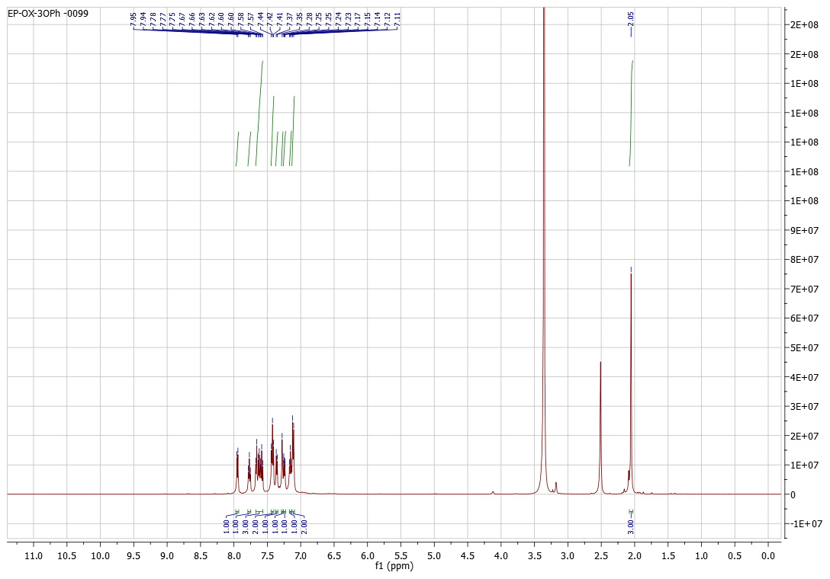

¹³C NMR
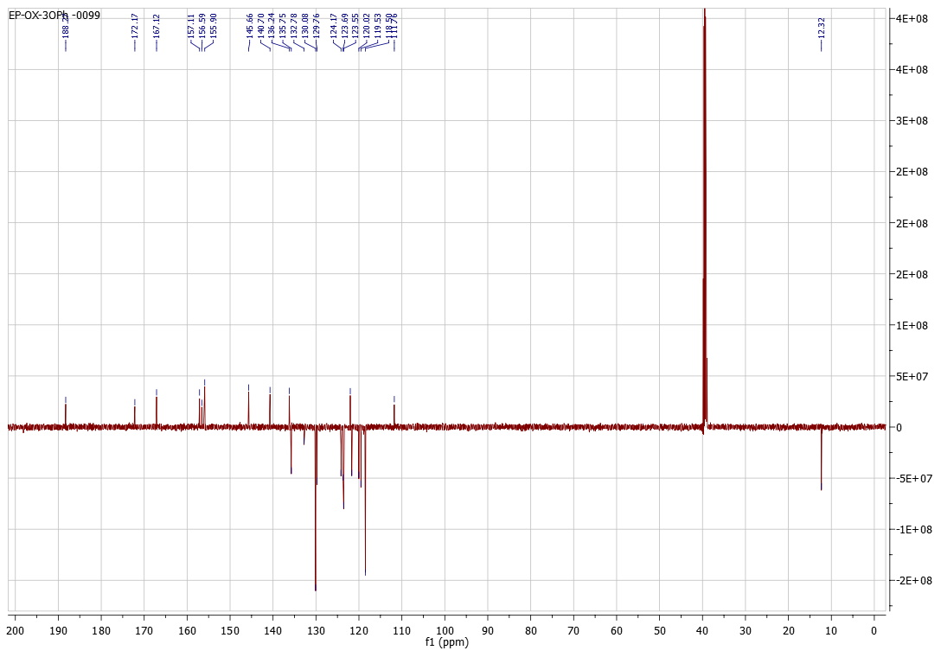

4g
¹H NMR
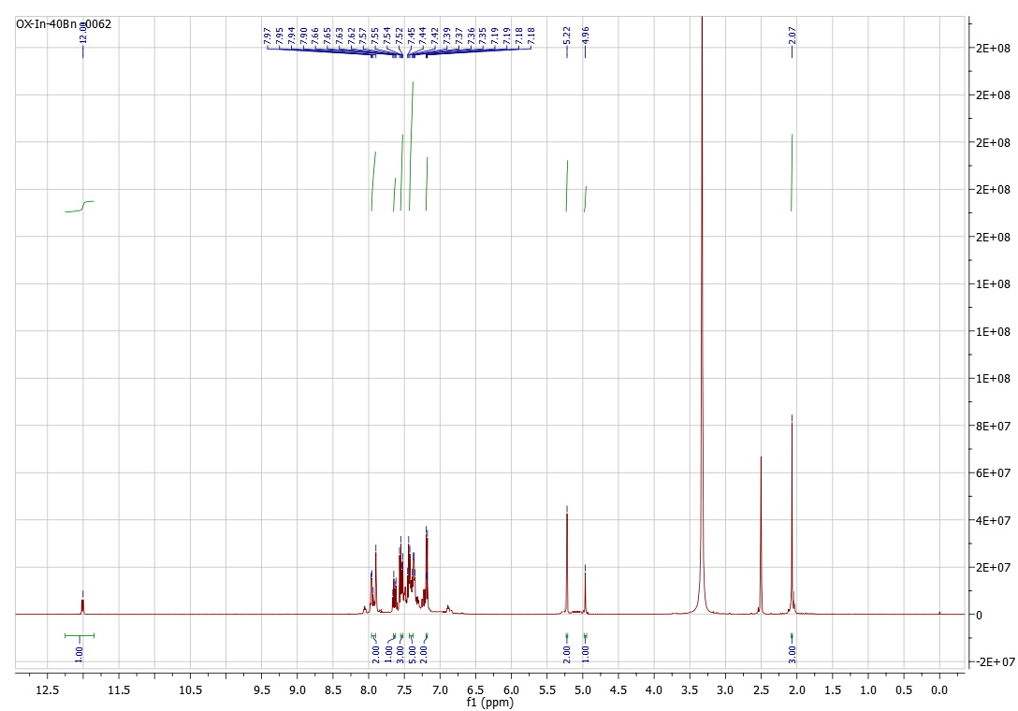

¹³C NMR
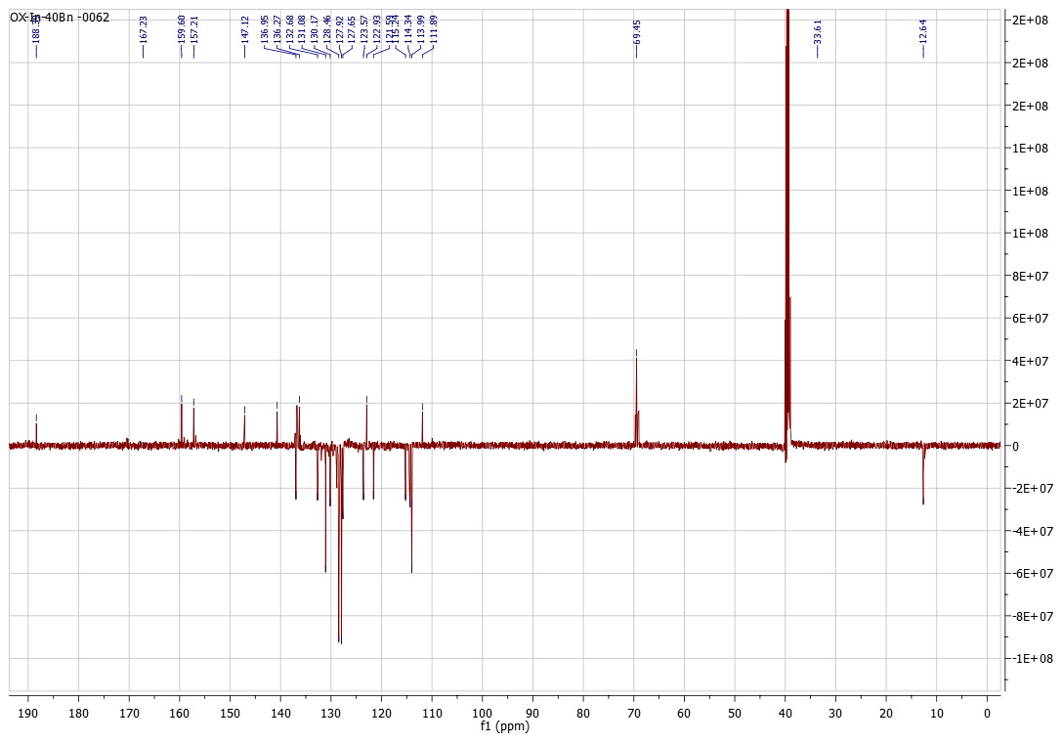

MS SPECTRA
4a
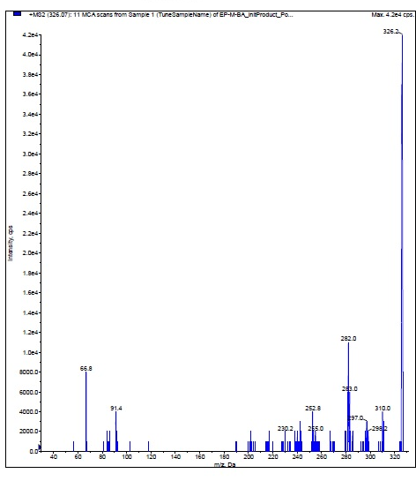
4b
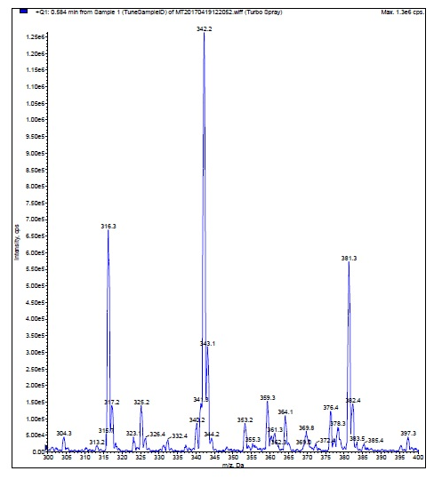
4c
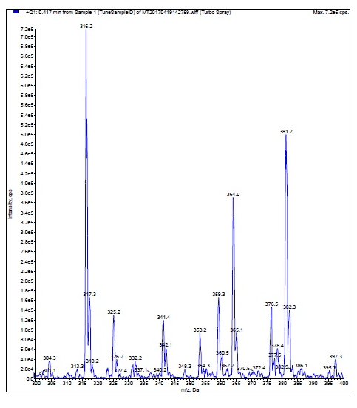
4d
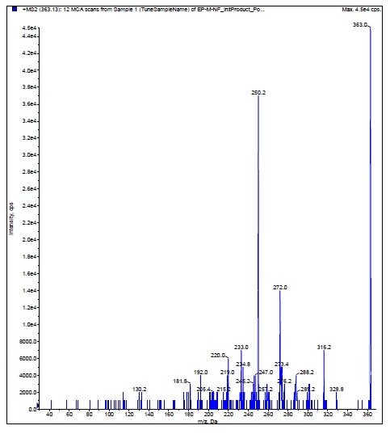
4f

