Figure S1. Comparison of mitochondrial gene order in Scorpaeniformes and Notothenioidei speceis. (A) Typical gene arrangement in Scorpaeniformes, including P. rubripinnis and I. japonicus. The complete mitochondrial genome is shown, with protein-coding genes (red), rRNAs (yellow), tRNAs (blue), and non-coding regions (green) indicated. Gene abbreviations follow standard mitochondrial nomenclature. (B) Variation in gene order from ND5 to D-loop region among Scorpaeniformes (P. rubripinnis and I. japonicus) and Notothenioidei species (P. borchgrevinki, C. hamatus, and P. charcoti). Colored blocks represent genes, with connecting lines indicating changes in gene position.

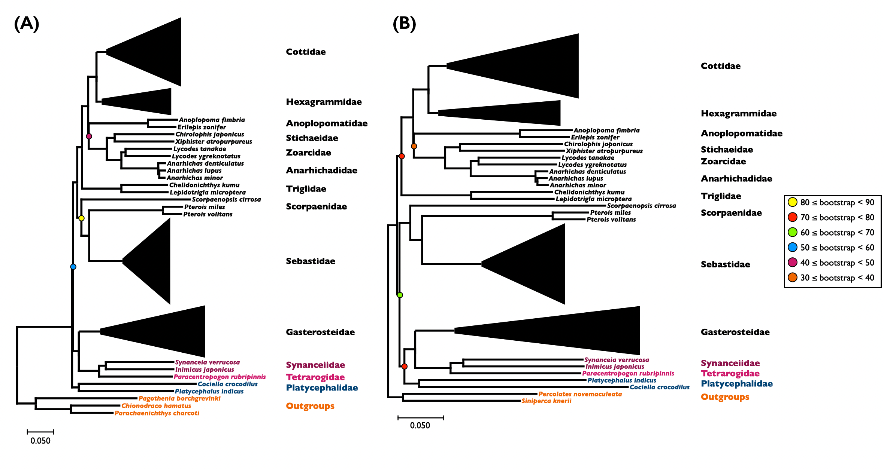

Figure S2. Phylogenetic trees of Scorpaeniformes including Platycephalidae, based on 13 mitochondrial protein-coding genes. (A) Tree using Notothenioidei species (P. charcoti, C. hamatus, and P. borchgrevinki) as outgroups. (B) Tree using Perciformes species (P. novemaculeata and S. knerii) as outgroups. Both trees were constructed using Maximum Likelihood method with GTR+F+R5 model. Colored circles at nodes represent bootstrap support values. Family names are indicated on the right of each tree. Major clades are collapsed and represented by triangles for clarity. Species names are shown for key taxa. Scale bars represent 0.05 substitutions per site.

Species | Accession number | Total sequenced bases (bp) | Number of reads | Read length | > Q30 (%) | Number of cleaned reads | % of  cleaned reads
P. rubripiniis | SRR11802645 | 59,840,384,656 | 592,479,056 | 101 | 91.085 | 572,273,932 | 96.6%
I. japonicus | SRR11802644 | 33,209,913,502 | 219,933,202 | 151 | 87.825 | 200,356,246 | 91.1%
Table S1. Statistics of genome sequencing data for two Scorpaeniformes species.

Table S2. A list of predicted conserved sequence blocks of the control region in mitogenomes of 12 species using DNAsp v.6.12.03.

Conserved sequence block | Region  (start-end) | Conservation | P-value | Sequence
Region-1 | 1-43 | 0.743 | 0 | AGAARRGAGATTYTAACTCCYRCCYCTRRCTCCCAAAGCYAKR
Region-2 | 176-186 | 0.636 | 0.0908 | ATYKATWTYAA
CSB-F | 452-496 | 0.705 | 0 | BATWYCTATAWKGYYAAMGKTTATTGARGGTGAGGGACAANDAWT
CSB-E | 498-505 | 0.625 | 0.1635 | GTRRGRGT
CSB-D | 515-553 | 0.667 | 0.0004 | TGMWYTATTCCYGRCATTTGGYTCYTMYKTCAGGKMCAY
CSB-1 | 811-821 | 0.636 | 0.0908 | CAWGDRCATAW
CSB-2 | 875-908 | 0.719 | 0.0002 | MGSGTTWAAMCCCCCCTACCCCCYWAAAGCTSSD
CSB-3 | 920-949 | 0.800 | 0 | VRYTCCTGHAAACCCCCCGGAAMCAGGAMA

