Supplementary materials to “Large-scale characterization of forest structure and complexity from remote sensing optical images”

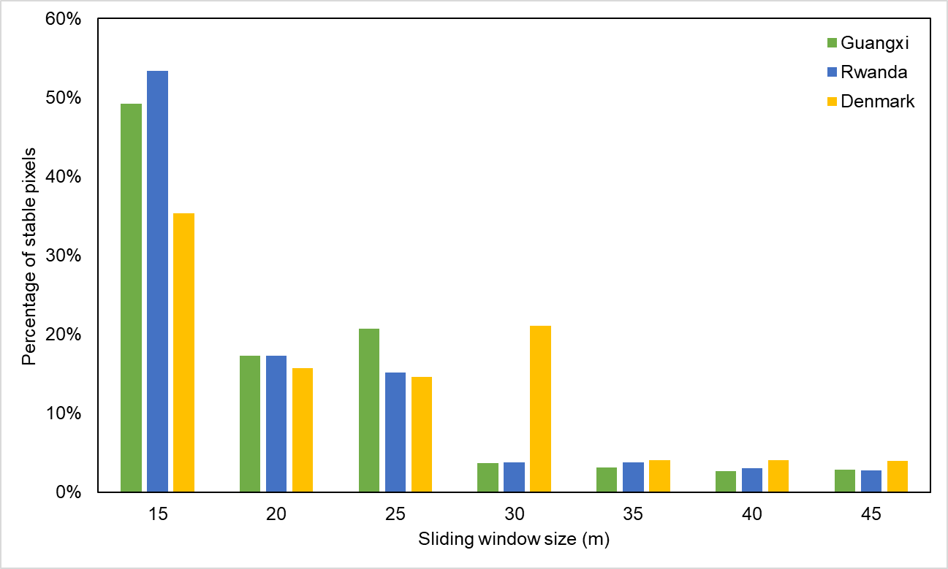
Fig. S1. Percentage of stable pixels for different sliding window size.

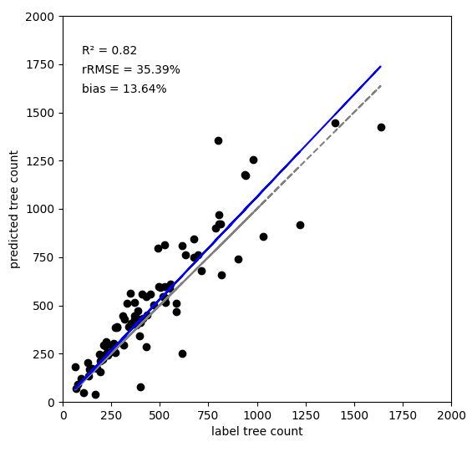
Fig. S2. Evaluation.

