Supplementary information

Supplementary Table 1. Full sets of mechanisms through which alien species can cause negative and positive impacts on native species as outlined in EICAT (IUCN 2020) and EICAT+ (Vimercati et al. 2022) and number of impact observations (N = 2021) assessed in this paper for each mechanism. Alien ungulates caused negative impacts to native species through 8 mechanisms and positive impacts through 7 mechanisms. For 1,896 impact observations, it was possible to unanimously assign impacts to a single mechanism, while for 125 observations more than one mechanism was assigned to the observed impacts. Numbers with superscript letters refer to cases where multiple mechanisms were simultaneously linked to a single observed impact. Direct mechanisms are underlined, while colours denote mechanisms through which both negative and positive impacts can be caused. Note that while chemical, physical, or structural impact on ecosystems were kept distinct in the original formulation of EICAT(+), here we have combined them following Volery et al. 2021. This decision reflects the reality that in most cases, a neat distinction between them was not elucidated in the impact report.
Mechanism | N. of impact observations | Total
EICAT
- Competitionª | 15, 2^{g}, 2^{c} | 19
- Predation^{b} | 52, 1^{d} | 53
- Hybridization | 24 | 24
- Transmission of disease^{c} | 4, 2ª | 6
- Parasitism | 0 | 0
- Poisoning/toxicity | 0 | 0
- Bio-fouling or other direct physical disturbance^{d} | 196, 91e, 8^{e,g}, 1^{b} | 296
- Grazing/herbivory/browsing^{e} | 864, 91^{d}, 8^{d,g}, 18^{f} | 981
- Chemical/Physical/Structural impact on ecosystem^{f} | 296, 18e | 314
- Indirect impact through interactions with other taxa^{g} | 45, 8^{e,d},2ª | 55
EICAT+
- Provision of trophic resources | 9 | 9
- Overcompensation | 11 | 11
- Hybridization | 10 | 10
- Disease reduction | 0 | 0
- Dispersal facilitation | 30 | 30
- Epibiosis or other direct provision of habitat^{h} | 3, 6^{j,i} | 9
7. Chemical/Physical/Structural impact on ecosystem^{i} | 68, 6^{h,j} | 74
8. Indirect impact through interactions with other taxa^{j} | 269, 6^{h,i} | 275

Supplementary Table 2. Complete list of post hoc pairwise comparisons with Tukey's correction conducted to identify differences between levels of categorical predictors on the probability of an alien LMH species causing a strong impact on native biodiversity. S. cons.: secondary consumers; P. cons.: primary consumers; Produc.: producers; Decomp.: decomposers. P-values: *p<.05; **p<.01; p<.001***. Asterisks indicate significant differences. ***p<.001; **p<.01; *p<.05.
Predictor | Comparison | odds.ratio | SE | z.ratio | p.value
Direction | Negative / Positive | 2.17 | 0.6 | 2.80 | 0.0051**
Location | Island / Mainland | 0.123 | 0.0701 | 3.679 | 0.0002***
Mechanism type | Direct / Indirect | 0.328 | 0.12 | -3.053 | 0.0023**
Trophic level | S. cons. / P. cons. | 3.07 | 1.253 | 2.751 | 0.0303*
Trophic level | S. cons. / Produc. | 1.54 | 0.636 | 1.037 | 0.7275
Trophic level | S. cons. / Decomp. | 5.02 | 3.894 | 2.083 | 0.1586
Trophic level | P. cons. / Produc. | 0.50 | 0.229 | -1.515 | 0.428
Trophic level | P. cons. / Decomp. | 1.64 | 1.325 | 0.607 | 0.9298
Trophic level | Produc. / Decomp. | 3.27 | 2.618 | 1.480 | 0.4494
Direction * Location | Direction = Negative  Island / Mainland | 0.0879 | 0.0494 | 4.329 | <.0001***
Direction * Location | Direction = Positive  Island / Mainland | 0.1722 | 0.1123 | 2.697 | 0.007**
Confidence | Low / Medium | 0.1957 | 0.0592 | -5.395 | <.0001***
Confidence | Low / High | 0.0641 | 0.0255 | -6.897 | <.0001***
Confidence | Medium / High | 0.3274 | 0.1137 | -3.215 | 0.0037**
Direction * Confidence | Direction = Negative  Low / Medium | 0.8226 | 0.2387 | -0.673 | 0.7792
Direction * Confidence | Direction = Negative  Low / High | 0.1596 | 0.0780 | -3.756 | 0.0005***
Direction * Confidence | Direction = Negative  Medium / High | 0.1940 | 0.0887 | -3.586 | 0.0010**
Direction * Confidence | Direction = Positive  Low / Medium | 0.0466 | 0.0229 | 6.235 | <.0001*
Direction * Confidence | Direction = Positive  Low / High | 0.0257 | 0.0136 | -6.936 | <.0001*
Direction * Confidence | Direction = Positive  Medium / High | 0.5525 | 0.2952 | -1.110 | 0.5077

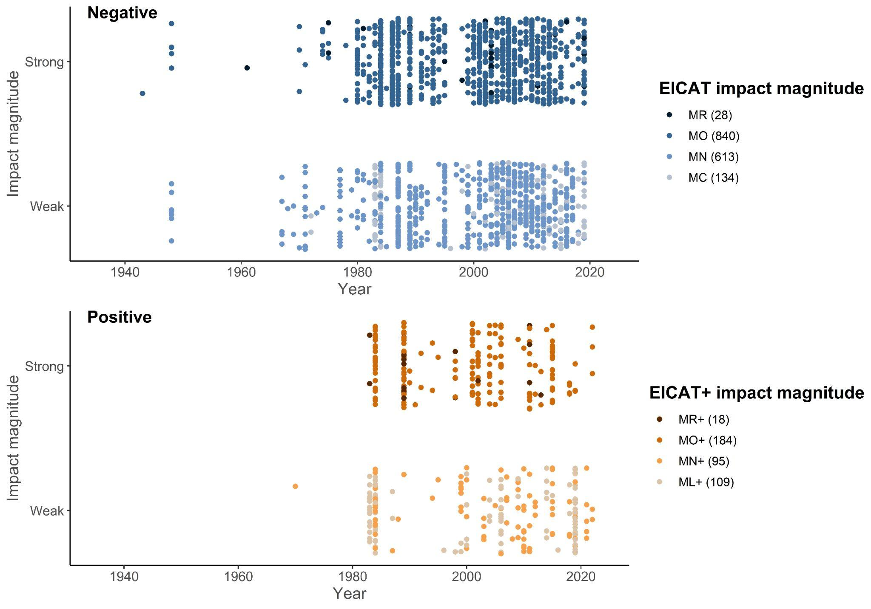
Supplementary Fig. 1. Dots represent single observations of negative and positive impacts having different impact magnitude (strong vs. weak) across years, with a jitter function to prevent overlap. Numbers in brackets represent the sample size for each group. Note that no impact observation, whether positive and negative, was assigned a “Massive” level of magnitude.

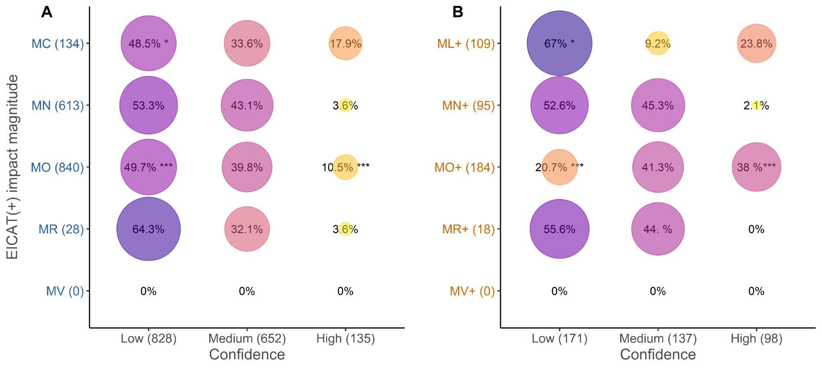
Supplementary Fig. 2. Percentage of impact observations assigned with different confidence with EICAT (A) and EICAT+ (B) at each level of impact magnitude. Asterisks indicate cases where the percentages differed significantly between negative (A) and positive impacts (B), as determined by pairwise Z-tests. P-values: *p<.05; **p<.01; p<.001***. Numbers in brackets represent the sample size for each group.
References

IUCN. IUCN EICAT Categories and Criteria. The Environmental Impact Classification for Alien Taxa. IUCN EICAT Categories and Criteria: First Edition. (2020). doi:10.2305/IUCN.CH.2020.05.en.

Vimercati, G. et al. The EICAT+ framework enables classification of positive impacts of alien taxa on native biodiversity. PLOS Biology 20, e3001729 (2022).

Volery, L. et al. Improving the Environmental Impact Classification for Alien Taxa (EICAT): a summary of revisions to the framework and guidelines. NeoBiota 62, 547 (2020).

