Supplementary Materials

Vascular Microphysiological System for Investigating Endothelial Barrier Function during Organ Preservation and Reperfusion

Yongdeok Kim^{1,2}, Ishan Goswami^{1,2}, Elisabeth Gill¹, S. Reza Mahmoodi^{1,2,†}, Anthony N. Consiglio³, Jazmin Velazquez¹, Gabriel Nieman¹, Alexis Abigail A. Alburo¹, Brady Woods¹, Bradley W. Ellis⁴, Irina Filz von Reiterdank⁴, Korkut Uygun⁴, Basak E. Uygun⁴, Boris Rubinsky^{1,3}, and Kevin E. Healy^{1,2 *}

¹Department of Bioengineering and California Institute for Quantitative Biosciences (QB3), University of California, Berkeley
²Department of Materials Science and Engineering, University of California, Berkeley
³Department of Mechanical Engineering, University of California, Berkeley
⁴Center for Engineering in Medicine and Surgery, Massachusetts General Hospital, Harvard Medical School and Shriners Children’s Boston, Boston

*Corresponding author: kehealy@berkeley.edu
†Current address: Department of Electrical and Computer Engineering, University of Denver

Supplementary Figures 1-17

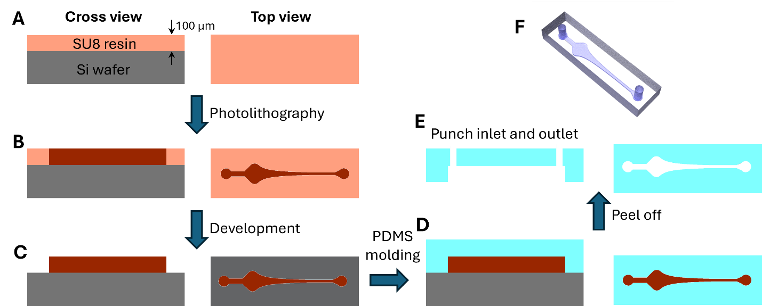
Figure S1. Scheme for MPS fabrication. Cross and top views of (A) Spin coated SU8 resin with 100 µm on a silicon wafer, (B) after UV exposure with the photomask, (C) after development of SU8 resin, (D) PDMS molding on the master mold, and (E) after peeling off the PDMS part from the wafer mold and punching holes for inlet and outlet. (F) Schematic of microfluidics channel on PDMS after fabrication.

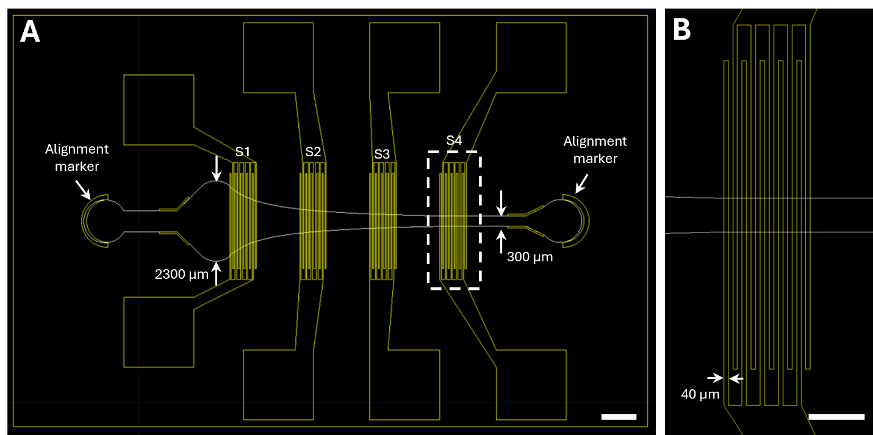
Figure S2. CAD for EIS-integrated MPS. (A) CAD for interdigitated gold electrodes pairs as yellow and microfluidics chamber as white. S1 through S4 indicate sensor location along the long axis of the vascular chamber. (B) Extended view of outlined region in A of S4. Scale bars: 500 µm.

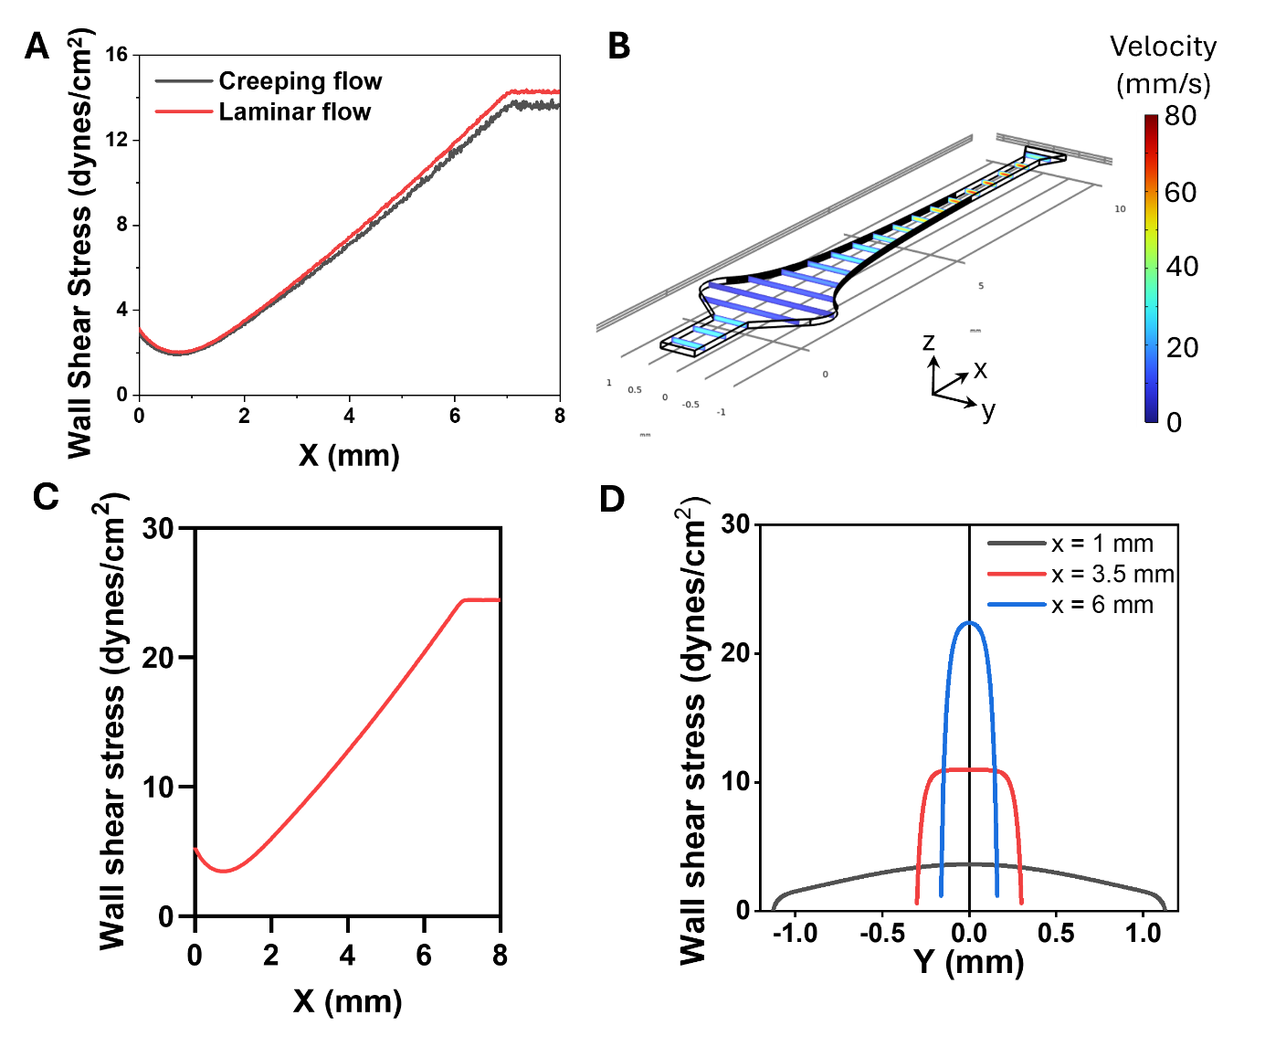
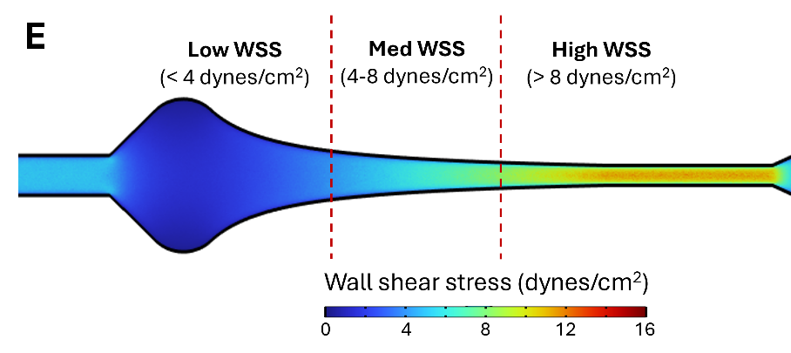
Figure S3. Finite element analysis for variable WSS on vascular MPS using COMSOL. (A) Fluid WSS for creeping flow and laminar flow along the X-axis at Y = 0 from Fig. 1Ci. (B) Fluid velocity profiles on the channel and WSS along (C) the X-axis at Y = 0 and (D) the Y-axis when X = 1, 3.5, and 6 mm for Q = 70 µL/min. (E) Categorization of channel depending on WSS for EC morphology analysis depending on region within the tissue chamber.

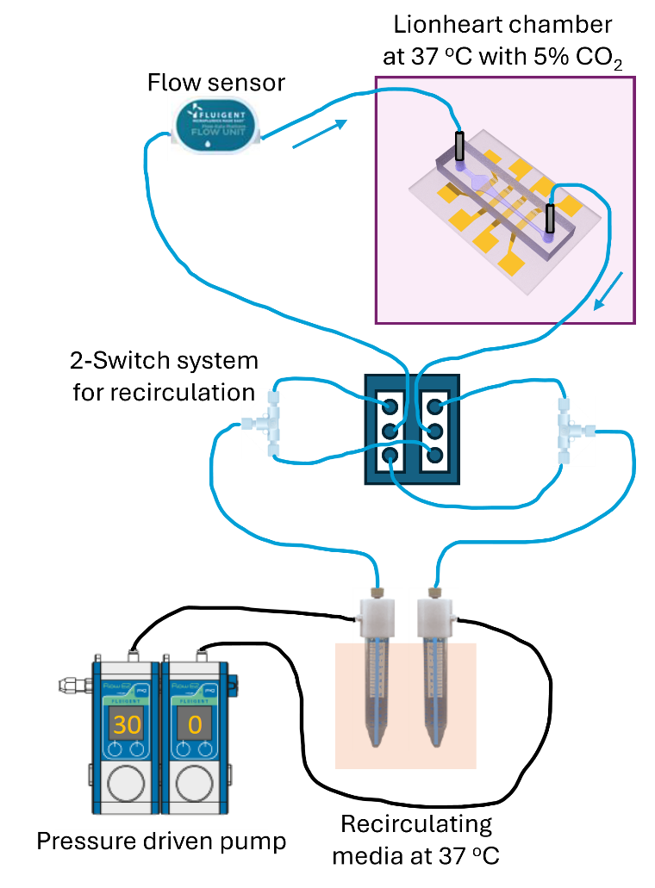
Figure S4. Microfluidics setup. Schematic of microfluidics setup including pressure-driven pump, switch system, flow sensor to sustain perfusion at elevated flow rates while minimizing media waste for extended of perfusion periods.

Figure S5. EC morphology in the absence of flow. Immunofluorescence images of ECs on the vascular MPS without WSS at the regions on wide (A) and narrow channels (B) with i) VE-Cadherin (Green), ii) VEGFR3 (Red), and iii) merged images with nuclei (DAPI - Blue). Scale bar: 100 µm.

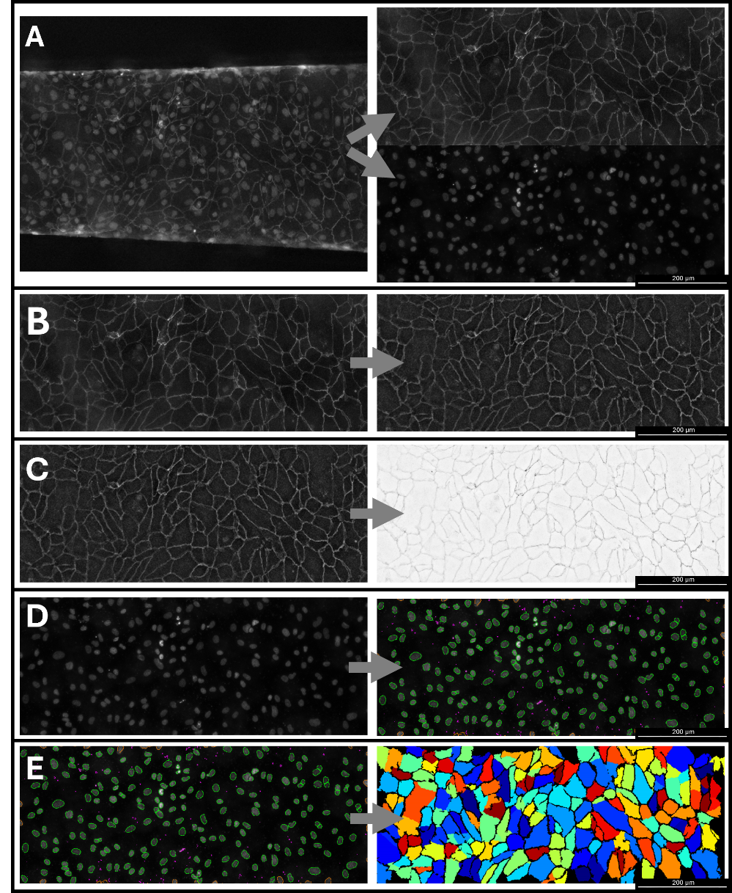
Figure S6. Image analysis steps for EC morphology quantification. (A) Combined DAPI and VE-cadherin channels of human coronary artery ECs on vascular MPS without WSS before and after cropping to remove the channel edges. (B) Cropped VE-cadherin channel with intensity corrected over all cells. (C) Inverted VE-cadherin intensity. (D) The DAPI channel undergoing adaptive two-class Otsu thresholding to identify nuclei. (E) The final false color mapping of cells found using adaptive two-class Otsu thresholding and identified nuclei. Scale bars are 200 µm.

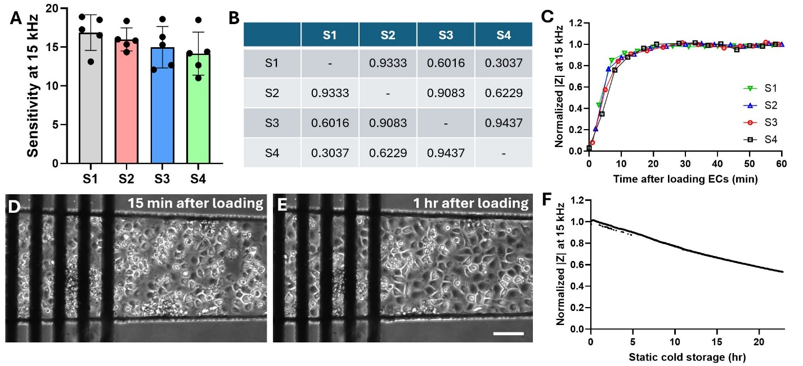
Figure S7. EIS sensitivity variations and temporal measurement of endothelium after seeding and during SCS. (A) EIS sensitivity (|Z| with cells /|Z| bare electrode) at 15 kHz. (B) P-values for comparison of different electrodes EIS sensitivity (|Z| with cells /|Z| bare electrode) for whole curves from 10 Hz to 1 MHz from Fig. 3B. (C) Real-time normalized |Z| at 15 kHz after loading ECs on all electrodes. |Z| were normalized to 1h after loading. (D) Corresponding microscopic images ECs 15 minutes after loading and (E) an hour after loading on S4. Scale bar: 100 µm. (F) Real-time normalized |Z| at 15 kHz on S4 during SCS. |Z| was normalized to before SCS. One way ANOVA with Tukey’s multiple comparisons post-hoc test was used for multigroup analysis. At least five independent replicates were used for EIS sensitivity analysis.

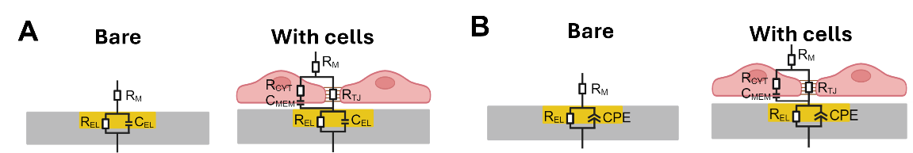
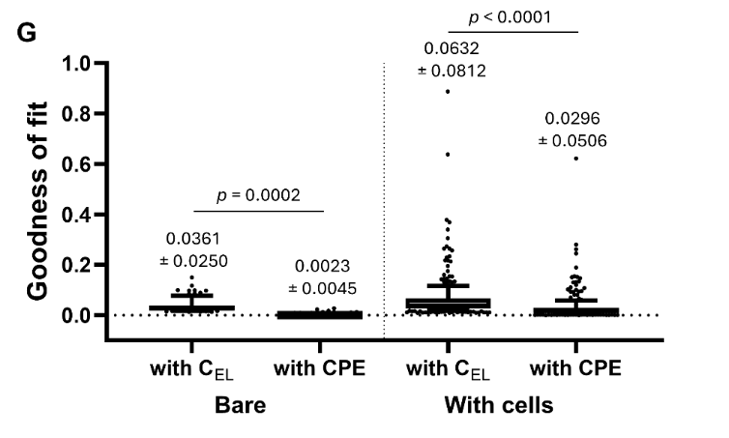
Figure S8. Fitting the equivalent circuit model to quantify barrier function. Equivalent circuit models using (A) electrode capacitance (C_{EL}) and (B) constant phase element (CPE) at bare electrode without cells and with cells on MPS. R_{M}: media resistance, R_{EL}: electrode resistance, C_{EL}: electrode capacitance, R_{CYT}: cytoplasmic resistance, R_{TJ}: tight junction resistance, C_{MEM}: membrane capacitance, CPE: constant phase element. Representative curve fitting with parameters using the simplex method for a bare electrode (C) using C_{EL} or (D) CPE. Representative curve fitting with parameters using the simplex method for cells and electrode (E) using C_{EL} or (F) CPE. (G) Goodness of fit comparison between two models A and B for bare electrode without cells and with cells. Data expressed as mean ± standard deviation. Whiskers in G indicate 10-90 percentile. One way ANOVA with Tukey’s multiple comparisons post-hoc test was used for multigroup analysis. At least 108 electrodes pairs were compared.
Figure S9. EIS bode plots for SCS and ICS preservation conditions with and without reperfusion. Bode plots comparing before preservation, immediately after preservation, and after 4 hour of reperfusion at the region higher of WSS (i.e., 8 dynes/cm²). SCS after (A) 24, (B) 48, (C) 72, and (D) 96 hours. ISC after (E) 24, (F) 48, (G) 72, and (H) 96 hours.

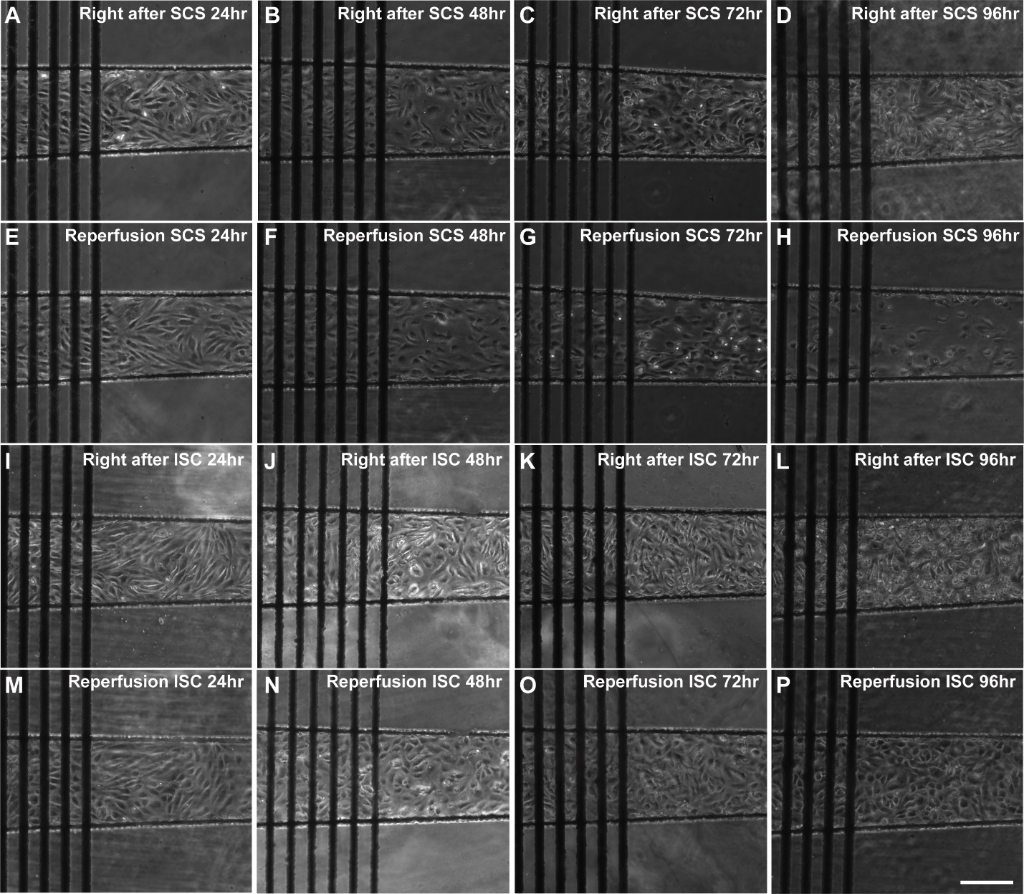
Figure S10. Brightfield images for ECs within the vascular MPS for SCS and ICS preservation conditions with and without reperfusion. Images immediately after SCS for (A) 24, (B) 48, (C) 72, and (D) 96 hours, and after 4 hours of reperfusion for (E) 24, (F) 48, (G) 72, and (H) 96 hours of SCS. Images immediately after ISC for (I) 24, (J) 48, (K) 72, and (L) 96 hours and after 4 hours of reperfusion for (M) 24, (N) 48, (O) 72, and (P) 96 hours of ISC. Scale bar: 200 µm.

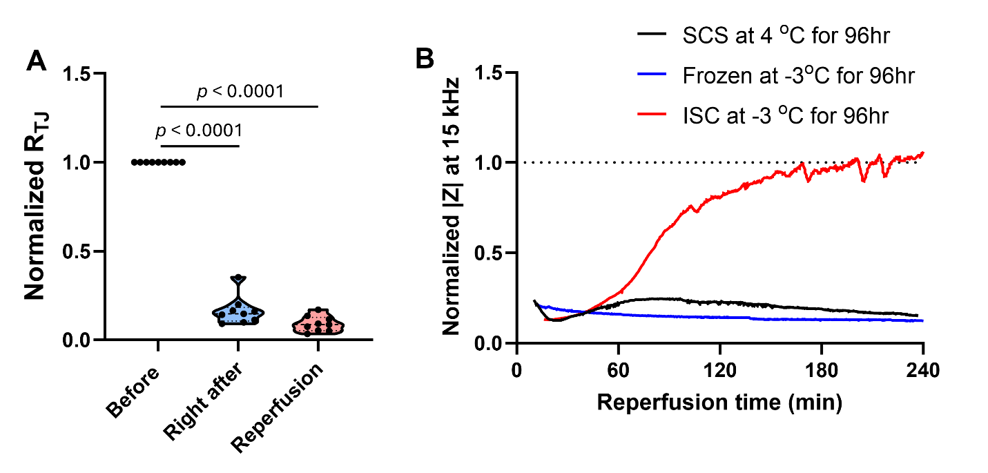
Figure S11. Normalized barrier function (R_{TJ}) for vascular MPS either frozen at -3 °C, SCS or ICS preservation conditions. (A) Normalized R_{TJ} before and after ECs frozen at -3 °C for 96 hours and after reperfusion for 4 hours. Data normalized to R_{TJ} before preservation. One way ANOVA with Tukey’s multiple comparisons post-hoc test was used for multigroup analysis. (B) Temporal normalized |Z| at 15 kHz with reperfusion after SCS, ISC, and frozen for 96 hours. Data were normalized to |Z| before preservation.

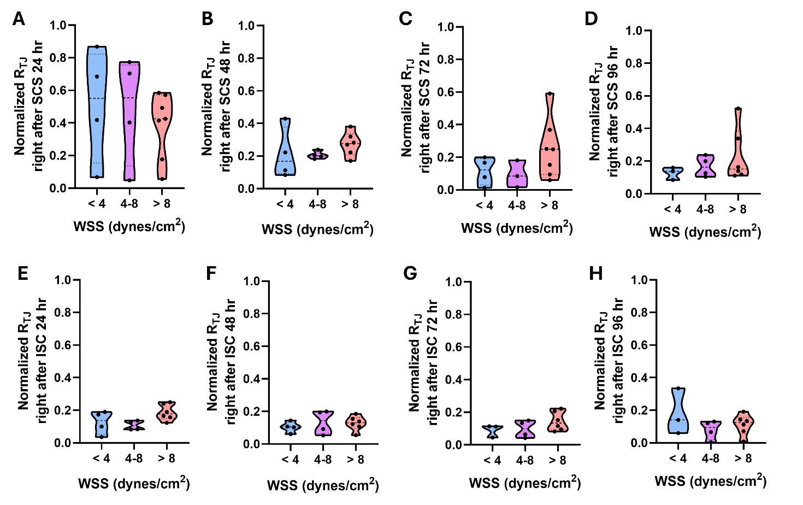
Figure S12. Barrier function (R_{TJ}) right after SCS and ISC at different WSS regions. Violin plots immediately post-SCS for (A) 24, (B) 48, (C) 72, and (D) 96 hours at different WSS. Violin plots immediately post-ISC for (E) 24, (F) 48, (G) 72, and (H) 96 hours at different WSS.

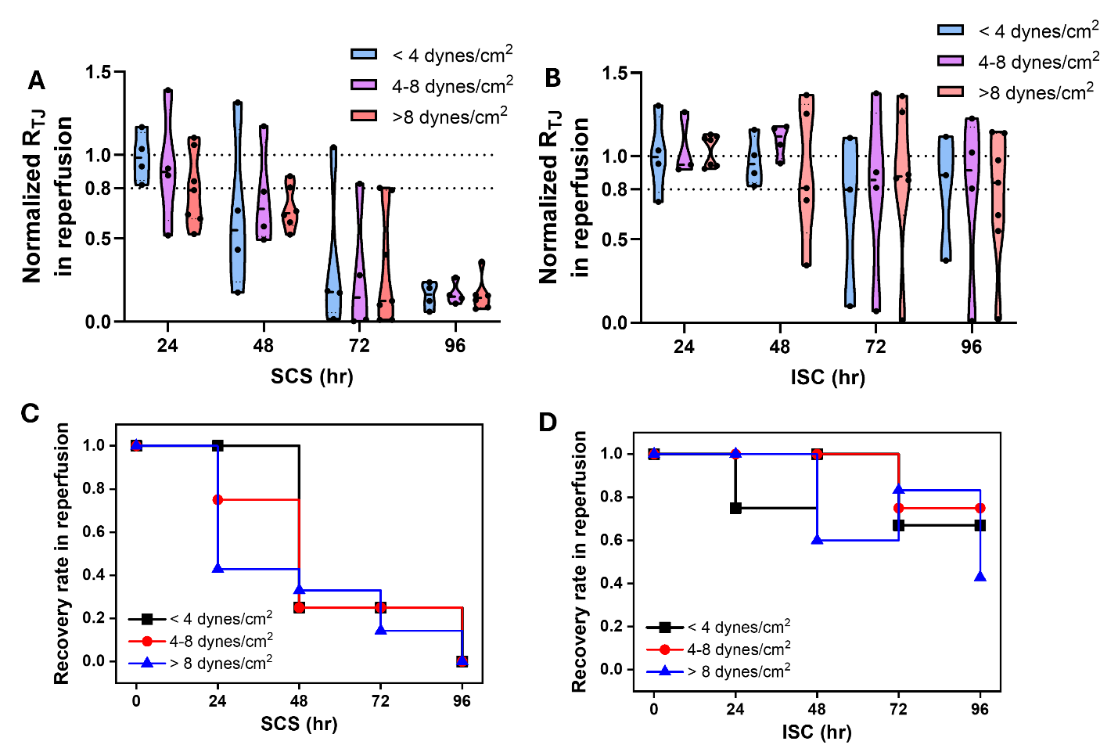
Figure S13. Effect of different WSS on recovery of ECs barrier function with reperfusion. Violin plots for normalized R_{TJ} immediately post (A) -SCS and (B) -ISC for 24, 48, 72, and 96 hours for different WSS. Dotted lines indicate 80 % and 100 % of normalized R_{TJ} after reperfusion. R_{TJ} data were normalized to before preservation. Barrier function recovery rate with reperfusion after (C) SCS or (D) ISC for 24, 48, 72, and 96 hours for different WSS.

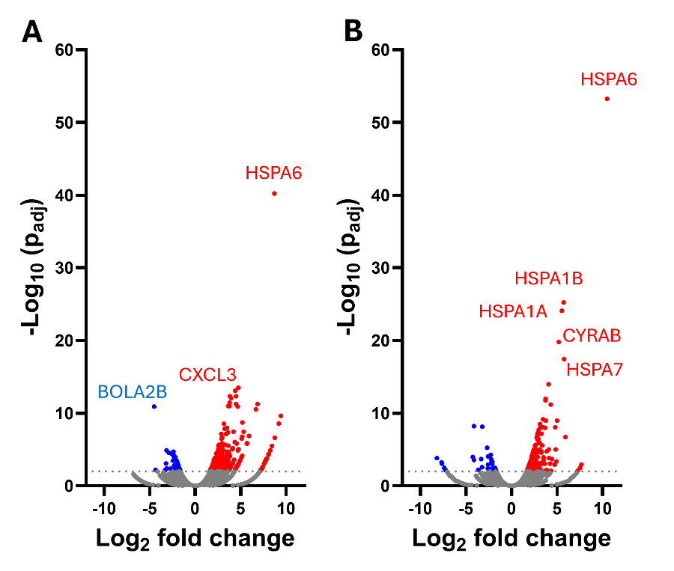
Figure S14. Volcano plots after 4 hours of reperfusion for either (A) SCS or (B) for 96 hours compared to control without preservation. The dotted lines indicate the –Log₁₀ (adjusted p-value = 0.01).

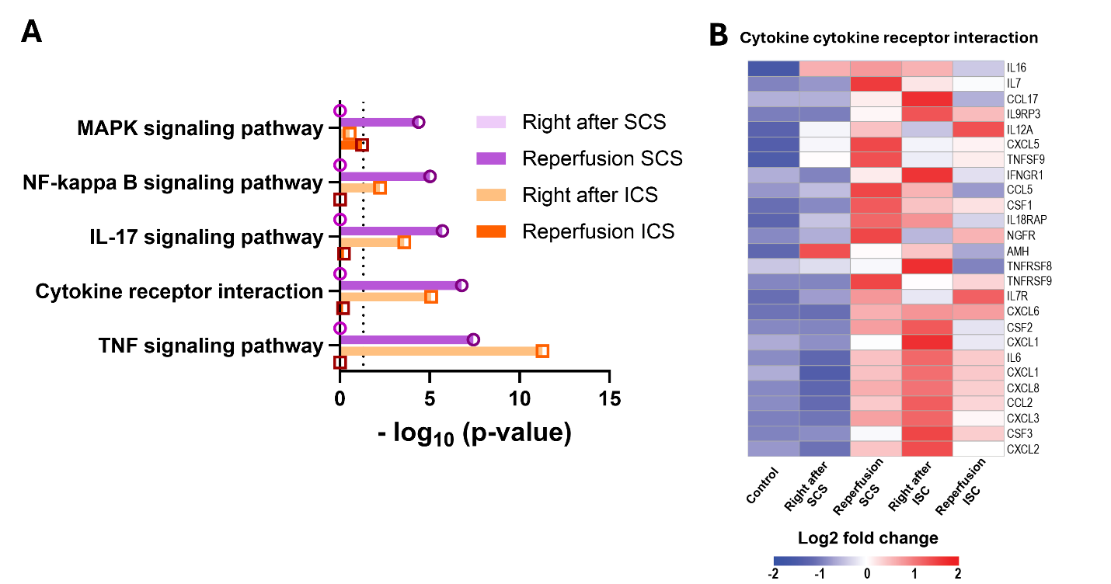
Figure S15. Inflammatory response after preservation and reperfusion in SCS and ISC for 96 hours. (A) Upregulated inflammatory responses from KEGG analysis with statistical differences (-log₁₀ (adjusted p-value)) and (B) heat map for cytokine-cytokine receptor interaction immediately post 96 hours of either SCS or ISC, and after 4 hours of reperfusion. The dotted line in A indicates the p = 0.05.

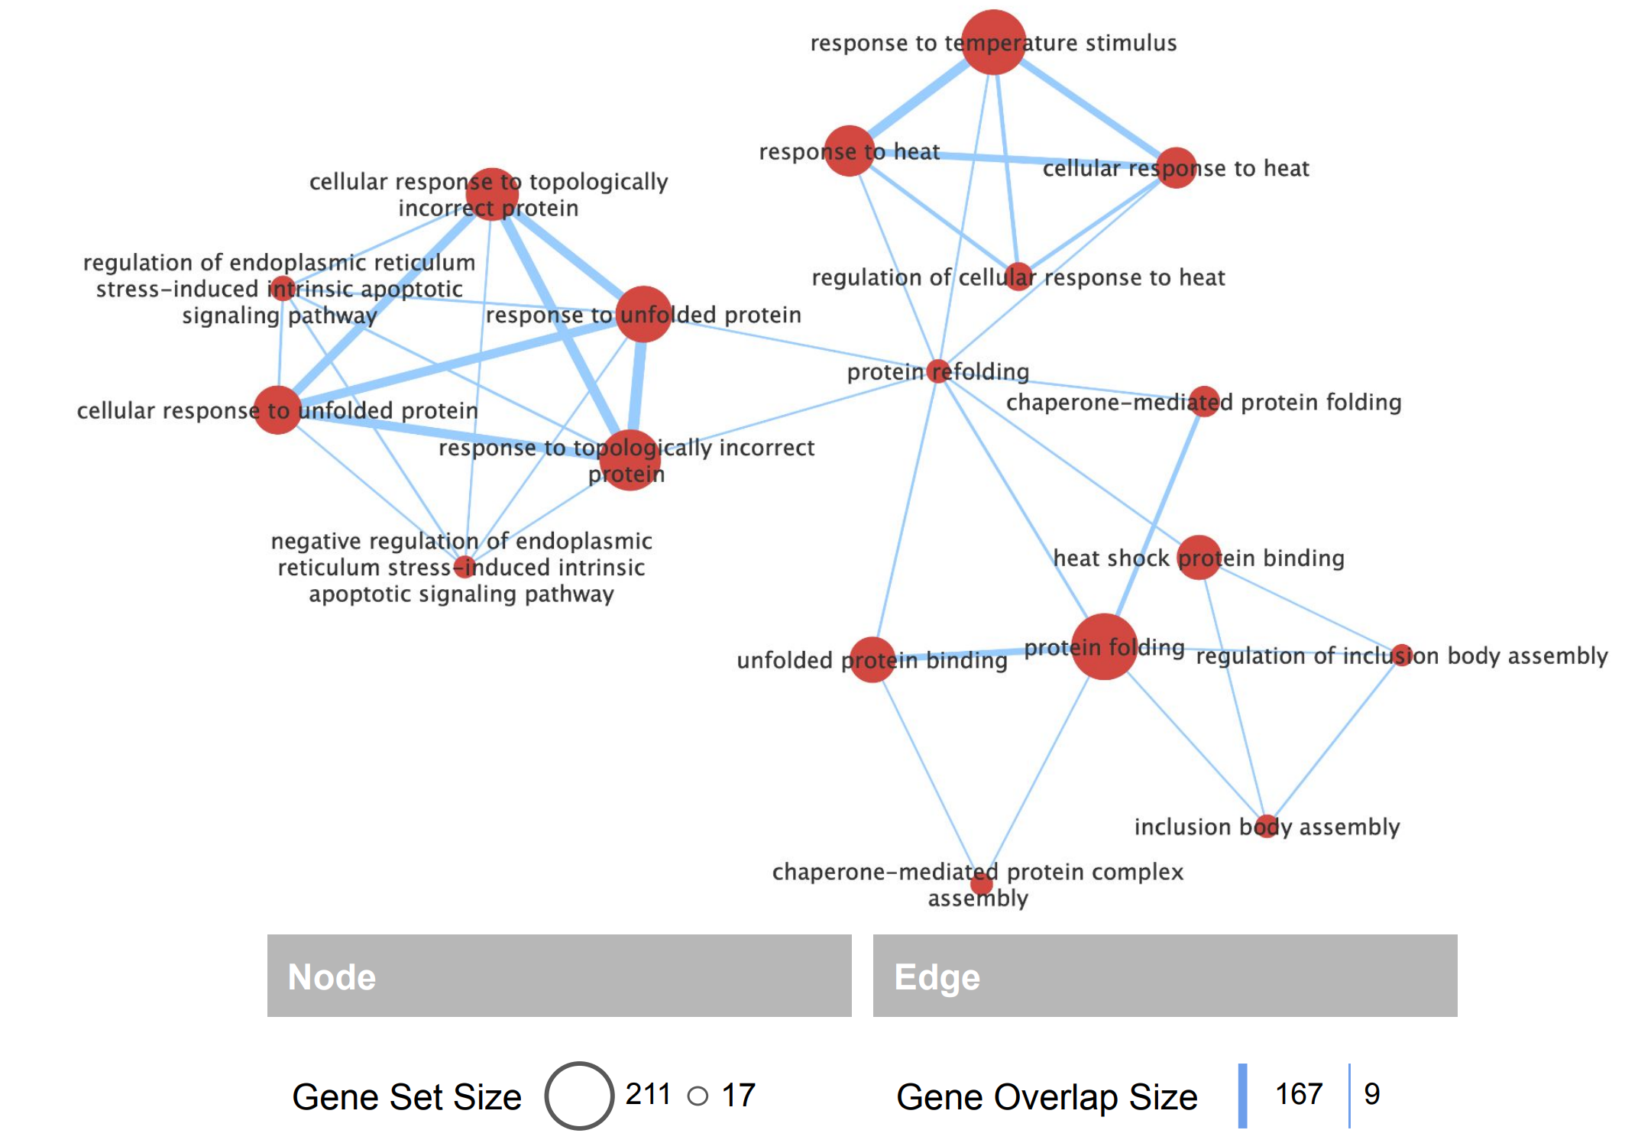
Figure S16. Enrichment map after reperfusion in ISC for 96 hours illustrating clustered unfolded protein responses and heat responses pathways identified through gene set enrichment analysis (GSEA) using a canonical pathway database. Pathways were filtered using an FDR q-value cutoff of 0.75 and a p value cutoff of 0.005. The gene set size indicates the total number of genes within each pathway, while gene set overlap represents the number of shared genes between pathways.

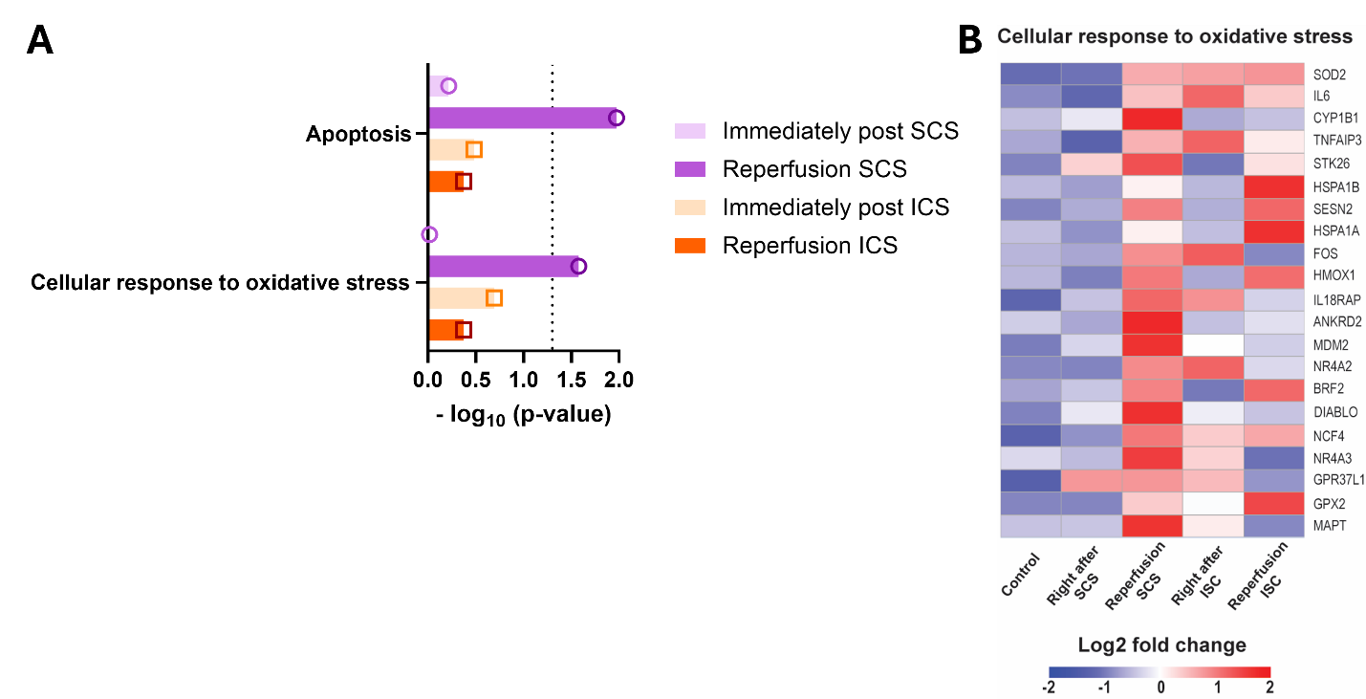
Figure S17. (A) Upregulated apoptosis and cellular response to oxidative stress from KEGG and gene ontology analysis with statistical differences (-log₁₀ (p-value)) and (B) Heat map for cellular response to oxidative stress immediately post-SCS and ISC for 96 hours and after 4 hours of reperfusion. The dotted line in A indicates the p = 0.05.

