SUPPLEMENTARY INFORMATION

Preliminary information on cell lines
The three breast cancer cell lines were checked for the gene and protein expression of ESR1 (ERα), ESR2 (ERβ), PGR, and ERBB2 (HER2). qRT-PCR and western blotting resulted in significantly high expression of ESR1 and PGR in MCF7 cells while HER2 was overexpressed in MDA-MB-453 cells. MDA-MB-231 was negative for all the markers as summarized in image S1.
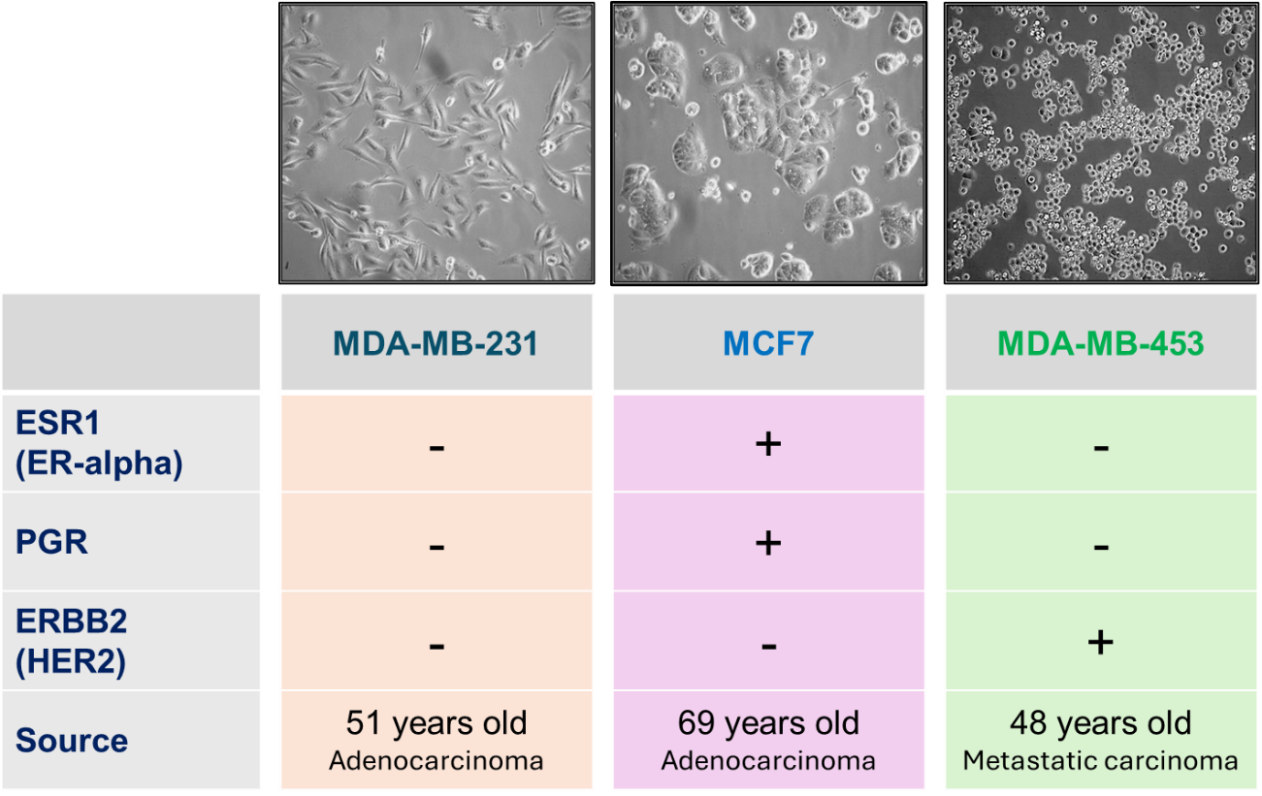
Figure S1. Receptor status summary of the cell lines

in silico analysis of AR and AR-V7 expression with survival outcomes:
Gene Expression Profiling Interactive Analysis 2 (GEPIA2; http://gepia2.cancer-pku.cn/) (last assessed: July 2024) web server-based analysis was carried out to investigate the gene expression data across the different breast cancer subtypes based on The Cancer Genome Atlas (TCGA) and the Genotype-Tissue Expression (GTEx) databases.^{[57]} in silico analysis of AR and AR-V7 expression and survival outcomes in TCGA cohorts were assessed using this tool.
The relative abundance of AR-FL and AR-V7 in tumors and normal tissues or organs was visualized. AR-FL had ubiquitous expression across the body in tumor and normal cases, whereas AR-V7 has extremely low expression in the breast, testis, and ovaries. The overall expression of AR-FL was significantly higher in the GEPIA database of breast cancer. The subtype-specific analysis further represents a significantly higher expression of AR-FL in luminal and HER2 enriched subtypes while a significant downregulation in the TNBC category. in silico data analysis of AR-V7 performed on the TCGA cohorts revealed an extremely low expression of AR-V7 in tumors and controls. AR-V7 expression in GEPIA analysis showed similar trends to those of the AR-FL, although at non-significant levels.
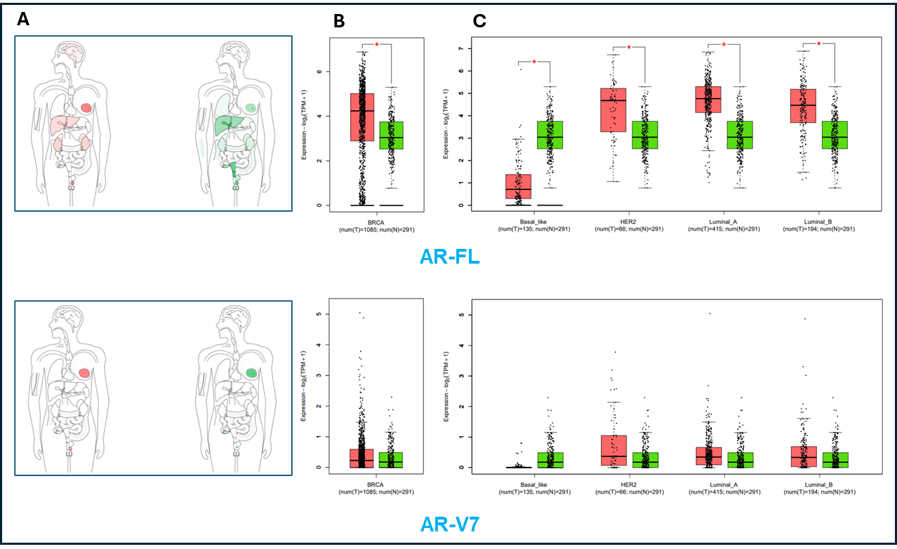
Figure S2. A. Bodymap representing the median expression of tumor (depicted in red color) and normal samples (in green color). B. Box plot depicting overall and C. subtype-specific expression of AR-FL (upper panel) and AR-V7 (lower panel) in breast cancer. The red color box indicates the tumor while the green denotes control. Dots represent individual tumors or control samples.

Survival analysis on TCGA cohorts from the GEPIA web server was utilized to assess AR-FL and AR-V7 expression levels and patient survival outcomes. The Kaplan-Meier curves for the high and low AR-FL/AR-V7 expression in breast cancer were not significantly associated with overall and disease-free survival. The survival outcomes of AR-FL and AR-V7 in prostate cancer, however, were linked to poor OS and DFS [HR (high) >1]. AR-V7 was found to be significantly associated with poor DFS in prostate cancer. These can be visualized in Kaplan-Meier curves attached in Figure S3.
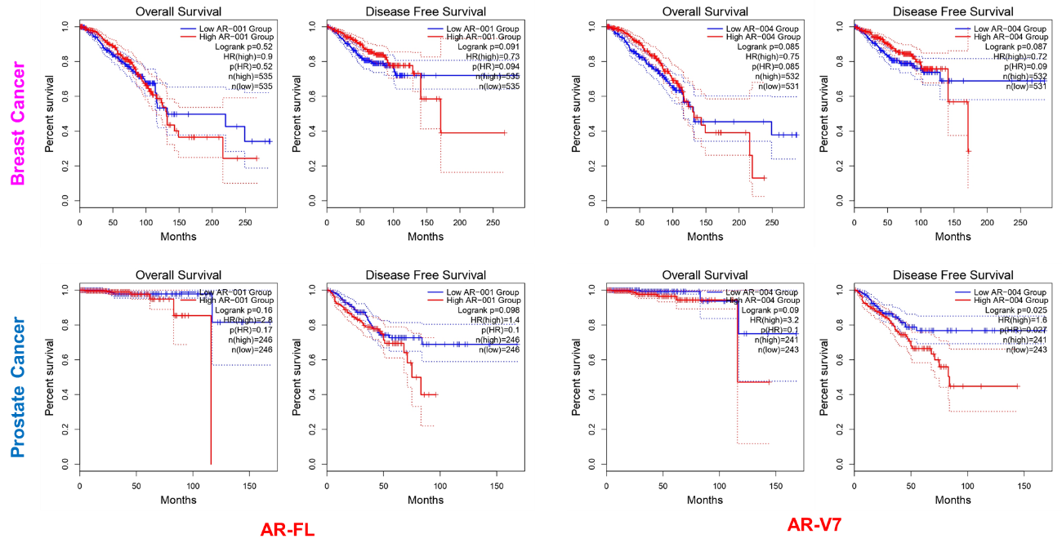
Figure S3. Overall and disease-free survival of TCGA cohorts of breast cancer based on AR-FL and AR-V7 expression

List of primers
Table 4. List of primers used in this study
Transcript | Primer sequence (5' to 3') |  | Application | Annealing temperature (°C) | Product size (bp)
GAPDH | F: | ACGGATTTGGTCGTATTGGG | qRT-PCR | 57.97 | 214
GAPDH | R: | CGCTCCTGGAAGATGGTGAT | qRT-PCR | 59.53 | 214
HPRT1 | F: | ACCAGTCAACAGGGGACATAA | qRT-PCR | 58.66 | 190
HPRT1 | R: | CTTCGTGGGGTCCTTTTCACC | qRT-PCR | 61.15 | 190
ACTB | F: | CCTCGCCTTTGCCGATCC | qRT-PCR | 60.9 | 70
ACTB | R: | CGCGGCGATATCATCATCC | qRT-PCR | 58.71 | 70
RNA18S | F: | GTAACCCGTTGAACCCCATT | qRT-PCR | 58.09 | 151
RNA18S | R: | CCATCCAATCGGTAGTAGCG | qRT-PCR | 57.93 | 151
AR_Pan | F: | CATGTACGCCCCACTTTTGG | qRT-PCR | 59.47 | 114
AR_Pan | R: | TCTTCAGTGCTCTTGCCTGC | qRT-PCR | 59.83 | 114
AR-FL | F: | CGAGCTAGCCGCTCCAGT | qRT-PCR | 61.52 | 176
AR-FL | R: | TGCTTCCTCCGAGTCTTTAGC | qRT-PCR | 59.8 | 176
AR-V7 | F: | AAGACCTGCCTGATCTGTGG | qRT-PCR | 59.38 | 231
AR-V7 | R: | GCCAACCCGGAATTTTTCTCC | qRT-PCR | 60.07 | 231
MKI67 | F: | GCCTGTACGGCTAAAACATGGAG | qRT-PCR | 61.78 | 133
MKI67 | R: | ACGTGCTGGCTCCTGTTCAC | qRT-PCR | 63.00 | 133

Uncropped blot images
