Table 1:

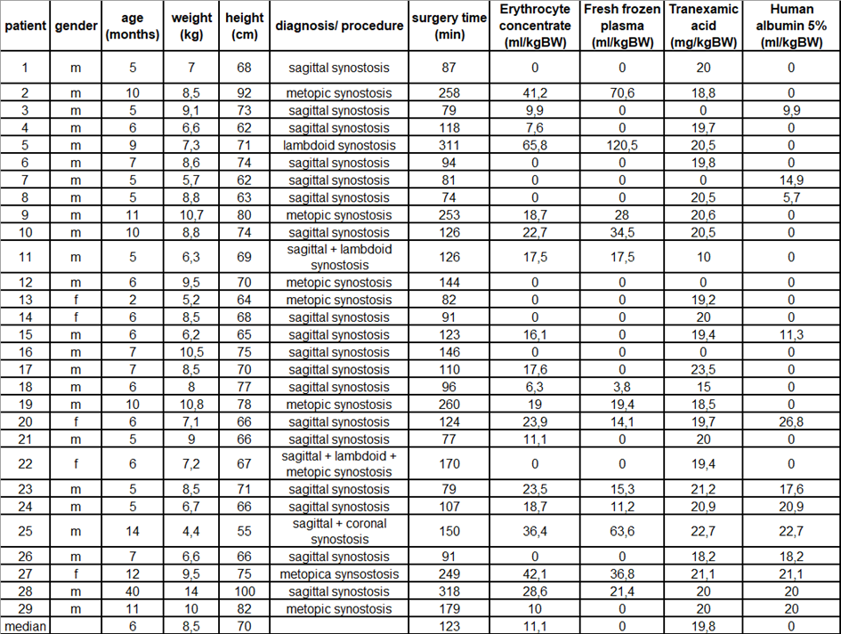
Legend for table 1: Basic parameters and intraoperative blood product (including the natural colloid albumin) and tranexamic acid administration of all study patients. kg = kilogram, cm = centimeter, BW = body weight). No patients received artificial colloids.

Table 3:

a)
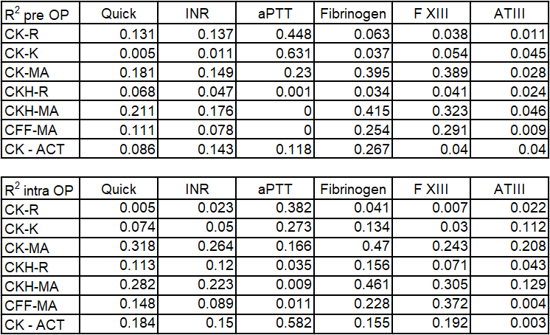

b)

Legend for table 2: R² (coefficient of determination) values of the preoperative (2a) respectively the intraoperative (2b) comparison of TEG 6s parameters with conventional coagulation analyses in all study patients (n=29).

