Supporting Information

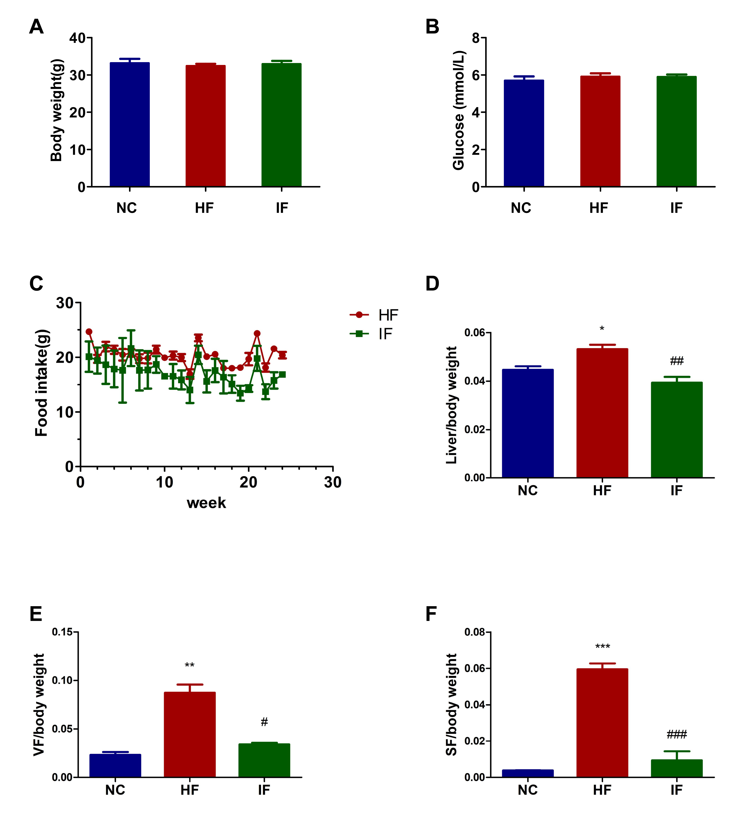
Figure S1. (A)Baseline body weight. (B)Baseline blood glucose. (C) Food intake. (D)Liver weight/body weight. (E) Visceral fat weight/body weight.(F) Subcutaneous fat weight/body weight.

Table S1. Composition and calorie distribution of high-fat diet
Iterms | g | kcal
Composition
Casein | 258.45 | 1033.80
Cystine | 3.88 | 15.52
Maltodextrin | 161.53 | 636.12
Sucrose | 88.91 | 355.64
Cellulose | 64.61 | 0
Soybean Oil | 32.31 | 290.79
Lard | 316.60 | 2849.40
Mineral Mix | 12.92 | 0
Dicalcium Phosphate | 16.80 | 0
Calcium Carbonate | 7.11 | 0
Potassium Citrate | 21.32 | 0
Vitamin Mix | 12.92 | 51.68
Choline Bitartrate | 2.58 | 0
Edible blue stain | 0.065 | 0
Total | 1000 | 5242.95
Calorie distribution | g% | kcal%
Protein | 26 | 20
Carbohydrate | 26 | 20
Fat | 35 | 60

