First indisputable fossil Ilex (Aquifoliales: Aquifoliaceae) flower found in Baltic amber
Finn N. Rasmussen, Bo Johansen, Kathleen Dollman, Erik Wisaeus & Lars Vilhelmsen

Supplementary Figure S1
The amber piece NHMD 872634 at the Natural History Museum of Denmark, DK 1073 in the Danish “Danekræ” fossil trove. The red arrow points to the Ilex wennebergii flower. The red squares are positions of the six arthropod syninclusions, not treated in the present paper. 1: Beetle, 2: Ichneumonid wasp, 3: Fly, 4: Polyxenid millipede, 5: Mite, 6: Stalk-eyed fly .
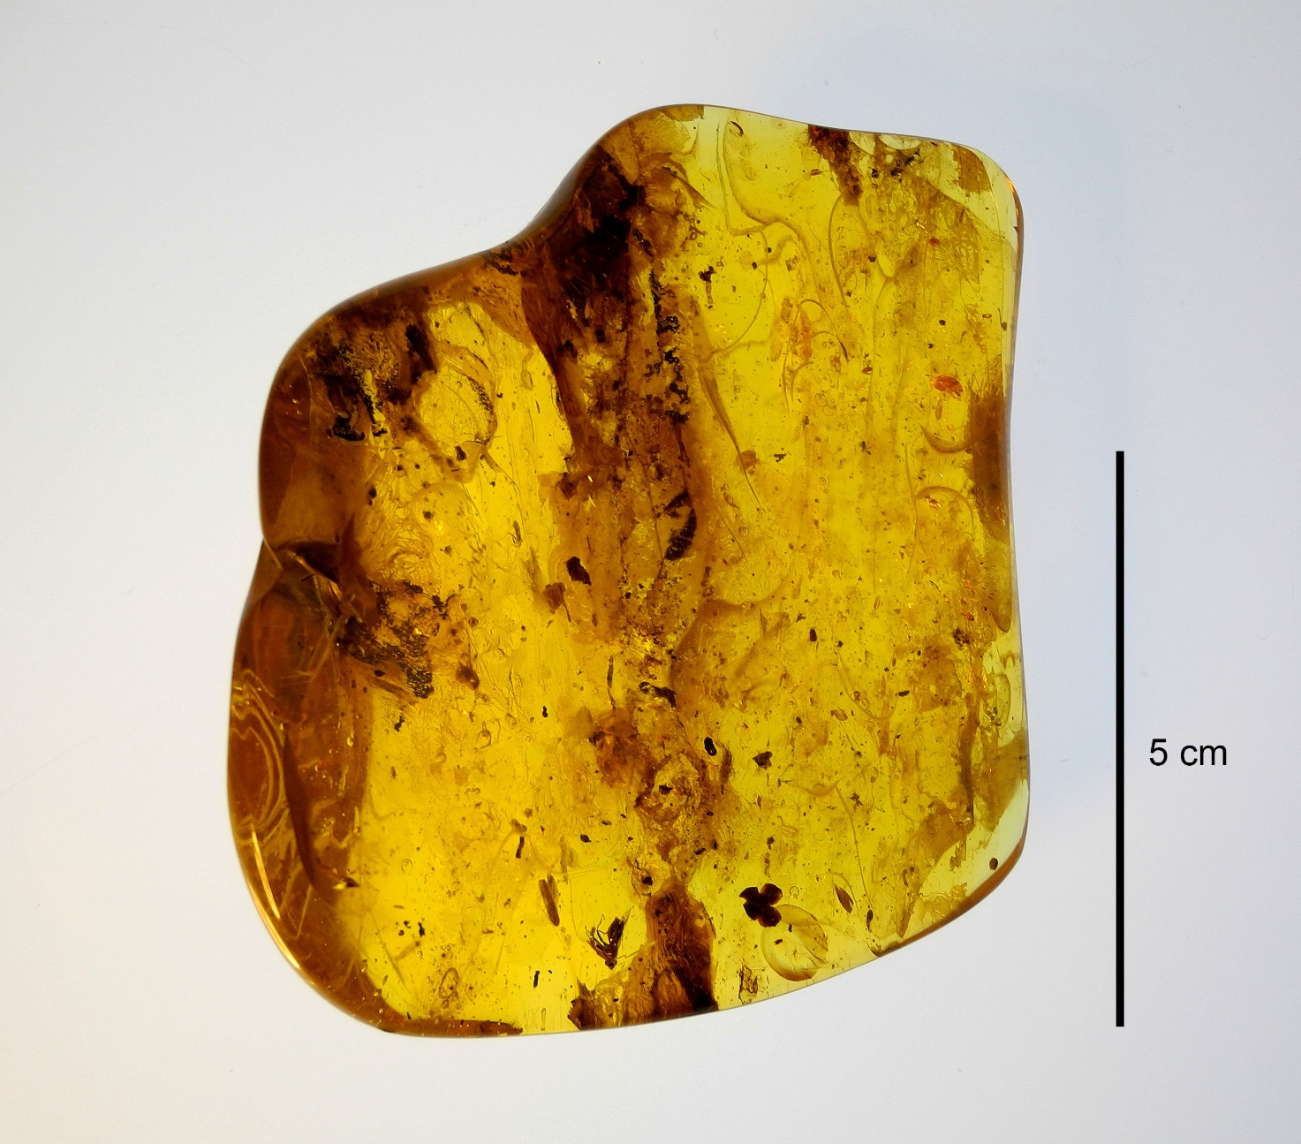
Ilex wennebergii
4
6
5
1
2
3

First indisputable fossil Ilex (Aquifoliales: Aquifoliaceae) flower found in Baltic amber
Finn N. Rasmussen, Bo Johansen, Kathleen Dollman, Erik Wisaeus & Lars Vilhelmsen

Supplementary S2 Methods.

Synchrotron radiation propagation phase contrast micro-computed tomography of the entire amber block was carried out at the European Synchrotron and Radiation Facility, Grenoble, France on beamline BM18. The complete amber piece was scanned at an isotropic voxel size of 13.24µm and the two regions of interest containing the flower and the stalk-eyed fly were scanned at 2µm. The beamline setup at 13.24µm with a synchrotron current of 70mA was for a filtered white beam with a 2000 µm thick luAg scintillator, a sample-detector distance of 15 meters at 90 keV, with sapphire (2.5mm) and glassy carbon (65mm) attenuator filters.
At 2µm, the beamline setup was a filtered white beam at 73keV at 3 meters of propagation distance with sapphire (12mm) attenuator filters with a 500µm thick luAg scintillator.
Acquisition as done with a PCO edge 4,2 sCMOS (PCO, Kelheim Germany), recording 6000 projections at both configurations.
At 13.24 µm, a total exposure time of 27ms single accumulation was recorded. At 2µm, a total exposure time of 42ms, with three accumulated images of 14ms was recorded [1]. The specimens were scanned at 2µm with a half-acquisition setup, with an offset of 900 pixels. The final tomographic volume with reconstructed using PyHST2 [2] and using the single distance Paganin phase retrieval approach [3].

3D image processing of the X-ray tomography dataset was conducted to facilitate 3D structural studies of the flower. The tomography dataset presented challenges due to its low contrast, even grey scales, and decayed state of organic material. The primary objective was to iteratively improve the Region of Interests (ROI) which form the complete Volume of Interest (VOI), ensuring the preservation of internal voids and flower structure, while removing as much of the amber matrix as possible.
3D alignment was performed using Bruker DataViewer software (v. 1.5.6.2). VOI selection began with a 3D Variance filter in Fiji software [4] removing a significant volume of amber. A more refined segmentation was achieved using the Trainable Weka Segmentation tool in Fiji software (v. 3.3.2) [5]. This machine learning-based approach enhanced the distinction between the flower and the surrounding amber.
VOI datasets underwent several iterations of manual processing including morphological operations and manual adding and removing of local ROI and VOI areas. Manual refinement aimed to ensure that all parts of the flower were included in the VOI, while non-relevant amber and remaining image artefacts were excluded. These iterations were performed using both Fiji software and Bruker CTAn software (v. 1.18.8.0).
3D visualisations were generated using Bruker CTVox software (v. 3.3.0), enhanced with RGBA transfer functions to highlight different features of the flower. Sub-datasets of each stamen were added and separately coloured to enhance visualisations.

1. Cau, A., et al. Synchrotron scanning reveals amphibious ecomorphology in a new clade of bird-like dinosaurs. Nature 552 395–399 (2017).

2. Mirone, A., Brun E., Gouillart, E., Tafforeau, P. & Kieffer, J. The PyHST2 hybrid distributed code for high speed tomographic reconstruction with iterative reconstruction and a priori knowledge capabilities. Nuclear Instruments and Methods in Physics Research Section B: Beam Interactions with Materials and Atoms. 324, 41-48 (2014).

3. Paganin, D., Mayo, S., Gureyev, T. E., Miller, P. R. & Wilkins, S. W. Simultaneous phase and amplitude extraction from a single defocused image of a homogeneous object. Journal of microscopy. 206, 33-40 (2002).

4. Schindelin, J., et al. Fiji: an open-source platform for biological-image analysis. Nature Methods, 9, 676–682. (2012). doi:10.1038/nmeth.2019

5. Arganda-Carreras, I., et al. (Trainable Weka Segmentation: a machine learning tool for microscopy pixel classification. Bioinformatics 33, 2424–2426. (2017). doi:10.1093/bioinformatics/btx180

