Supporting Information

Excellent energy storage properties with ultrahigh W_{rec} in lead-free ferroelectric ceramics via heterogeneous structure design
Qizhen Chaiª, Zhaobo Liu^{b}, Zhongqi Deng^{c}, Zhanhui Pengª, Xiaolian Chaoª, Jiangbo Lu^{c,*}, Houbing Huang^{b, *}, Shujun Zhang,^{d, *}Zupei Yang^{a, *}

* Corresponding authors:
- mail addresses: S. Zhang (shujun@uow.edu.au), Z. Yang (yangzp@snnu.edu.cn)

This PDF file includes:
Fig. S1 to S9
Experimental
References

Fig. S1 a) Ambient-temperature P-E loops and b) P_{max} and P_{r} of (1-x)KNN-xSNZ ceramics measured at 10 Hz under 200 kV cm⁻¹. c) Calculated values of W_{rec}, W_{total}, and η.

Fig. S2 Ambient-temperature P-E loops of (1-x)KNN-xSNZ ceramics measured under various electric fields of a) x = 0.03, b) x = 0.06, c) x = 0.09, d) x = 0.12. Composition-dependent energy storage parameters (W_{rec}, W_{total}, and η) of e) x = 0.03, f) x = 0.06, g) x = 0.09, h) x = 0.12, all samples used in this study are 0.1 mm in thickness with electrode area of 0.785 mm².

Fig. S3 P_{max}, P_{r}, and ΔP under different electric fields of a) x = 0.14, b) x = 0.15, c) x = 0.16, d) x = 0.18.
Fig. S4 a) XRD patterns of (1-x)KNN-xSNZ ceramics measured at ambient temperature. b) Enlarged view of 2θ from 44° to 47°. Temperature-dependent XRD patterns of c) x = 0.03 and d) x = 0.15 ceramics.

Fig. S5 a) Raman spectra of the (1-x)KNN-xSNZ ceramics measured at ambient temperature. b) Composition-dependent wavenumber and FWHM of the v₁ mode.
Fig. S6 FE-SEM images of (1-x)KNN-xSNZ ceramics of a) x = 0.03, b) x = 0.06, c) x = 0.09, d) x = 0.12, e) x = 0.14, f) x = 0.15, g) x = 0.16, h) x = 0.18.
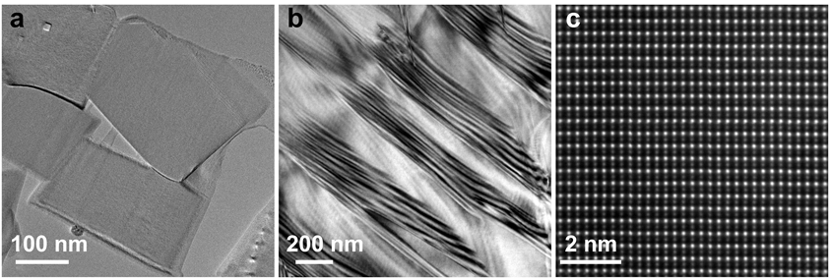
Fig. S7 TEM images of (1-x)KNN-xSNZ ceramics of a) x = 0.15, b) x = 0. c) Atomic resolution HAADF-STEM image along [110]c of x = 0.15 ceramic.
Fig. S8 Simulation of the two-dimensional domain structure of (1-x)KNN-xSNZ ceramics of a) x = 0.12, b) x = 0.15, c) x = 0.18, exhibiting the O and T nanodomains in the C matrix.
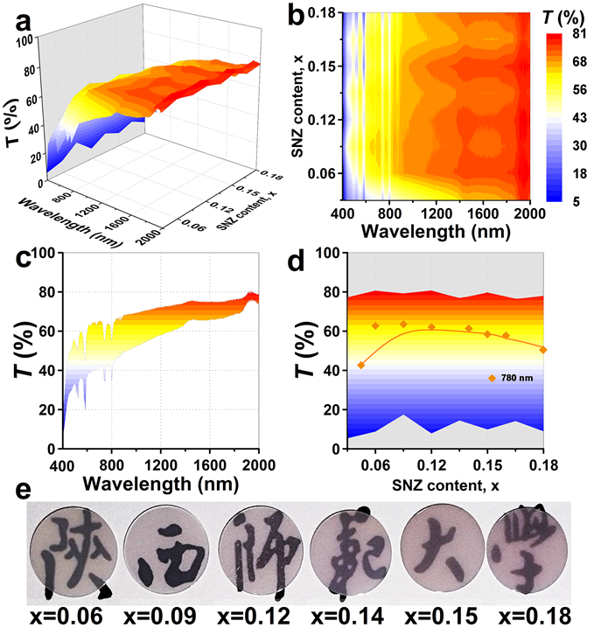

Fig. S9 Optical transmittance spectra of (1-x)KNN-xSNZ ceramics. a) 3D plots, b) top view, c) left view, and d) front view. e) Visual photograph of (1-x)KNN-xSNZ samples with a thickness of ~0.3 mm.
Experimental
Phase-Field Simulations: To reveal the temporal evolution of the polarization field and the domain structure, we employed the time-dependent Ginzburg-Landau (TDGL) equation [1-4],
$\frac{∂P_{i}\left(r,t\right)}{∂t}=-L\frac{δF}{δP_{i}\left(r,t\right)},$ (i = 1,2,3) (S1)
where P_{i}(r, t) is the polarization, r is the space position, t is time, L is the kinetic coefficient, and F is the total free energy of the system.
The total free energy of the system includes the bulk free energy, the gradient energy, the elastic energy, and the electrostatic energy:
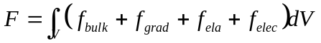 (S2)
where V is the system volume, f_{bulk} represents the Landau bulk free-energy density, f_{grad} is the gradient energy density, f_{ela} is the elastic energy density, and f_{elec} is the electrostatic energy density. The bulk free-energy density for a stress-free ferroelectric can be expressed as:
$f_{bulk}$ =${ a}_{1}P_{i}^{2}$+$a_{11}P_{i}^{4}$+$a_{12}P_{i}^{2}P_{j}^{2}$+${ a}_{111}P_{i}^{6}$+ $a_{112}P_{i}^{4}P_{j}^{2}$ +$a_{123}P_{i}^{2}P_{j}^{2}P_{k}^{2}$ (S3)
where a₁, a₁₁, a₁₂, a₁₁₁, a₁₁₂, a₁₁₃ are Landau energy coefficients, whose values depend on concentration c and temperature T and determine the thermodynamic behaviors of bulk phases. The gradient energy density is related to the contribution of the domain wall to the total free energy,
$f_{grad}$ $=$ $\frac{1}{2}G_{ijkl}P_{i,j}P_{k,l}$ (S4)
where $P_{i,j}=∂P_{i}/∂x_{j}$, G_{ijkl} is the gradient energy coefficient. The homologous elastic
energy density can be obtained as:
$f_{elas}=\frac{1}{2}C_{ijkl}\left(ε_{ij}-ε_{ij}^{0}\right)\left(ε_{kl}-ε_{kl}^{0}\right)$ (S5)
where C_{ijkl} is the elastic stiffness tensor, $ε_{ij}$is the total strain, $ε_{ij}^{0}$ is the electrostrictive stress-free strain, For a given domain structure, the electrostatic energy density is calculated by
$f_{elec}=f_{dep}+f_{appel}$ (S6)
$f_{dep}=-\frac{1}{2}ε_{0}ε_{r}E_{i}E_{j}$ (S7)
$f_{appl}=-E_{i}P_{i}$ (S8)
where $ε_{0}$ is the vacuum conductivity, _{r} is the dielectric constant, and E_{i} is the local electric field.
References
[1] L. Chen, J. Shen, J. Appl. Phys. 1998, 83, 5125-5136.
[2] M. Zhou, J. Wang, L. Chen, C. Nan, J. Appl. Phys. 2018, 123, 154106.
[3] H. Pohlmann, J. Wang, B. Wang, L. Chen, Appl. Phys. Lett. 2017, 110, 019901.
[4] J. J. Wang, P. P. Wu, X. Q. Ma, L. Q. Chen, J. Appl. Phys. 2010, 108, 114105.

