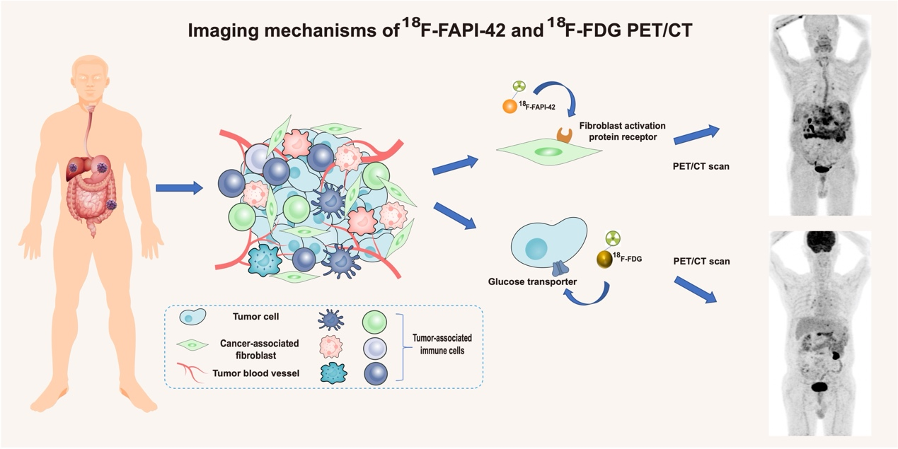
Supplement Fig.1 Demonstration of FDG PET and FAPI PET imaging mechanisms in digestive system neoplasms.
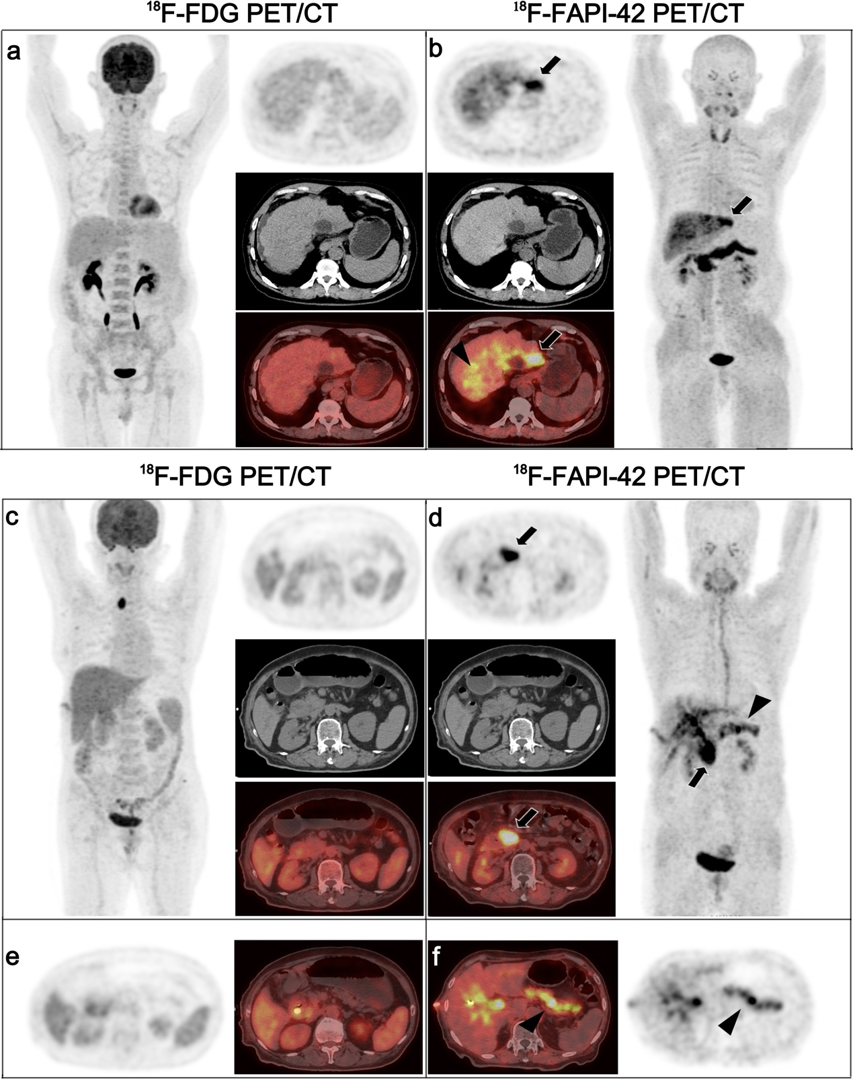
Supplement Fig.2 Images showing diffuse uptake of ¹⁸F-FAPI-42 in nontumor parenchyma duo to fibrosis (b, black triangle) or inflammation (f, black triangle). A 59-year-old man (a and b) with a history of postoperative hepatocellular carcinoma (HCC) presented with persistently elevated AFP level (1053.88 ug/L). ¹⁸F-FAPI-42 showed significantly increased uptake in the residual cavity margin (b, thick black arrow), while no uptake was observed in 18F-FDG (b). Follow-up imaging (one month later) confirmed recurrence with an enlarged volume. A 74-year-old woman (c and d) was diagnosed with carcinoma of the head of the pancreas by postoperative pathology. 18F-FAPI-42 PET/CT demonstrated a soft tissue mass in the pancreatic head with obviously high activity (d, thick black arrow). However, 18F-FDG PET/CT showed no activity in the same part (c). Increased uptake in the right lobe of the thyroid gland in (c) was considered a benign thyroid nodule.

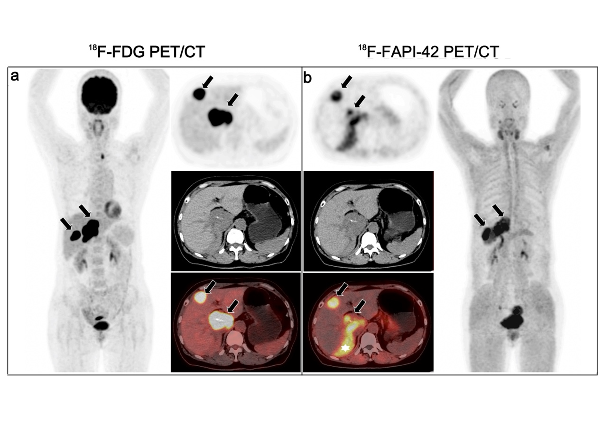Supplement Fig.3 Comparative images of ¹⁸F-FDG PET/CT (a) and ¹⁸F-FAPI-42 PET/CT (b) in a patient with a primary liver tumor. A 60-year-old man had liver spindle cell tumors confirmed by postoperative pathology. Both imaging modalities showed intrahepatic lesions with high uptake (a and b, thick black arrow).¹⁸F-FAPI-42 PET/CT displayed a banded high uptake (b, white asterisk) behind the mass, which was considered focal fibrosis.

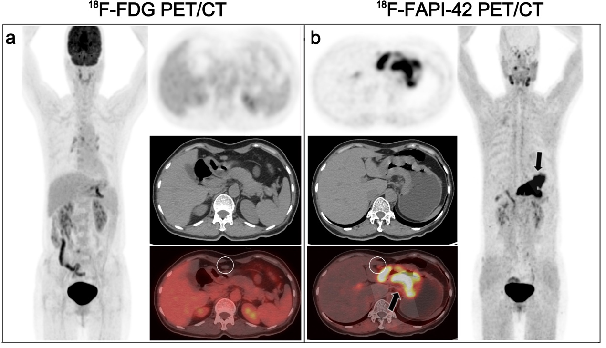
Supplement Fig.4 Representative images of ¹⁸F-FDG PET/CT and ¹⁸F-FAPI-42 PET/CT for patient treatment management. A 58-year-old woman presented with fullness and discomfort in the epigastric region and was recommended for an ¹⁸F-FDG PET/CT examination to determine the cause. The thickened stomach wall without ¹⁸F-FDG uptake (a) was observed. Therefore, ¹⁸F-FAPI-42 PET/CT was performed for a differential diagnosis, revealing diffuse uptake of ¹⁸F-FAPI-42 at the thickened stomach wall (b, thick black arrow). Additionally, a perigastric lymph node (short diameter= 0.9 cm) showed mild- to-moderate uptake in ¹⁸F-FAPI-42. Finally, a diagnosis of hypo-differentiated adenocarcinoma of the stomach with perigastric lymph node metastasis was established after surgical excision.

