Supplementary information

Reference dataset dictionaries
Variable | Default encoding | Definition
index_itt_treatment | factor | Intention-to-treat treatment
horizon_mainStudyDisposition_2y | factor | Main study disposition
index_age | num | Age at baseline
index_sex | factor | Sex
index_weight | num | Weight at baseline
index_diseaseDuration | num | Years since the disease onset
index_edss | num | Baseline EDSS
index_nbT1GdBrain | num | Number of GdE lesions at baseline
index_volT2HyperBrain | num
horizon_nbRelapses_toMainEnd | num | Number of relapses during the main study
horizon_exposure_0_2y | num | Follow-up duration
index_geographicRegion | factor | Geographic region
past_diff_nbRelapses_1y | num | Number of relapses the previous years
horizon_rescueTherapy_0_2y | factor | Rescue therapy received
horizon_delay_relapse | num | Survival delay to the first relapse
horizon_status_CDW3m | factor | Survival status for 12-week-CDW
horizon_delay_CDW3m | num | Survival delay for 12-week-CDW
horizon_status_CDW6m | factor | Survival status for 24-week-CDW
horizon_delay_CDW6m | num | Survival delay for 24-week-CDW
horizon_nbT1GdBrain_mean_0_2y | num | Mean number of GdE lesions per MRI scan
horizon_nbActiveT2HyperBrain_mean_0_2y | num | Mean number of T2 active lesions per MRI scan
horizon_nbCUABrain_mean_0_2y | num | Mean number of CUA lesions per MRI scan
horizon_nbAe_toMainEnd | num | Number of adverse events during the main study
horizon_nbMildHeadache_toMainEnd | num | Number of mild headache during the main study
horizon_nbSevereHeadache_toMainEnd | num | Number of severe headache during the main study
horizon_nbMildLymphocytopenia_toMainEnd | num | Number of mild lymphopenia during the main study
horizon_nbSevereLymphocytopenia_toMainEnd | num | Number of severe lymphopenia during the main study
horizon_nbMildNasopharyngitis_toMainEnd | num | Number of mild nasopharyngitis during the main study
horizon_nbMildUrti_toMainEnd | num | Number of mild upper respiratory tract infections during the main study
horizon_nbMildNausea_toMainEnd | num | Number of mild nausea during the main study
horizon_nbSevereNausea_toMainEnd | num | Number of severe nausea during the main study
horizon_nbSae_toMainEnd | num | Number of serious adverse events during the main study
horizon_nbInfection_toMainEnd | num | Number of infections during the main study
horizon_nbNeoplasm_toMainEnd | num | Number of neoplasms during the main study
horizon_nbFatalAe_toMainEnd | num | Number of fatal adverse events during the main study

Supplementary Table 1. Dictionary of the minimal dataset of CLARITY. The main study lasted 2-years and was followed by an extension study. CDW: confirmed disability worsening; CUA: Combined Unique Active; EDSS; Expanded disability status scale; GdE: Gadolinium-enhancing.

Variable | Default encoding | Definition
TRTREA1 | factor | Treatment disposition (first year)
TRTREA2 | factor | Treatment disposition (second year)
ARM | factor | Study arm
EDSSBL | num | Baseline EDSS
RLPS3YR | num | Number of relapses the 3 previous years
AGE | num | Age at baseline
YRSON_0_1y | num | Follow-up duration during the first study year
YRSON_1_2y | num | Follow-up duration during the second study year
nbRelapses_0_1y | num | Number of relapses during the first study year
nbRelapses_1_2y | num | Number of relapses during the second study year
nbNewOrGrowingT2Lesions_0_1y | num | Number of new or enlarging T2 lesions during the first study year
nbNewOrGrowingT2Lesions_1_2y | num | Number of new or enlarging T2 lesions during the second study year
cdw12w_status | factor | Survival status for 12-week-CDW
cdw12w_delay | num | Survival delay for 12-week-CDW
cdw24w_status | factor | Survival status for 24-week-CDW
cdw24w_delay | num | Survival delay for 24-week-CDW
T2LESBL | num | Number of T2 lesions at baseline
nbGadoLesions_2y | num | Number of GdE lesions at 2 years
GDLESBL | num | Number of GdE lesions at baseline
GDLESGR | factor | Presence of GdE lesions
SEX | factor | Sex
RLPS1YR | num | Number of relapses the previous years
ONSYRS | num | Years since the disease onset
DIAGYRS | num | Years since the diagnosis of the disease
MCDBL | factor | McDonald diagnostic criteria status at baseline

Supplementary Table 2. Dictionary of the minimal dataset of ADVANCE. CDW: confirmed disability worsening; EDSS; Expanded disability status scale; GdE: Gadolinium-enhancing.

Robustness of the method
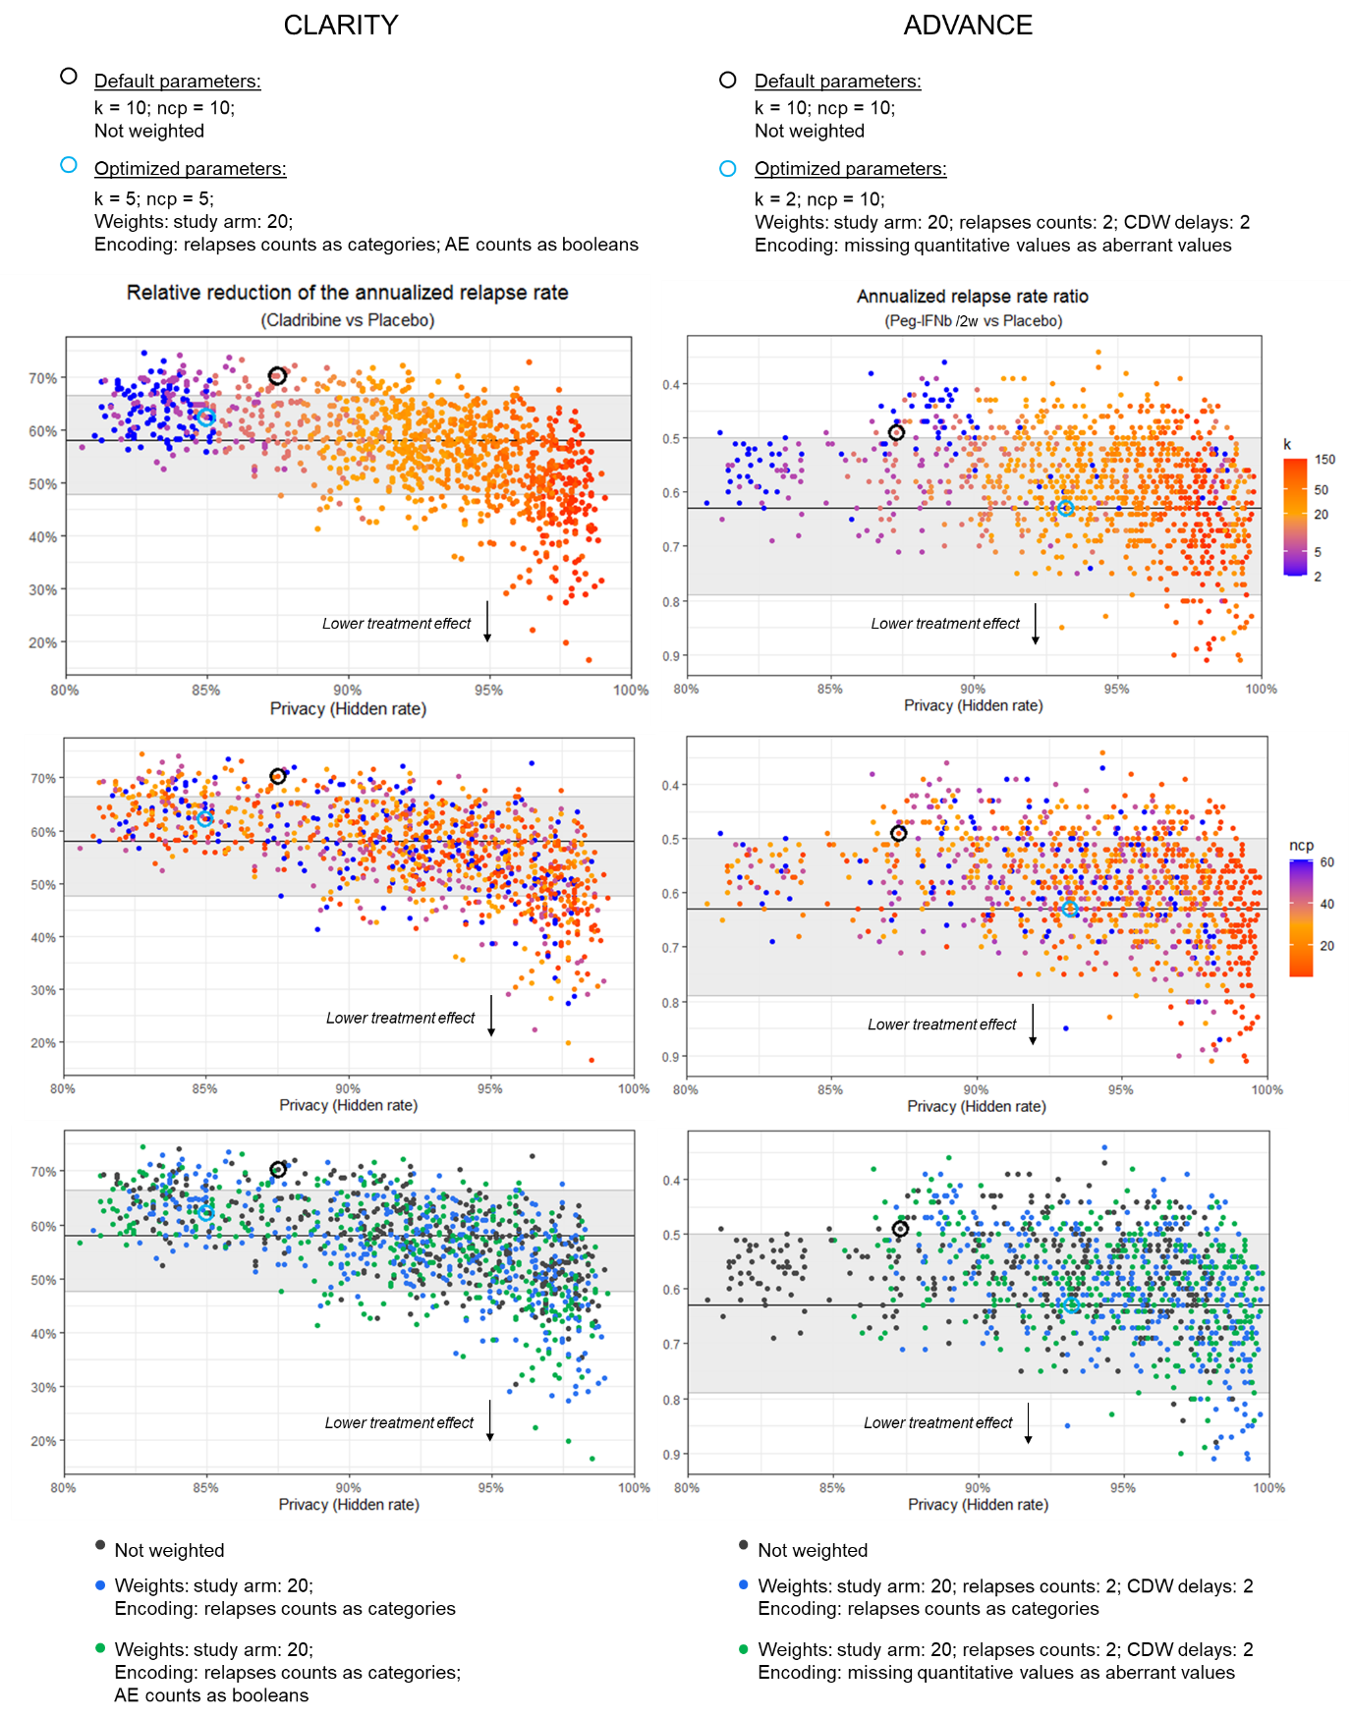
Supplementary Figure 1. Robustness for the primary endpoint replications and privacy (Full version). Each point represents a generated synthetic dataset (n = 1080 datasets for each RCT). Privacy is expressed by the hidden rate, assessing the probability of failure of a distance-based membership inference attack. The reported estimations of the primary endpoints are plotted with their 95% CI (horizontal lines and grey areas). Over the 1080 generated datasets, 813 (75.3%) were within the reported 95% CI for CLARITY and 871 (80.6%) for ADVANCE. Higher privacy tended to lower the inferred treatment effect, which likely reflected the pooling of statistical signals between both arms. The 2 selected datasets with optimized parameters are highlighted as well as the 2 generated with default configurations. AE: adverse events; CDW: confirmed disability worsening; CI: confidence interval; ncp: number of principal components; Peg-IFNb /2w: Peginterferon beta 1 dose every 2 weeks; RCT: randomized clinical trial.

General Utility
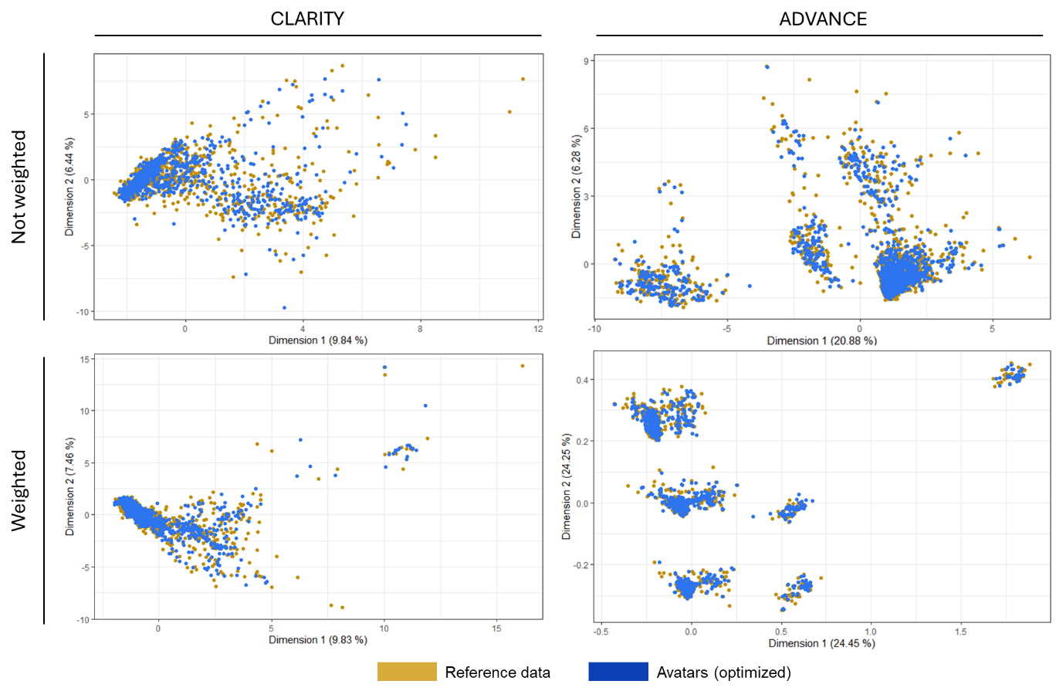
Supplementary Figure 2. Comparison of the FAMD projections obtained with or without applying the weights of the selected parameter configuration. As a result of the primary design of the avatars as an anonymization technique, the avatar data points tend to localize in clusters, which is less reidentifying.

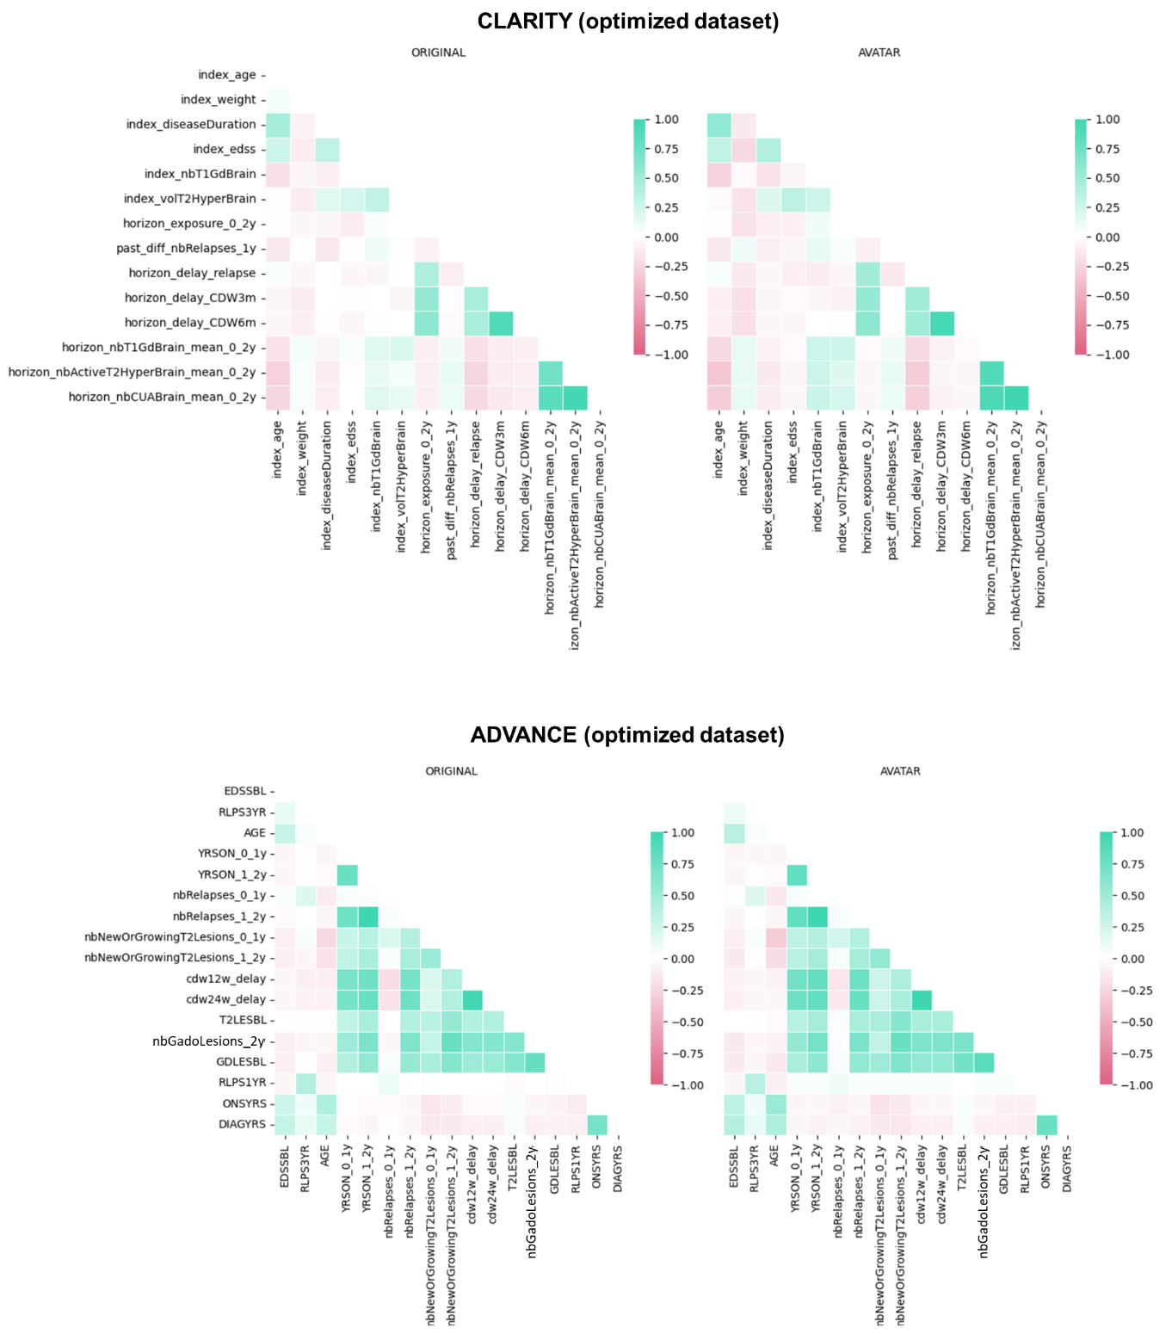
Supplementary Figure 3. Comparison of the bivariate correlations of the quantitative variables assessed by the Pearson’s coefficient. The figures are extracted from the avatarization report generated by the avatars client.

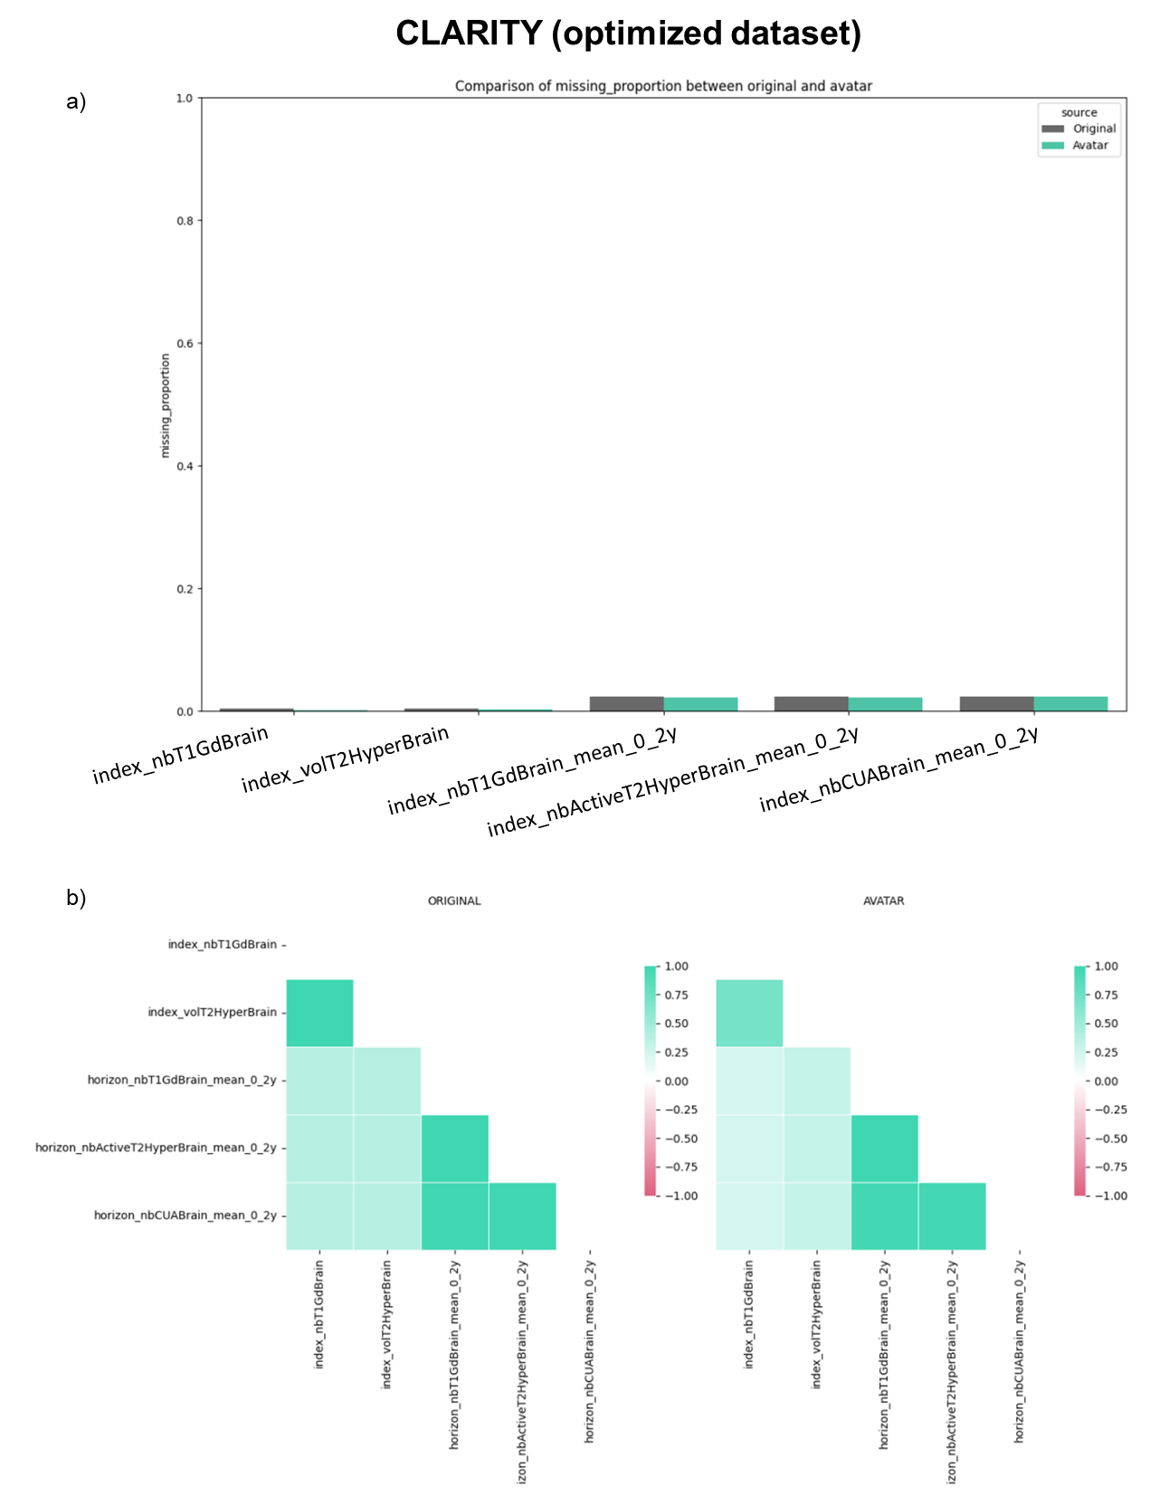
Supplementary Figure 4. Comparison of the missing rates (a) and the bivariate patterns of missingness (b). The figures are extracted from the avatarization report generated by the avatars client. The encoding of the optimized ADAVCE dataset left no missing data, as missing categorical variables were encoded as “missing” and missing quantitative data were encoded as aberrant negative values.

Replication of the flowchart and tables of CLARITY
According to the RCT publication (https://doi.org/10.1056/nejmoa0902533).
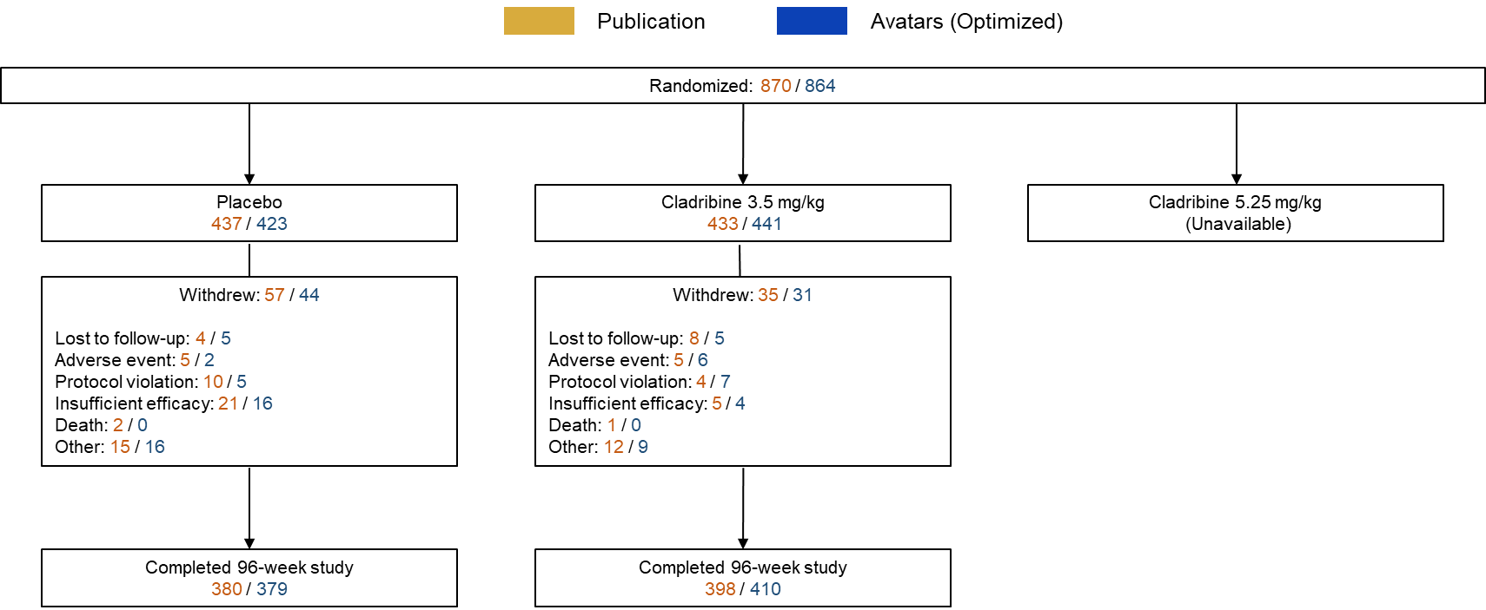
Supplementary Figure 5. Replication of the CLARITY flow chart. It is supplemental Figure 2 in the RCT report: “Patient Enrollment and Disposition”. Data of the Cladribine 5.25 mg/kg arm were not available.

Variable | Placebo  (N = 437 / 423) | Cladribine 3.5 mg/kg  (N = 433 / 441)
Age — yr
Mean | 38.7±9.9  38.1±7.0 | 37.9±10.3  39.8±7.9
Range | 18–64  20-58 | 18–65  21-59
Female sex — no. (%) | 288 (65.9)  278 (65.7) | 298 (68.8)  317 (71.9)
Mean weight — kg | 70.3±15.4  69.5±10.7 | 68.1±14.6  69.5±10.4
Disease duration from first onset — yr
Mean | 8.9±7.4  8.1±4.6 | 7.9±7.2  8.2±5.6
Range | 0.4–39.5  0.6-30.4 | 0.3–42.3  1.0-34.6
EDSS score
0 — no. (%) | 13 (3.0)  5 (1.2) | 12 (2.8)  2 (0.5)
1 — no. (%) | 70 (16.0)  22 (5.2) | 75 (17.3)  40 (9.1)
2 — no. (%) | 127 (29.1)  150 (35.5) | 133 (30.7)  142 (32.2)
3 — no. (%) | 96 (22.0)  152 (35.9) | 108 (24.9)  157 (35.6)
4 — no. (%) | 83 (19.0)  67 (15.8) | 71 (16.4)  74 (16.8)
≥5 — no. (%) | 48 (11.0)  27 (6.4) | 34 (7.9)  26 (5.9)
Mean score | 2.9±1.3  2.8±1.0 | 2.8±1.2  2.8±1.0
Gadolinium-enhancing T1-weighted lesions
Patients with lesions — no. (%) | 128 (29.3)  190 (44.9) | 138 (31.9)  171 (38.9)
Mean no. of lesions | 0.8±2.1  1.0±1.9 | 1.0±2.7  0.6±1.3
Mean volume of T2-weighted lesions — mm3 | 14,287.6±13,104.8  14,458±9,899 | 14,828.0±16,266.8  12,078±8,785

Supplementary Table 3. Replication of the CLARITY baseline characteristics table. It is Table 1 in the RCT report: “Demographic and Clinical Characteristics of the Patients at Baseline (Intention-to-Treat Population)”. The publication and avatar results are respectively in brown and blue. Plus–minus values are means ±SD. Percentages may not total 100 because of rounding.

End point | Placebo  (N = 437 / 423) | Cladribine 3.5 mg/kg  (N = 433 / 441)
Relapse rate (primary end point)
Annualized relapse rate (95% CI) | 0.33 (0.29–0.38)  0.33 (0.29–0.38) | 0.14 (0.12–0.17)  0.12 (0.10-0.15)
Relative reduction in annualized relapse rate for cladribine vs. placebo — % |  | 57.6  62.3
P value |  | <0.001  <0.001
Relapse-free rate
Patients without relapse — no. (%) | 266 (60.9)  250 (59.1) | 345 (79.7)  367 (83.2)
Odds ratio for cladribine vs. placebo (95% CI) |  | 2.53 (1.87–3.43)  3.43 (2.50-4.73)
P value |  | <0.001  <0.001
Relapse at 96 weeks
No. of relapses — no. of patients (%)
0 | 266 (60.9)  250 (59.1) | 345 (79.7)  367 (83.2)
1 | 109 (24.9)  115 (27.2) | 69 (15.9)  56 (12.7)
2 | 44 (10.1)  41 (9.7) | 13 (3.0)  13 (2.9)
3 | 15 (3.4)  17 (4.0) | 5 (1.2)  5 (1.1)
≥4 | 3 (0.7)  0 (0.0) | 1 (0.2)  0 (0.0)
Need for rescue therapy
Patients receiving rescue therapy — no. (%) | 27 (6.2)  28 (6.6) | 11 (2.5)  10 (2.3)
Odds ratio for cladribine vs. placebo (95% CI) |  | 0.40 (0.19–0.81)  0.34 (0.16-0.70)
P value |  | 0.01  0.0047
Time to first relapse
Hazard ratio for cladribine vs. placebo (95% CI) |  | 0.44 (0.34–0.58)  0.50 (0.32-0.77)
P value |  | <0.001  0.002
Time to 3-mo sustained change in EDSS score
Hazard ratio for cladribine vs. placebo (95% CI) |  | 0.67 (0.48–0.93)  0.54 (0.39-0.75)
P value |  | 0.02  <0.001
Patients without a 3-mo sustained change in EDSS score
Patients with no change — no. (%) | 347 (79.4)  325 (76.8) | 371 (85.7)  384 (87.0)
Odds ratio for cladribine vs. placebo (95% CI) |  | 1.55 (1.09–2.22)  1.95 (1.35-2.81)
P value |  | 0.02  0.01
Lesion activity on brain MRI
Gadolinium-enhancing T1-weighted lesions
Mean no. | 0.91  0.77 | 0.12  0.13
Relative reduction — % |  | 85.7  83.0
Active T2-weighted lesions
Mean no. | 1.43  1.28 | 0.38  0.39
Relative reduction — % |  | 73.4  70.0
Combined unique lesions
Mean no. | 1.72  1.50 | 0.43  0.43
Relative reduction — % |  | 74.4  71.0

Supplementary Table 4. Replication of the endpoints table of CLARITY. It is Table 2 in the RCT report: “Clinical and Imaging End Points and Relapses during the 96-week Study (Intention-to-Treat Population)”. The publication and avatar results are respectively in brown and blue.

Adverse Event | Placebo  (N = 435 / 423) | Cladribine 3.5 mg/kg  (N = 430 / 441)
Any adverse event — no. of patients (%) | 319 (73.3)  312 (73.8) | 347 (80.7)  353 (80.1)
Most common adverse events — no. of patients (%)
Headache | 75 (17.2)  72 (17.0) | 104 (24.2)  106 (24.0)
Lymphocytopenia | 8 (1.8)  20 (4.7) | 93 (21.6)  86 (19.5)
Nasopharyngitis | 56 (12.9)  50 (11.8) | 62 (14.4)  65 (14.7)
Upper respiratory tract infection | 42 (9.7)  48 (11.3) | 54 (12.6)  48 (10.9)
Nausea | 39 (9.0)  32 (7.6) | 43 (10.0)  45 (10.2)
Any serious adverse event — no. of patients (%) | 28 (6.4)  17 (4.0) | 36 (8.4)  29 (6.6)
Infections and infestations | 7 (1.6)  3 (0.7) | 10 (2.3)  5 (1.1)
Neoplasms (benign, malignant, and unspecified) | 0  0 | 6 (1.4)  5 (1.1)
Death | 2 (0.5)  2 (0.5) | 2 (0.5)  3 (0.7)

Supplementary Table 5. Replication of the endpoints table of CLARITY. It is Table 3 in the RCT report: “Adverse Events and Investigator-Assessed Severity at 96 Weeks (Safety Population)”.
The publication and avatar results are respectively in brown and blue. The mild:severe event ratios could not be replicated due to the encoding of the adverse event variables as Booleans in the optimized dataset.

Replication of the flowchart and tables of ADVANCE
According to the 1-year and 2-year publications (https://doi.org/10.1016/S1474-4422(14)70068-7 and https://doi.org/10.1177/1352458514557986). Adverse events and individual relapses data were not available.
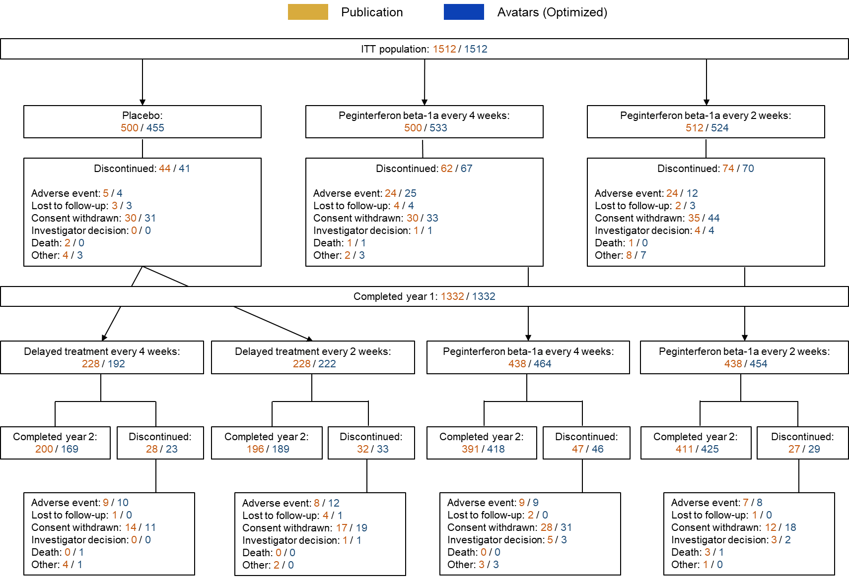
Supplementary Figure 6. Replication of the 2-year ADVANCE flow chart. It is Figure 1 in the 2-year RCT report: “Patient disposition – over 2 years”. N, n = number of subjects.

 | Placebo group (n=500 / 455) | Peginterferon beta-1a 125 μg every 2 weeks group  (n=512 / 524) | Peginterferon beta-1a 125 μg every 4 weeks group  (n=500 / 533)
Age (years) | 36·3 (9·7)  35.9 (8.6) | 36·9 (9·8)  37.1 (8.9) | 36·4 (9·9)  36.3 (8.8)
Women | 358 (72%)  335 (74%) | 361 (71%)  374 (71%) | 352 (70%)  367 (69%)
Time since first multiple sclerosis symptoms (years) | 6·3 (6·3)  6.1 (5.7) | 6·9 (6·6)  6.7 (6.0) | 6·5 (6·1)  6.6 (5.6)
Time since multiple sclerosis diagnosis (years) | 3·5 (4·6)  3.3 (3.9) | 4·0 (5·1)  3.9 (4.7) | 3·4 (4·4)  3.4 (4.1)
Relapses within the previous 3 years | 2·6 (1·00)  2.5 (0.88) | 2·6 (0·99)  2.5 (0.87) | 2·5 (0·77)  2.4 (0.71)
Relapses within the previous 12 months | 1·6 (0·67)  1.5 (0.62) | 1·6 (0·67)  1.6 (0.65) | 1·5 (0·62)  1.5 (0.59)
EDSS score | 2·44 (1·18)  2.43 (1.06) | 2·47 (1.26)  2.49 (1.20) | 2·48 (1·24)  2.47 (1.09)
<4 | 432 (86%)  400 (88%) | 423 (83%)  440 (84%) | 413 (83%)  469 (88%)
≥4 | 68 (14%)  55 (12%) | 89 (17%)  84 (16%) | 87 (17%)  64 (12%)
Patients without gadolinium-enhancing lesions | 59%  60% | 65%  64% | 59%  54%
Number of gadolinium-enhancing lesions | 1·6 (3·8)  1.4 (3.7) | 1·2 (3·4)  1.1 (2.7) | 1·8 (5·4)  2.0 (4.5)
Number of T2 lesions | 50·6 (35·7)  49.7 (33.5) | 48·7 (36·8)  46.0 (31.4) | 51·4 (36·0)  52.0 (31.8)

Supplementary Table 6. Replication of the baseline characteristics table of ADVANCE. It is Table 1 in the 1-year RCT report: “Baseline characteristics”. Data are mean (SD) or n (%).

Endpoint | Delayed treatment (n=500 / 455) | Peginterferon beta-1a every 2 weeks  (n=512 / 524) | Peginterferon beta 1a every 4 weeks  (n=500 / 533)
Annualized relapse rate at 2 years
Annualized relapse rate (95% CI) | 0.351 (0.295, 0.418)  0.32 (0.27, 0.36) | 0.221 (0.183, 0.267)  0.21 (0.17, 0.25) | 0.291 (0.244, 0.348)  0.25 (0.22, 0.29)
Rate ratio vs. delayed treatment (95% CI) |  | 0.629 (0.500, 0.790)  0.63 (0.50, 0.79) | 0.829 (0.666, 1.030)  0.82 (0.66, 1.02)
p-value vs. delayed treatment |  | <0.0001  <0.0001 | 0.0906  0.072
Rate ratio every 2 weeks vs. every 4 weeks (95% CI) |  | 0.759 (0.600, 0.959)  0.77 (0.61, 0.96)
p-value (every 2 weeks vs. every 4 weeks) |  | 0.0209  0.023
Estimated proportion of patients with a relapse at 2 year
Number of patients relapsed | 192  160 | 124  122 | 158  158
Proportion relapsed | 0.402  0.352 | 0.265  0.233 | 0.344  0.296
Disability progression at 2 years (12-week confirmed)
Number of patients with disability progression | 75  59 | 51  37 | 56  64
Estimated proportion with disability progression | 0.162  0.132 | 0.112  0.08 | 0.123  0.135
Hazard ratio vs. delayed treatment (95% CI) |  | 0.67 (0.47, 0.95)  0.54 (0.36, 0.82) | 0.75 (0.53, 1.05)  0.96 (0.68, 1.37)
p-value vs. delayed treatment |  | 0.0257  0.003 | 0.0960  0.83
Hazard ratio every 2 weeks vs. every 4 weeks (95% CI) |  | 0.89 (0.61, 1.31)  0.56 (0.37, 0, 84)
p-value (every 2 weeks vs. every 4 weeks) |  | 0.5665  0.005
Disability progression at 2 years (24-week confirmed)
Number of patients with disability progression | 57  54 | 34  28 | 52  57
Estimated proportion with disability progression | 0.119  0.102 | 0.077  0.06 | 0.113  0.121
Hazard ratio vs. delayed treatment (95% CI) |  | 0.59 (0.38, 0.90)  0.56 (0.35, 0.91) | 0.91 (0.63, 1.33)  1.16 (0.78, 1.73)
p-value vs. delayed treatment |  | 0.0137  0.019 | 0.6243  0.46
Hazard ratio every 2 weeks vs. every 4 weeks (95% CI) |  | 0.64 (0.42, 0.99)  0.49 (0.31, 0.76)
p-value (every 2 weeks vs. every 4 weeks) |  | 0.0459  0.002
New or newly enlarging T2-weighted hyperintense lesions at 2 years
Number of patients evaluated | 393  414 | 407  456 | 389  465
Adjusted mean number of lesions | 14.8  16.5 | 5.0  5.6 | 12.5  15.6
Lesion mean ratio (peginterferon beta-1a:delayed treatment) (95% CI) |  | 0.33 (0.27, 0.41)  0.38 (0.32, 0.46) | 0.84 (0.69. 1.03)  0.95 (0.79, 1.14)
p-value (peginterferon beta-1a:delayed treatment) |  | <0.0001  <0.0001 | 0.0973  0.59
Lesion mean ratio (every 2 weeks:every 4 weeks) (95% CI) |  | 0.40 (0.32, 0.49)  0.40 (0.34, 0.48)
p-value (every 2 weeks vs. every 4 weeks) |  | <0.0001  <0.0001
Gd+ lesions at 2 years
Number of patients evaluated | 393  414 | 407  456 | 389  465
Mean number of lesions (SE) | 0.5 (0.08)  0.2 | 0.2 (0.06)  0.4 | 0.7 (0.12)  0.7
p-value (peginterferon beta-1a vs. delayed treatment) |  | 0.0002  <0.0001 | 0.2169  0.16
Percent reduction (every 2 weeks vs. every 4 weeks) |  | 71  141 (increase)
p-value (every 2 weeks vs. every 4 weeks) |  | <0.0001  <0.0001

Supplementary Table 7. Replication of the endpoints table of ADVANCE. It is Table 1 in the 2-year RCT report: “Summary of clinical and MRI endpoints over 2 years by original randomization group”. The hazard ratio of relapses could not be replicated because individual relapse events data were not available.

