Table S1: Morphological characteristics of bacterial isolates 1 to 7 isolated from Leucopholis coneophora and 8 to 17 from Holotrichia serrata
S.No | Bacterial isolates | Margin | Shape | Elevation | Cell shape | Colour | Gram stain
1 | LC1B1 | Smooth | Round | Raised | Rod | White | -
2 | LC1B2 | Irregular | Irregular | Flat | Rod | Yellow | +
3 | LC2B1 | Smooth | Irregular | Raised | Rod | Yellow | +
4 | LC2B2 | Smooth | Round | Raised | Rod | Cream | +
5 | LC2B3 | Smooth | Round | Raised | Rod | Yellow | -
6 | LC3B1 | Smooth | Round | Raised | Rod | Cream | -
7 | LC6B1 | Smooth | Round | Raised | Rod | White | -
8 | H2B1 | Irregular | Round | Raised | Rod | White | -
9 | H3B1 | Irregular | Round | Raised | Rod | White | -
10 | H3B2 | Irregular | Round | Raised | Rod | Cream | -
11 | H3B3 | Smooth | Round | Raised | Rod | Yellow | -
12 | H3B4 | Smooth | Round | Flat | Rod | White | -
13 | H4B1 | Smooth | Irregular | Flat | Rod | White | -
14 | H4B2 | Smooth | Irregular | Raised | Rod | White | -
15 | H4B3 | Smooth | Irregular | Flat | Rod | White | -
16 | H5B1 | Smooth | Irregular | Flat | Rod | White | -
17 | H5B2 | Smooth | Round | Raised | cocci | Cream | -

Table S2: Profiling of various bacterial species colonizing the fermentation chamber of Leucopholis coneophora through 16SrRNA gene
Bacterial isolates | Bacteria identified from closest strain in gene bank | Similarity  percentage | Phylum
LC1B1 | Klebsiella sp. | 99.50 % | γ-proteobacteria
LC1B2 | Bacillus siralis | 99.12 % | Firmicutes
LC2B1 | Bacillus toyonensis | 90 % | Firmicutes
LC2B2 | Bacillus cereus | 95 % | Firmicutes
LC2B3 | Klebsiella oxytoca | 98.21 % | γ-proteobacteria
LC3B1 | Citrobacter farmeri | 97.7 % | γ-proteobacteria
LC6B1 | Klebsiella pasteurii | 98.28 % | γ-proteobacteria

Table S3: Profiling of various bacterial species colonizing the fermentation chamber of Holotrichia serrata through 16SrRNA gene
Bacterial isolates | Bacteria identified from closest strain in gene bank | Similarity  percentage | Phylum
H2B1 | Pseudomonas sp. strain H374 | 99.13 % | γ-proteobacteria
H3B1 | Pseudomonas monteilii | 99.14 % | γ-proteobacteria
H3B2 | Pseudomonas urethralis strain BML-PP042 | 99.07 % | γ-proteobacteria
H3B3 | Achromobacter piechaudii strain ERG1 | 93.38 % | ꞵ-proteobacteria
H3B4 | Citrobacter koseri strain IHB B 6842 | 98.49 % | γ-proteobacteria
H4B1 | Enterobacter tabaci strain TBMAX92 | 96.49 % | γ-proteobacteria
H4B2 | Enterobacter ludwigii strain AA1 | 96.56 % | γ-proteobacteria
H4B3 | Enterobacter sp. JBIWA003 | 97.68 % | γ-proteobacteria
H5B1 | Enterobacter sp. strain LFR1 | 99.1 % | γ-proteobacteria
H5B2 | Acinetobacter baumannii strain JC359 | 90 % | γ-proteobacteria

Table S4: Taxonomical classification of bacterial isolates in fermentation chamber of Leucopholis coneophora
Phylum | Class | Family | Genus | Species
Proteobacteria | γ-proteobacteria | Enterobacteriaceae | Klebsiella | Klebsiella sp.  K oxytoca  K pasteurii
Firmicutes | Bacilli | Bacillaceae | Bacillus | B siralis  B toyonensis  B cereus
Proteobacteria | γ-proteobacteria | Enterobacteriaceae | Citrobacter | C farmeri

Table S5: Taxonomical classification of in fermentation chamber of Holotrichia serrata
Phylum | Class | Family | Genus | Species
Proteobacteria | γ-proteobacteria | Pseudomonadaceae | Pseudomonas | Pseudomonas sp.  P monteilii  P urethralis
Proteobacteria | γ-proteobacteria | Enterobacteriaceae | Enterobacter | E tabaci  E ludwigii
Proteobacteria | γ-proteobacteria | Moraxellaceae | Acinetobacter | A baumannii
Proteobacteria | γ-proteobacteria | Enterobacteriaceae | Citrobacter | C koseri
Proteobacteria | ꞵ-proteobacteria | Alcaligenaceae | Achromobacter | A piechaudii

Table S6: Cellulolytic index of bacteria isolated from fermentation chamber of two white grub species
S.no | Bacterial isolates | Cellulolytic index
1 | LC1B1 | 1.66 ± 0.042^{b}
2 | LC1B2 | 0.77 ± 0.015^{d}
3 | LC2B1 | 0.44 ± 0.019e
4 | LC2B3 | 0.24 ± 0.015e
5 | LC3B1 | 1.93 ± 0.037ª
6 | H3B1 | 0.78 ± 0.012^{d}
7 | H3B3 | 0.36 ± 0.012e
8 | H3B4 | 0.77 ± 0.015^{d}
9 | H4B1 | 0.32 ± 0.012e
10 | H4B2 | 0.26 ± 0.012e
11 | H4B3 | 1.49 ± 0.04^{b}
12 | H5B1 | 0.28 ± 0.009e
13 | H5B2 | 1.18 ± 0.015^{c}
 | C.D. | 0.066
 | SE(m) | 0.023
 | C.V. | 4.838
The cellulolytic index ± S.E. of bacterial isolates with DMRT differences between each factor at P=0.05 with triplicates

Table S7: Substrate degradation ratio (%) of cellulolytic isolates with different agricultural residues
Bacterial isolates | Paddy degradation (%) | Corn cob degradation (%) | Groundnut husk degradation (%)
LC1B1 | 22.75 ± 0.89 | 26 ± 0.736 | 22.37 ± 1.109
LC3B1 | 28.15 ± 1.56 | 31.45 ± 0.608 | 33.25 ± 0.823
H4B3 | 25.625 ± 1.93 | 28.35 ± 0.888 | 31.75 ± 0.722
H5B2 | 20.625 ± 1.12 | 23.375 ± 0.669 | 27.72 ± 0.732
C.D. | 2.49 | 2.283 | 2.561
SE(m) | 0.799 | 0.733 | 0.822
C.V. | 6.581 | 5.369 | 5.714
Substrate degradation ratio ± S.E. with 4 replicates
Table S8: Endoglucanase activity (U/mL) of cellulolytic isolates with different agricultural substrates
 | Endoglucanase activity (U/mL)
Substrates | LC1B1 | LC3B1 | H4B3 | H5B2
GN | 2.168 ± 0.07 | 3.614 ± 0.02 | 2.4 ± 0.03 | 1.626 ± 0.01
PS | 1.628 ± 0.01 | 0.69 ± 0.01 | 0.522 ± 0.04 | 0.444 ± 0.01
CC | 1.162 ± 0.06 | 2.082 ± 0.02 | 1.74 ± 0.02 | 1.588 ± 0.02
C.D. | 0.03 | 0.072 | 0.234 | 0.062
SE(m) | 0.01 | 0.023 | 0.032 | 0.02
C.V. | 1.312 | 2.434 | 4.636 | 3.662
GN: Groundnut husk, PS: Paddy straw, CC: Corn cob; Endoglucanase activity (U/mL) ± S.E. with 4 replicates

C
M
1
2
3
4
7
6
5
2000bp
1500bp
1000bp
Fig. S1: Amplification of the 16S rRNA gene from bacterial isolates of Leucopholis coneophora; M: 1kb ladder, Lanes 1-7: LC1B1, LC1B2, LC2B1, LCB2, LC2B3, LC3B1, LC6B1 and C- Control

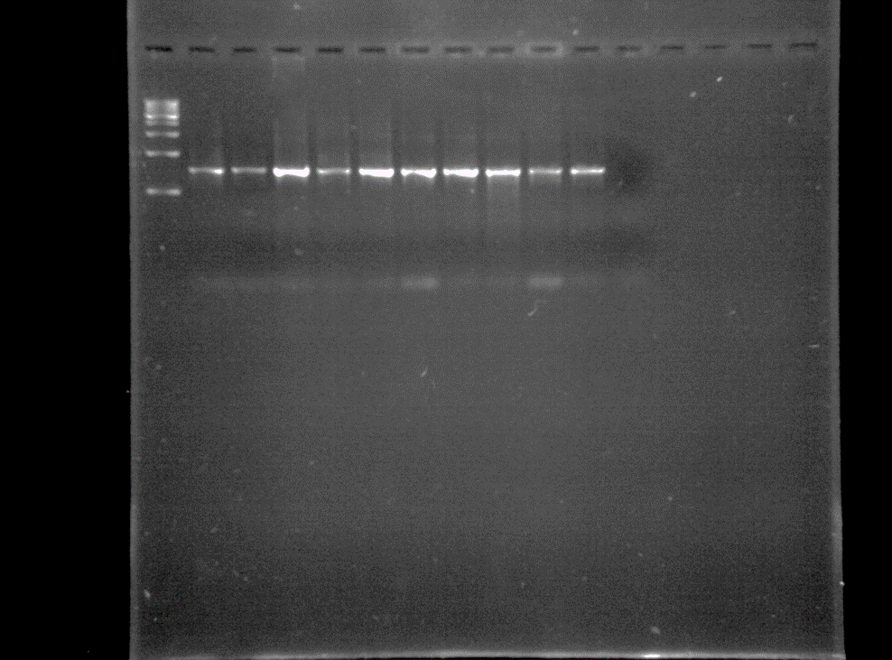
2000bp
1500bp
1000bp
2
1
M
C
10
9
8
7
6
5
4
3

Fig. S2: Amplification of the 16s rRNA gene from bacterial isolates of Holotrichia serrata (F) M: 1kb ladder, Lanes 1-10: H2B1, H3B1, H3B2, H3B3, H4B1, H4B2, H4B3, H5B1, H5B2 and C- Control

