Supplementary files
Figure S1 Normalization by GDC histograms (normal samples are coloured blue and cancer red). 4 moments are indicated

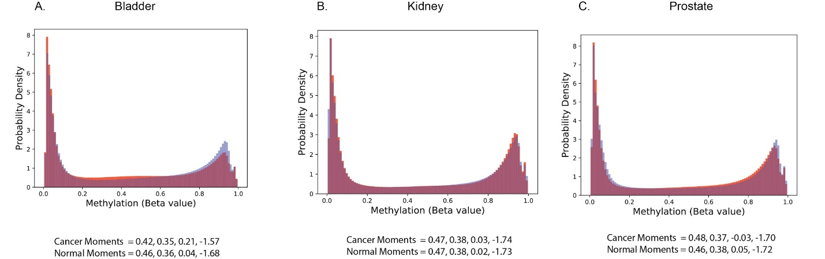

Following manifest files uploaded to GitHub:
- Bladder cancer manifest file: gdc_manifest.2019-11-09_bladder.txt
- Kidney cancer manifest file: gdc_manifest.2019-11-09_kidney.txt
- Prostate cancer manifest file: gdc_manifest.2019-10-19_prostate.txt

