Prof. Petr Pyšek,
Editor, Alien Floras Section, Biological Invasions,
Head of the Department of Invasion Ecology
the Institute of Botany, Academy of Sciences of the Czech Republic
Průhonice, Czech Republic
20th August 2024
Re: Alien floras paper- The introduced and invasive flora of Bermuda
Dear Prof. Pyšek,

Prof. Wayne Dawson and I would like to submit this paper, entitled ‘The introduced and invasive flora of Bermuda’ for publication in the Alien Floras section of the Biological Invasions journal. Our paper details research carried out from 2020 to 2024 describing the complete flora of the country of Bermuda. We have both reviewed and approved the submitted manuscript.
From 2008 until 2022 I was the Biodiversity Officer for the Bermuda Government. This experience showed me that i) Bermuda’s habitats are dominated by invasive plants, ii) these invasives are threatening the survival of rare native plants and animals, iii) the Bermudian public and those responsible for habitat management, have little knowledge of plant species. Also, in 2021 following passage of the Invasive Alien Species Act, risk assessments for imported plants became required which further motivated us to undertake this work.
Completing risk assessments and educating Bermudians about plants is difficult because Bermuda lacks an up-to-date and publicly available checklist of plant species growing in the country. The most complete flora including naturalized ‘weedy’ species, along with native plants and cultivated introductions was written over 100 years ago. Therefore, we compiled an inventory of 1587 plant names from literature, herbaria, and field visits. We assigned each plant to an introduction pathway and invasion stage class, and noted introduction date, life form and continent of native origin. We found that only 9.5% of the plants in the inventory are native, while 89.7% were introduced. Of the 43 species we classified as invasive, 93% were intentionally introduced and 77% escaped from ornamental horticulture. These figures should convince the ornamental horticulture sector and import regulators that preventing high risk ornamental imports is the best way to prevent future invasions.
This work aligns very well with the other studies previously published in the Alien Floras section of Biological Invasions. The criteria we used to define casual, naturalized and invasive species are similar to previous studies in this series. We endeavoured to explain our criteria in detail, including a supplement with detailed methods, to make our results comparable with other studies and more useful to others.
The results generated during this research are housed in Bermuda (the host country). The inventory will be shared with the Bermuda Government once accepted for publication. I would like to share this work in a public lecture in Bermuda in January, 2025. Once published, the complete database and resulting paper will be deposited at the library of the Bermuda Natural History Museum, where they can be accessed by the public.
This research has not been previously published or submitted for publication elsewhere. This work was undertaken by me as part of a Doctor of Philosophy (Biosciences) degree from Durham University, with Dr Dawson as my supervisor and collaborator. The field and herbarium visits were undertaken after approval of a Durham University fieldwork risk assessment and emergency plan, and following receipt of a research permit from the Bermuda Department of Environment and Natural Resources.
Thank you for your time and efforts in considering our submission.
Sincerely,
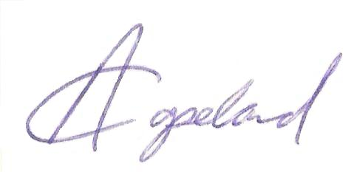
Alison Copeland,
PhD Student
Durham University
alison.i.copeland@durham.ac.uk

