Supplementary material

Table S1. Treatment-emergent AEs (related TEAEs) related to treatment reported during the 6-year treatment with ADV7103.
Body system  Preferred term | N related TEAEs | Patients with at least one related-TEAE, all patients (N=30)
Body system  Preferred term | N related TEAEs | n | %
All | 13 | 6 | 20.0
Gastrointestinal disorders | 11 | 5 | 16.7
Abdominal pain | 2 | 2 | 6.7
Abdominal pain upper | 2 | 2 | 6.7
Diarrhea | 3 | 1 | 3.3
Dyspepsia | 2 | 2 | 6.7
Gastrointestinal disorder | 1 | 1 | 3.3
Gastrointestinal pain | 1 | 1 | 3.3
Metabolism and nutrition disorders | 1 | 1 | 3.3
Hypokalemia | 1 | 1 | 3.3
Kidney and urinary disorders | 1 | 1 | 3.3
Nephrolithiasis | 1 | 1 | 3.3
N, number of evaluated patients; n, number of patients; TEAE, treatment-emergent adverse event.

Supplementary Figure S1. Evolution of mean height Z-score by age group and in all patients (descriptive analysis).

Supplementary Figure S2. Evolution of mean plasma phosphate Z-score by age group and in all patients (descriptive analysis).

Supplementary Figure S3. Mean prescribed ADV7103 dose over time (mEq/kg/d) by age group and in all patients (descriptive analysis). Only the dose administered at the beginning of the interval was used for the analysis.
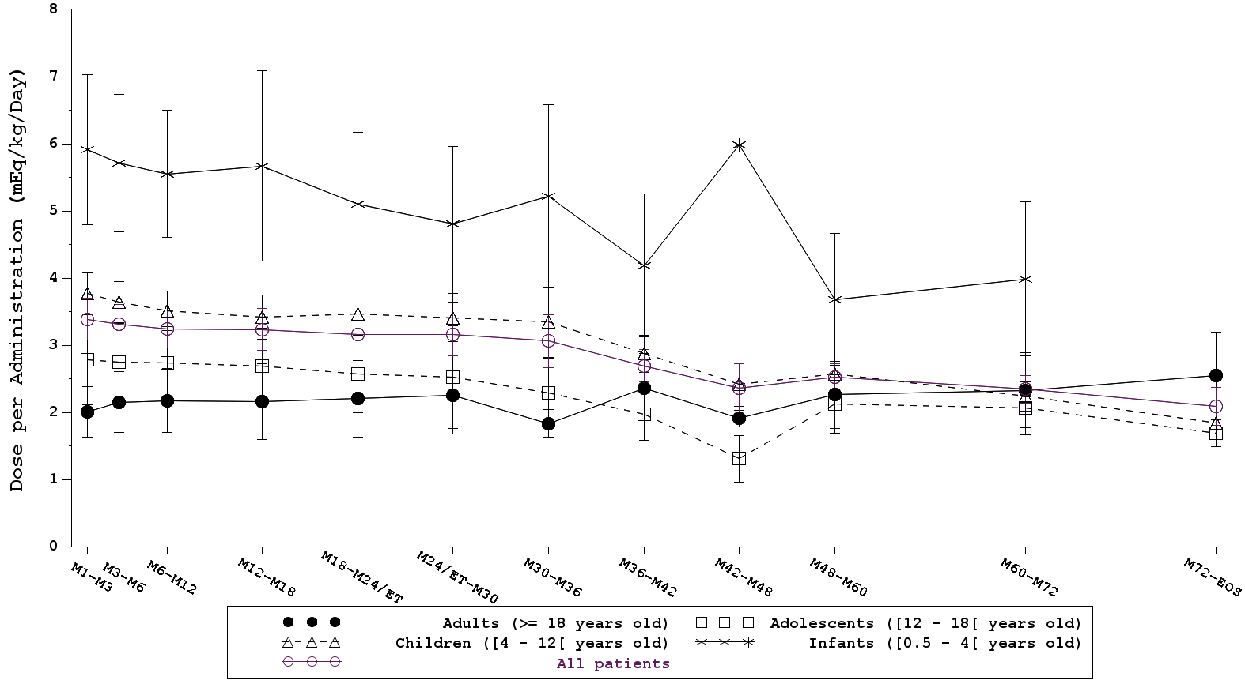

Supplementary Figure S4. Long-term compliance in all patients (descriptive analysis).

