Supplementary Figures

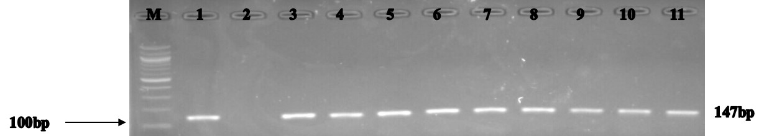
Figure S1. PCR products of the amplification of uidA gene (E. coli). Lane M: 100 bp molecular weight marker; Lane 1: positive control (ATCC 25922); Lane 2: negative control; Lanes 3-11: positively confirmed isolates

Figure S2. PCR products of the amplification of ibeA gene (NMEC). Lane M: 100 bp molecular weight marker; Lane 1: negative control; Lanes 2-7: positive isolates.

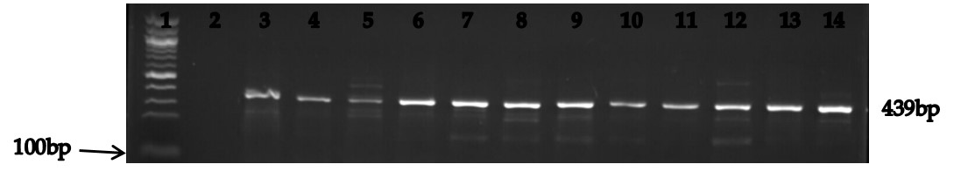
Figure S3. PCR products of the amplification of bla_{NDM-1} gene. Lane1: 100bp molecular weight marker; Lane 2: negative control; Lanes 3-14: positive isolates.

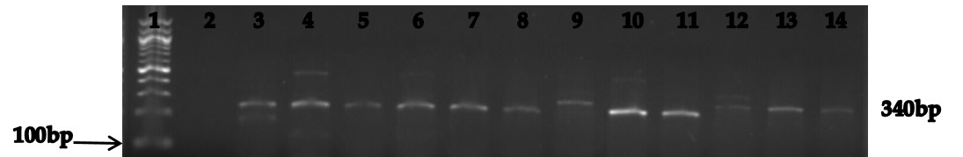
Figure S4. PCR products of the amplification of bla_{KPC} gene. Lane1: 100bp molecular weight marker; Lane 2: negative control; Lanes 3-14: positive isolates.

Table S1: List of primers for the confirmation of E. coli, selected virulence genes (VG), ERIC-PCR, carbapenem resistance genes and their corresponding amplicon sizes and PCR conditions.

Target strain/ gene | Primer Sequence (5’→3’) | Amplicon size (bp) | PCR Cycling Conditions | References
E. coli/ uidA | F: CGC GTA CTA TAC GCC ATG AAC GTA  R: ACC GTT GAT CAC TTC GGT CAGG | 147 | Initial denaturation of 2 min at 94 °C followed by 25 cycles, denaturation at 94 °C for 1 min, annealing at 58 °C for 1 min, extension at 72 °C for 1 min and final extension at 72 °C for 2 min. | Ahmed et al., [34]
NMEC/ IbeA | F: ATT TGA AGA GGT TGC AAA CGAT  R: TTC ACT CTG AAG TTT TCT TGT GTTC | 342 | Initial denaturation of 2 min at 94 °C followed by 30 cycles, denaturation at 94 °C for 1 min, annealing at 55.6 °C for 30 s, extension at 72 °C for 1 min and final extension at 72 °C for 5 min. | Ebomah et al., [6]
EAEC/ eagg | F: GAT ACG GAG TAT GCC TTT ACG GTG  R: TAG CCT TTA TCA AGC GGA TAC TGG | 377 | Initial denaturation of 2 min at 94 °C followed by 28 cycles, denaturation at 94 °C for 1 min, annealing at 57.9 °C for 30 s, extension at 72 °C for 1 min and final extension at 72 °C for 5 min. | Ebomah et al., [6]
DAEC/ daae | F: GAT ACG GAG TAT GCC TTT ACG GTG  R: TAG CCT TTA TCA AGC GGA TAC TGG | 542 | Initial denaturation of 2 min at 94 °C followed by 28 cycles, denaturation at 94 °C for 45 s, annealing at 57 °C for 30 s, extension at 68 °C for 3 min and final extension at 72 °C for 5 min. | Ebomah et al., [6]
EPEC/ bfp | F: GAT ACG GAG TAT GCC TTT ACG GTG  R: TAG CCT TTA TCA AGC GGA TAC TGG | 300 | Initial denaturation of 2 min at 94 °C followed by 28 cycles, denaturation at 95 °C for 30 s, annealing at 58.6 °C for 30 s, extension at 72 °C for 1 min and final extension at 72 °C for 5 min. | Ebomah et al., [6]
ETEC/ lt | F: GAT ACG GAG TAT GCC TTT ACG GTG  R: TAG CCT TTA TCA AGC GGA TAC TGG | 450 | Initial denaturation of 2 min at 94 °C followed by 28 cycles, denaturation at 94 °C for 1 min, annealing at 55 °C for 1 min, extension at 72 °C for 1 min and final extension at 72 °C for 5 min. | Ebomah et al., [6]
STEC/ stx1 | F: GAT ACG GAG TAT GCC TTT ACG GTG  R: TAG CCT TTA TCA AGC GGA TAC TGG | 584 | Initial denaturation of 2 min at 94 °C followed by 28 cycles, denaturation at 94 °C for 40 s, annealing at 61.5 °C for 40 s, extension at 72 °C for 1 min and final extension at 72 ºC for 5 min. | Ebomah et al., [6]
bla_{NDM-1} | F: AAA ACG GCA AGA AAA AGC AG  R: AAA ACG GCA AGA AAA AGC AG | 439 | Initial denaturation of 5 min at 95ºC followed by 35 cycles, denaturation at 95ºC for 1 min, annealing at 52ºC for 1 min, extension at 72ºC for 1 min and final extension at 72ºC for 5 min. | Salloum et al., [36]
bla_{KPC} | F: AAA ACG GCA AGA AAA AGC AG  R: AAA ACG GCA AGA AAA AGC AG | 340 | Initial denaturation of 5 min at 95ºC followed by 35 cycles, denaturation at 95ºC for 1 min, annealing at 56ºC for 1 min, extension at 72ºC for 1 min and final extension at 72ºC for 5 min. | Salloum et al., [36]
Bla_{OXA-48-like} | F: TTGG TGGC ATCG ATTA TCGG  R: GAGC ACTT CTTT TGTG ATGG C | 597 | Initial denaturation of 5 min at 95ºC followed by 35 cycles, denaturation at 95ºC for 1min, annealing at 56ºC for 1 min, extension at 72ºC for 1 min and final extension at 72ºC for 5 min. | Salloum et al., [36]
ERIC | F: ATGAAGCTCCTGGGGATTCAC  R: AAGTAAGTGACTGGGGTGAGCG | 40 | Initial denaturation of 4 min at 94 °C followed by 40 cycles, denaturation at 94 °C for 45 s, annealing at 25 °C for 45 s, extension at 72 °C for 1 min and final extension at 72 °C for 5 min. | Heras et al., [37]

