Supplementary Information
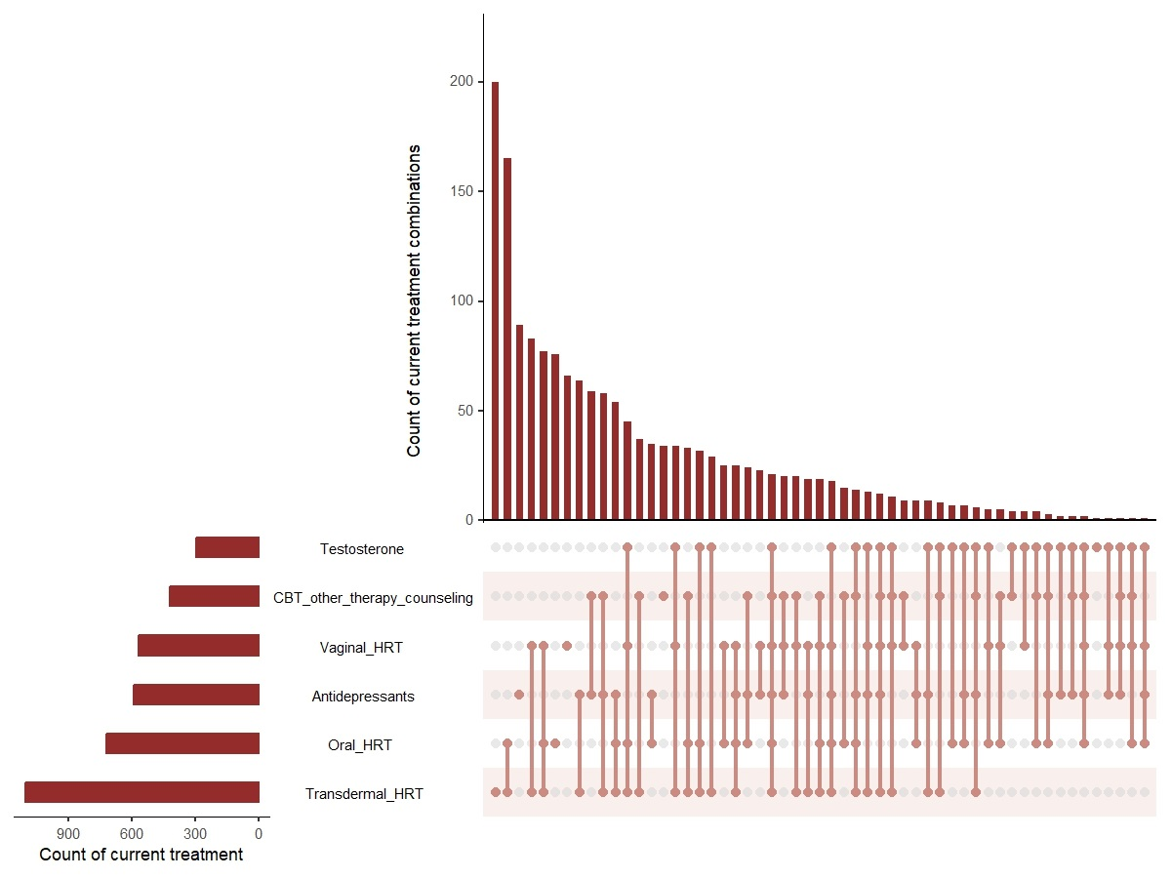
Supplementary Figure 1. Frequency of current treatment combinations (any length of use) and overall frequency of current treatment use (any length of use) per treatment option. Key. CBT, cognitive behavioral therapy; HRT, hormone replacement therapy.

Supplementary Table 1. Treatment response (% responders) for the 29 menopausal symptoms from the Menopause-Specific Quality of Life Questionnaire (MENQOL) per treatment (current use ≥3months)
 | Transdermal HRT  (n=871) | Oral HRT  (n=470) | Vaginal HRT  (n=347) | Antidepressants  (n=356) | Testosterone  (n=180) | CBT/other therapy/  counselling  (n=146 ª)
 | n (%)
Hot flushes | 527 (60.51) | 235 (50.00) | 22 (6.34) | 30 (8.43) | 11 (6.11) | 1 (0.68)
Night sweats | 506 (58.09) | 232 (49.36) | 18 (5.19) | 18 (5.06) | 16 (8.89) | 1 (0.68)
Sweating | 190 (21.81) | 98 (20.85) | 10 (2.88) | 10 (2.81) | 7 (3.89) | 1 (0.68)
Being dissatisfied with my personal life | 163 (18.71) | 48 (10.21) | 10 (2.88) | 79 (63.20) | 17 (9.44) | 77 (52.74)
Feeling anxious/nervous | 361 (41.45) | 140 (29.79) | 12 (3.46) | 225 (63.20) | 29 (16.11) | 112 (76.71)
Experiencing poor memory | 280 (32.15) | 86 (18.30) | 9 (2.59) | 23 (6.46) | 50 (27.78) | 6 (4.11)
Accomplishing less than I used to | 161 (18.48) | 46 (9.79) | 4 (1.15) | 24 (6.74) | 43 (23.89) | 33 (22.60)
Feeling depressed/down/blue | 258 (29.62) | 75 (15.96) | 6 (1.73) | 181 (50.84) | 36 (20.00) | 81 (55.48)
Being impatient with other people | 302 (34.67) | 100 (21.28) | 6 (1.73) | 88 (24.72) | 21 (11.67) | 43 (29.45)
Feelings of wanting to be alone | 102 (11.71) | 29 (6.17) | 3 (0.86) | 53 (14.89) | 16 (8.89) | 33 (22.60)
Flatulence/gas pains | 35 (4.02) | 14 (2.98) | 2 (0.58) | 3 (0.84) | 0 (0.00) | 1 (0.68)
Aching in muscles/joints | 303 (34.79) | 88 (18.72) | 9 (2.59) | 15 (4.21) | 41 (22.78) | 2 (1.37)
Feeling tired/worn out | 239 (27.44) | 80 (17.02) | 6 (1.73) | 30 (8.43) | 70 (38.89) | 11 (7.53)
Difficulty sleeping | 382 (43.86) | 226 (48.09) | 12 (3.46) | 63 (17.70) | 19 (10.56) | 19 (13.01)
Aches in back of neck/head | 66 (7.58) | 25 (5.32) | 1 (0.29) | 4 (1.12) | 4 (2.22) | 3 (2.05)
Decrease in physical strength | 68 (7.81) | 21 (4.47) | 3 (0.86) | 3 (0.84) | 69 (38.33) | 2 (1.37)
Decrease in stamina | 80 (9.18) | 25 (5.32) | 3 (0.86) | 4 (1.12) | 72 (40.00) | 3 (2.05)
Feeling a lack of energy | 185 (21.24) | 72 (15.32) | 4 (1.15) | 29 (8.15) | 97 (53.89) | 12 (8.22)
Dry skin | 105 (12.06) | 33 (7.02) | 8 (2.31) | 4 (1.12) | 5 (2.78) | 0 (0.00)
Weight gain | 79 (9.07) | 45 (9.57) | 5 (1.44) | 7 (1.97) | 14 (7.78) | 1 (0.68)
Increased facial hair | 29 (3.33) | 10 (2.13) | 2 (0.58) | 2 (0.56) | 1 (0.56) | 1 (0.68)
Changes in appearance/texture/tone of skin | 58 (6.66) | 18 (3.83) | 6 (1.73) | 2 (0.56) | 7 (3.89) | 1 (0.68)
Feeling bloated | 63 (7.23) | 27 (5.74) | 2 (0.58) | 2 (0.56) | 1 (0.56) | 1 (0.68)
Lower backache | 46 (5.28) | 20 (4.26) | 2 (0.58) | 4 (1.12) | 5 (2.78) | 1 (0.68)
Frequent urination | 106 (12.17) | 32 (6.81) | 98 (28.24) | 3 (0.84) | 3 (1.67) | 1 (0.68)
Involuntary urination when laughing/coughing | 54 (6.20) | 14 (2.98) | 47 (13.54) | 2 (0.56) | 1 (0.56) | 0 (0.00)
Change in sexual desire | 119 (13.66) | 42 (8.94) | 45 (12.97) | 6 (1.69) | 102 (56.67) | 3 (2.05)
Vaginal dryness during intercourse | 161 (18.48) | 54 (11.49) | 244 (70.32) | 3 (0.84) | 9 (5.00) | 1 (0.68)
eTable 1. Treatment response (% responders) for the 29 menopausal symptoms from the Menopause-Specific Quality of Life Questionnaire (MENQOL) per treatment (current use ≥3months)
Avoiding intimacy | 61 (7.00) | 18 (3.83) | 47 (13.54) | 5 (1.40) | 42 (23.33) | 9 (6.16)
Note. CBT, cognitive behavioral therapy; HCP, health care professional; HRT, hormone replacement therapy
Key. ª Missing data from one respondent

