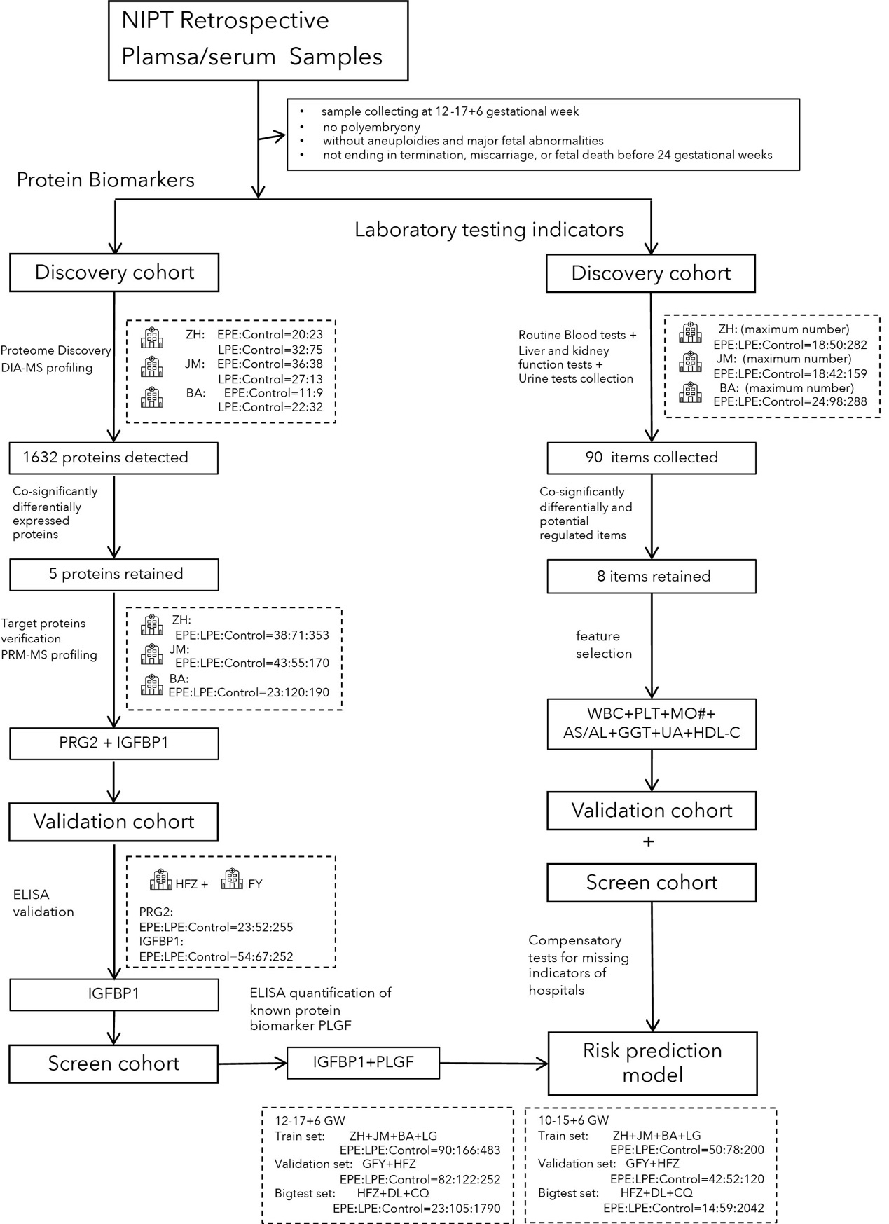
Extended data figure. 1 The overall workflow of protein biomarkers and laboratory tests indicators screen, and machine learning model construction using features screened above. NIPT (non-invasive prenatal testing) retrospective plasma/serum samples from eight hospitals were collected based on the established criteria. For protein biomarkers, samples from three hospitals were defined as the discovery cohort, which was used for the proteomic discovery and target protein verification processes. The validation cohort was used for further validation processes. For the laboratory test indicators, three major test categories were collected in the discovery cohort for selection. The protein biomarkers, along with the known biomarker PLGF quantified by ELISA, and the selected laboratory test indicators with compensatory tests, were used as features to construct a preeclampsia risk prediction model based on machine learning.

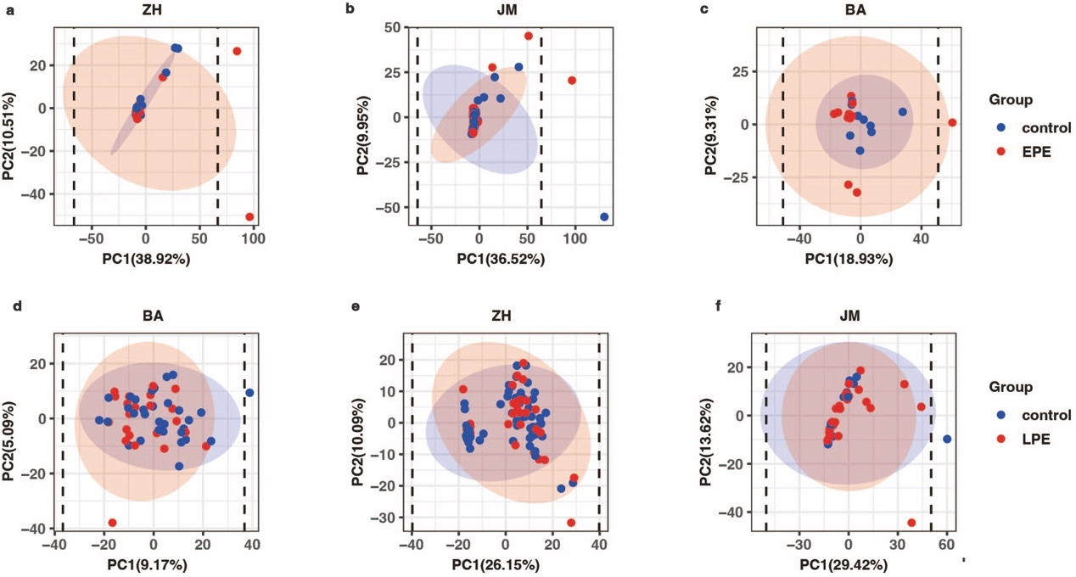
Extended data figure. 2 PCA analysis for proteomic discovery. PCA analysis plot of the proteome of early-onset pre-eclampsia versus control samples from a, ZH hospital b, JM hospital c, BA hospital. PCA analysis plot of the proteome of late-onset pre-eclampsia versus control samples from d, ZH hospital e, JM hospital f, BA hospital. Dash line represent PC1 mean ± 3SD.
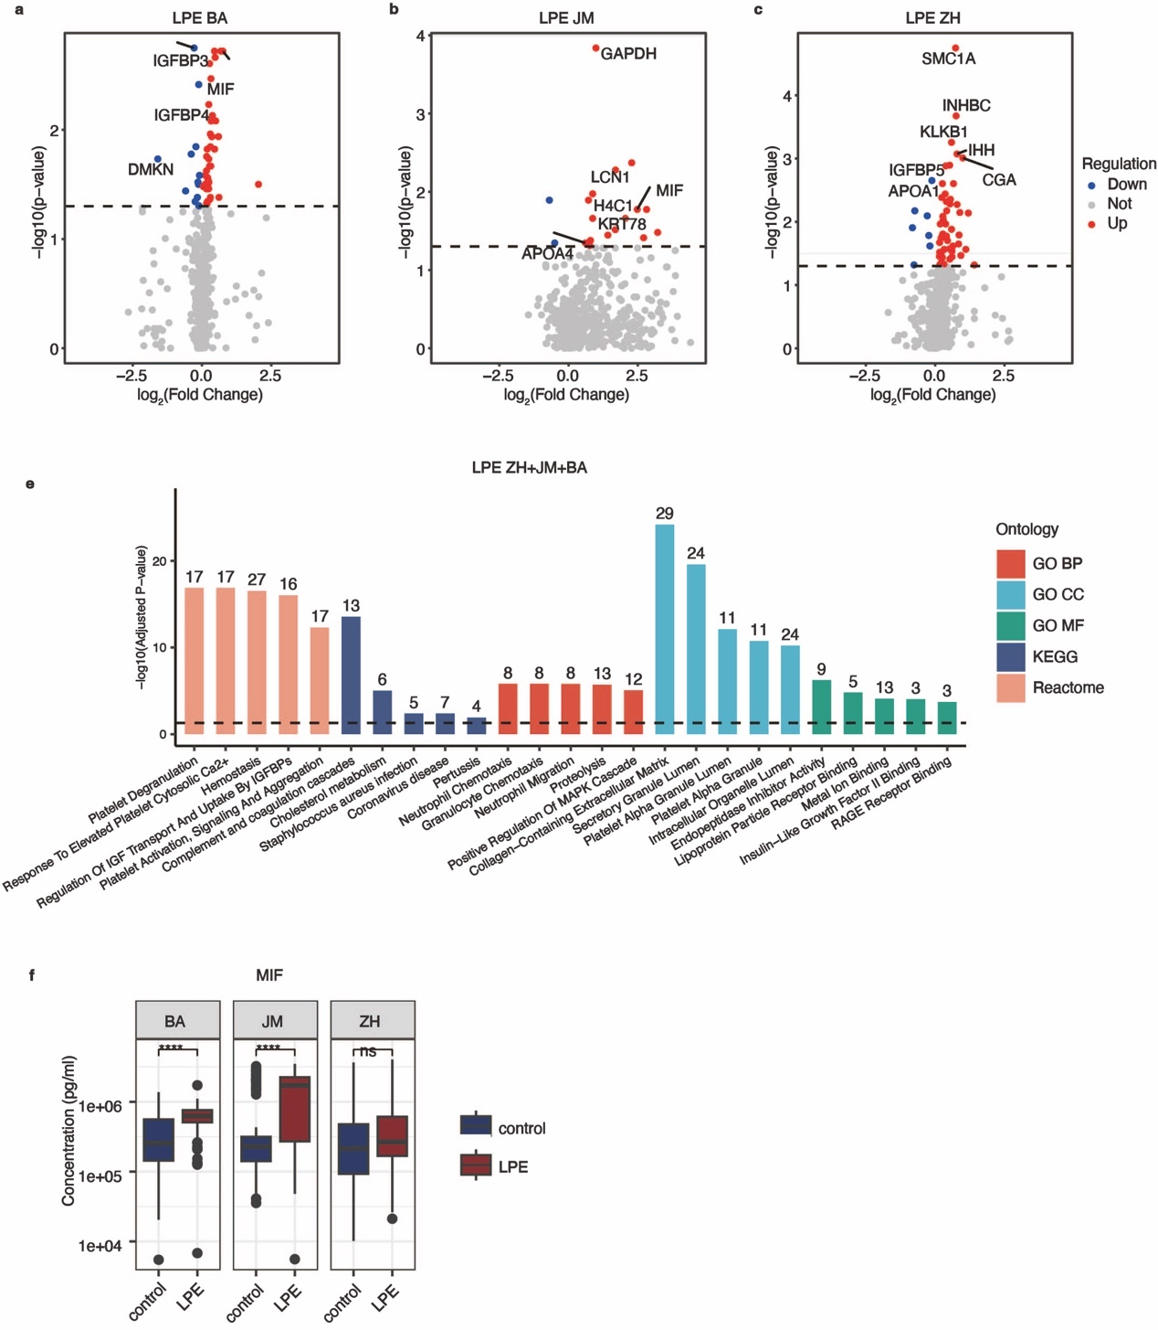
Extended data figure. 3 Protein biomarker candidates of LPE selected in discovery cohort.

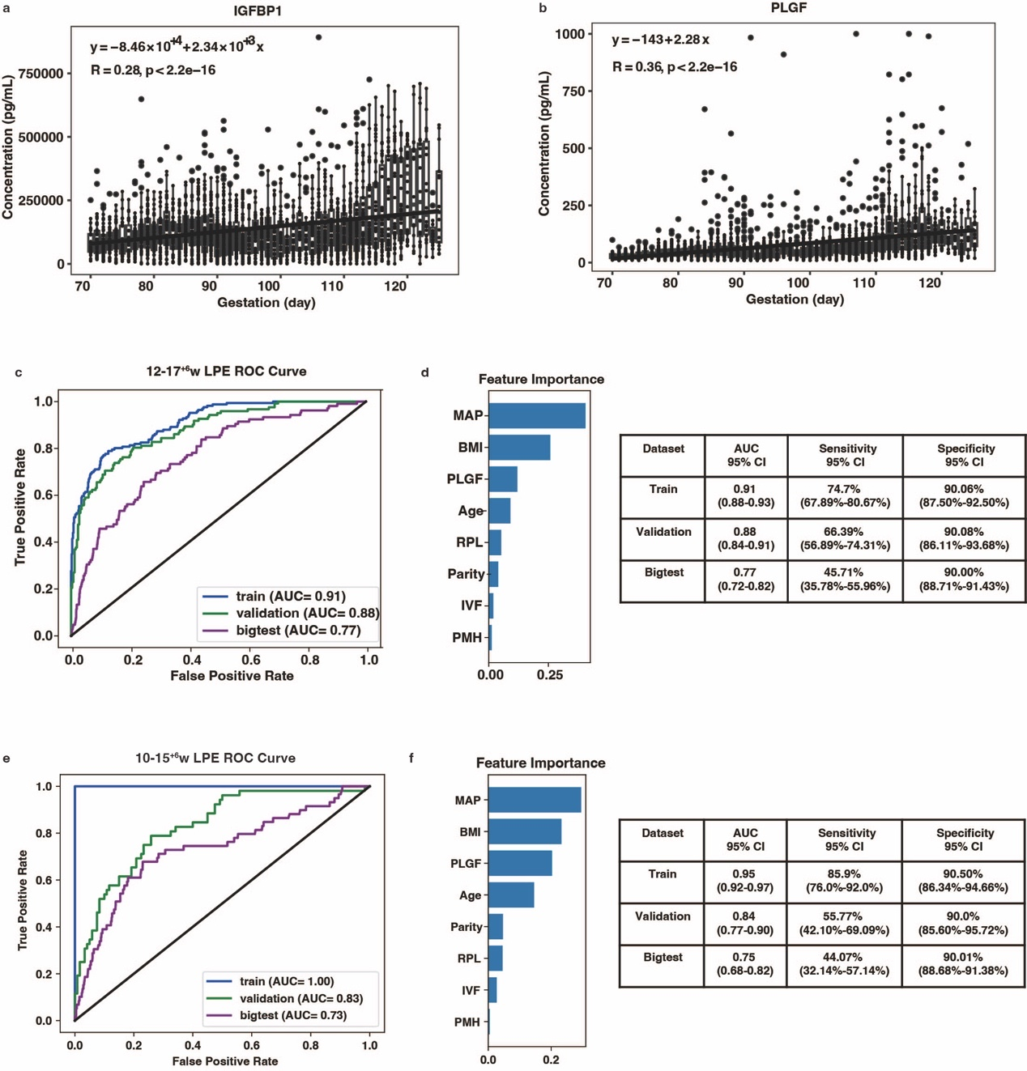
Extended data figure. 4 biomarker gestational changes and risk prediction models for LPE. Concentration levels detected by ELISA for a, IGFBP1 and b, PLGF across gestational days. Boxes show median, first and third quartiles; whiskers extend to the largest/ smallest value or at most to 1.5× interquartile range, after which dots are represented as individual data points. Pearson’s correlation coefficients, p-value and linear regression formula are shown. The significance of linear correlation was determined by one-sided joint hypotheses test. Lines represent the regression line. c, ROC curve and AUC of models for LPE at 12-17⁺⁶w. d, The corresponding feature importance of train set in d. e, ROC curve and AUC of models for LPE at 10-15⁺⁶w. f, The corresponding feature importance of train set in f.
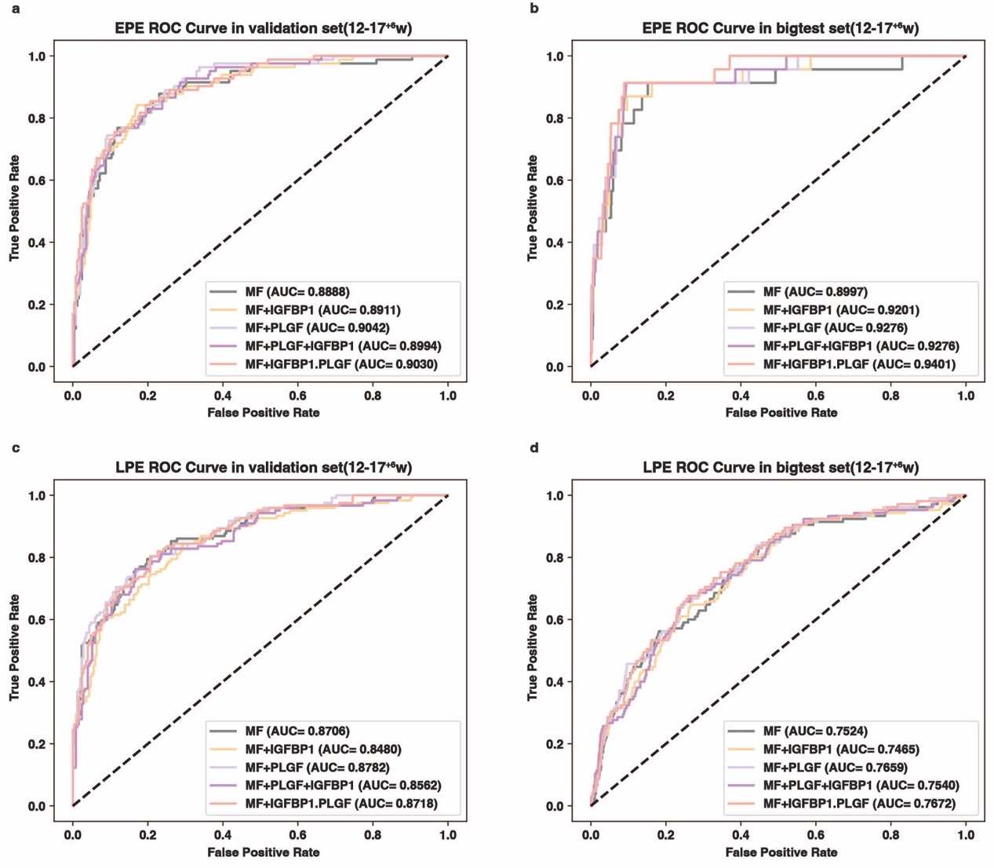
Extended data figure. 5 Risk prediction models at 12-17⁺⁶w. ROC curve and AUC of models for EPE at 12-17⁺⁶w in a, validation set and b, bigtest set. ROC curve and AUC of models for LPE at 12-17⁺⁶w in c, validation set and d, bigtest set.
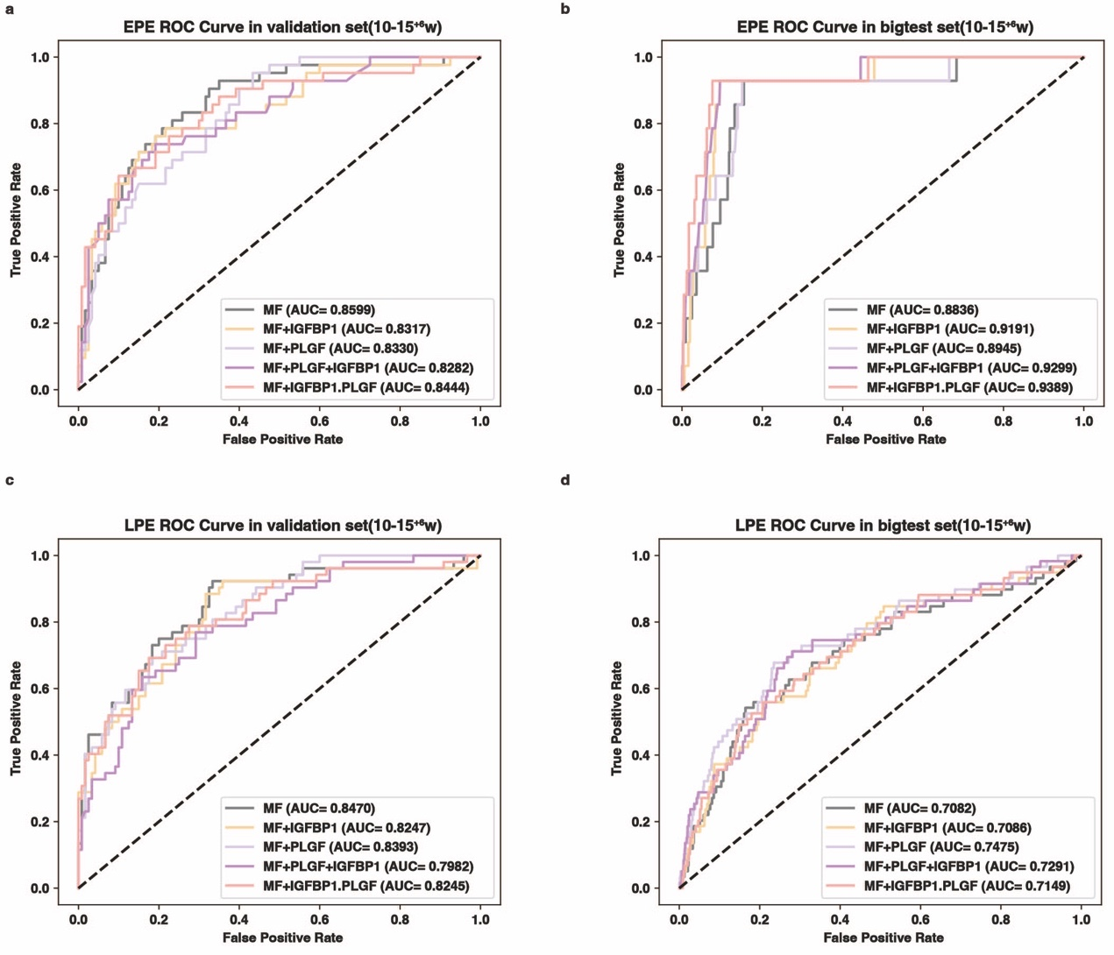
Extended data figure. 6 Risk prediction models at 10-15⁺⁶w. ROC curve and AUC of models for EPE at 10-15⁺⁶w in a, validation set and b, bigtest set. ROC curve and AUC of models for LPE at 10-15⁺⁶w in c, validation set and d, bigtest set.

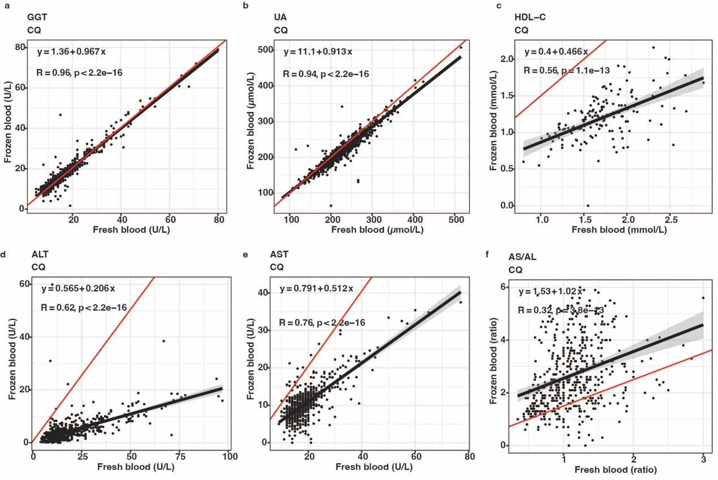
Extended data figure. 7 Correlation plots of liver function indicators detected in frozen and fresh blood. Correlation analysis of a, GGT b, UA c, HDL-C d, ALT e, AST and f, AS/AL quantification results in frozen and fresh blood in CQ hospital. Pearson’s correlation coefficients, p-value and linear regression formula are shown. The significance of linear correlation was determined by one-sided joint hypotheses test. Black Lines with shaded areas represent the regression line and confidence interval of linear regression. Red lines represent the y=x.
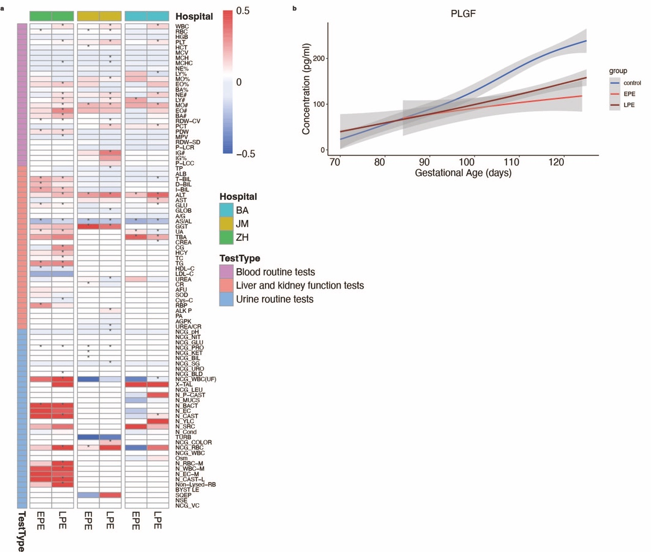
Extended data figure. 8 Laboratory indicator selection and PLGF level changes across early pregnancy. a, Heatmap representation of log2foldchange profile of all laboratory tests in three hospitals. * represent p-value<0.05. b, Lines represent the levels of circulating PLGF at 70-124 gestational days (10-17⁺⁶gestational weeks). Shaded areas represent 95% CIs.

