Supplementary Materials
for
Human umbilical cord mesenchymal stem cells restores mTOR-mediated autophagy homeostasis to alleviate placental injury and improve pregnancy outcomes in preeclampsia

Miao Xu¹, Huijing Ma¹, Yuwen Chen², Xinhuan Zhang¹, Mengnan Li¹, Hong Yu¹, Jing Ji¹, Juanwen Li¹, Nan Zhang¹, Fang Wang¹, Huiniu Hao¹, Lu Li², Ruidan Zhang¹,Yinmin Chen¹, Lijun Yang¹, Zhuanghui Hao¹, Huifang Song²,Sheng He²*, Hailan Yang¹*

¹The First Hospital of Shanxi Medical University, Department of Obstetrics, Innovative research base for mesenchymal stem cell therapy for serious complications during pregnancy, Umbilical Cord Mesenchymal Stem Cell Research Center, Shanxi Medical University, Taiyuan, China

²The First Hospital of Shanxi Medical University, Department of Biochemistry and Molecular Biology, Shanxi Key Laboratory of Birth Defect and Cell Regeneration, MOE Key Laboratory of Coal Environmental Pathogenicity and Prevention,The Transformation Pilot-Base of Shanxi Clinical Cell Therapy, Shanxi Medical University, Taiyuan, China
*Correspondence:
Hailan Yang
yanghailan100@163.com

Sheng He
hesheng@sxmu.edu.cn

Supplemental figures
Fig. S1. (A) Flow cytometry histograms showing that human umbilical cord mesenchymal stem cells (hUC-MSCs) were positive for mesenchymal cell markers CD90, CD44, CD105, and CD73, and (B) negative for hematopoietic stem cell lineage markers HLA-DR, CD45, CD19, and CD11b. hUC-MSCs were able to differentiate into (C) adipogenic (Oil Red O), (D) osteogenic (Alizarin Red S), and (E) chondrogenic lineages (Alcian Blue).

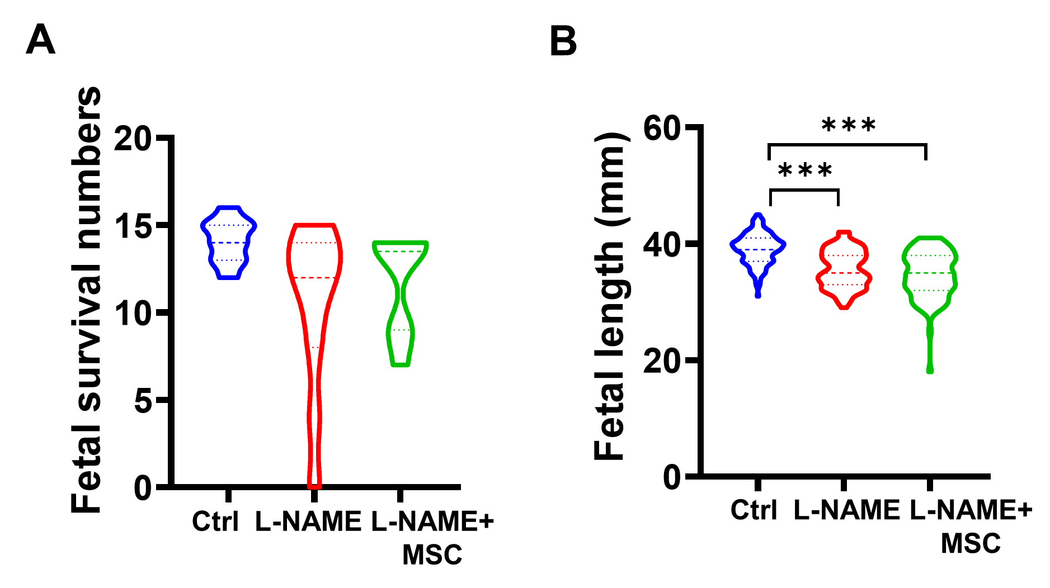
Fig. S2. (A) Fetal survival numbers and (B) lengths among pregnant saline-injected control (Ctrl), N-nitro-L-arginine methyl ester (L-NAME)-injected (L-NAME), and L-NAME with hUC-MSC (L-NAME+MSC)-injected pregnant rats. Data are shown as mean±SEM. n=10/group. ***P<0.001.

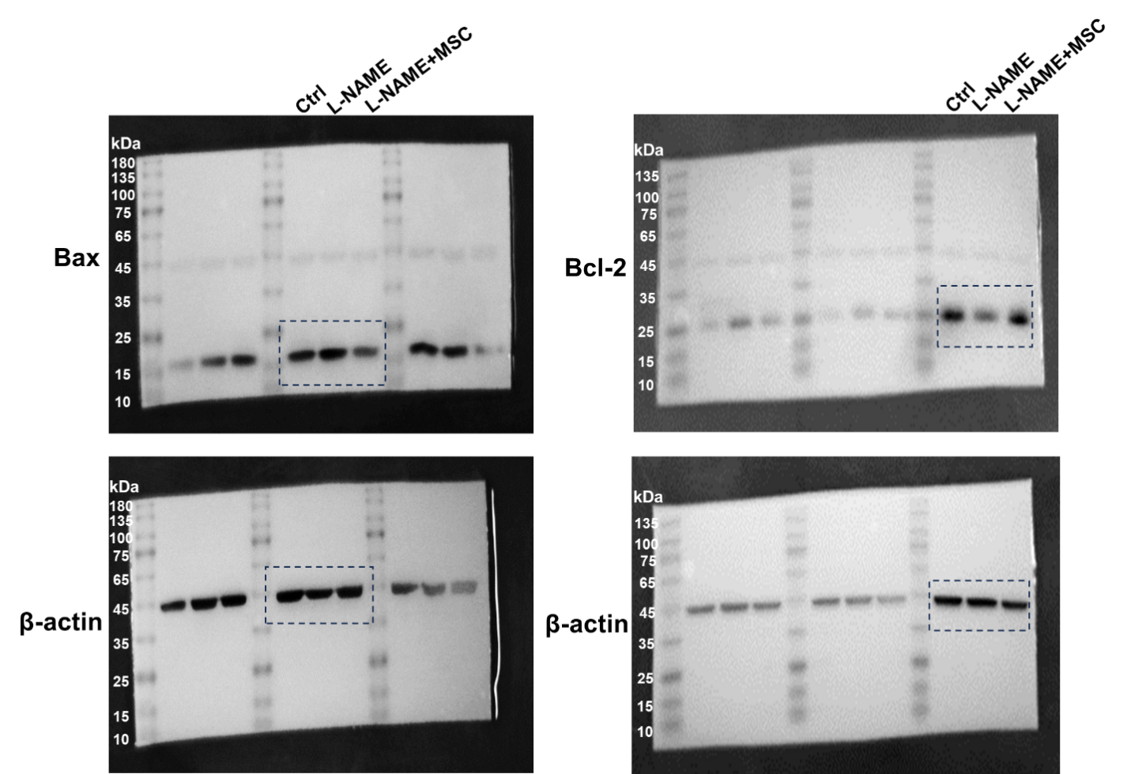
Fig. S3. Full-length blots for Fig. 3D.

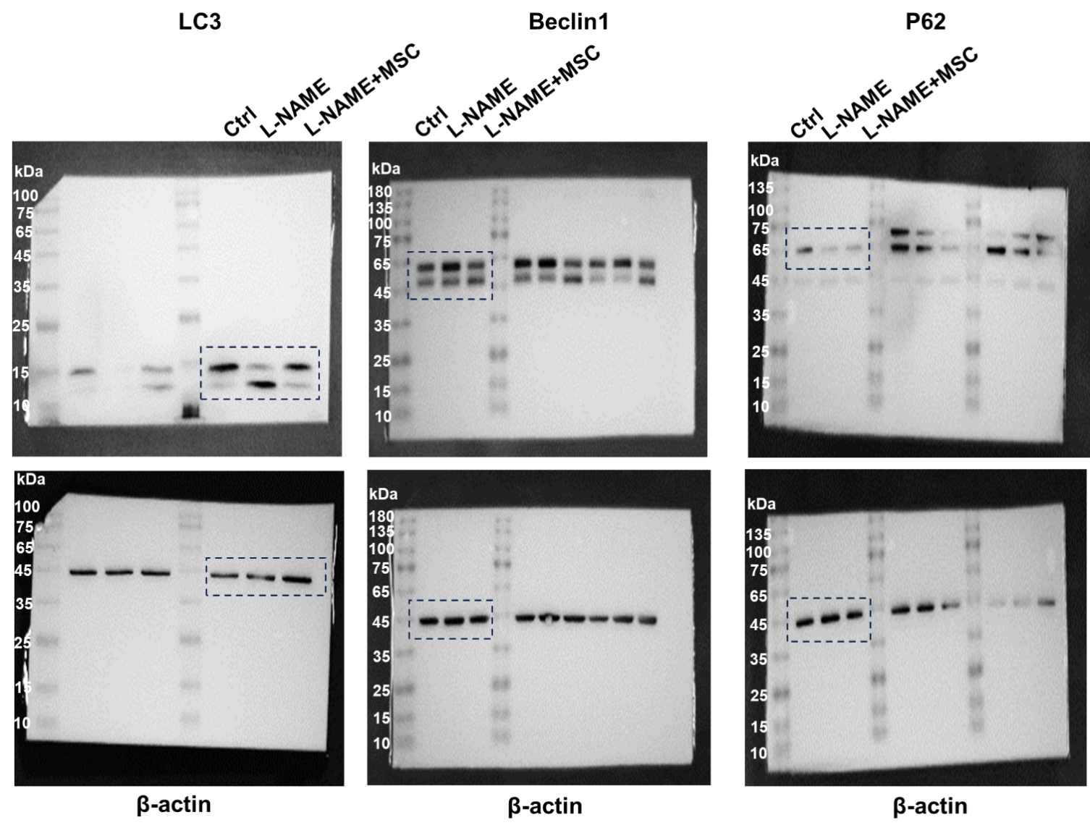
Fig. S4. Full-length blots for Fig. 6D.

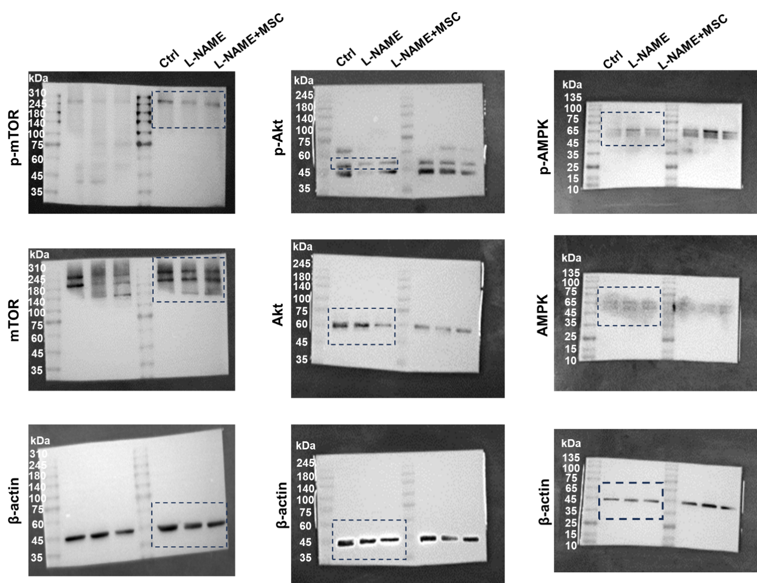
Fig. S5. Full-length blots for Fig. 6I.

Supplementary table
Table S1. Primers used for Real-time RT-qPCR
Gene | Forward primer sequence | Reverse primer sequence
ACTB | ACAGGATGCAGAAGGAGATTAC | ACAGTGAGGCCAGGATAGA
Beclin1 | CAGGAACTCACAGCTCCATTAC | CCATCCTGGCGAGTTTCAATA
LC3 | TTATAGAGCGATACAAGGGGGAG | CGCCGTCTGATTATCTTGATGAG
P62 | CTAGGCATCGAGGTTGACATT | CTTGGCTGAGTACCACTCTTATC
mTOR | CAAGGCTTCTTCCGTTCTATCT | ATCTGGCCAGTGACCATAATC
AMPK | CGGGATCCATCAGCAACTATC | AGGTCACGGATGAGGTAAGA
Akt | ACGACGTAGCCATTGTCAAG | GCCGTTCCTTGTAGCCAATA

