Additional file 2: Borderline RHD
Pathological mitral regurgitation
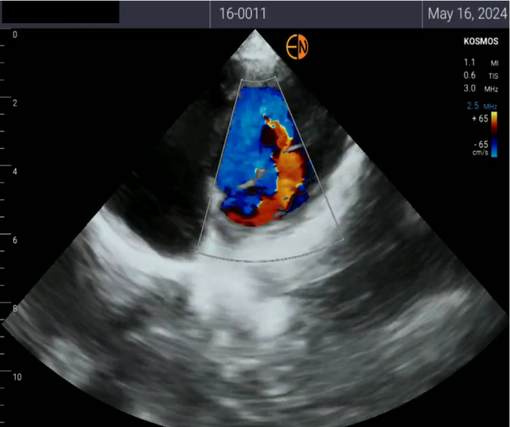

Pathological mitral regurgitation
