Supporting Information
Critical Role of Precursor Flux in Modulating Nucleation Density in 2D Material Synthesis revealed by Digital Twin
Abhinav Sinha^{1,#}, Manvi Verma^{1,#}, Nandeesh Kumar K M¹, Keerthana S Kumar¹, Ananth Govind Rajan^{2 ,*}, Akshay Singh^{1,*}
¹Department of Physics, Indian Institute of Science, Bengaluru, Karnataka 560012, India
²Department of Chemical Engineering, Indian Institute of Science, Bengaluru, Karnataka 560012, India
#These authors contributed equally
*Corresponding authors: aksy@iisc.ac.in, ananthgr@iisc.ac.in

- Inert gas flushing of CVD reactor before growth:
Model component | Material
Reactor (tube) | Quartz
Precursors | S (equation (S2)), MoO₃ (equation S3))
Carrier gas | N₂ properties in COMSOL© Multiphysics
Insulation zones | Resin bonded glass fiber board BCR 64
Precursor boats | Alumina
Substrate holder | Alumina
Substrate | Alumina
Table S-I. Material properties of reactor components in COMSOL© Multiphysics

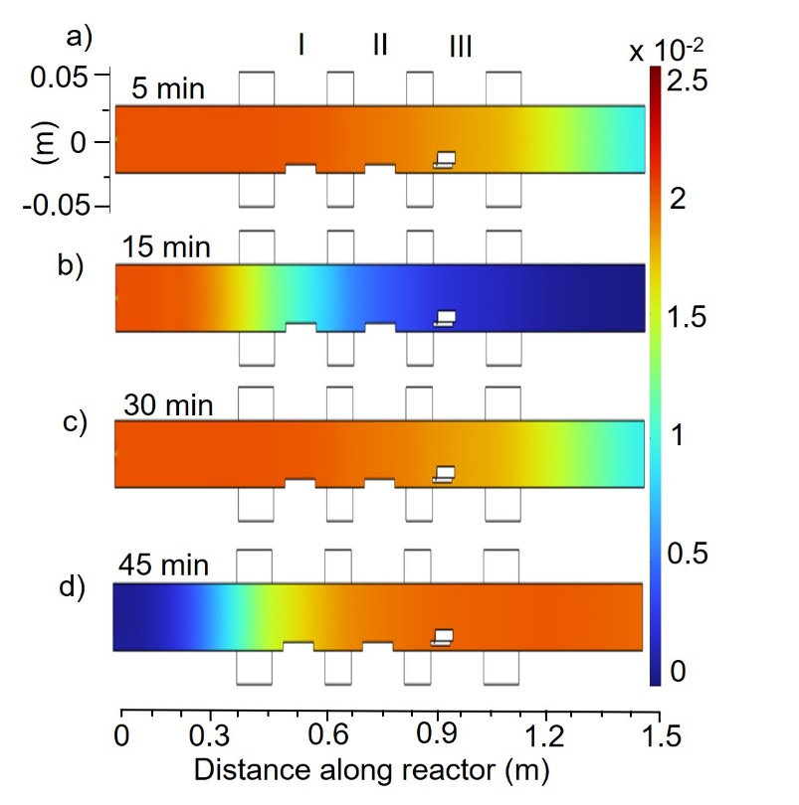
Figure S-I. Axial O₂/N₂ profiles along the reactor during inert gas flushing. Gas flow rate is 500 sccm. Simulated profiles at a) 0, b) 15, c) 30, and d) 45 minutes are shown. Representation is not to scale, and the reactor is stretched vertically to highlight variations in concentration profiles.

A multi-scale Computational Fluid Dynamics (CFD) model was established in COMSOL© Multiphysics. Table S-I shows the material properties used for setting up the reactor and precursor evaporation model. The deposition process can be divided into four broad parts – nitrogen flushing, reactor heating, precursor vaporization, and reaction and deposition. Using the as-developed, integrated model for the first three of the mentioned processes, we simulated the actual experimental conditions as closely as possible. To obtain an inert atmosphere and flush out ambient air, water vapor and/or other contaminants, inert gas at high flow rates was flown through the reactor. We use ultra-high purity N₂ for flushing, for a period of ~1 hour. Figure S-I and video V-I show axial O₂/N₂ profiles through the reactor at specified times. It may be observed that after ~ 45 minutes of flushing, the O₂/N₂ ratio drops to ~ 1.5% of the initial value. In around 60 minutes, a steady state is achieved and O₂ levels do not change significantly.

- Comparison of horizontal vs. vertical substrate placement:
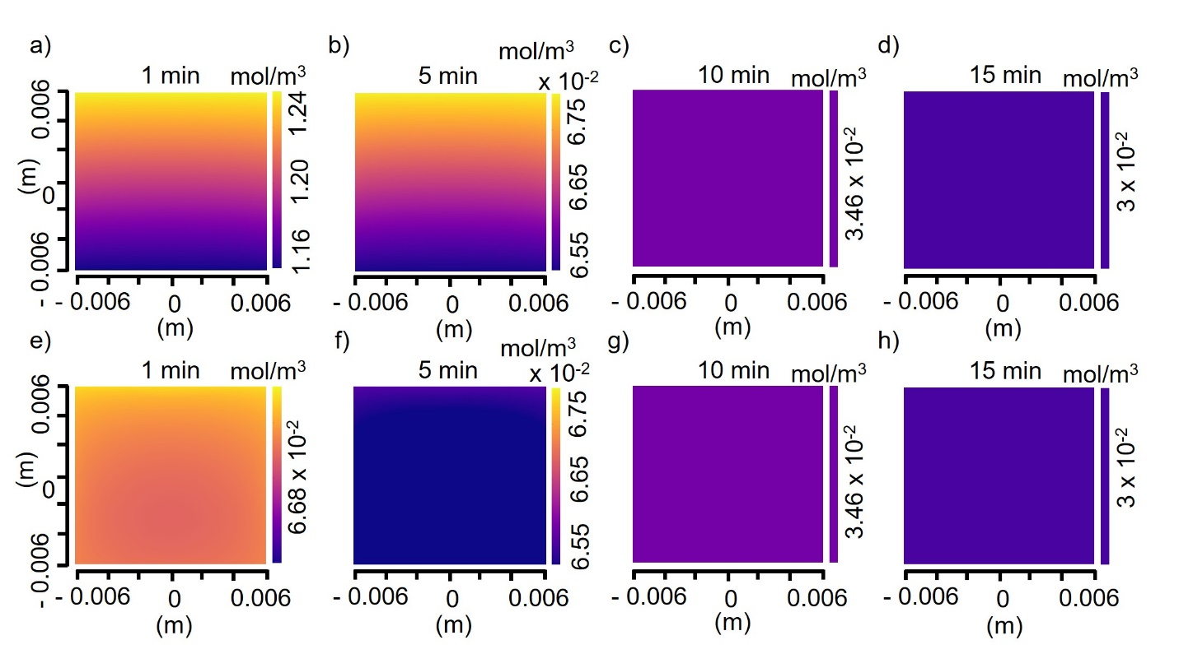
Figure S-II. Comparison of MoO₃/S₈ profile for a horizontal and vertical substrate. a), b), c), d) depict profiles for substrate kept horizontally. e), f), g), h) depict profiles for substrate kept vertically in a slot. Time steps are specified for each plot.
In the context of thin film growth, the placement of the substrate in the reactor is an important factor, which directly affects reactant concentrations. In addition to the distance from precursor, the substrate geometry angle relative to carrier gas flow may significantly affect the nucleation and type of obtained growth¹. For a given precursor source distance, the substrate may be placed parallel (horizontal), perpendicular (vertical), or at some angle (tilted) to the incoming carrier gas. Earlier works have studied the precursor environment at a horizontally kept substrate, particularly in the case of low-pressure CVD, MOCVD, or cold-wall reactors^{1,2}. The precursor profile at the substrate was found to be spatially varying and non-uniform, resulting in less control over the growth and type of nucleation throughout. However, similar studies in the context of atmospheric-pressure CVD reactors with powder precursor sources are limited. To understand precursor concentration variation along the substrate before and during growth in our reactor, we carried out multiphysics simulations for two different substrate configurations, horizontal and vertical.
As shown in Figure S-II, it may be observed that there exists a precursor concentration gradient (MoO₃/S₈) for a horizontally kept substrate in Figure S-II a)-d). In comparison, vertical placement ensures a more uniform profile as shown in Figure S-II e)-h). This effect is most pronounced during the nucleation stage, which is the first step and critically affects the type of growth obtained. Towards the end of the growth, precursor profiles become essentially similar and more uniform at the substrate. Since vertical placement of the substrate provides a more uniform local environment, we chose this configuration for the CVD of monolayer MoS₂.

- Characterization of as-grown monolayer MoS₂:
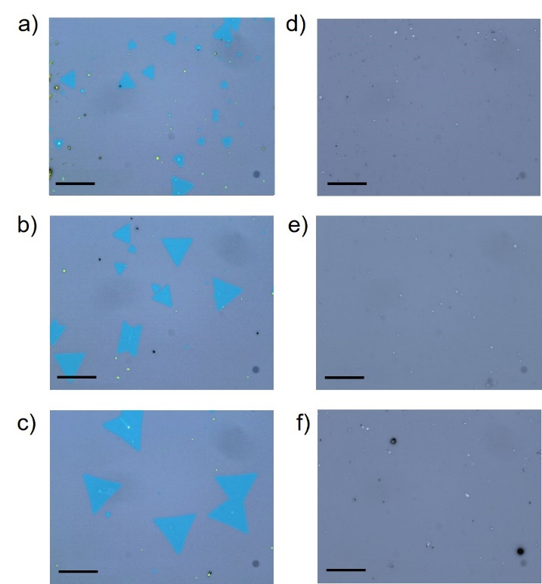
Figure S-III. Optical microscopy (OM) images of substrates post- growth. a), b), and c) OM images of a substrate kept vertically at different regions along the slot. d), e) and f) OM images of a substrate kept vertically without the slot. Images are acquired at similar substrate regions in both cases for comparison. The scale bar is 20 µm.
To study the effect of the slot in influencing the type of growth obtained, we employed both slotted and non-slotted configurations for CVD growth of MoS₂. Figure S-III a)-c) and d)-f) shows representative optical microscopy (OM) images for both the configurations, respectively. For a substrate kept in the slot, 15-20 µm edge length monolayer MoS₂ flakes were obtained in and near to the slot, as can be seen from the OM images. In contrast, only some small bulk deposition was obtained for substrate kept without slot under similar optimized growth conditions (Figure S-III d)-f)). This indicates the decisive effect of the presence of the slot in determining the type of growth obtained or even presence of growth.
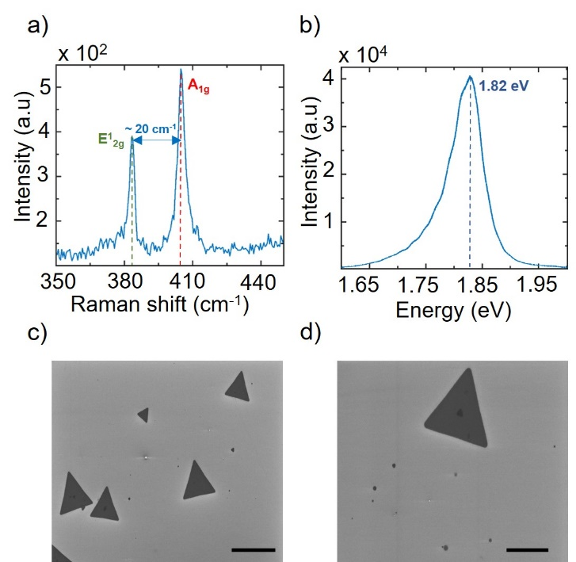
Figure S-IV. Characterization of CVD-grown monolayer MoS₂ flakes. a) Raman and b) Photoluminescence spectrum of monolayer MoS₂ deposited on a substrate kept vertically in the slot. c), d) Scanning Electron Microscopy (SEM) images of as-grown single crystalline monolayer MoS₂ (scale bar is 25 µm in c) and 10 µm in d)).
Raman and photoluminescence spectroscopy were used for optical characterization of obtained monolayer MoS₂ flakes. In-plane (E¹_{2g}) and out-of-plane (A_{1g}) Raman vibrational modes were observed at ~385 and 405 cm⁻¹ (Fig. S-IV a). A Raman shift of ~ 20 cm⁻¹ confirms the monolayer nature of MoS₂. High photoluminescence intensity and A-exciton resonance at ~ 1.82 eV also characterizes the as-grown flakes as monolayer MoS₂³ (Figure S-IV b). SEM images show growth of uniform and clean flakes with good coverage (Figure S-IV c and Figure S-IV d). Bulk deposition and/or multilayers were not observed.

- Details of precursor evaporation and related modeling:
To ensure better control over initiation of growth, we experimentally controlled the precursor supply to the substrate. Premature precursor evaporation may lead to uncontrolled nucleation, sub-standard growth, and inability to track the nucleation and growth windows. For this purpose, we inhibit precursor evaporation before the set temperature is realized in the following way. Sulfur powder precursor is kept outside the furnace during the heating cycle, to prevent premature evaporation and transport. As the set temperature is realized, the boat is pushed in using a pair of magnets to ensure controlled and uniform sulfur supply. For MoO_{3,} however, the vapor pressure is almost negligible below the set temperature of the second zone. Hence, for modeling purposes, it may be assumed to start evaporating after completion of the heating step. The Chapman-Enskog equation⁴, along with the appropriate Lennard-Jones parameters was employed to obtain the temperature-dependent diffusivities of gaseous as well as vaporized precursor species⁵:
$$\begin{aligned}D \left[\frac{{cm}^{2}}{s}\right]= \frac{0.0026280 \sqrt{T^{3}\left(\frac{M_{1}+M_{2}}{2M_{1}M_{2}}\right)}}{pσ_{12}^{2}Ω_{12}^{\left(1,1\right)*}\left(T_{12}^{*}\right)}\#\left(S1\right)\end{aligned}$$
where D is diffusivity (cm²/s), p is system pressure (atm), T is absolute temperature of the system (K), M₁ is molar mass of precursor (g/mol), M₂ is molar mass of carrier gas (g/mol), $(σ_{i}, ϵ_{i})$ are 12-6 Lennard-Jones parameters of the precursor (i=1) and the carrier gas (i=2), $T_{12}^{*}= \frac{k_{B}T}{ϵ_{12}}$ is reduced temperature, and $Ω_{12}^{(1,1)*}$is a collision integral. Combining rules are applicable such that
$σ_{12}= \left(\frac{σ_{1}+ σ_{2}}{2}\right)$ and $ϵ_{12}= {\left(ϵ_{1}ϵ_{2}\right)}^{\frac{1}{2}}$. The values of $σ$and $ϵ$ are listed in another work⁵ and $Ω_{12}^{(1,1)*}$ is available in tabular format⁴.
The source term r_{S}, as mentioned in equation (2) in the main text, depends on their respective saturation vapor pressures (P_{S}) and precursor flux.
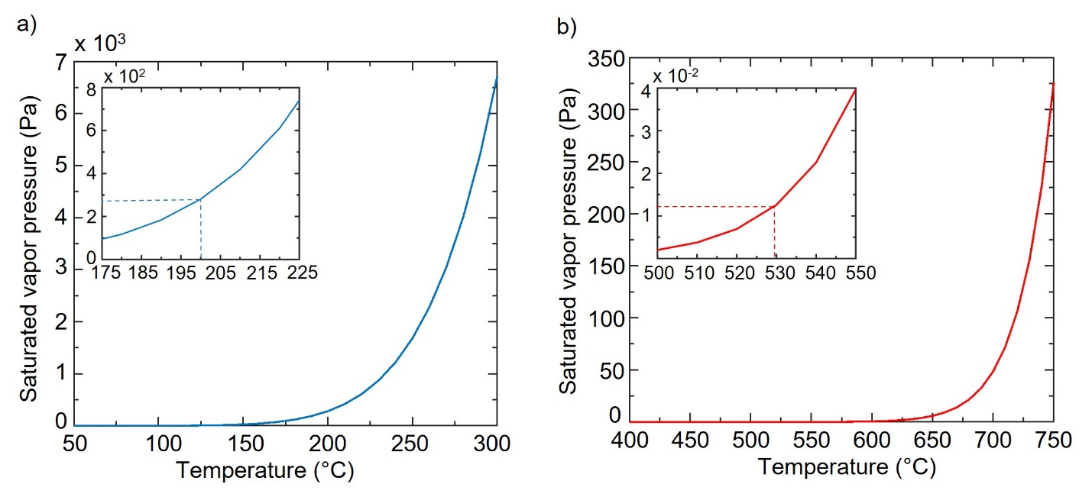
Figure S-V. Vapor pressure (analytical) of S and MoO₃ powder precursors. a) Saturated vapor pressure of S precursor. b) Saturated vapor pressure of MoO₃ precursor. Insets show limited range plots of saturated vapor pressures at experimental set temperatures of 200° C and 530 °C respectively.
The vapor pressure of sulfur (𝑝*) is described by the following correlation⁶ (389 K < T < 1313 K):
$$\begin{aligned}\ln\left(\frac{p^{*}}{p_{c}}\right)= \left[A\left(1-\frac{T}{T_{c}}\right)+B{\left(1-\frac{T}{T_{c}}\right)}^{\frac{3}{2}}+C{\left(1-\frac{T}{T_{c}}\right)}^{3}+D{\left(1-\frac{T}{T_{c}}\right)}^{6}\right]\left(\frac{T_{c}}{T}\right)\#\left(S2\right)\end{aligned}$$

where, T is the absolute precursor temperature (K), T_{c} = 1313 K, $p_{c}$= 18208 kPa, and A (-7.246), B (0.187), C (5.271), and D (-12.128) are constants.
The vapor pressure of MoO3 (𝑝*) is described by the following correlation⁷ (873 K < T < 973 K):
$$\begin{aligned}4.576\log{p^{*}{\left(MoO_{3}\right)}_{\overline{n}}= -\frac{75400}{T}}+62.3 ±0.2\#\left(S3\right)\end{aligned}$$

where, T is the absolute precursor temperature (K) and $\overline{n}$ is average molecular association number for MoO₃⁷.
Figure S-Va and S-Vb depict saturation vapor pressures of sulfur and MoO₃ respectively. At our optimized growth conditions, the saturation vapor pressures above the precursors are ~ 280 Pa (sulfur) and ~ 1.25 $×$ 10⁻² Pa (MoO₃).
The amount (flux) of precursors evaporated is governed by the Knudsen-Langmuir equation⁸:
$$\begin{aligned}φ_{p}= \frac{ α\left(P_{v}-P_{s}\right)N_{A}}{\sqrt{2πMRT}}\#\left(S4\right)\end{aligned}$$

where, $φ_{p}$ denotes the precursor flux (mol/(m².s)), $α$ is the evaporation coeffecient, $P_{v}$ and $P_{s}$ are vapor pressures of saturated vapor and that above the precursor source, respectively (Pa), M is the precursor molar mass (kg/mol), T is the absolute precursor temperature (K), and $N_{A}$ and R are Avogadro’s number and the universal gas constant (J/(mol-K)), respectively.
$P_{s}$ assumes a constant equilibrium value soon after the evaporation starts, owing to the steady velocity profile and constant temperature over the precursor during the growth. For the purpose of simulation, this constant is ignored, and its effect is accounted for by appropriately fixing the value of $α$.
The value of α depends on environmental composition as well and related data is usually not available. We employ an empirical approach to fix α by measuring the average amount of precursors evaporated during growths. α is set as such to give similar experimentally found evaporated amounts during the simulations as well ($α\left(MoO_{3}\right)=1.21 × {10}^{-1}$ and $α(S)=1.29 × {10}^{-4}$). Videos V-II and V-III show time-dependent evaporation of MoO₃ and S respectively.

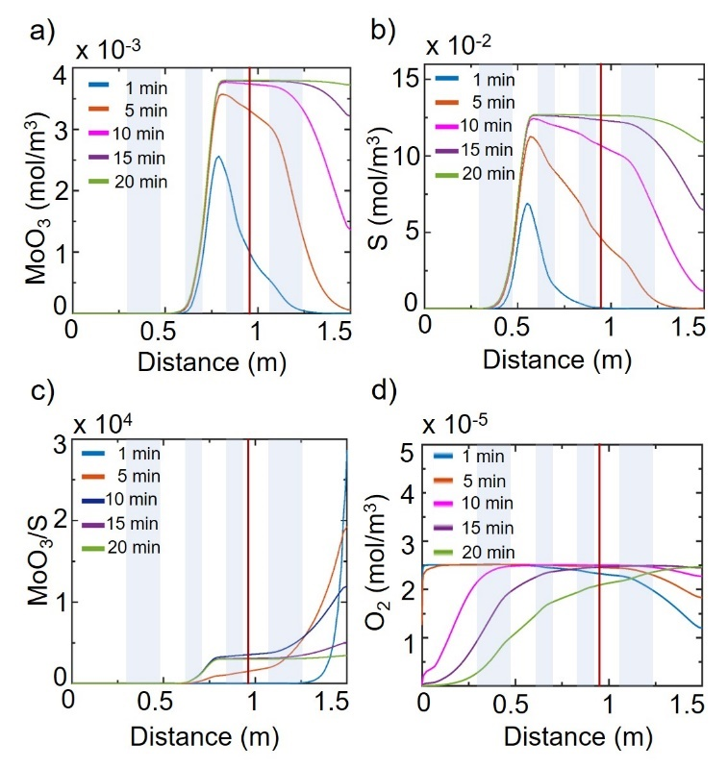
Figure S-VI. 1-D axial line plots for species concentration along the center of the reactor. a) MoO₃, b) S₈, c) MoO₃/S₈, and d) O₂ concentration at the line (0, 0, 0)-(0, 0, 1.5m). Plots for 5 mins and 10, 15, and 20 mins are multiplied by a factor of 10⁴ and 10⁵ respectively in c). Time steps are as specified. Insulation zones are shaded in blue and substrate position is indicated by the red line.
Axial line plots of MoO₃, S₈, and O₂ are shown in Figure S-VI. Figure S-VI a) and b) show 1-D line plots of MoO₃ and S₈ along the length of the reactor with time. As can be seen in Figure S-VI c), for t $≤$ 1 min, MoO₃/S₈ ratio is quite high due to very low concentration of sulfur at the substrate. It is suggested that MoS₂ nucleation is sensitive primarily to the Mo concentration^{9,10}. According to related studies, it is understood that the S₈ allotrope of sulfur having a puckered ring structure is the major constituent in the vapor phase along with other allotropes present in minor quantities¹¹. From our simulations, the ratio of MoO₃/S₈ ratio is lowest during the initial 5 minutes of growth and this seems to be the window for controlled 2-D nucleation. In this window, sulfur concentration increases rapidly as shown by individual line plots for MoO₃ and S₈ in Figur S-VI a) and b). It should be noted that the concentration of MoO₃ remains almost constant throughout growth ($∆C_{MoO_{3}}\sim 7.5×{10}^{-4} mol/m^{3}$) while the S concentration is changing throughout ($∆C_{Sulphur}\sim 1.2×{10}^{-1} mol/m^{3}$). This can also be visualized with axial plots along the length of the reactor in Figure S- VI. Figure S-VII shows the reactor environment in terms of MoO₃/S₈ ratio and O₂ species’ concentration. An appropriate Mo:S ratio is required for uniform and monolayer growth. Fluctuations in the amount of S present leads to undesirable growth kinetics which limit the domain size and affects repeatability¹². A more uniform chalcogen supply may be achieved by altering the gas flow, temperature of the heating zone and/or employing gaseous chalcogen precursors like H₂S.
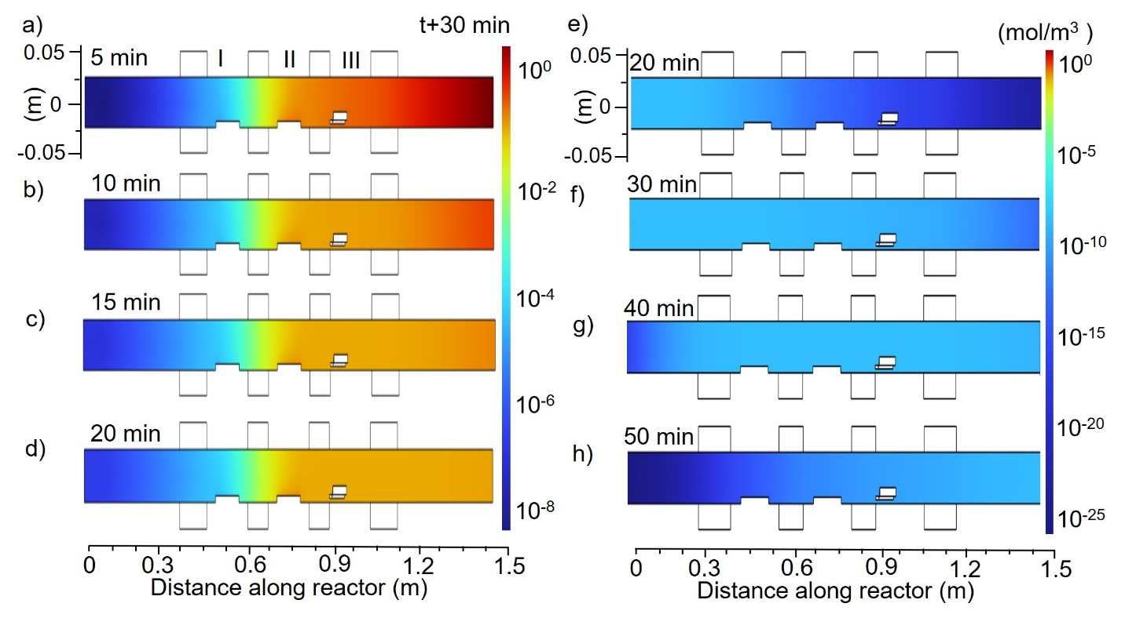
Figure S-VII. Axial concentration profiles along the reactor during heating and growth. a), b), c), and d) axial MoO₃/S₈ ratio concentration profiles at 5, 10, 15, and 20 minutes of growth respectively. The total growth time is 20 minutes. Since precursors are allowed to evaporate only after reactor heating, only profiles during growth are shown. e), f), g), and h) O₂ flow (at controlled flow rate of 2 sccm) during heating (30 minutes) and 5 more minutes during growth. Profiles are plotted for specified times (t=0 corresponds to start of reactor heating to the end of the growth process). Representation is not to scale; the reactor is stretched vertically to highlight variations in the concentration profiles.
Axial concentration profiles of MoO₃/S₈ ratio with time is shown in Figure S-VII a- d. As seen in the figure, for t < 1 min, the MoO₃/S₈ ratio is quite high due to very low concentration of sulfur at the substrate. Axial concentration profiles of O₂ in Figure S-VII e)-h) show that the concentration is higher during initial stages of growth when there is controlled O₂ flow of 2 sccm and decreases toward the end.
We also introduce a small amount of oxygen into the system (see Methods in main text for details of growth process), as it is known to prevent poisoning of the transition metal oxide precursor in a reducing chalcogen environment and improves repeatability^{12,13}. Figures S-VI d), S-VII e-h and video V-IV show the concentration of O₂ with time along the reactor. It may be noted that for a given flow rate (2 sccm), the concentration of O₂ increases steadily throughout heating as can be seen in the axial surface plot in Figure S-VII e)-h) but remains almost constant during growth. Line plots in Figure S-VI d) show O₂ profiles throughout the reactor with time. Due to the uniform O₂ concentration and effective MoO₃ precursor re-oxidation, we can ensure a uniform and continuous supply of transition metal precursor to the substrate. It has been observed that in the absence of sufficient O₂, the MoO₃ is reduced by sulfur (observable blackening of MoO₃ powder) and limits the precursor supply.
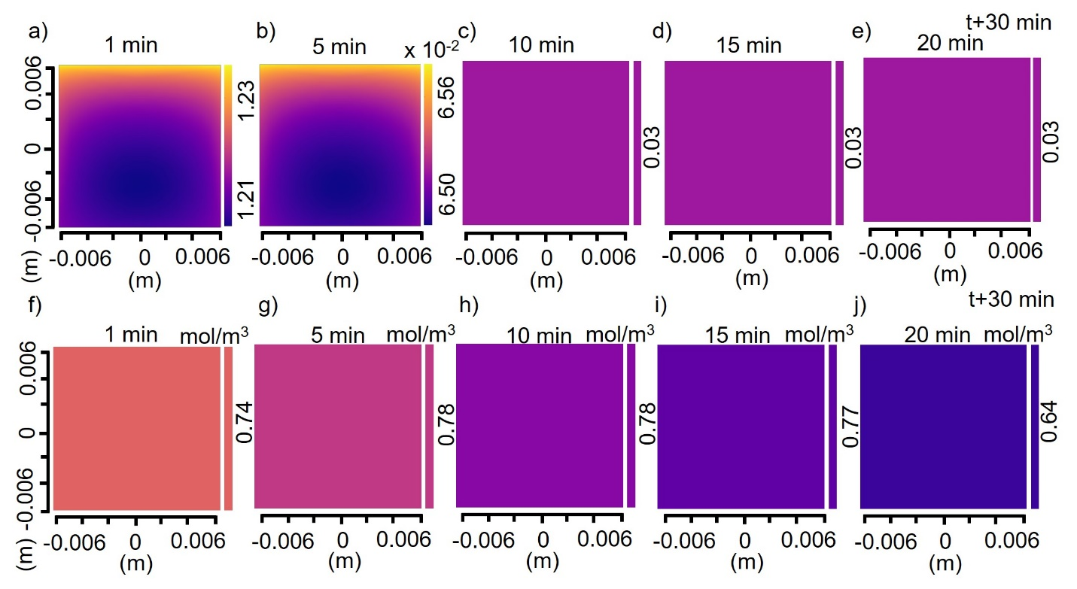
Figure S-VIII. Time dependent surface concentration profiles for substrate kept in the slot. a)-e) Surface concentration of MoO₃/S₈ ratio at the substrate at 1, 5, 10, 15, and 20 minutes of growth. The total growth time is 20 minutes. f)-j) Surface concentration of O₂ at the substrate at the same time intervals. Specified time steps exclude reactor heating time of 30 minutes.
In order to track the near substrate environment, we plot MoO₃/S₈ ratio and O₂ directly at the substrate in Figure S-VIII. Since variation along the substrate is minimal, we have chosen to represent average concentration values. As mentioned above, the MoO₃/S₈ ratio is highest during the initial stage of growth (Figure S-VIII a)-d)) and drops by two orders of magnitude toward the end of the nucleation window (1-5 min). In contrast, the concentration of O₂ remains almost constant throughout the growth process of 20 minutes.

- Calculating precursor adatom flux at the substrate for slotted and non- slotted configurations:
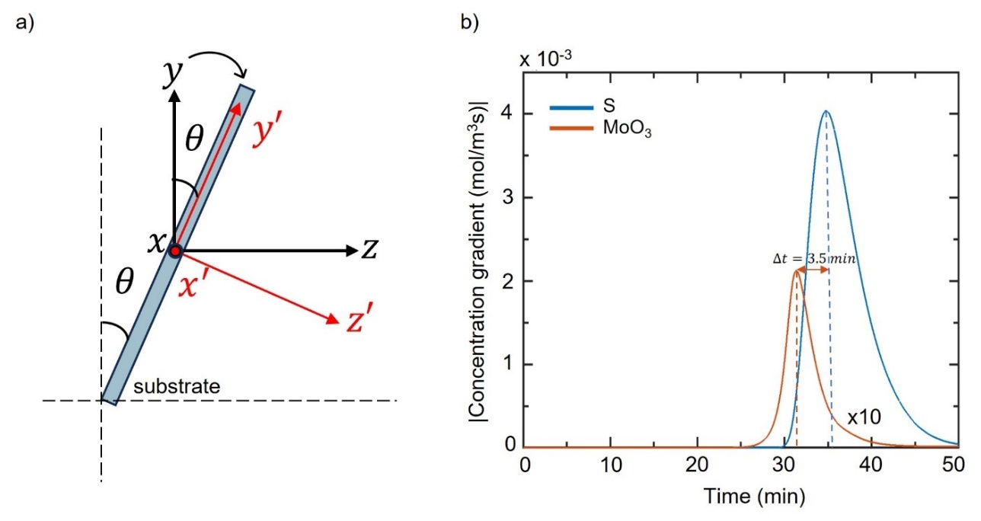
Figure S-XIV. Calculation of precursor adatom flux. a) Rotation of the coordinate system for flux calculation. The $x$ axis goes into the plane depicted. b) Average absolute concentration gradient profiles at the substrate for slotted configuration for S₈ and MoO₃. The time lag is indicated.
To corroborate our understanding of the non-trivial influence of the carrier gas velocity profile and precursor concentration, we calculated the incoming precursor flux at the substrate analytically. For a given surface, precursor concentration, growth time, and substrate temperature, the precursor flux is a useful indicator of the nucleation density, as described below. Since a real substrate is almost never homogenous due to the presence of defects, dislocations and impurity adatoms, we consider the theory of heterogenous nucleation¹⁴. For the case of vapor condensation of the reacting species, atoms arriving from the vapor phase impinge on the substrate and begin to migrate after a thermal accommodation period of the order of several atomic vibrations. These adatoms now collide with each other to produce atom clusters that are stable above a critical size, which gives critical radius of nuclei formation. The concentration of these atoms is proportional to the adsorption flux J (mol/m²s),
$\begin{aligned}J=\frac{P}{{\left(2πmkT\right)}^{\frac{1}{2}}}\#(S5) \\ \#\end{aligned}$ where P is the vapor equilibrium pressure (Pa), and T is absolute temperature of the vapor (K). Further, the mean residence time $τ_{s}$ (s) of the adatoms on the surface can be calculated as$\begin{aligned}τ_{s}= \frac{1}{ν_{⊥}}exp\left(\frac{E_{des}}{kT}\right)\#\left(S6\right)\end{aligned}$
where $E_{des}$ denotes the activation energy for desorption (J/mol) and $ν_{⊥}$, the vibrational frequency (Hz) of adatoms in the direction normal to the surface plane. It follows that the adatom concentration $n_{s}$ (mol/m³) can be obtained as
$$\begin{aligned}n_{s}= J.τ_{s}= \frac{P}{{\left(2πmkT\right)}^{\frac{1}{2}}}\frac{1}{ν_{⊥}}exp\left(\frac{E_{des}}{kT}\right)\#\left(S7\right)\end{aligned}$$
Now, the precursor adatom flux toward the critical nuclei on the substrate is given by $j_{s}$ (mol/m³), which can be estimated as
$$\begin{aligned}j_{s}= D_{s} ∇n_{s} ≅D_{s} \frac{n_{s}}{a}\#\left(S8\right)\end{aligned}$$
where the surface diffusion coefficient (m²/s) is determined as
$$\begin{aligned}D_{s}= a^{2}.ν_{=}exp\left(\frac{-E_{sd}}{kT}\right)\#\left(S9\right)\end{aligned}$$
Here, $E_{sd}$ is the activation energy of surface diffusion (J/mol) and $ν_{=}$ is the vibrational frequency of attachment of the atoms to the critical nuclei (Hz) and a is the length of a diffusion jump (m).
For a semispherical critical nucleus, assuming a radius of curvature r*, and wetting angle θ at the substrate and assuming $ν_{⊥}= ν_{=}= ν$, we obtain the frequency of attachments of atoms $ω^{*}$ (Hz) as
$$ω^{*}=2πr^{*}\sin{θ}. n_{s}.j_{s}$$
$$\begin{aligned}ω^{*}= 2πr^{*}\sin{θ} \frac{P}{{\left(2πmkT\right)}^{\frac{1}{2}}} a\exp\left(\frac{E_{des}-E_{sd}}{kT}\right)\#\left(S10\right)\end{aligned}$$
For the steady-state nucleation rate $Q_{0}$ (number/m³s), we can write
$$\begin{aligned}Q_{0}= ω^{*}Γ N^{*}\#\left(S11\right)\end{aligned}$$
where${ N}^{*}$ is equilibrium concentration of adatoms (mol/m³), and $Γ$ is known as the Zeldovich factor¹⁴ given by,
$$\begin{aligned}Γ= {\left(\frac{ΔG^{*}}{3πkTn^{*2}}\right)}^{\frac{1}{2}}\#\left(S12\right)\end{aligned}$$
where $ΔG^{*}$ is the free energy of nucleation (J) and $n^{*}$ is the number of atoms in critical nuclei of radius $r^{*}$.
Finally, we obtain the following expression for the steady-state nucleation $Q_{0}$ rate:
$$\begin{aligned}Q_{0}=2πr^{*}\sin{θ}\frac{J^{2}a}{ν} Γ\exp\left(\frac{{2E}_{des}-E_{sd}}{kT}\right) exp\left(-\frac{ΔG^{*}}{kT}\right)\#\left(S13\right)\end{aligned}$$
where $Γ$ now also contains the wetting function.
In order to quantitatively understand the effect of the presence of the slot on the type of growth obtained, we have used the simulated concentration profiles to obtain the precursor adatom flux at the substrate. As given by equation (S13), the rate of nucleation depends directly on the square of the precursor adatom flux,
$$Q_{0} ∝ J^{2}$$
Hence, calculating the precursor flux for both slotted and non-slotted configurations based on the simulated velocity and concentration profiles would be a direct indication of the nucleation density at the substrate. Since the vector profiles from the simulation are in accordance with the reactor’s global coordinates, we carry out a coordinate transformation to obtain the simulated profiles and derivatives w.r.t the new coordinates (centered at the substrate, Figure S-IX a)) as follows:
$$x=x'$$
$$y=y^{'}\cos{θ}-z^{'}\sin{θ}$$
$$z=y^{'}\sin{θ}+z^{'}\cos{θ}$$
$$\frac{∂y}{∂y'}=\cos{θ} ; \frac{∂y}{∂z'}= -\sin{θ}$$
$$\frac{∂z}{∂y'}=\sin{θ} ; \frac{∂z}{∂z'}=\cos{θ}$$
where $θ={10}^{°}$ is the angle made by the substrate with the vertical axis. Following the above coordinate transformation, $y'$ aligns with the substrate and $z'$ is perpendicular to and toward the substrate. The velocity transformations after taking the first derivative w.r.t. time are
$$\begin{aligned}v_{x}=v_{x^{'}}\#\left(S14\right)\end{aligned}$$
$$\begin{aligned}v_{y}=v_{y^{'}}\cos{θ}-v_{z^{'}}\sin{θ}\#\left(S15\right)\end{aligned}$$
$$\begin{aligned}v_{z}=v_{y^{'}}\sin{θ}+v_{z^{'}}\cos{θ}\#\left(S16\right)\end{aligned}$$
From equations (S15) and (S16),
$$\begin{aligned}v_{z^{'}}=v_{z}\cos{θ}-v_{y}\sin{θ}\#\left(S17\right)\end{aligned}$$
The transformation for the partial derivatives $\frac{∂C}{∂y^{'}}$ and $\frac{∂C}{∂z^{'}}$ is given by:
$$\begin{aligned}\frac{∂C}{∂y^{'}}= \frac{∂C}{∂y}\frac{∂y}{dy^{'}}+\frac{∂C}{∂z}\frac{∂z}{∂y^{'}}= \frac{∂C}{∂y}\cos{θ}+\frac{∂C}{∂z}\sin{θ}\#\left(S18\right)\end{aligned}$$

$$\begin{aligned}\frac{∂C}{∂z^{'}}= \frac{∂C}{∂y}\frac{∂y}{∂z^{'}}+\frac{∂C}{∂z}\frac{∂z}{∂z^{'}}= -\frac{∂C}{∂y}\sin{θ}+\frac{∂C}{∂z}\cos{θ}\#\left(S19\right)\end{aligned}$$
The final molar flux of species perpendicular to the substrate is given by
$$\begin{aligned}J= v_{z^{'}}.C-D\left(T\right). \frac{∂C}{∂z^{'}}\#\left(S20\right)\end{aligned}$$
From equations (S17) and (S19),
$\begin{aligned}J= \left(v_{z}\cos{θ}-v_{y}\sin{θ}\right).C-D\left(T\right).\left(\frac{∂C}{∂z}\cos{θ}-\frac{∂C}{∂y}\sin{θ}\right)\#\left(S21\right)\end{aligned}$

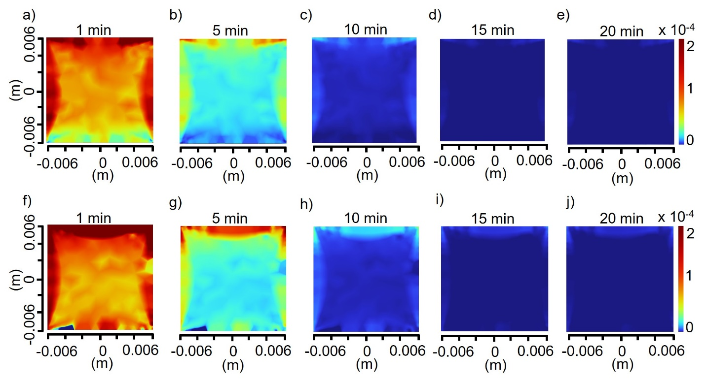
Figure S-X. Time-dependent transition metal precursor flux profiles for substrate kept in the slot, and without slot. MoO₃ precursor flux at the substrate kept a)-e) in the slot and f)-j) without slot at 1, 5, 10, 15, and 20 minutes of growth. The total growth time is 20 minutes. Specified time steps exclude reactor heating time of 30 minutes.
The above expression may be used to calculate the precursor flux using the simulated concentration and concentration gradient profiles from our integrated model. Figure S-X shows the transition metal (MoO₃) flux at the substrate throughout the growth process. It should be noted that these calculations depict the transition metal flux at the substrate well above the boundary layer and do not consider substrate reaction/diffusion phenomenon. A comparison of Figure S-X a)-e) (with slot) and S-X f)-j) (without slot) configurations reveals interesting and noteworthy features. First, the flux is lower around the region of the substrate physically in the slot in the top panel, compared to the rest of the substrate and substrate kept without slot. Second, the effect of the slot is local, while outside the slotted area flux values are essentially similar for both configurations. Lastly, the difference is most pronounced in the initial 5 minutes of growth, which is also the probable 2D nucleation window as discussed above. Due to a lower value of the transition metal flux in the presence of slot, the nucleation density is effectively reduced as per equation (6) in the main text.
This understanding corroborates our observed 2D monolayer MoS₂ growth and OM images, and is also confirmed by the SEM images later. As discussed earlier, a reduced nucleation density is a prerequisite for obtaining uniform, monolayer MoS₂ with a larger edge length instead of several small domains. Hence, we relate the modified velocity profile due to the presence of the slot to the decreased transition metal flux which in turn reduces the observed nucleation density in the slot and gives rise to the observed growth.
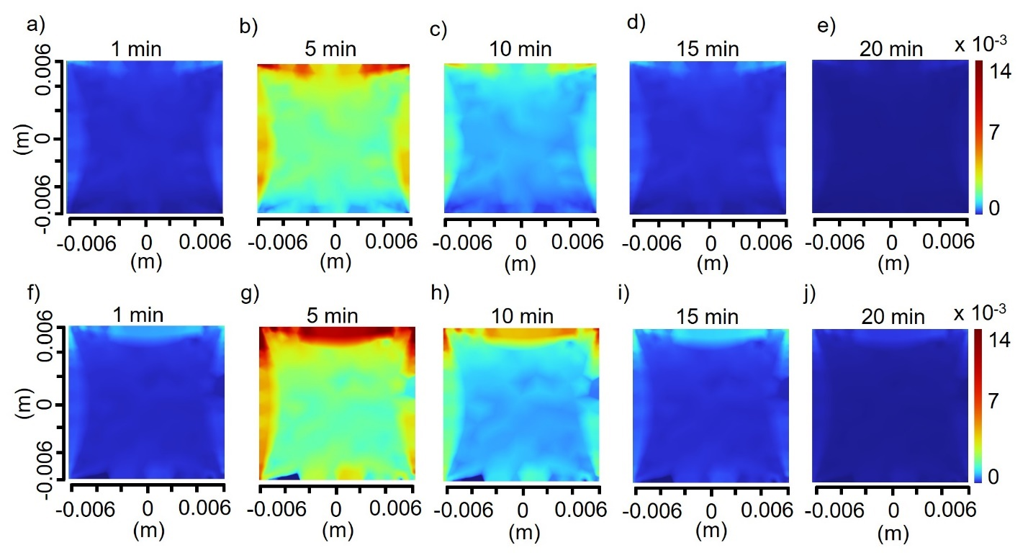
Figure S-XI. Time-dependent chalcogen precursor flux profiles for substrate kept in the slot, and without slot. Sulfur precursor flux at the substrate for a)-e) slotted and f)-j) non- slotted configurations. Time stamps are at 1, 5, 10, 15, and 20 minutes of growth. The total growth time is 20 minutes. Specified time steps exclude the reactor heating time of 30 minutes.
Figure S-XI shows the sulfur precursor flux at the substrate throughout the growth time. A comparison of Figure S-XI a)-e) and f)-j) shows that the presence of the slot also decreases the flux for sulfur precursor, although the difference is less pronounced. This may be due to the high concentration of sulfur compared to MoO₃ due to its higher vapor pressure. A significantly higher concentration and higher atomic diffusivity (as found by Chapman-Enskog relation) compared to MoO₃ may lead to efficient diffusion and convection of chalcogen atoms, thus suppressing the effect of the slot to some extent. However, it may be noted that unlike the transition metal precursor flux which decreases monotonically throughout the growth, the chalcogen flux is lower at the beginning of the growth, starts increasing at around 5 minutes after start of growth as seen in Figure S-XI b) and g) and then eventually decreases. This trend is desirable and results in better controlled growth as explained below. Since the distance between substrate and the chalcogen source is larger, there exists a time lag of ~ 4 minutes between MoO₃ and S achieving maximum concentration at the substrate. Thus, a sulfur-depleted local environment is formed near the substrate in the initial window of nucleation. This allows us to tune the nucleation density by tuning MoO₃ precursor supply only and thus offers better control without added complexity. The observed trend from simulated sulfur flux profiles in Figure S-XI also indicates that the growth rates might be lesser in the initial 5 minutes due to the lower chalcogen flux than at later times.
Another interesting trend to observe in the flux profiles in Figures S-X and S-XI is the decrease in the precursor flux during the later stages of growth. The MoO₃ and S fluxes peak at ~31 and ~35 minutes respectively and decrease hereafter. This trend may be explained by observing the precursor concentration gradients averaged over the substrate as in Figure S-IX (b). Since the concentration rises and becomes constant over a period of several minutes (main text, Figure- 2 e)), the gradient function resembles a Gaussian. As the second term in equation 20 contributes positively to the flux, a decrease in the absolute value of the concentration gradient, $\left(\frac{∂C}{∂z}\cos{θ}-\frac{∂C}{∂y}\sin{θ}\right)$ results in a decrease in the overall precursor flux at the substrate.

- Scanning electron microscopy (SEM) for comparing nucleation density:
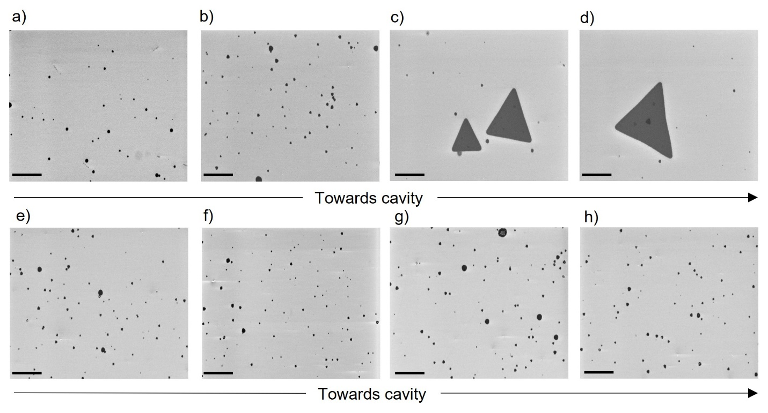
Figure S-XII. Scanning Electron Microscopy (SEM) comparison of slotted and non-slotted configurations. a) and b) SEM images of substrate in the slotted configuration at different vertical places along the length. c) and d) SEM images of monolayer MoS₂ physically inside the slot. e), f), g) and h) SEM images of the substrate in the non-slotted configuration. Scans are acquired starting from the top edge toward the bottom edge.
To support our analytical calculations regarding nucleation density, we performed SEM on the as-grown samples. Figure S-XII shows SEM images for both the slotted and non-slotted configurations (top and bottom panels respectively). Figures S-XII a)-d) and S-XII e)-h) are representative scans at the from the top edge to bottom edge for the substrates kept with and without the slot respectively. Uniform monolayer growth is observed only toward the bottom edge, near the region of the substrate in or closer to the slot. No single-crystal triangular MoS₂ flakes could be observed for the substrate kept without slot. Comparison of Figure S-XII panels c), d) and g), h) highlights the significant effect of a slot on observed nucleation. For the substrate kept inside the slot (Figure S-XII c) and d)), owing to low precursor flux, number of new nuclei formed is lower and much of the material feeds into the existing nuclei, which gives larger flakes for similar precursor concentrations and carrier gas flow. This also supports our analytical calculations as discussed in Section V above, where modifications of the carrier gas velocity field near the substrate results in comparatively lower transition metal flux in confined space of the slot. Interestingly, farther away from slot, in Figure S-XII a) and b), the deposition is almost similar (compared to Figure S-XII e) and f) which indicates that slot induced modifications to the growth environment are local to the created confined space.

- Temperature profile along the reactor and at the substrate during heating and growth:
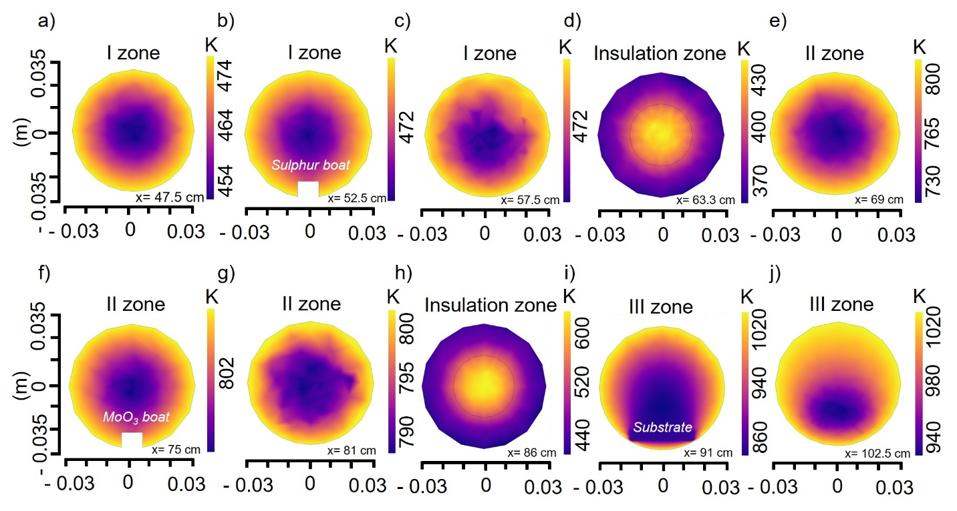
Figure S-XIII. Simulated temperature profiles along the reactor. a)-h) Radial temperature profiles at specified distances from the inlet (left end of the reactor). Distance from the inlet is indicated at the bottom right for each plot. Precursor boats and the substrate are marked.
Temperatures of the growth zone and the substrate in particular are critical factors which can directly affect initiation of nucleation, growth rates, and the probability of secondary deposition^{9,15}. In order to better understand the growth environment, we closely look at temperature simulations of the growth zone (III zone). Fig. S-XIII shows the radial temperature profiles along the reactor length at specified distances from the inlet. It can be observed that there exists a significant radial temperature gradient away from the boundary heating sources as well as in the insulation zones. Video V-V shows axial temperature profile in the reactor duirng heating as well as growth.
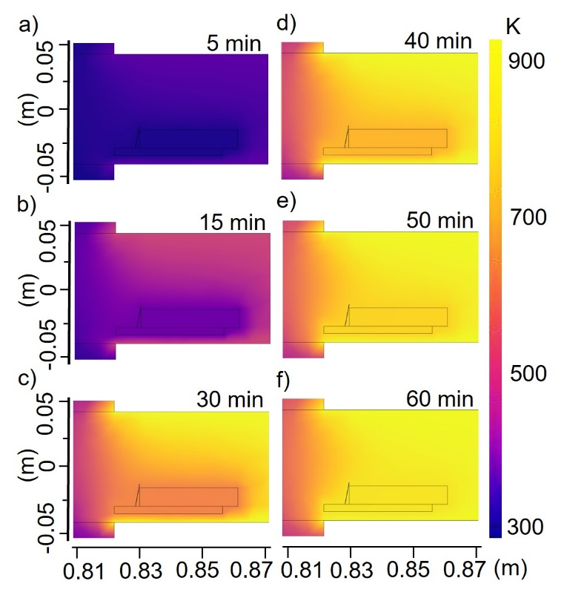
Figure S-XIV. Axial temperature profiles at and near the substrate. a)- f) Axial temperature profiles in the third zone (near the substrate) at specified times.
Figure S-XIV a)-f) shows the axial temperature profile near to the substrate assembly at specified times. Interestingly, the effect of the holder material (alumina) is clearly visible in this simulation. As a widely used material for high-temperature CVD and related processes, alumina holders, boats, and supports are routinely employed. Even though specific heat capacities of alumina (0.880 J/g-ºC) and inert gases such as N₂/Ar or even air (1.012 J/g-ºC) are similar, the density of the former material is much higher. The density of alumina is ~ 3.99 g/cm³, whereas that of N₂ is ~ 1.25$×$10⁻³ g/cm³. Thus, for a given occupied volume, alumina heats up slowly compared to its gaseous environment. This is an important detail with respect to the growth process as 3/4th of total growth time is up by the time the temperature achieves the saturation value at the substrate. Also, since precursors are also kept in alumina boats, the saturation vapor pressure at any given time may be lower than expected from the set temperature.
Interestingly, as seen in Figure 4 and discussed in Section VII on temperature modeling, there exists a temperature gradient between the substrate (at a lower temperature) and the local inert gas environment (at a higher temperature). The thermal boundary layer formed due to this variation may give rise to Thermo-Diffusion also called the Ludwig-Soret effect¹⁶. Due to the thermal gradient present, the convective currents generated will tend to accumulate the lighter chalcogen atoms toward the hotter regions while heavier transition metal atoms near the colder region (substrate)¹⁷. However, further studies are required to understand if the present thermal gradients might give rise to experimentally significant Thermo-Diffusion, and to assess its tunability for nucleation and growth by precursor concentration modulation.

References:
(1) Sharifi, Y.; Achenie, L. E. K. Effect of Substrate Geometry on the Deposition Rate in Chemical Vapor Deposition. J. Cryst. Growth 2007, 304 (2), 520–525. https://doi.org/10.1016/j.jcrysgro.2007.03.046.
(2) Huet, B.; Zhang, X.; Redwing, J. M.; Snyder, D. W.; Raskin, J.-P. Multi-Wafer Batch Synthesis of Graphene on Cu Films by Quasi-Static Flow Chemical Vapor Deposition. 2D Mater. 2019, 6 (4), 045032. https://doi.org/10.1088/2053-1583/ab33ae.
(3) Pengfei Yan, Jin Wang, Guofeng Yang, Naiyan Lu, Guangyong Chu, Xiumei Zhang, Xiaowen Shen, Chemical Vapor Deposition of Monolayer MoS₂ on Sapphire, Si and GaN Substrates, Superlattices and Microstructures, Volume 120, 2018, Pages 235-240, ISSN 0749-6036, Https://Doi.Org/10.1016/j.Spmi.2018.05.049.
(4) Hirschfelder, J. O.; Curtiss, C. F.; Bird, R. B. The Molecular Theory of Gases and Liquids; Wiley, 1954.
(5) Govind Rajan, A.; Warner, J. H.; Blankschtein, D.; Strano, M. S. Generalized Mechanistic Model for the Chemical Vapor Deposition of 2D Transition Metal Dichalcogenide Monolayers. ACS Nano 2016, 10 (4), 4330–4344. https://doi.org/10.1021/acsnano.5b07916.
(6) Peng, D.-Y.; Zhao, J. Representation of the Vapour Pressures of Sulfur. J. Chem. Thermodyn. 2001, 33 (9), 1121–1131. https://doi.org/10.1006/jcht.2001.0835.
(7) Gulbransen, E. A.; Andrew, K. F.; Brassart, F. A. Vapor Pressure of Molybdenum Trioxide. J. Electrochem. Soc. 1963, 110 (3), 242. https://doi.org/10.1149/1.2425719.
(8) Ohring, M. Chapter 3 - Thin-Film Evaporation Processes. In Materials Science of Thin Films (Second Edition); Ohring, M., Ed.; Academic Press: San Diego, 2002; pp 95–144. https://doi.org/10.1016/B978-012524975-1/50006-9.
(9) Wang, W.; Zeng, X.; Wu, S.; Zeng, Y.; Hu, Y.; Ding, J.; Xu, S. Effect of Mo Concentration on Shape and Size of Monolayer MoS₂ Crystals by Chemical Vapor Deposition. J. Phys. Appl. Phys. 2017, 50 (39), 395501. https://doi.org/10.1088/1361-6463/aa81ae.
(10) Wang, T.; Guo, J.; Zhang, Y.; Yang, W.; Feng, X.; Li, J.; Yang, P. Synthesis of High-Quality Monolayer MoS₂ via a CVD Upstream Deposition Strategy for Charge Capture and Collection. Cryst. Growth Des. 2024, 24 (7), 2755–2763. https://doi.org/10.1021/acs.cgd.3c01369.
(11) Lyons, J. R. An Estimate of the Equilibrium Speciation of Sulfur Vapor over Solid Sulfur and Implications for Planetary Atmospheres. J. Sulfur Chem. 2008, 29 (3–4), 269–279. https://doi.org/10.1080/17415990802195615.
(12) Zafar, A.; Zafar, Z.; Zhao, W.; Jiang, J.; Zhang, Y.; Chen, Y.; Lu, J.; Ni, Z. Sulfur-Mastery: Precise Synthesis of 2D Transition Metal Dichalcogenides. Adv. Funct. Mater. 2019, 29 (27), 1809261. https://doi.org/10.1002/adfm.201809261.
(13) S Kumar, K.; Dash, A. K.; Sabreen H, H.; Verma, M.; Kumar, V.; Watanabe, K.; Taniguchi, T.; Gautam, G. S.; Singh, A. Understanding Interplay of Defects, Oxygen and Strain in 2D Materials for next-Generation Optoelectronics. 2D Mater. 2024. https://doi.org/10.1088/2053-1583/ad4e44.
(14) Markov, I. V. Crystal Growth for Beginners: Fundamentals of Nucleation, Crystal Growth and Epitaxy; World Scientific, 2003.
(15) Arafat, A.; Islam, M. S.; Ferdous, N.; Islam, A. S. M. J.; Sarkar, M. M. H.; Stampfl, C.; Park, J. Atomistic Reaction Mechanism of CVD Grown MoS₂ through MoO₃ and H₂S Precursors. Sci. Rep. 2022, 12 (1), 16085. https://doi.org/10.1038/s41598-022-20531-x.
(16) Rahman, M. A.; Saghir, M. Z. Thermodiffusion or Soret Effect: Historical Review. Int. J. Heat Mass Transf. 2014, 73, 693–705. https://doi.org/10.1016/j.ijheatmasstransfer.2014.02.057.
(17) YEH, H.-M. Enrichment of Heavy Water by Thermal Diffusion. Chem. Eng. Commun. 1998, 167 (1), 167–179. https://doi.org/10.1080/00986449808912699.

