Supplementary Material for

Ultra-Compact Solar Telescope with Wavefront Correction Ability
Naiting Gu^{a,b,c,d,*}, Hao Chen^{a,c,d}, Ao Tang^{a,c,d}, Xinlong Fan^{a,c,d}, Carlos Quintero Noda^{e,f}, Yawei Xiao^{a,b,c,d}, Libo Zhong^{a,c,d}, Xiaosong Wu^{a,b,c,d}, Zhenyu Zhang^{c}, Yanrong Yang^{g}, Xiaohu Wu^{h,*}, Linhai Huang^{a,b,c,d,*},Zao Yi^{i}, and Changhui Rao^{a,b,c,d}
ªNational Laboratory on Adaptive Optics, Chengdu 610209, China
^{b}University of Chinese Academy of Sciences, Beijing 101408, China
^{c}Institute of Optics and Electronics, Chinese Academy of Sciences, Chengdu 610209, China
^{d}The Key Laboratory on Adaptive Optics, Chinese Academy of Sciences, Chengdu 610209, China
^{e}Departanmento de Astrofísica, Univ. De La Laguna, La Laguna, Tenerife, E-38025, Spain
^{f}Instituto de Astrofísica de Canarias, E-38025, La Laguna, Tenerife, Spain
^{g}Chengdu University of Traditional Chinese Medicine, Chengdu 610075, China
^{h}Thermal Science Research Center, Shandong Institute of Advanced Technology, Jinan 250100, Shandong, China
^{i}Joint Laboratory for Extreme Conditions Matter Properties, Southwest University of Science and Technology, Mianyang 621010, China

*Corresponding authors: Naiting Gu(mailto:gnt7328@163.com), Xiaohu Wu(xiaohu.wu@iat.cn), and Linhai Huang(hlhai@ioe.ac.cn)

A 600 mm prototype system of solar adaptive optics telescope (SAOT) mainly aims to verify the proposed method and design. The detailed system parameters of 600 mm SAOT are shown in Table S1.
Table S1 System parameters of the 600 mm prototype of SAOT.
Parameter | Value
Optical style | On-axis Gregorian optics
Aperture Size | Φ600 mm with Φ590 mm of clear aperture
Obstruction ratio(in Diameter) | 35.6%
Field of View(FoV) | ~Φ3'
Spectral coverage | 380-2500 nm
Shape of SDM | Concave ellipsoid
Mount | Equatorial type, DDM160 made by ASA
Image space F# | ~F/9
Post-focus instrument | TiO band imager for first light  Hα line and magnetic field imager for future
The initial scientific goal of the prototype of SAOT is to perform near-diffraction-limit imaging of the solar atmosphere at activity regions and its evolution process in the photosphere layer. The optical system design scheme and the corresponding systematic structure of the established 600 mm aperture size SAOT system are shown in Fig. S1(a) and (b). We adopt a single Gregorian optics design, and an open tube truss is used to keep all optical elements at their right positions and is equipped with an equatorial mount of DDM160 made by ASA, Austria. Sun shield coated by TiO₂ layer can protect the tube truss, avoiding radiation of sun light. The primary focus position F1 is used to equip a Heat-Stop to prevent sunlight and thermal response. A SDM with 61 actuators is installed behind the focus F1, about 300mm from the exit pupil position. We set up a folded axis reflector FM above the primary mirror and placed the scientific focus F2 and post-focus instruments on the tube truss of SAOT, mainly because the active thermal control system needs to be installed behind the primary mirror of SAOT to carry out high-precision control of mirror surface temperature, avoiding mirror seeing effect and thermal deformation, as shown in Fig. S1(b). The post-focus instruments are installed in the instrument box and fixed on the tube truss together, including an imaging detector and a Hartmann wavefront sensor (HS WFS) for measuring full wavefront aberrations including global tip-tilt error and higher-order wavefront aberration in real time. In initial configuration of SAOT, only one imaging channel for observing the photosphere layer with TiO band was equipped with the center light band of 705.7 nm. The other kinds of post-focus instruments will be equipped successively, including imaging channels for observing the chromosphere layer at Hα line and magnetic filed imager etc., in the following time. The critical components of the SAOT system are described in detail below.
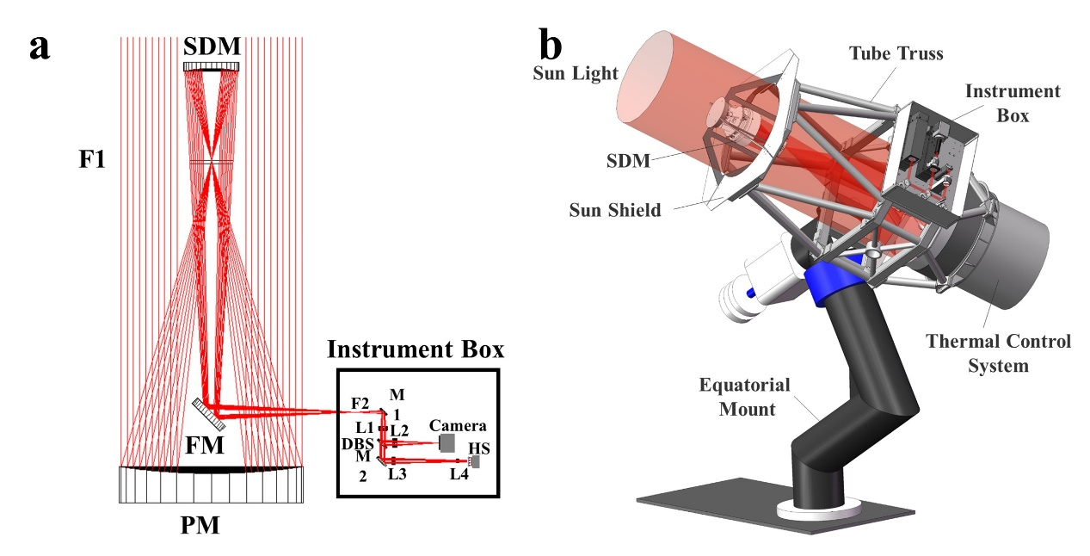
Fig. S1 Prototype of SAOT with 600mm aperture size. (a) Optical design of 600mm prototype of SAOT. (b) Systematic structure of 600mm SAOT system. PM: primary mirror; SDM: secondary deformable mirror; FM: fold mirror; DBS: dichroic beam-splitter; F1: primary focus; F2: scientific focus; M1/2: reflective mirror; L1: collimator; L2: imaging lens; L3&4: beam shrink lenses; HS: Hartmann-Shack wavefront sensor (WFS).
600 mm prototype of SAOT adopts a 2-mirror Gregorian system, which includes two focusing mirrors (PM and SDM) and a plane folding mirror (FM). The primary mirror adopts a light-weighted honeycomb primary mirror made of ULE material, with a coaxial paraboloid surface and a focal length of about 1020 mm. The secondary deformable mirror (SDM) adopts a concave ellipsoid surface and a radius of 504.8 mm with a conic coefficient of about -0.466. The fold mirror has a planar surface made of SiC material. The optical parameters of the three mirrors are shown in the table below.
Table S2 Mirrors of the 600 mm SAOT.
Parameter | PM | SDM | FM
Shape | Concave paraboloid | Concave ellipsoid | Flat
Conic | -1.000 | -0.466 | -
Radius | -2040 mm | 504.8 mm | -
Clear Aperture | Φ590 mm | Φ174 mm | 56mm×78mm, ellipse
Coating | Protected Aluminum | Protected Silver | Protected Silver
The parameter design of the SDM and its HS WFS is directly related to the telescope system and the atmospheric conditions at the site. The 600 mm SAOT is to be installed at Lijiang Observatory, which is located on the top of Tiejia Mountain, near the Gaomeigu village, Lijiang City, Yunnan Province in China (East:100°01'48'', North: 26°41'42'', at the height of 3200 m) [1]. The Lijiang Observatory is the biggest optical astronomical site in southern China. Atmospheric seeing condition at night ranges from 0.5'' to 5.5'', and the annual statistical mean seeing is about 1.16'', equivalent to 9.8 cm of atmospheric coherence length r₀ [1]. Influenced by solar radiation, the seeing condition at Lijiang Observation Station is worse in the daytime than at night. According to our measurement results of seeing conditions in some daytime around April 2013, between 9:00 a.m. and 6:00 p.m., the atmospheric coherence length r₀ in the daytime firstly decreased rapidly from 11.5 cm to about 1.5 cm at noon. It then slowly rose to about 6.0 cm after 2:30 p.m.
In this work, the measured atmospheric coherence length data were fitted. The median value was taken as the design basis for the SDM in the 600 mm SAOT system. As shown in Fig. S2, corresponding to the fitting data, the best and worst r0 are about 9.75cm and 0.75cm, respectively, and the median value is about 4.5 cm. According to the corresponding relationship of different spectral atmospheric coherence lengths, the equivalent r₀ at the TiO band can be analyzed to be about 6.07 cm, which is the design reference of HS WFS and SDM in the 600 mm SAOT system.
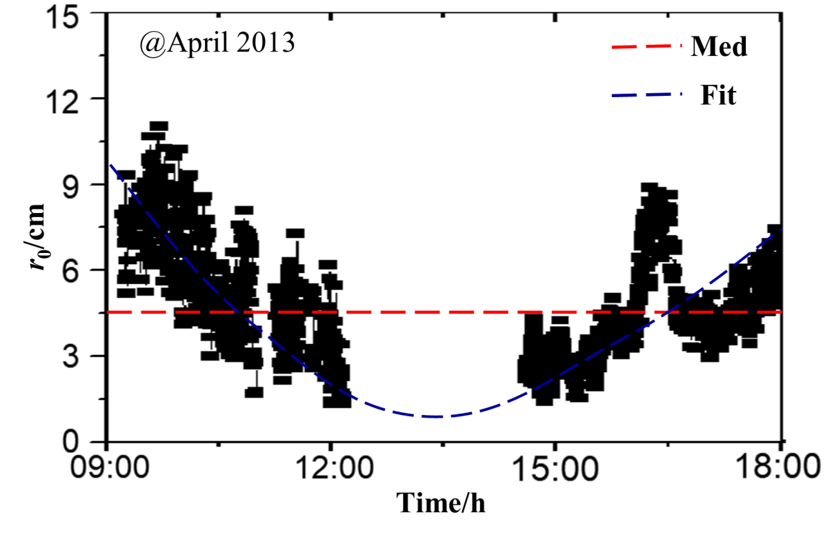
Fig. S2 Atmospheric coherent length r₀ varies with time during daytime at Lijiang Observatory (blue dash line: fitting data; red dash line: median value).
The SDM in the 600 mm SAOT system adopts a discrete actuator and continuous face plate. The piezoelectric PZT is used as the actuator material, adopting its faster response and higher accuracy. According to the early research results of Greenwood et al. [2], the number of SDM actuators required for the atmospheric wavefront aberration correction ability, N_{act}, can be preliminarily determined as follows:
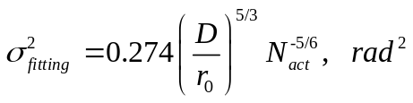 (6)
Here, σ_{fitting} refers to the fitting residual after atmospheric aberration correction by SDM, which is required to be below 0.1λ; D is the light-through aperture of SAOT, which is 590 mm; r₀ is the equivalent atmospheric coherent length of the observation band, which is 6.07 cm. Thus it can be preliminarily analyzed that the number of SDM actuators N_{act}≥60.95 according to Eqn. (6). In this system, N_{act} is taken at 61, which coincides with the usual number of deformable mirror actuators with hexagon distribution. The initial position of these actuators is located uniformly in three rings with a center actuator, and the number of actuators in each ring are 6, 18 and 36, respectively. However, the actuator distribution of SDM should be optimized for practical application, and this will be discussed in the third part. The detailed design parameters of SDM are shown in Table S3.
Table S3 Parameters on 61-SDM
Parameter | Value
Aperture size | Φ210 mm
Clear aperture | Φ174 mm
Freedom of correction | 61
Actuator layout | Annular
Actuator material | PZT
Actuator spacing | 18.5 mm(~62.8 mm, mapping to PM)
Actuator stroke | ±3 μm
Coupling coefficient | ~10%
The HS WFS is critical for SDM to complete accurate correction, and its role is to detect wavefront aberration of incident light. In this work, 600 mm SAOT adopts a cross-correlation HS WFS, which uses the (normalized) cross-correlation or the other similar algorithm to estimate sub-image offset, due to the solar atmosphere being an extended object. The HS WFS selects the center wavelength of 550 nm with about 10nm bandwidth for wavefront detection to avoid the imaging spectrum.
To conduct high dynamic measurement of atmospheric wavefront aberration, a high frame frequency CMOS detector EoSens@CL is chosen, which has a maximum frame frequency of up to 2000 fps and a high spatial resolution of 528×528 with 14 μm×14 μm pixel size. To achieve the best balance between wavefront detection frequency and pixel resolution of each sub-aperture, we design a 12×12 square lenslet array with a single sub-aperture size of 500 μm and a sub-aperture focal length of 30 mm. Each lenslet covers about 36×36 pixels and ensures that at least 2 pixels are sampled for diffraction-limit point spread function (PSF) in each micro-lenslet. The detailed design parameters of HS WFS are shown in Table S4.

Table S4 Parameters of HS WFS
Parameter | Value
Wavelength | 550 nm with 10nm bandwidth
Resolution | 12×12square(96 valid)
Size of each lenslet | 500 μm×500 μm
Field of View | ~30″
Focal length of lenslet | 30 mm
Pixel resolution of each lenslet | ~36×36 with 14 μm×14 μm pixel size
Frame frequency | 900-2000 fps
Different from the traditional night astronomy adaptive optical wavefront sensor, the HS WFS of SAOT needs to set an additional field stop, which mainly consists of a square hole placed at the focus position of the relay optical system, to prevent the signal crosstalk between different sub-apertures of HS WFS. In the 600 mm SAOT system, the detection field of view of HS WFS is about 30", and the pupil diameter is about Φ6 mm. The optical layout is shown in Fig. S3.
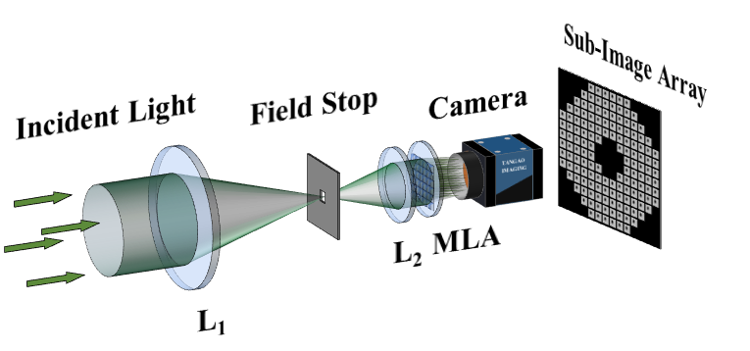
Fig. S3 System configuration of cross-correlation HS WFS. MLA: micro-lenslet array; L1&L2: lenses of relay optics.
The controller is another essential part of 600 mm SAOT for realizing wavefront correction, which mainly includes telescope tracking pointing control, global tip-tilt control, and high-order wavefront aberration control. The DDM160 equatorial type mount equipped in 600 mm SAOT has a sun guider module, which can guide the sun stably with a pointing accuracy of 8" and tracking accuracy of 0.25" within 5min. Certainly, it cannot solve some tracking errors caused by system vibration and atmosphere turbulence, and the SDM becomes the only corrector to correct the global tip-tilt caused by these sources. Besides, the SDM also corrects the dynamic higher-order wavefront aberration in real time. The flowchart of 600 mm SAOT controller is illustrated in Fig. S4. Under the guidance of the sun guider module of DDM160, the 600mm SAOT steadily tracks the solar active region of interest, and the HS WFS detects the wavefront aberration of the 600mm SAOT pupil plane in high dynamics using the solar atmosphere itself as a beacon and acquires the sub-image array in real-time. For high-order wavefront aberration detection, the high-order wavefront aberration corresponding to each sub-image array can be recovered in real-time by analyzing each sub-lenslet concerning the reference sub-lenslet correlation coefficient (CCC), and calculating the slop distribution of wavefront by using the centre-of-mass algorithm. At the same time, the sub-image array detected by HS WFS in real-time can be used to analyse and calculate the CCC of each sub-aperture relative to the corresponding sub-aperture at the reference time to estimate the global tip-tilt at the current time. The real-time controller (RTC) carries out proportional-integral control (proportional-integral control) on the detected higher-order wavefront aberration and global tip-tilt and calculates the SDM control signal, which is outputted and controlled by a high-voltage amplifier High-Voltage Amplifier (HVA). After the HVA, the SDM control signal is calculated and output to control the SDM surface type, which realizes the fast and effective correction of high order aberration and global tip-tilt.
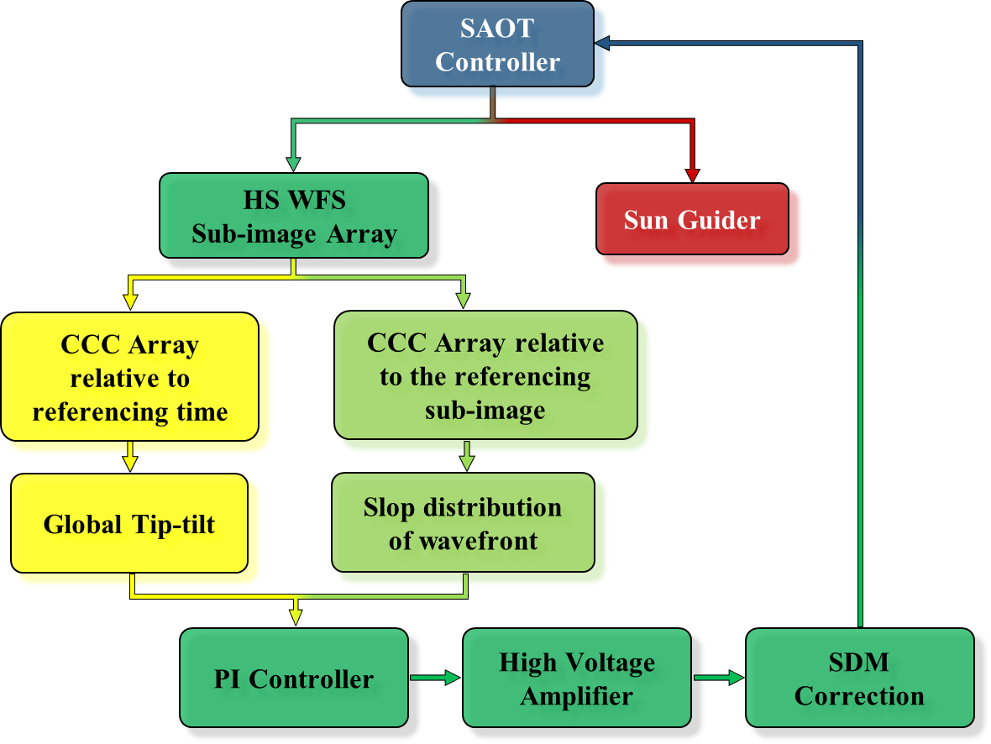
Fig. S4 Flowchart of 600 mm SAOT controller (CCC: cross correlation coefficient).
Fig. S5 shows the detected wavefront aberration by HS WFS and the corresponding residual wavefront error compared to the simulated random phase screen. There was little difference between the detected wavefront aberration and the given random phase screen due to the ability limitation of HS WFS for high spatial frequency components and spatial filtering by using the first 65 orders of Zernike polynomials. The PV and RMS of the detected wavefront, as shown in (a), are 2.56λ and 0.48λ respectively.
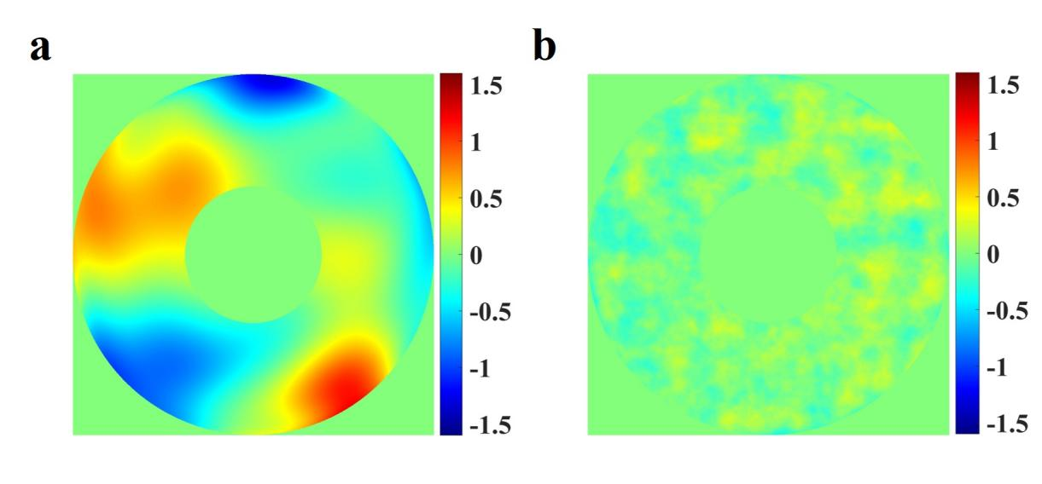
Fig. S5 Wavefront detection of HS WFS and its residual wavefront error. (a) Phase distribution of wavefront aberration detected by HS WFS(PV=2.56λ, RMS=0.48λ); (b) Residual wavefront error compared to the given random phase screen(PV=0.73λ, RMS=0.12λ).
The measured slopes of HS WFS were input to the SAOT controller, and the corresponding correction voltage value were calculated and output to SDM. The shape of SDM after wavefront correction and the corresponding residual wavefront error are illustrated in Fig. S6. In comparison, the SDM surface type is relatively smooth, and its high-frequency correction ability is limited. Hence, the wavefront correction residual is mainly high-frequency aberration. Still, overall, the RMS value of the wavefront after correction decreases to below 0.10λ.
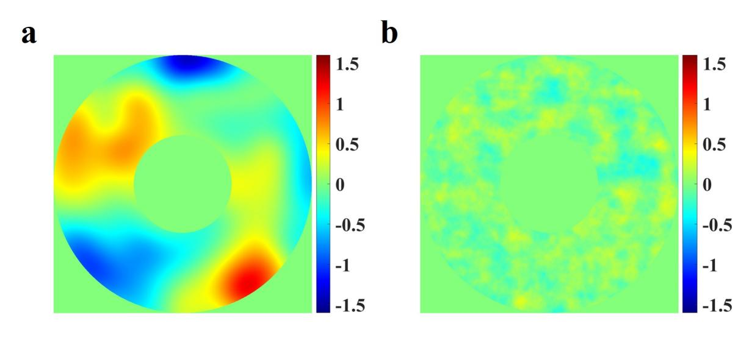
Fig. S6 Shape of SDM and the corresponding residual wavefront error after wavefront correction. (a) Shape of SDM after wavefront correction (PV=2.65λ, RMS=0.47λ); (b) The corresponding residual wavefront error after correction (PV=0.72λ, RMS=0.10λ).
During the wavefront correction process, the image quality was affected obviously by wavefront aberration. Fig. S7 (a) shows the simulated original image of the solar atmospheric photosphere with about 66″ of field of view (FoV), which is generated by Dr. Carlos Quintero Noda. The diffraction-limit image can be obtained by using convolution operation between the original image and the ideal PSF of the 600mm SAOT, as shown in Fig. S7(b). Fig. S7(c) and (d) are images blurred by atmosphere turbulence before SDM correction and after correction. We use the structure similarity based image quality (SSIM) index [3] to assess the image quality before and after SDM correction. The original image is selected as the referencing image, and thus its SSIM = 1.0. And when the wavefront aberration is smaller after SDM correction, the value of SSIM is closer to 1.0. In our simulations, the SSIM of the diffraction-limited image is about 0.7817, and it is blurred to 0.2690 before SDM correction and improved to 0.6891 after wavefront correction, respectively.
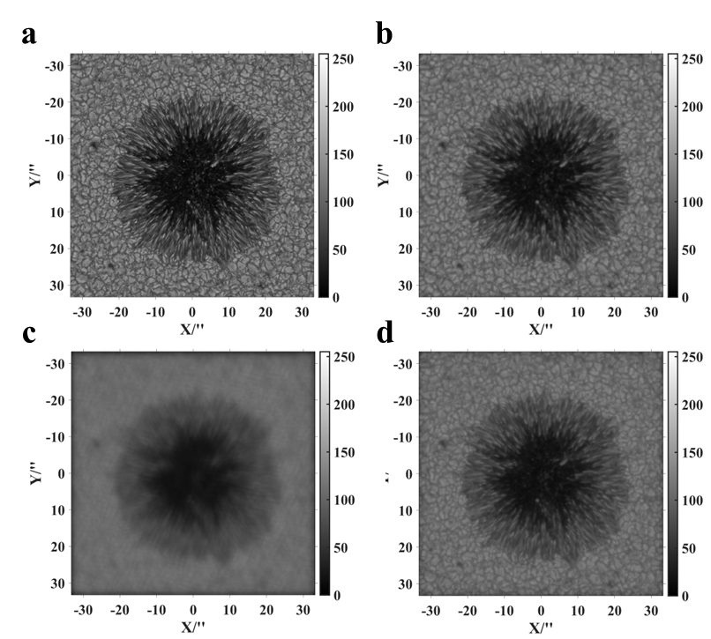
Fig. S7 Images of original, diffraction limit, before and after wavefront correction. (a) Original image on solar photosphere layer (referencing image, SSIM=1.0); (b) Diffraction limit image of (a) limited by the ideal PSF of 600mm SAOT (SSIM=0.7817); (c) Blurred image before wavefront correction (SSIM=0.269) and (c) Image after wavefront correction (SSIM=0.6891) .
The correction ability for static wavefront aberration was validated first. The simulated static wavefront aberration was mainly generated from the mismatch between SDM and the following optics adjusting by Hexapod mechanism and shape change of SDM itself. The 12×12 resolution HS WFS was fabricated and used to detect the simulated wavefront aberration, and the data was input to real-time controller (RTC) and used to control the shape of SDM. Wavefront detection, control, and correction were conducted for both point and extended objects. The wavefront aberrations of the experimental system before and after SDM correction are shown in Fig. S8. The simulated static wavefront aberration was mainly composed of the first 15-order Zernike aberration, and the PV value and RMS value were 3.59 μm and 0.67 μm respectively, which were approximately 5.1λ and 0.95λ of the working wavelength. After SDM correction, the PV and RMS of the residual wavefront error were reduced obviously to 0.23 μm and 0.04 μm, respectively, which were approximately 0.33λ and 0.06λ of the working wavelength. The SDM correction ability for static wavefront aberration is validated.
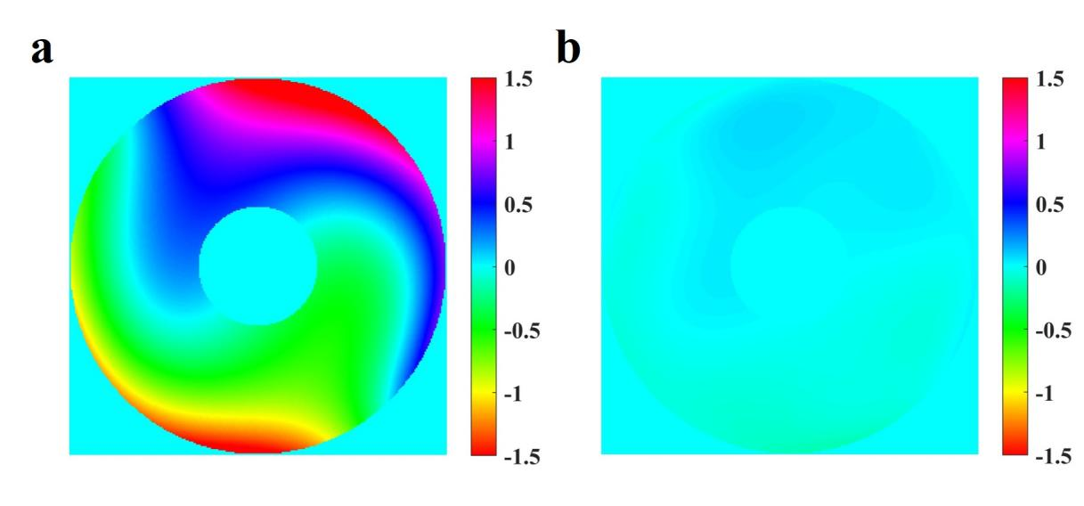
Fig. S8 Experimental results on wavefront aberration correction. (a) Wavefront aberration before SDM correction (PV≈5.1λ, RMS≈0.95λ) and (b) Residual wavefront error after SDM correction (PV≈0.33λ, RMS≈0.06λ).
Fig. S9 shows the images of the simulated extended light source captured by the camera before and after wavefront correction. It can be seen that the image quality of extended objects is significantly improved before and after wavefront aberration correction. The imaging contrast of the simulated extended target is improved by a factor of 1.72 after SDM correction.
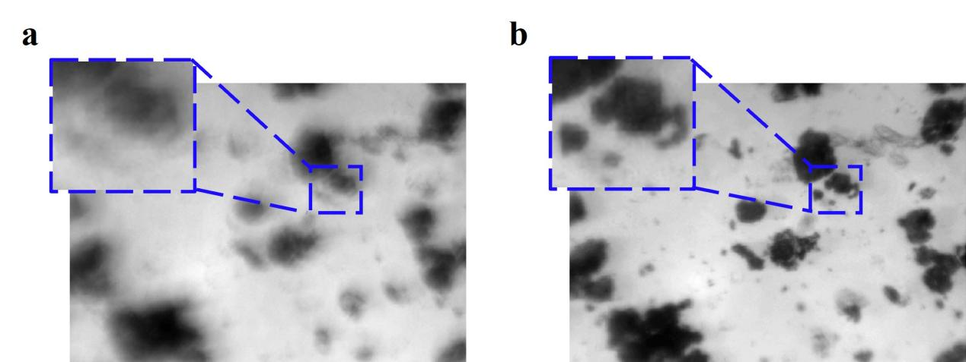
Fig. S9 Experimental images of the simulated extended light source captured by the camera before and after wavefront correction. (a) Image before wavefront correction and (b) Image after wavefront correction (improve about 1.72 times of the imaging contrast).
Fig. S10 shows the dynamic tracking curves and power spectral distribution (PSD) of 600 mm SAOT along the X and Y directions before and after SDM correction. The results show that the tracking error is significantly reduced. Among them, the tracking error in the X direction is reduced from the maximum 1'' before SDM correction to about ±0.07'' after correction, and the tracking accuracy is increased by about 14.3 times (as shown in Fig. S10 (a)); the tracking error in the Y direction is reduced from the maximum 0.8'' before SDM correction to ±0.15'' after correction, and the correction accuracy is increased by 5.3 times (as shown in Fig. S10 (c)). Figs. S10 (b) and (d) show the PSD curves of tracking error along the X and Y directions before and after SDM correction. According to the results of the analysis, it can be estimated that the skew error correction bandwidth is about 30 Hz.
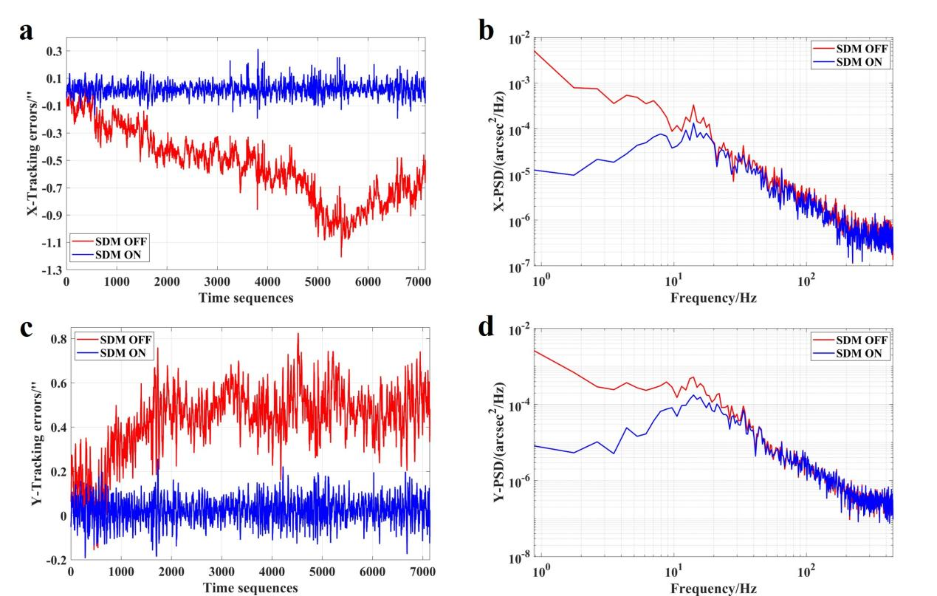
Fig. S10 Tracking error before and after SDM correction. (a) Tracking error at X direction; (b) PSD of tracking error at X direction; (c) Tracking error at Y direction; (d) PSD of tracking error at Y direction.
As shown in Fig. S11, the RTC is generally employed to calculate the slope distribution and even wavefront aberration with super fast speed and control SDM shape to correct the measured wavefront aberration in real-time.
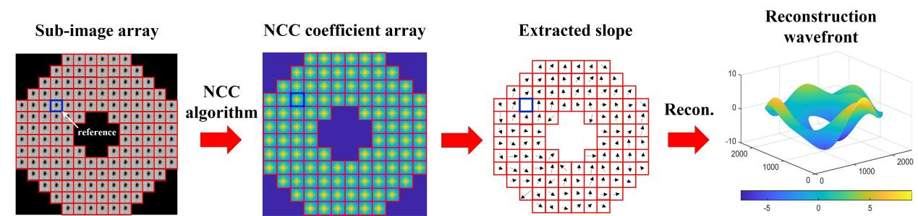
Fig. S11 Wavefront detection process of cross-correlation HS WFS. NCC: normalized cross-correlation; Recon.:reconstruction.
Fig. S12 shows the measurement principle of global tip-tilt based on time sequenced sub-images captured from HS WFS. Different to conventional fine-tracking sensors, global tip-tilt based on HS WFS requires a reference image to be determined as the datum for the global tip-tilt measurement. Comparing to a single and fixed image in a conventional fine-tracking sensor, the reference image of our method is the sub-image array of HS WFS. Let the acquisition moment corresponding to the reference sub-image array be t₀, and the intensity distribution of the sub-images corresponding to the i^{th} row and j^{th} column of the sub-aperture be denoted as I^{t0}_{i,j}(u, v), where (u, v) is the sub-image positional variable along the horizontal and vertical coordinates. Similarly, the intensity distribution of the i^{th} row and j^{th} column sub-images detected by the HS WFS at time t is denoted as I^{t}_{i,j}(u, v). The NCC algorithm between sub-images similar to Eq. (1) can calculate the cross correlation factor between the corresponding sub-images. Finally, full-wavefront aberration including the global tip-tilt and higher-order wavefront aberrations can be detected synchronously based only one sub-image array acquired from cross-correlation HS WFS.
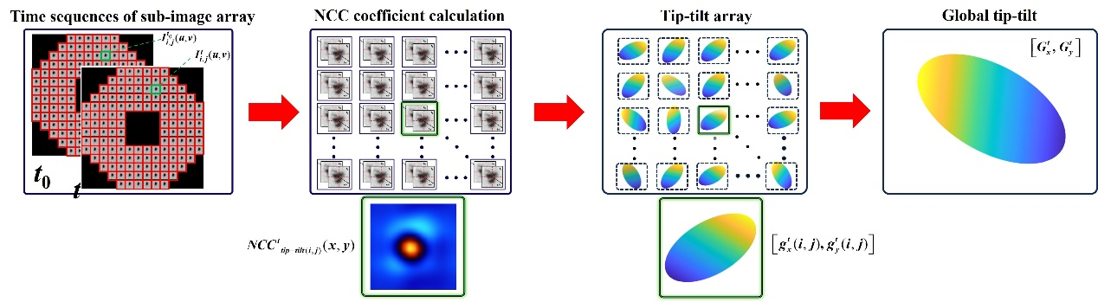
Fig. S12 Measurement principle of global tip-tilt based on time sequenced sub-images captured from HS WFS.

Reference
- Shumko, S. et al. AO-308: the high-order adaptive optics system at Big Bear Solar Observatory. Proc. SPIE. 9148, 914835 (2014).
- Greenwood, D. P. Mutual Coherence Function of a Wavefront Corrected by Zonal Adaptive Optics. J. Opt. Soc. Am. 69, 549-553 (1979).
- Wang, Z., Bovik, A. C., Sheikh, H. R. & Simoncelli, E. P. Image Quality Assessment: From Error Visibility to Structural Similarity. IEEE Transactions on Image Processing. 13(4):600- 612(2004).

