Supplementary Information

Table S1: Results of linear mix-effect model i
Table S1 presents the results for model i, LST ~ Forest Cover * Location + NDVI + (1|Location/Zone). The model explains 48.1% of the variance in the fixed effects, which include forest cover, location, and NDVI. For the random effects associated with location and zonation, the model accounts for 74.9% of the variance.

 | LST
Predictors | Estimates | CI | p
(Intercept) | 39.92 | 38.84 – 40.99 | <0.001
Forest cover [Coniferous forest] | 0.55 | 0.48 – 0.62 | <0.001
Location [Hainich] | -3.34 | -4.86 – -1.82 | <0.001
Location [Jasmund] | -4.38 | -5.90 – -2.86 | <0.001
Location [Kellerwald] | -2.11 | -3.63 – -0.59 | 0.006
Location [Serrahn] | -2.00 | -3.52 – -0.48 | 0.010
NDVI | -12.70 | -12.80 – -12.60 | <0.001
Forest cover [Coniferous forest] *Location [Hainich] | -0.38 | -0.46 – -0.29 | <0.001
Forest cover [Coniferous forest] * Location [Kellerwald] | -0.14 | -0.22 – -0.06 | 0.001
Forest cover [Coniferous  forest] * Location  [Serrahn] | -1.01 | -1.08 – -0.93 | <0.001
Random Effects
σ² | 0.78
τ₀₀ _{Zone:Location} | 0.79
τ₀₀ _{Location} | 0.04
ICC | 0.52
N _{Zone} | 3
N _{Location} | 5
Observations | 320425
Marginal R² / Conditional R² | 0.481 / 0.749

Table S2: Results of linear mix-effect model ii.
Table S2 presents the results of the linear mixed-effects model ii LST ~ NDVI * Zone + Year + (1|Location/Year). The model explains 41.5% of the variance for the fixed effects, which include NDVI, zone interactions, and year. For the random effects associated with location and year, the model accounts for 89.1% of the variance.
 | LST
Predictors | Estimates | CI | p
(Intercept) | 23.42 | 21.30 – 25.54 | <0.001
NDVI | -5.05 | -5.43 – -4.66 | <0.001
NDVI:Zone buffer | -4.63 | -5.05 – -4.22 | <0.001
NDVI:Zone border | -5.82 | -6.26 – -5.38 | <0.001
Year2018 | 4.61 | 2.60 – 6.63 | <0.001
Year2019 | 5.97 | 3.95 – 7.99 | <0.001
Year2020 | 2.76 | 0.74 – 4.77 | 0.007
Year2021 | 2.10 | 0.08 – 4.12 | 0.041
Year2022 | 6.57 | 4.56 – 8.59 | <0.001
Year2023 | 4.64 | 2.62 – 6.66 | <0.001
buffer | 4.16 | 3.80 – 4.53 | <0.001
border | 5.59 | 5.22 – 5.97 | <0.001
Random Effects
σ² | 1.30
τ₀₀ _{Year:Location} | 2.65
τ₀₀ _{Location} | 3.06
ICC | 0.81
N _{Year} | 7
N _{Location} | 5
Observations | 128713
Marginal R² / Conditional R² | 0.415 / 0.891

Table S3: Results of linear mix-effect model iii.
Table S3 presents the results of the linear mixed-effects model iii, LST ~ Year * Zone + NDVI + (1|Location/Year). The model accounts for 42.7% of the variance in the fixed effects, including year, zone interactions, and NDVI. For the random effects related to location and year, the model explains 89.8% of the variance.
 | LST
Predictors | Estimates | CI | p
(Intercept) | 28.24 | 26.15 – 30.32 | <0.001
NDVI | -9.55 | -9.68 – -9.42 | <0.001
Year2018 | 3.55 | 1.53 – 5.56 | 0.001
Year2018:Zone border | 0.32 | 0.25 – 0.38 | <0.001
Year2018:Zone buffer | 2.00 | 1.95 – 2.06 | <0.001
Year2019 | 4.88 | 2.86 – 6.89 | <0.001
Year2019:Zone border | 0.58 | 0.51 – 0.65 | <0.001
Year2019:Zone buffer | 1.88 | 1.82 – 1.94 | <0.001
Year2020 | 1.72 | -0.29 – 3.74 | 0.094
Year2020:Zone border | 0.54 | 0.47 – 0.61 | <0.001
Year2020:Zone buffer | 1.83 | 1.77 – 1.89 | <0.001
Year2021 | 1.36 | -0.65 – 3.38 | 0.184
Year2021:Zone border | 0.07 | -0.00 – 0.13 | 0.064
Year2021:Zone buffer | 1.45 | 1.40 – 1.51 | <0.001
Year2022 | 5.31 | 3.29 – 7.32 | <0.001
Year2022:Zone border | 1.07 | 1.00 – 1.14 | <0.001
Year2022:Zone buffer | 2.03 | 1.97 – 2.09 | <0.001
Year2023 | 3.51 | 1.50 – 5.52 | 0.001
Year2023:Zone border | 0.71 | 0.64 – 0.78 | <0.001
Year2023:Zone buffer | 1.93 | 1.87 – 1.99 | <0.001
border | 0.12 | 0.07 – 0.17 | <0.001
buffer | -1.45 | -1.49 – -1.41 | <0.001
Random Effects
σ² | 1.22
τ₀₀ _{Year:Location} | 2.64
τ₀₀ _{Location} | 3.00
ICC | 0.82
N _{Year} | 7
N _{Location} | 5
Observations | 128713
Marginal R² / Conditional R² | 0.427 / 0.898
Table S4: Dunn’s Test Pairwise Comparisons for zones
Comparison | Z-value | p-value
core-buffer | 56.668 | <0.001
border-buffer | -125.597 | <0.001
core-border | 153.497 | <0.001
(Positive z value indicate higher NDVI in the first zone)

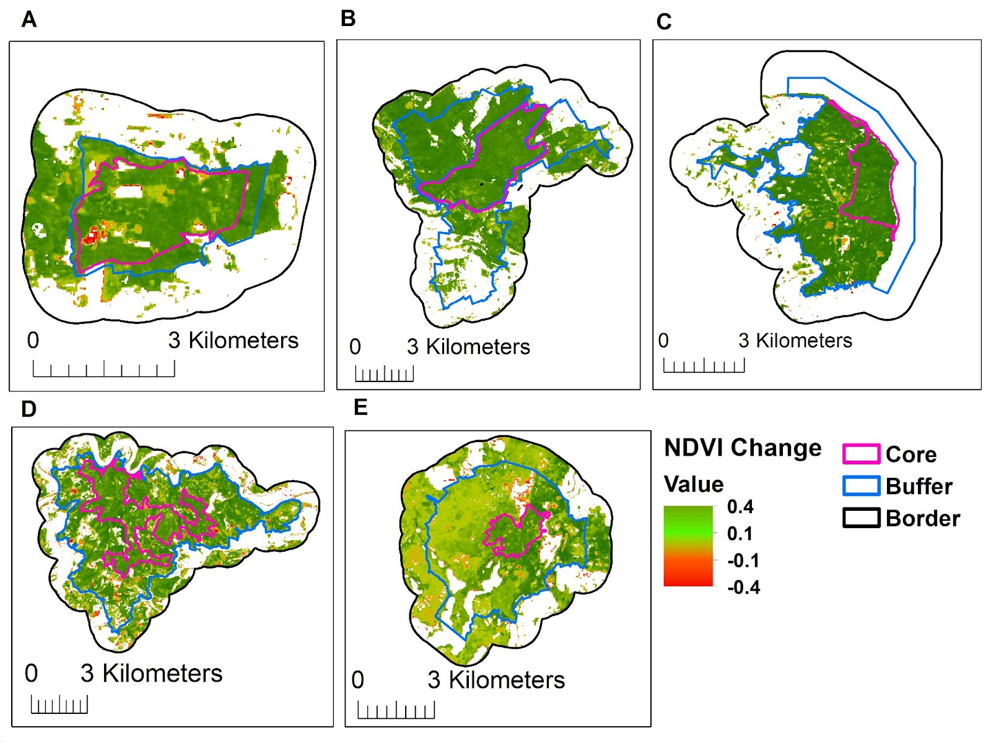
Fig. S1: Recent average NDVI of the five WHB. The NDVI is defined as “greenest” pixels (i.e., the highest NDVI value) of summer month composites (May-September) in the Landsat 8,9 NDVI time series 2017-2023.

Fig. S2: Recent vitality (based on NDVI average 2017-2023) for the core, buffer and border zones in the five German World Heritage beech forests. The NDVI is defined as “greenest” pixels (i.e., the highest NDVI value) of summer month composites (May-September) in the Landsat 8,9 NDVI time series 2017–2023 for the core, buffer and border areas.

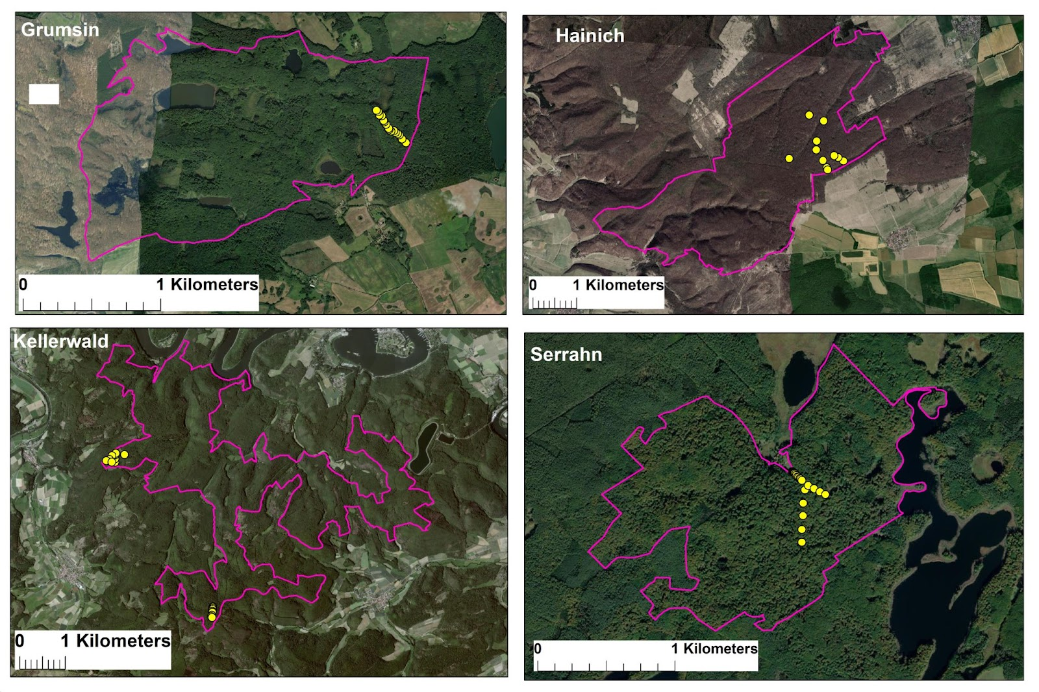
Fig. S3: Location of the data loggers in the core zone of Grumsin, Hainich, Kellerwald and Serrhan used for quantifying the differences between LST and AT.

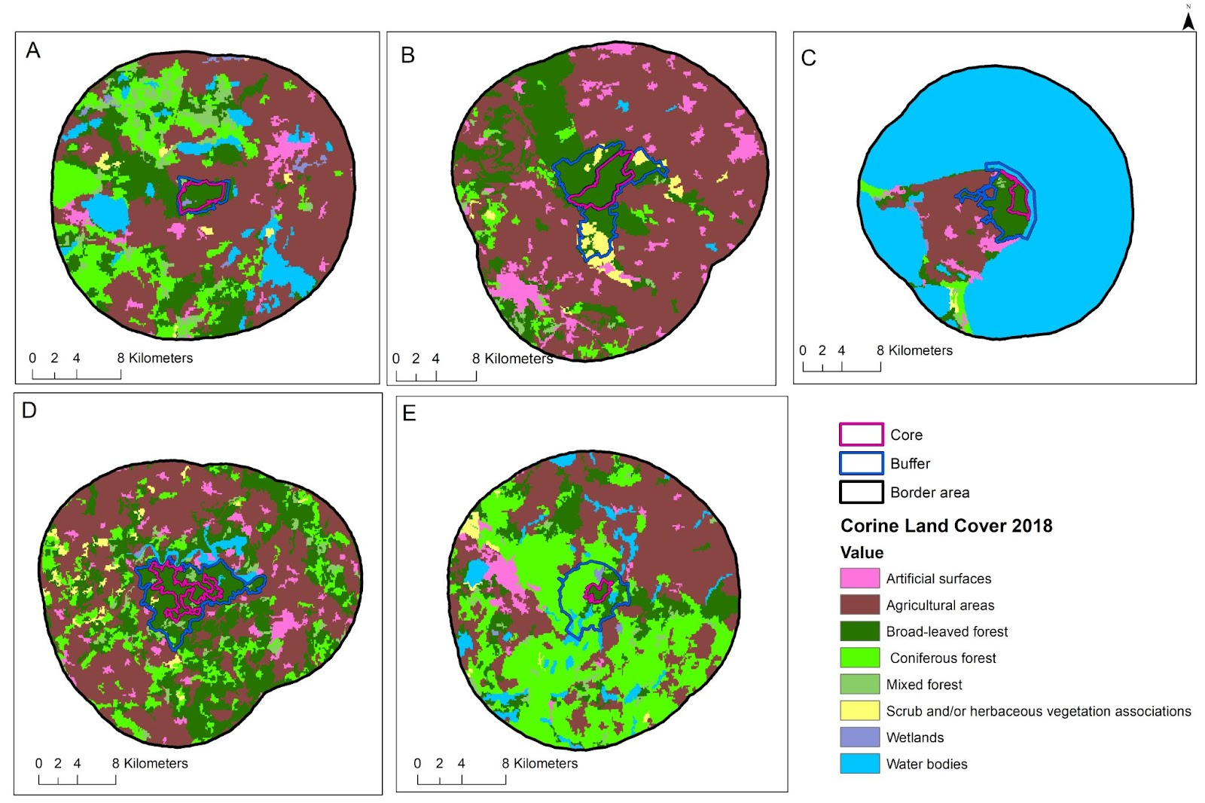

Fig. S4: Land Use Map Using CORINE Classification (2018) showing zoning of the five German sites with core zones in pink, buffer zones in blue, and borders in black (extending 10 km from the buffer zone) for A) Grumsin, B) Hainich, C) Jasmund, D) Kellerwald, and E) Serrahn.

