Supplementary file

Quantification of ochratoxin A in a coffee sample utilizing an electrochemical aptasensor fabricated through encapsulation of toluidine blue within a Zn-based metal-organic framework

Elaheh Amini–Nogorani, Hamid R. Zare*, Fahime Jahangiri–Dehaghani, Ali Benvidi

Department of Chemistry, Yazd University, Yazd, 89195–741, Iran
Fax No.: +98 353 8210991 Tel. No.: +98 353 1232669
E–mail address: hrzare@yazd.ac.ir

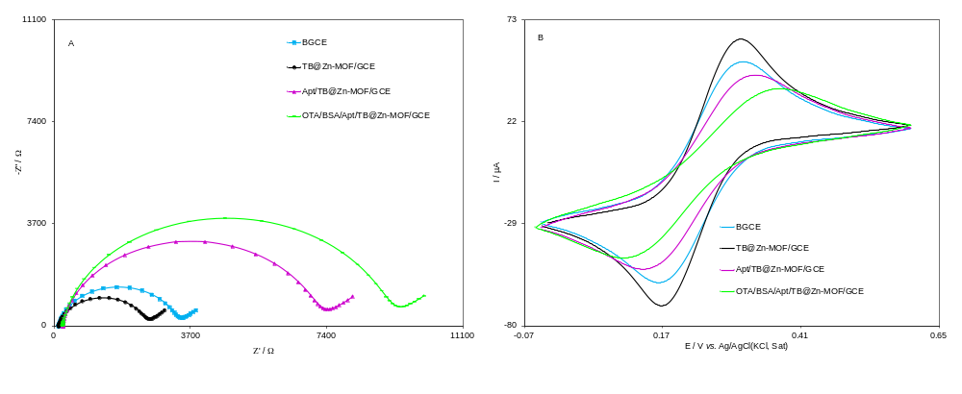
Fig. S1 (A) Electrochemical impedance spectroscopy plots and (B) cyclic voltammograms of BGCE, TB@Zn-MOF, Apt/TB@Zn-MOF/GCE and OTA/BSA/Apt/TB@Zn-MOF/GCE in a 0.1 M phosphate buffer (pH 7.0) containing 5.0 mM [Fe(CN)₆]^{3−/4−} and 0.1 M KCl. OTA concentration: 0.5 ng mL^{–1}.

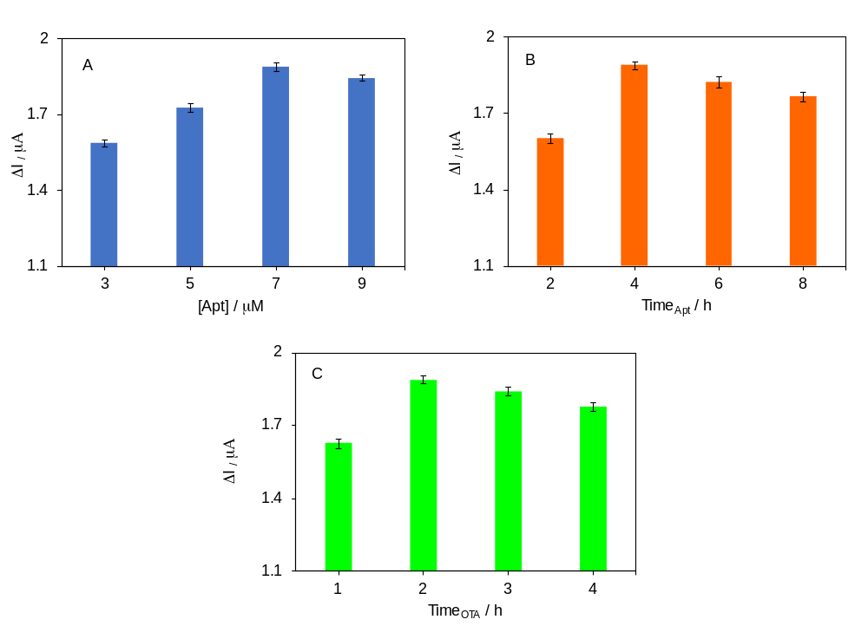
Fig. S2 Effect of (A) aptamer concentration (aptamer immobilization time: 4 hours, OTA incubation time: 2 hours), (B) aptamer immobilization time (aptamer concentration: 7.0 µM, OTA incubation time: 2 hours), and (C) OTA incubation time (aptamer concentration: 7.0 µM, aptamer immobilization time: 4 hours). OTA concentration: 0.5 ng mL^{–1} in all experiments. Eerror bars represent the relative standard deviation of three independent experiments

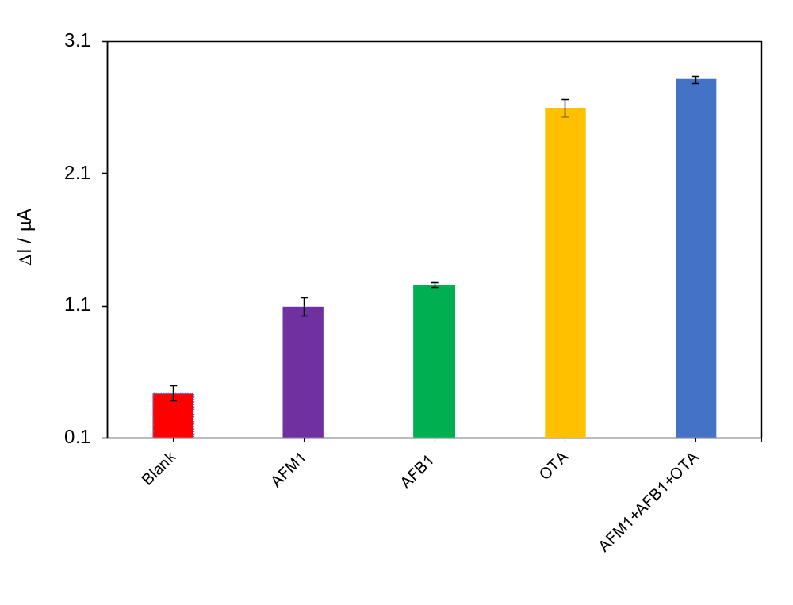Fig. S3 Current response of the aptasensor for the determination of 50.0 ng mL⁻¹ OTA in the presence of AFM1 (50.0 ng mL⁻¹), AFB1 (50.0 ng mL^{–1}) and a mixture of both. Error bars represent the standard deviation obtained from three replicate experiments.

