Supporting Materials for Article:
Electrochemical Upcycling of Food Shell Waste for Fertilizer Production from Wastewater

Zhengshuo Zhan ª, Jiayu Luo ª, Jiyao Liu ^{b}, Michel Saakes ^{c}, Renata D. van der Weijden ^{b}, Cees J. N. Buisman ^{b, c}, Chongxuan Liu ª and Yang Lei ^{a,} *
ª Shenzhen Key Laboratory of Precision Measurement and Early Warning Technology for Urban Environmental Health Risks, School of Environmental Science and Engineering, Southern University of Science and Technology (SUSTech), Shenzhen 518055, China
^{b} Department of Environmental Technology, Wageningen University and Research, P.O. Box 17, 6700AA Wageningen, The Netherlands
^{c} Wetsus, Centre of Excellence for Sustainable Water Technology, P.O. Box 1113, 8900CC Leeuwarden, The Netherlands
* Corresponding author,
E-mail: leiy3@sustech.edu.cn (Dr. Lei)
Additional information, as noted in the text, includes 13 figures, 5 tables, and 3 notes:
The Raman spectrum (Figure S1) and Ca 2p and Mg 2p XPS spectra (Figure S2) of the oyster shells, eggshells, and snail shells, the XRD pattern of the product reclaimed by oyster shell upcycling (Figure S3), the nutrient reclamation performance by eggshell upcycling (Figure S4), the saturation index (SI) of calcium phosphate species in response to oyster shell and eggshell upcycling under ascending current density (Figure S5) and declining crushing degree (Figure S6), the carbon sequestration in electrochemical shell wastes upcycling (Figure S7), the changes of Cl⁻ and active chlorine in actual wastewater during the nutrient reclamation performance investigation (Figure S8), foaming occurs during electrochemical shell waste upcycling for nutrient reclamation towards WAC wastewater (Figure S9), the change of Ca²⁺, total nitrogen (TN), N-NH₄⁺ (TAN) concentration, and cell voltage recorded over long-term operation (Figure S10), characterization of the solid product from eggshell upcycling and urine P reclamation by household prototype (Figure S11), the household prototype after long-term operation (Figure S12), the urinal with a collection container (Figure S13), the chemical and elemental compositions of the shell wastes (Table S1), the composition of real waste streams in high, medium, and low P levels (Table S2), the elemental compositions of the reclaimed product from household upcycling prototype (Table S3), summary of reported technologies targeting urine phosphorus removal in terms of the type of urine, initial P concentration, operation cost, and product quality (Table S4), the economic aspect of household eggshell upcycling for urine P reclamation (Table S5), details of the household scenario (Note S1), calculational detail of life cycle assessment (Note S2), explanation of the economic aspect (Note S3).

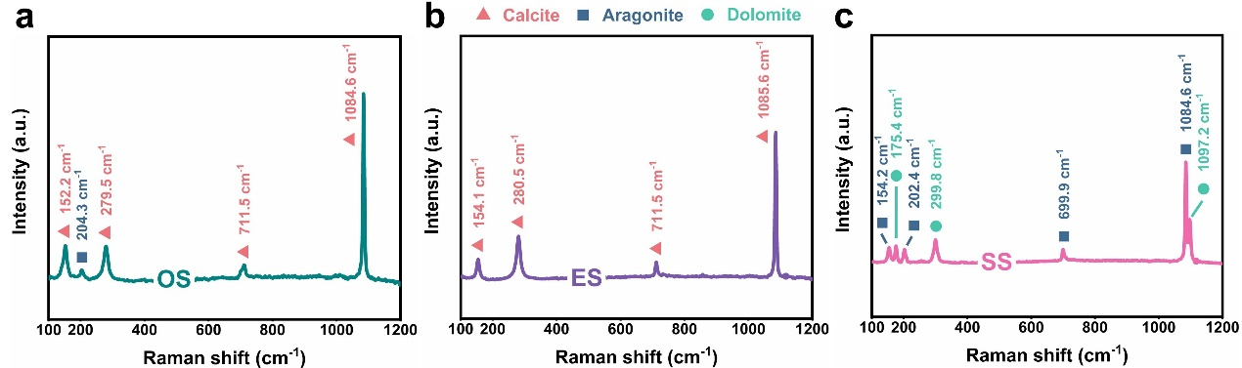
Figure S1. The Raman spectrum of the oyster shells, eggshells, and snail shells.

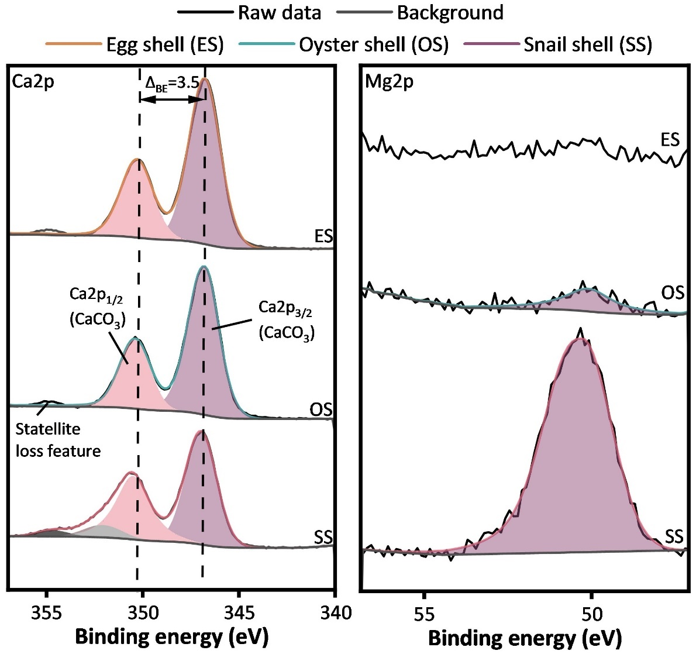
Figure S2. The (a) Ca 2p and (b) Mg 2p XPS spectra of the oyster shells, eggshells, and snail shells.

Figure S3. The XRD pattern of the reclaimed product by oyster shell upcycling.

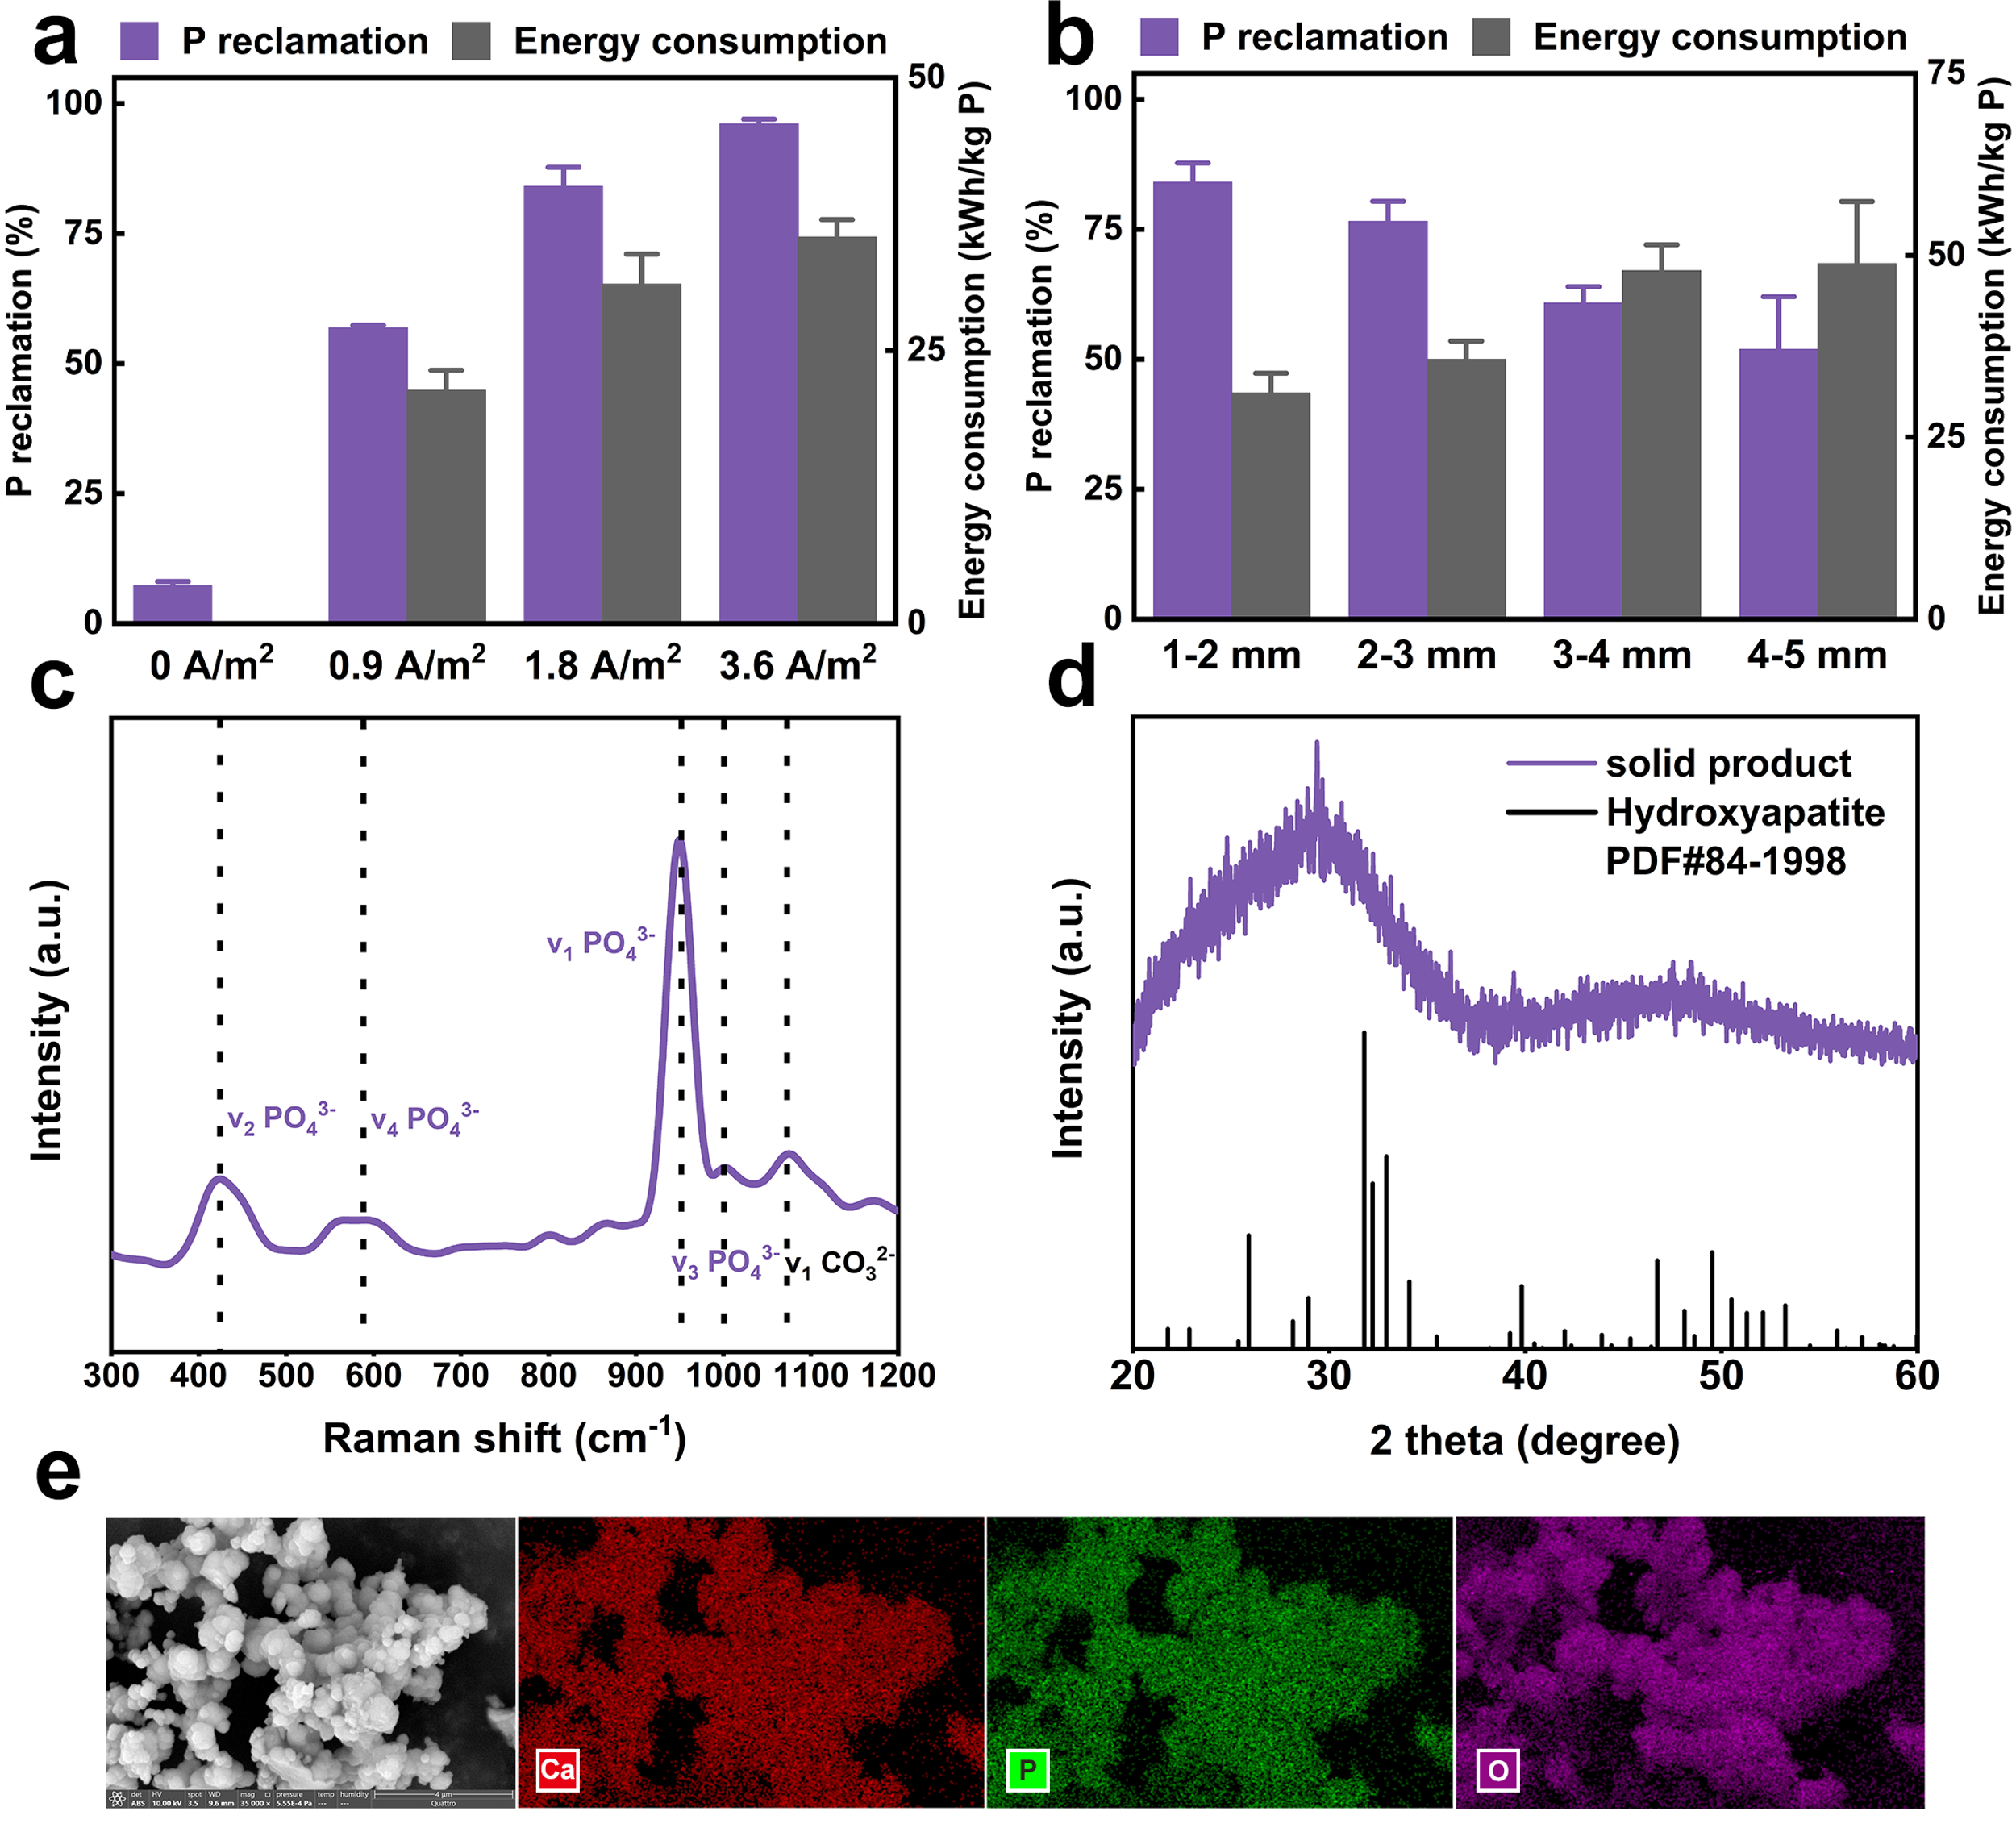
Figure S4. Nutrient reclamation performance by eggshell upcycling. a,b, The impacts of applied current density (a) and crushing degree of eggshell (b) on the electrochemical P upcycling regarding P reclamation and specific energy consumption. c,d, The Raman spectrum (c) and XRD pattern (d) of the reclaimed product. e, The morphology and elemental distribution of the reclaimed product. WOS, wasted oyster shell.

Figure S5. The saturation index (SI) of calcium phosphate species in response to the enhanced Ca²⁺ release and OH⁻ accumulation from oyster shell and eggshell upcycling under ascending current density, calculated by Visual Minteq. OS, oyster shell; ES, eggshell.

Figure S6. The saturation index (SI) of calcium phosphate species in response to the enhanced Ca²⁺ release and OH⁻ accumulation from oyster shell and eggshell upcycling under declining crushing degree, calculated by Visual Minteq. OS, oyster shell; ES, eggshell.

Figure S7. Carbon sequestration in electrochemical shell wastes upcycling. a-b, The changes of soluble Ca²⁺ and total inorganic carbon (TIC) in mM over time during electrochemical shell waste upcycling (a) and P reclamation (b). c, The changes of solution pH over time during electrochemical upcycling. d, The TIC fraction in response to the pH (Conditions: oyster shell; 0.9 A/m²; 1-2 mm size; 1L; 4 h). e, The net CO₂ sequestration under three different current densities.

Figure S8. The change of Cl⁻ and active chlorine in WAC wastewater (a), stored urine (b), and municipal influent wastewater (c) during the nutrient reclamation performance investigation.

Figure S9. Foaming occurs during electrochemical shell waste upcycling for nutrient reclamation towards WAC wastewater.

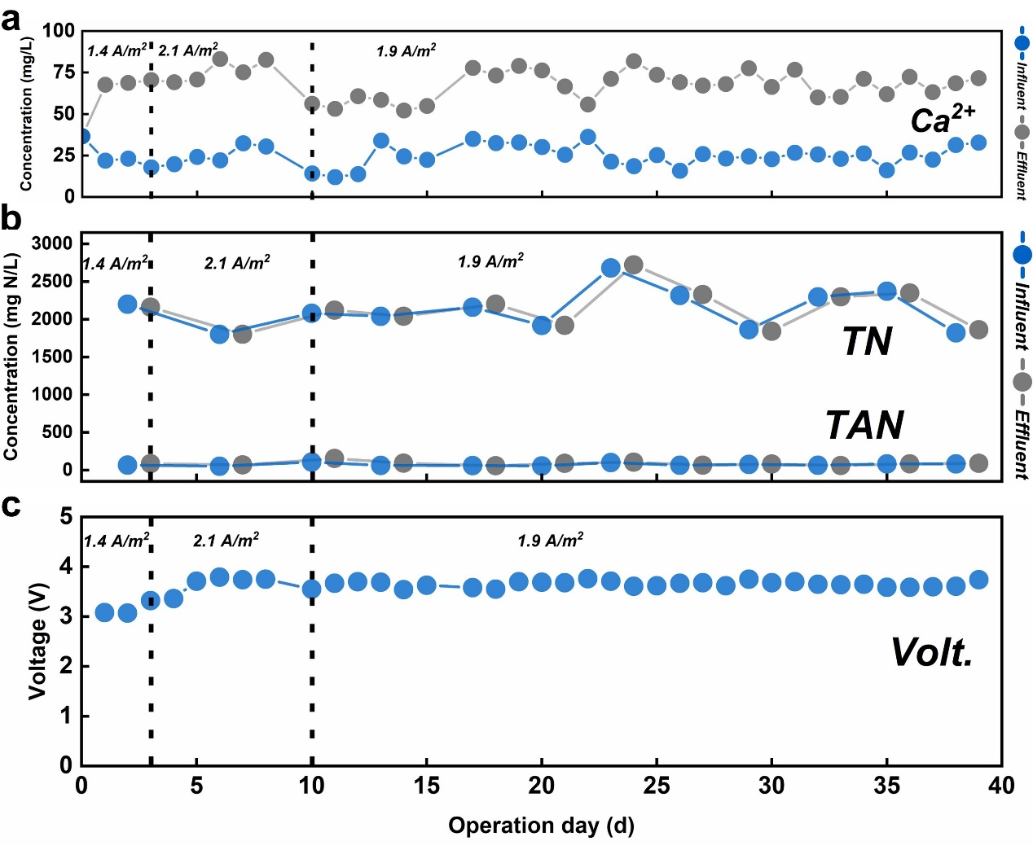
Figure S10. The change of Ca²⁺, total nitrogen (TN), N-NH₄⁺ (TAN) concentration, and cell voltage over long-term operation.

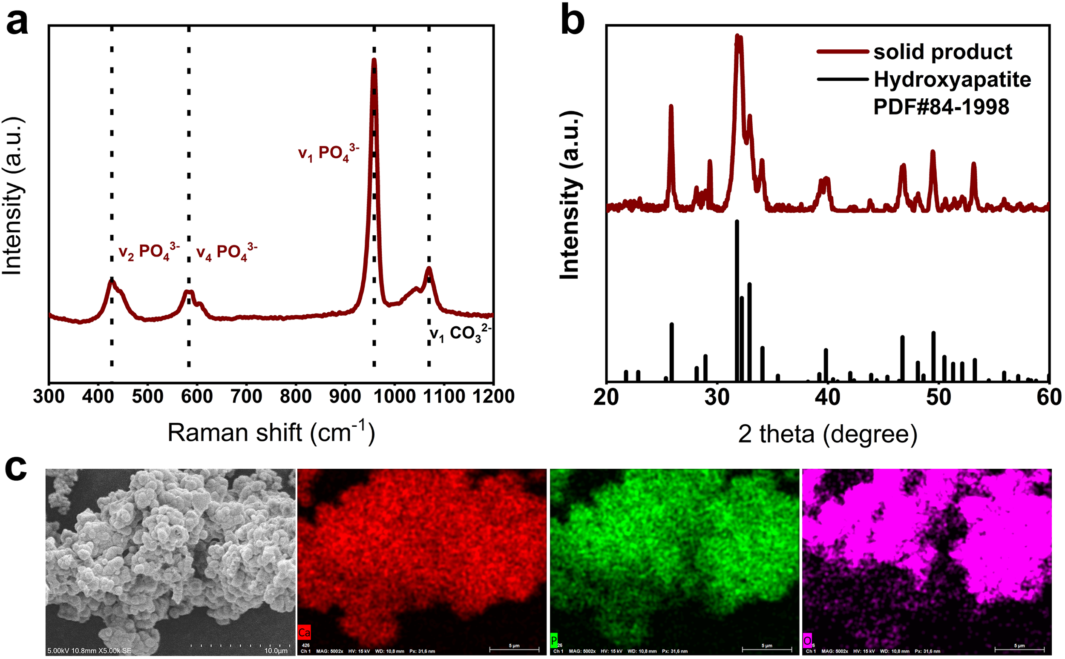
Figure S11. Characterization of the solid product from eggshell upcycling and urine P reclamation by the household prototype. a,b, The Raman spectrum (a) and XRD pattern (b) of the reclaimed product. c, The morphology and elemental distribution of the reclaimed product.

Figure S12. The household prototype after long-term operation. a, The products detached from the cathode and accumulated at the funnel-shaped bottom awaiting collection. b, The solid products remained on the cathode.

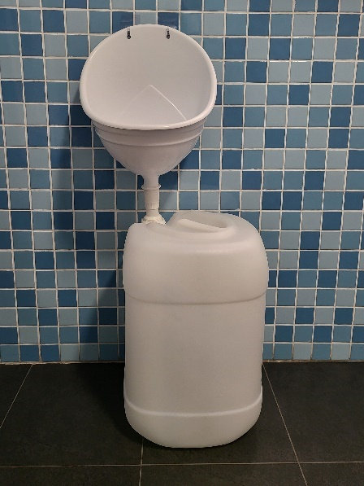
Figure S13. The urinal with a collection container.

Table S1. Chemical and elemental compositions of the shell waste used in this study.
 | Shell waste
Compositions | Oyster shell | Eggshell | Snail shell | Unit
Organics | 1.0 | 4.8 | 1.7 | dw%ª
Ca | 38.7 | 38.6 | 33.9 | dw%ª
Si | 2.5 | <1.1^{b} | <1.1^{b} | dw%ª
Mg | 0.2 | 0.3 | 8.4 | dw%ª
Al | 0.3 | 0.1 | <0.1^{b} | dw%ª
Na | 0.9 | 0.2 | 0.1 | dw%ª
K | 0.6 | 0.2 | 0.1 | dw%ª
P | 0.04 | 0.1 | 0.1 | dw%ª
Fe | <0.3^{b} | <0.3^{b} | <0.3^{b} | μg/g
Zn | <0.2^{b} | <0.2^{b} | <0.2^{b} | μg/g
Cu | <0.4^{b} | <0.4^{b} | <0.4^{b} | μg/g
Ni | <0.4^{b} | <0.4^{b} | <0.4^{b} | μg/g
Pb | <1.1^{b} | <1.1^{b} | <1.1^{b} | μg/g
As | <1.4^{b} | <1.4^{b} | <1.4^{b} | μg/g
Mn | <0.1^{b} | <0.1^{b} | <0.1^{b} | μg/g
Se | <3.1^{b} | <3.1^{b} | <3.1^{b} | μg/g
Cd | <0.1^{b} | <0.1^{b} | <0.1^{b} | μg/g
Co | <0.5^{b} | <0.5^{b} | <0.5^{b} | μg/g
Li | <0.03^{b} | <0.03^{b} | <0.03^{b} | μg/g
ª Reported by dry weight basis.
^{b} Below detection limit (μg/g).

Table S2. The composition of real waste streams in high, medium, and low P levels.
 | WAC wastewater  (High P-level) |  | Stored urine  (Mid P-level) |  | Municipal influent  (Low P-level)
Parameters | Value | S.D. | Value | S.D. | Value | S.D. | Unit
pH | 2.0 | 0.0 | 7.2 | 0.0 | 7.7 | 0.2
Conductivity | 6031.6 | 13.6 | 2761.1 | 146.7 | 1594.3 | 74.2 | μS/cm
Turbidity | 408.0 | 2.0 | 71.1 | 12.4 | 52.2 | 9.3 | NTU
COD | 698.0 | 65.1 | 1596.0 | 288.3 | 266.0 | 5.7 | mg/L
P | 1577.5 | 12.0 | 27.6 | 7.3 | 7.2 | 0.0 | mg/L
Na | 16.6 | 2.5 | 148.4 | 0.1 | 231.2 | 23.5 | mg/L
Ca | 139.9 | 12.2 | 0.3 | 0.1 | 55.8 | 1.2 | mg/L
K | 35.6 | 0.4 | 77.8 | 1.8 | 24.6 | 0.0 | mg/L
Mg | 4.8 | 0.3 | 0.4 | 0.2 | 28.5 | 1.4 | mg/L
PO₄³⁻ | 4833.9 | 340.7 | 80.8 | 5.7 | 22.8 | 0.7 | mg/L
SO₄²⁻ | n.a. | 10.3 | 88.9 | 2.7 | 180.9 | 2.8 | mg/L
NO₃⁻ | n.a. | 10.4 | 57.5 | 2.5 | 3.2 | 0.1 | mg/L
Cl⁻ | 176.6 | 29.4 | 259.3 | 1.2 | 136.6 | 3.3 | mg/L
Al | 3.2 | 0.1 | <0.12 μg/L |  | <0.12 μg/L |  | mg/L
Fe | 2.3 | 0.0 | <0.25 μg/L |  | <0.25 μg/L |  | mg/L
Zn | 0.8 | 0.0 | <0.19 μg/L |  | <0.19 μg/L |  | mg/L
Cr | 0.2 | 0.0 | <0.21 μg/L |  | <0.21μg/L |  | mg/L

Table S3. The elemental compositions of the reclaimed product from the household upcycling prototype.

Compositions | Value | Standard deviation | Unit
Ca | 30.7 | 1.4 | dw%ª
P | 12.9 | 0.3 | dw%ª
Mg | 0.9 | 0.1 | dw%ª
Na | 0.1 | 0.1 | dw%ª
Fe | <0.25^{b} |  | μg/g
Si | <1.09^{b} |  | μg/g
K | <0.60^{b} |  | μg/g
Al | <0.12^{b} |  | μg/g
Zn | <0.19^{b} |  | μg/g
Cu | <0.39^{b} |  | μg/g
Ni | <0.36^{b} |  | μg/g
Pb | <1.06^{b} |  | μg/g
As | <1.43^{b} |  | μg/g
Mn | <0.07^{b} |  | μg/g
Se | <3.05^{b} |  | μg/g
Cd | <0.07^{b} |  | μg/g
Cr | <0.21^{b} |  | μg/g
ª Reported by dry weight basis.
^{b} Below detection limit (μg/g).

Table S4. Summary of reported technologies targeting urine phosphorus removal in terms of the type of urine, initial P concentration, operation cost, and product quality.
Type of method | Type of waste stream | Cost per  kg P removed# | Product | Reference
Ca(OH)₂ dosing | Stored urine  (309 mg/L P-PO₄³⁻) | €10.0/kg Pª | 1.5% P containing sludge | Pradhan et al. 2017¹
Ca(OH)₂ dosing | Fresh urine  (260 mg/L P-PO₄³⁻) | €2.9/kg P | N/A | Randall et al. 2016²
Ca(OH)₂ dosing | Stored urine  (225 mg/L P-PO₄³⁻) | €27.6/kg Pª | 1-2% P containing sludge | Pradhan et al. 2019³
MgO dosing | Stored urine  (112 mg/L P-PO₄³⁻) | €18.5/kg P^{b} | 12.6% P containing precipitates | Antonini et al. 2011⁴
Fluidized bed homogeneous crystallization | Synthetic urine  (957.0 mg/L P-PO₄³⁻) | €3.7/kg P | K-struvite pellets of 95% purity | Le et al. 2020⁵
Flow-electrode capacitive deionization | Synthetic urine  (62.3 mg/L P-PO₄³⁻) | €2.4/kg P | P-rich solution | Xu et al. 2020⁶
Electrochemical precipitation | Toilet wastewater  (18.6 mg/L P-PO₄³⁻) | €373.9/kg P | 9.8% P containing precipitates | Cid et al. 2018⁷
Mg electrocoagulation | Synthetic urine  (255.5 mg/L P-PO₄³⁻) | €112.2/kg P | Struvite precipitates | Govindan et al. 2021⁸
Basket-anode electrochemical system | Stored urine  (60 mg/L P-PO₄³⁻) | €2.8/kg P | 6% P containing precipitates | Zhan et al. 2023⁹
Flow-electrode capacitive deionization coupled with a liquid membrane chamber (LMC) | Synthetic urine  (526.1 mg/L P-PO₄³⁻) | < €1.3/kg P | high-purity phosphoric acid | Xu et al. 2021¹⁰
Fe electrocoagulation | Fresh urine  (49.0 mg/L P-PO₄³⁻) | €4.1/kg P | Iron phosphate species | Zheng et al. 2009¹¹
Fe electrocoagulation | Fresh urine  (490.2 mg/L P-PO₄³⁻) | €0.85/kg P | Iron phosphate species | Zheng et al. 2009¹¹
Al electrocoagulation | Synthetic urine  (52.7 mg/L P-PO₄³⁻) | €2.2/kg P | Aluminium phosphate species | Zheng et al. 2010¹²
Al electrocoagulation | Synthetic urine  (526.5 mg/L P-PO₄³⁻) | €0.4/kg P | Aluminium phosphate species | Zheng et al. 2010¹²
Integrated Electrochemical fixed bed packed with separate zones of Magnesite/Carbon | Synthetic urine  (31.0 mg/L P-PO₄³⁻) | €4.2/kg P | Struvite precipitates | Hao et al. 2022¹³
Microbial electrolysis cell coupled with ion exchange membranes | Synthetic urine  (74.2 mg/L P-PO₄³⁻) | €2.8/kg P | Nutrients concentrate | Tice et al. 2014¹⁴
Electrochemical household prototype for eggshell upcycling and urine P reclamation | Fresh urine  (75.0 mg/L P-PO₄³⁻) | €1.2/kg P | 12.9% P containing Ca-phosphate | This study
ª Only cost related to phosphorus removal was considered.
^{b} The MgO price is normalized at €12.46/kg¹⁵.
# The operation costs are provided directly by the literature. For a few studies in which operation costs were not directly provided, only the chemicals cost was considered in non-electrochemical methods. In contrast, only electricity consumption (€0.085/kWh) was considered in electrochemical methods due to their chemical-free nature.

Table S5. The economic aspect of electrochemical eggshell upcycling for urine P reclamation by the household prototype.
 | Amount | Normalized Cost (-)/Benefit (+)
CAPEX
Urine-diverting toilets | €300/set^{16,17} | €1.83/m³ (-)
Mass-produced household device | €20/set | €0.30/m³ (-)
OPEX
Electricity consumption | 1.0 kWh/m³ ¹⁸ | €0.085/m³ (-)
Revenue
Eggshell treating margin | €75/tonnes¹⁹ | €0.07/m³ (+)
Urine treating margin | €4.313/kg P²⁰ | €0.27/m³ (+)
Revenue from fertilizer production | €1.500/kg P²¹ | €0.20/m³ (+)
Total cost |  | €1.68/m³ or €11.0/year (-)
Total revenue with existing UD toilets |  | €0.15/m³ or €1.0/year (+)
Note S1—details of the household scenario.
According to actual circumstances, we assumed that each family member consumes one egg (5.8 g eggshell) and produces 1.2 L of urine per day, thereby giving a total production of 17.4 g eggshell and 18 L urine (including flush water) for a typical family of three on a daily basis. To ensure alignment with practical needs, all the tests related to the 8.65 L household prototype were operated following this assumption. Combined with our characterizations towards eggshell (with a Ca weight of 38.6%) and urine (75 mg/L P), the Ca content (0.17 mol/day) in eggshell is sufficient (gives a Ca/P molar ratio of 4.25:1) for in-situ P reclamation from urine (0.04 mol/day), even in cases of higher urine volume as you suggested, given the molar ratio of hydroxyapatite at around 1.67. Therefore, as the urine can be managed right after production, additional storage is not needed, thereby saving space and avoiding potential issues during urine storage.
We acknowledge the safety concern regarding H₂ production and have ensured it remains within safe limits. The current household prototype is non-sealed and does not have gas collection components. Therefore, any H₂ produced is directly released into the operational environment (e.g., the restroom). According to the H₂ safety regulations, safety concerns arise within a range of hydrogen gas volume ratios in air between 4.0% and 77.0%.
In our case, the household prototype works under a current of 210 mA, and according to Faraday's law, assuming that all the electricity consumed was used for water reduction and meanwhile supposing other reactions did not consume the H₂ produced, the molecular weight of H₂ generated can be calculated by equation 3 and S1:
$$M\left(H_{2}\right)=\frac{It}{zF} (S1)$$
I, electricity current (A); t, electrolysis time (s); z, number of electrons transferred per mole H₂, z=2; Faraday constant 96485 (C/mol).
Theoretically, the prototype produces 0.094 mol of H₂ per day, which is 0.190 g and 2.283 L (H₂ density = 0.083 kg/m³). Thus, even if the prototype works for a week in an entirely unventilated bathroom (assuming the bathroom has 4 m² area and 3 m height, resulting in a space of 12 m³), the H₂ produced would only account for 0.133% of the total space, far below the lowest explosive/flammable limit for H₂ (4.0%). As we excluded the potential risk of H₂, we also recognize its value as renewable energy. When implementing this system in larger operational units (e.g., office buildings and hospitals), H₂ collection and reutilization is recommended.

Note S2—Calculational details of life cycle assessment.
Input data
The model inputs are divided into four categories, all referring to the electrochemical upcycling of eggshells and P reclamation from urine in a family of three over one year. These include eggshell disposal, household urine P reclamation with prototype, centralized wastewater treatment, and fertilizer manufacturing.

Eggshells disposal
It is worth noting that the specific percentages of household kitchen/food waste biological treatment and incineration globally may vary as waste management practices evolve and different regions adopt different approaches. In the Netherlands, over 90% of the household organic kitchen/food waste is separately collected and composted²². As the household scenario that applied in our work was selected in the Netherlands, in the corresponding LCA and economics assessment, shell waste is deemed kitchen waste and is being composted, which is a common practice in the Netherlands.
In the baseline Scenario A, the weight of eggshells is accounted for in the transportation and composting from each household to the central composting site in the community. The composting of kitchen waste includes transportation and the operation and maintenance of related infrastructures. The environmental impacts, including kitchen waste transportation, wastewater, and gas control, and the construction and maintenance of infrastructures, are derived from the Ecoinvent version 3 database²³. Considering that the eggshells in Scenario B are upcycled in situ for P reclamation from urine, the corresponding environmental impacts are therefore not considered.

Household urine P reclamation with prototype
In Scenario B, a urine-diverting toilet is necessary to facilitate urine separation, and the environmental impacts from its manufacture and installation are derived from the Ecoinvent version 3 database²³ with a lifespan of 25 years. In Scenario B, urine passes through the electrochemical household prototype along with the flushing water before being discharged into the municipal pipelines. Given its all-in-one and chemical-free characteristics, only a single electrochemical prototype is connected to one toilet in each household for in situ upcycling. The treated urine is returned to the toilet for following pipelines and centralized treatment. Considering that the prototype may be applied to water-saving or even waterless toilets, flush water is estimated to be 4 times the urine volume, less than the flushing volume of existing toilets. Collectively, 18 L of flushed urine (3.6 L urine + 14.4 L flushing water) is treated daily with an HRT of 11.5 h.
The electricity requirements (1.0 kWh/m³) for urine P reclamation at the electrochemical prototype are based on the influent volumetric flow of urine and urine flush water combined with the electricity use recorded over the 30-day operation.

Centralized wastewater treatment
To determine the environmental benefits of the household urine upcycling prototype, we must also quantify the impacts of this household urine treatment on the endmost centralized wastewater treatment (e.g., electricity and chemicals savings). For both scenarios, the effluent flows from household per functional unit are all estimated to be 6.57 m³, including 1.314 m³ of urine and 5.256 m³ of flushing water. For Scenario A, the nutrient load of wastewater is based on the composition of fresh urine. The environmental impacts of the centralized urine treatment, including electricity, chemicals, land use, and the construction and maintenance of infrastructures, are derived from the Ecoinvent version 3 database²³. For Scenario B, 85% of the P in the wastewater is assumed to be removed before centralized wastewater treatment.

Fertilizer manufacture
Based on the data collected from the 30-day operation, 85% of the P in urine was reclaimed, and 0.42 kg P of P fertilizer will be obtained over one year. The P fertilizer produced from urine contributes to the environmental benefits as it can be considered an alternative to the conventional fertilizer brought by a family for gardening or crop cultivation. Therefore, "P₂O₅" represents the avoided conventional fertilizer in Simapro (ISO14040/44).
In Scenario B, 0.42 kg P of fertilizer is manufactured and transported to households, and the distance between was determined to be 100 km, as reported¹³.

Note S3—explanation of the economic analysis.
Important factors acquired from the lab tests
Treatment efficiency: 85% P removal from the urine at an initial concentration of 75 mg/L;
Treatment capacity: 6.57 m³ urine/year;
Eggshells upcycling: 6.351 kg of eggshell is upcycled per year;
P reclamation: 0.42 kg of P fertilizer will be obtained over one year.
Costs are either given on an m³ basis or normalized to an m³ basis by dividing the capital cost by the expected lifetime of the investment.
In the household prototype, the Ru-Ir coated titanium sheet anode (70 cm length, 1 cm width, thickness 0.2 cm) was purchased from SHUERTAI Industrial Technology Co., LTD (Suzhou, China) at €10. The Polymethyl Methacrylate (PMMA) reactor was assembled by PMMA tubes and valves costing around €25. The other investments, including stainless-steel cathode, are estimated at the expense of €5. Hence, this initial household prototype resulted in a total cost of approximately 40 euros. However, water treatment equipment, from prototyping to mass production, has varied cost reductions depending on optimized material procurement, increased production scale, and improved production processes. Information gathered from personal communication with potential business partners indicates that if such a reactor undergoes large-scale production, a cost reduction of up to 50% could be achieved. Overall, the capital cost for the mass-produced household device is 20 euros. In our case, with an estimated lifespan of 10 years, the household device presents a normalized CAPEX (capital expenditures) of €0.30/m³ urine treated.
The comparative cost overview provided by Rieck et al. indicates that worldwide installation costs of UDTs (urine-diverting toilets) can range from 50 to 600 euros, including toilet replacement, pipeline modification, and so on¹⁷. The household prototype was integrated for in-situ P reclamation from urine, and the urine treated can be discharged via the existing sanitation pipes. Therefore, no pipeline modification was required in this case, and the capital cost for a urine-diverting toilet is estimated to be 300 euros, which is €1.83/m³ urine treated with a lifespan of 25 years¹⁶.
Given the chemical-free nature of the electrochemical household upcycling prototype, the OPEX (operating expense) is the electricity consumption that drives the electrochemical reactions. Specific energy consumption was derived from the 15-day test as 1.0 kWh/m³, suggesting 1 kWh is required for treating 1 m³ urine. Combined with the electricity price of €0.085/kWh¹⁸, an operational cost for treating 1 m³ urine is €0.085.
Notably, upcycling eggshells for urine P reclamation is expected to derive revenues from the eggshells and urine treatment margin revenue from fertilizer production. According to the limited literature on the cost of kitchen waste composting¹⁹, the cost of collecting, transporting, and composting household kitchen waste was estimated to be at least €75 per ton in our study. As 6.351 kg eggshell is upcycled for P reclamation from 6.570 m³ urine over a year, a cost-saving from eggshell disposal is derived, which is €0.07/m³ urine treated.
Based upon the data provided in 2021²⁰, the spending on nutrient trade waste discharge to sewer pipelines was given at €1.138 per kg total Kjeldahl nitrogen and €4.313 per kilogram of phosphorus. By the household prototype coupled with eggshell upcycling, 63.75 g of phosphorus can be removed from 1 m³ urine before it enters the sewage treatment facilities, which derives a rebate of €0.27.
The current P fertilizer price as triple super phosphate (TSP) is around €1.5/kg P²¹. Accordingly, the revenue from fertilizer production from 1 m³ urine would total €0.20, including the cost saving from fertilizer purchasing and the gain from selling the phosphorus product.
Collectively, we estimated that the large-scale replacement of the current strategies with eggshell upcycling for urine P reclamation results in an overall cost of €1.68/m³ of urine treated, which is €11.0/year. In regions where urine source separation has been implemented (such as dry toilets or urban areas equipped with urine-diverting toilets), there is potential for revenue (€0.15/m³ or €1.0/year) generation.

Reference
1 Pradhan, S. K., Mikola, A. & Vahala, R. Nitrogen and phosphorus harvesting from human urine using a stripping, absorption, and precipitation process. Environmental Science & Technology 51, 5165-5171 (2017).
2 Randall, D. G., Krähenbühl, M., Köpping, I., Larsen, T. A. & Udert, K. M. A novel approach for stabilizing fresh urine by calcium hydroxide addition. Water Research 95, 361-369 (2016).
3 Pradhan, S. K., Mikola, A., Heinonen-Tanski, H. & Vahala, R. Recovery of nitrogen and phosphorus from human urine using membrane and precipitation process. Journal of Environmental Management 247, 596-602 (2019).
4 Antonini, S., Paris, S., Eichert, T. & Clemens, J. Nitrogen and phosphorus recovery from human urine by struvite precipitation and air stripping in Vietnam. CLEAN–Soil, Air, Water 39, 1099-1104 (2011).
5 Le, V.-G. et al. Phosphorus and potassium recovery from human urine using a fluidized bed homogeneous crystallization (FBHC) process. Chemical Engineering Journal 384, 123282 (2020).
6 Xu, L. et al. Selective recovery of phosphorus from synthetic urine using flow-electrode capacitive deionization (FCDI)-based technology. ACS ES&T Water 1, 175-184 (2020).
7 Cid, C. m. A., Jasper, J. T. & Hoffmann, M. R. Phosphate recovery from human waste via the formation of hydroxyapatite during electrochemical wastewater treatment. ACS Sustainable Chemistry & Engineering 6, 3135-3142 (2018).
8 Govindan, K., Im, S.-J., Muthuraj, V. & Jang, A. Electrochemical recovery of H2 and nutrients (N, P) from synthetic source separate urine water. Chemosphere 269, 129361 (2021).
9 Zhan, Z. et al. Basket anode filled with CaCO₃ particles: A membrane-free electrochemical system for boosting phosphate recovery and product purity. Water Research 231, 119604 (2023).
10 Xu, L. et al. Selective recovery of phosphorus and urea from fresh human urine using a liquid membrane chamber integrated flow-electrode electrochemical system. Water Research 202, 117423 (2021).
11 Zheng, X.-y. et al. Phosphate removal from source separated urine by electrocoagulation using iron plate electrodes. Water Science and Technology 60, 2929-2938 (2009).
12 Zheng, X.-Y. et al. Phosphate removal from source-separated urine by electrocoagulation using aluminium plate electrodes. Fresenius Environmental Bulletin 19, 635-640 (2010).
13 Hao, J. et al. Nitrogen and phosphorous recycling from human urine by household electrochemical fixed bed in sparsely populated regions. Water Research 218, 118467 (2022).
14 Tice, R. C. & Kim, Y. Energy efficient reconcentration of diluted human urine using ion exchange membranes in bioelectrochemical systems. Water Research 64, 61-72 (2014).
15 Szymoniak, L., Claveau-Mallet, D., Haddad, M. & Barbeau, B. Application of magnesium oxide media for remineralization and removal of divalent metals in drinking water treatment: a review. Water 14, 633 (2022).
16 Ishii, S. K. & Boyer, T. H. Life cycle comparison of centralized wastewater treatment and urine source separation with struvite precipitation: Focus on urine nutrient management. Water Research 79, 88-103 (2015).
17 Rieck, C., Von Münch, E. & Hoffmann, H. Technology review of urine-diverting dry toilets (UDDTs): Overview on design, management, maintenance and costs. Deutsche Gesellschaft fuer Internationale Zusammenarbeit (GIZ) GmbH, Eschborn, Germany (2012).
18 Lei, Y., Zhan, Z., Saakes, M., van der Weijden, R. D. & Buisman, C. J. Electrochemical recovery of phosphorus from wastewater using tubular stainless-steel cathode for a scalable long-term operation. Water Research 199, 117199 (2021).
19 Sakarika, M. et al. Proof of concept of high-rate decentralized pre-composting of kitchen waste: Optimizing design and operation of a novel drum reactor. Waste Management 91, 20-32 (2019).
20 Badeti, U. et al. Impact of source-separation of urine on effluent quality, energy consumption and greenhouse gas emissions of a decentralized wastewater treatment plant. Process Safety and Environmental Protection 150, 298-304 (2021).
21 Brownlie, W. J. et al. Phosphorus price spikes: A wake-up call for phosphorus resilience. Frontiers in Sustainable Food Systems 7, 1088776 (2023).
22 Frick, K., Bidlingmaier, W. & Muller, W. Low cost pre-treatment of waste landfill emissions-does mechanically biologically treated waste facilitate the operation of low environmental impact landfills. Organic Recovery and Biological Treatment. Rhombos, Berlin (1999).
23 Wernet, G. et al. The ecoinvent database version 3 (part I): overview and methodology. The International Journal of Life Cycle Assessment 21, 1218-1230 (2016).

