Supplementary Appendix: The Global Burden and Epidemiological Trends of Common Pediatric Neurologic Disorders, 1990-2019

Content
e Figures: Geographical variations for Global Pediatric Neurologic Burden in 2019
Figure e1. Geographical variations for neonatal encephalopathy in 2019 in both sexes, females and males (page3)
Figure e2. Geographical variations for meningitis in 2019 in both sexes, females and males (page4)
Figure e3. Geographical variations for neural tube deficit in 2019 in both sexes, females and males (page5)
Figure e4. Geographical variations for migraine in 2019 in both sexes, females and males (page6)
Figure e5. Geographical variations for tension-type headache in 2019 in both sexes, females and males (page7)
Figure e6. Geographical variations for idiopathic epilepsy in 2019 in both sexes, females and males (page8)
Figure e7. Geographical variations for encephalitis in 2019 in both sexes, females and males (page9)
Figure e8. Geographical variations for idiopathic developmental intellectual disability in 2019 in both sexes, females and males (page10)
Figure e9. Geographical variations for brain and CNS cancer in 2019 in both sexes, females and males (page11)
Figure e10. Geographical variations for other neurologic disorders in 2019 in both sexes, females and males (page12)
Figure e11. Geographical variations for tetanus in 2019 in both sexes, females and males (page13)
Figure e12. Geographical variations for motor neuron disease in 2019 in both sexes, females and males (page14)
Figure e13. Geographical variations for multiple sclerosis in 2019 in both sexes, females and males (page15)
Table e1: List of International Classification of Diseases (ICD) codes mapped to the Global Burden of pediatric neurologic disorders (page16)
Table e2: List of “other neurological disorders” in ICD 10 (page17)

Figure e1. Geographical variations for neonatal encephalopathy in 2019 in both sexes, females and males
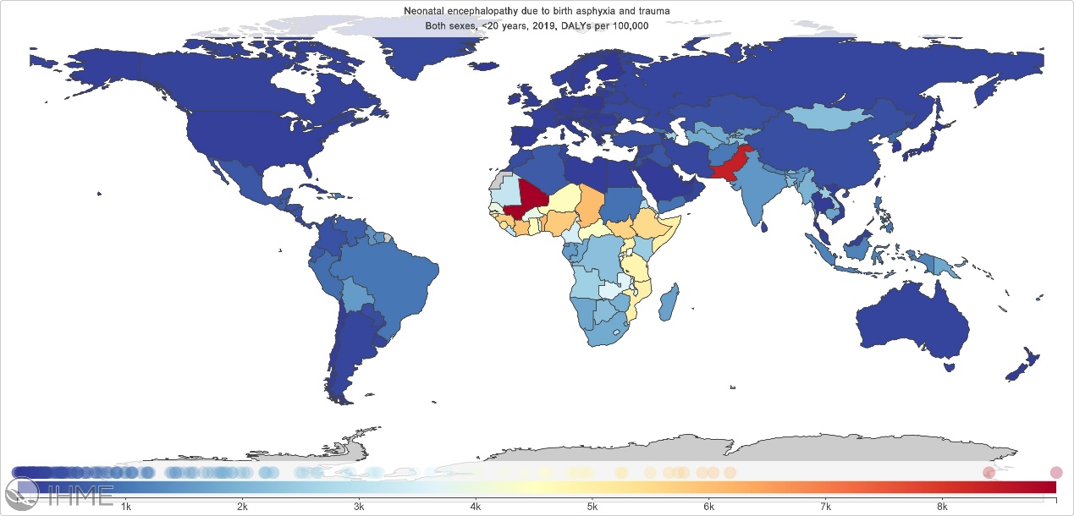
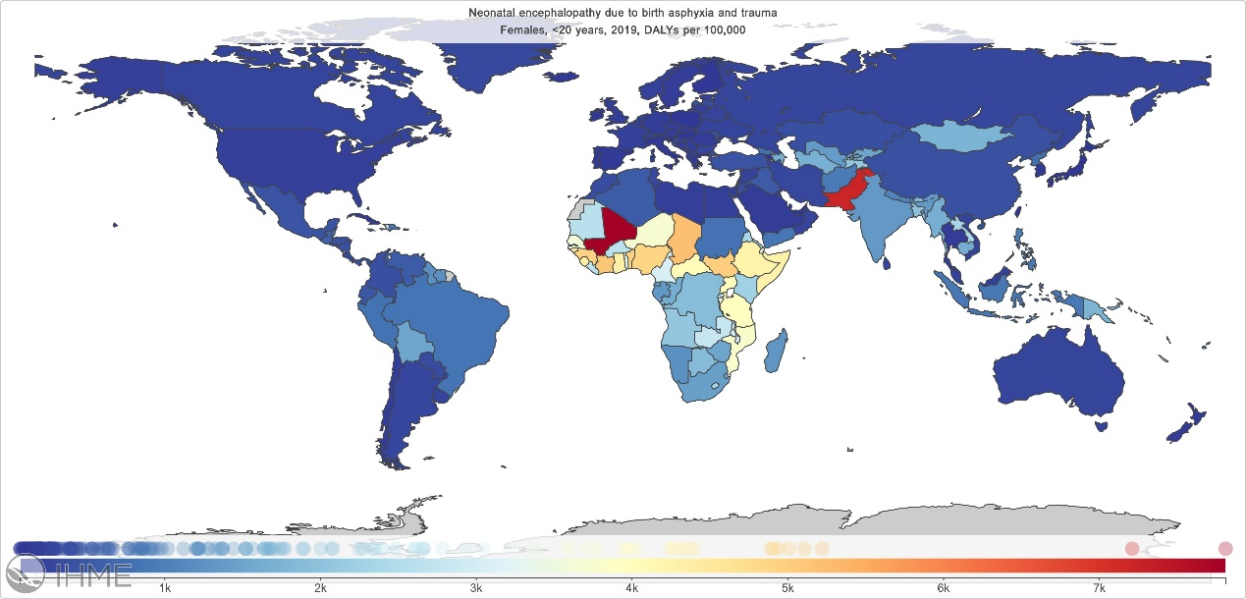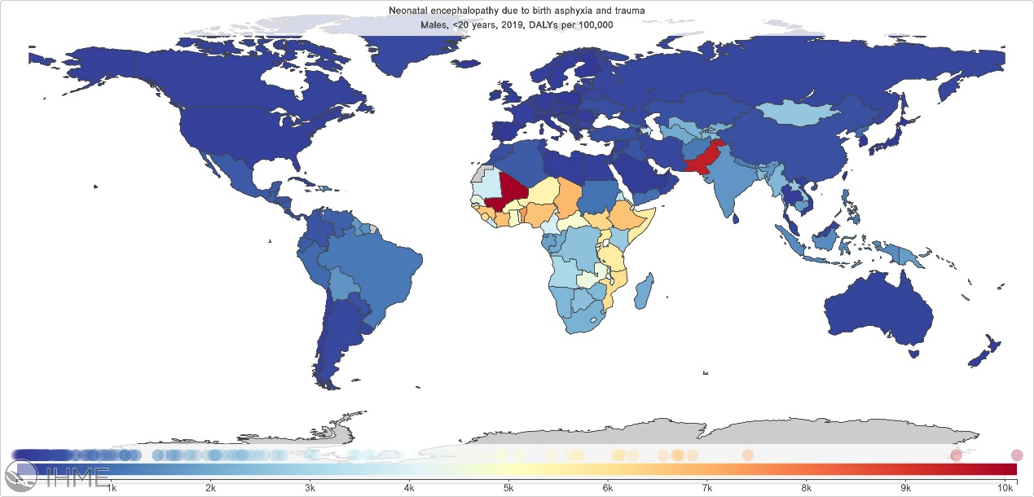

Figure e2. Geographical variations for meningitis in 2019 in both sexes, females and males
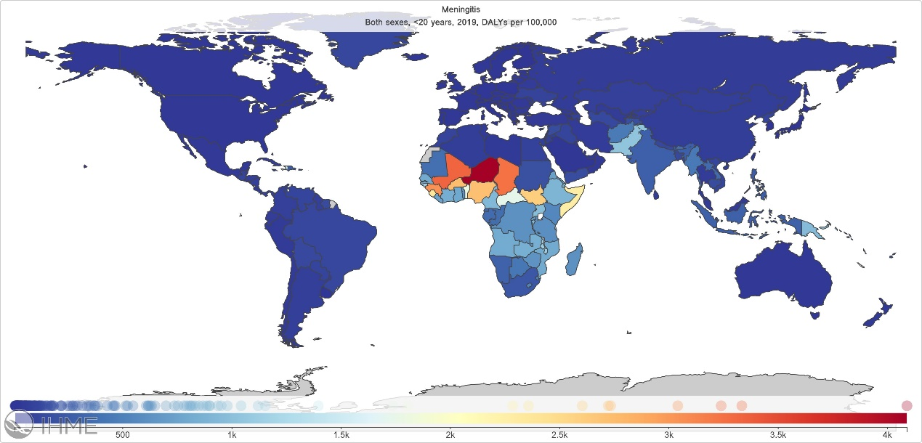
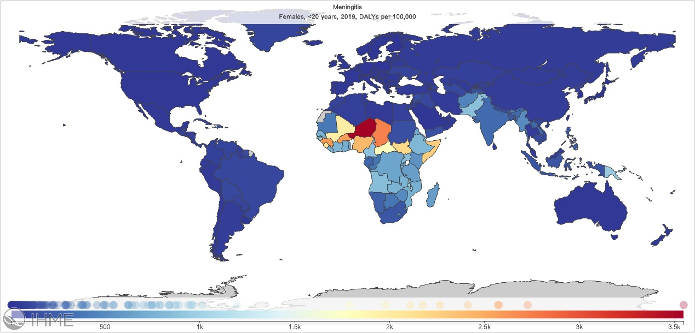
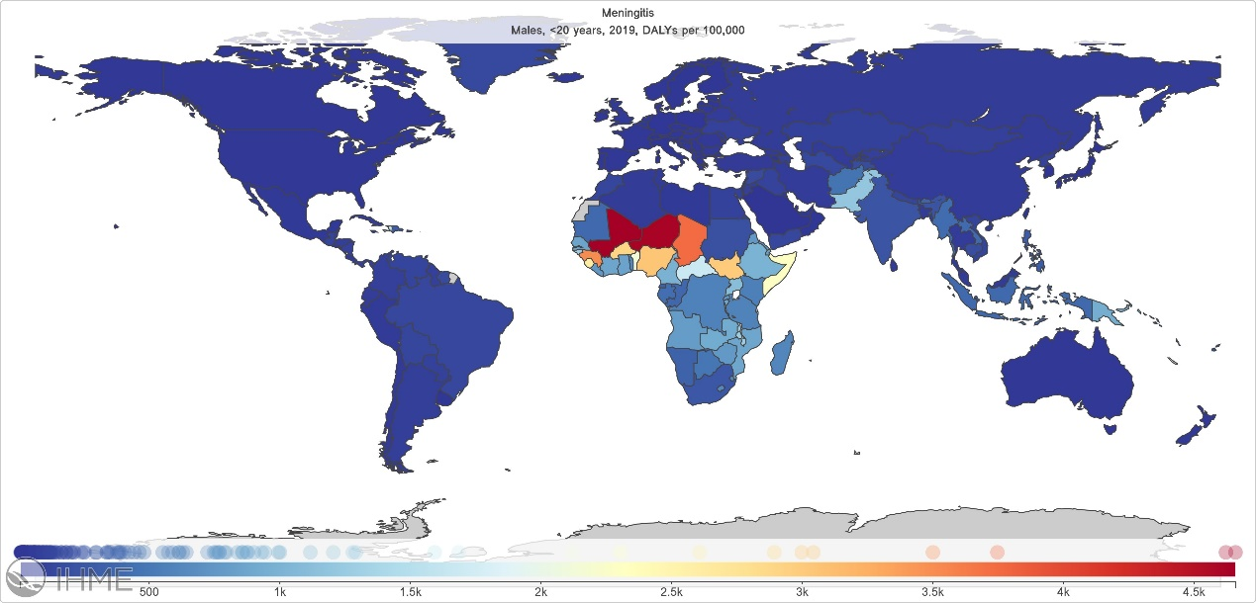

Figure e3. Geographical variations for neural tube deficit in 2019 in both sexes, females and males
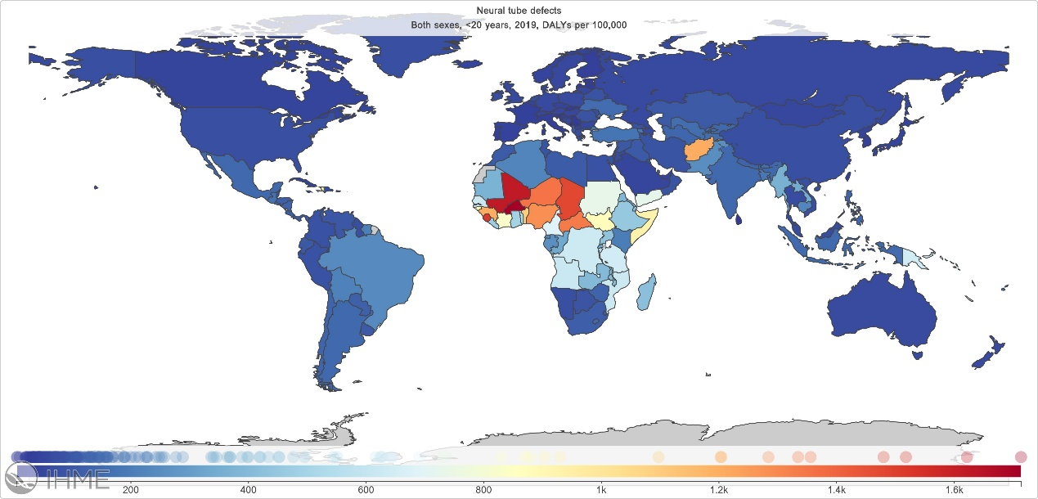
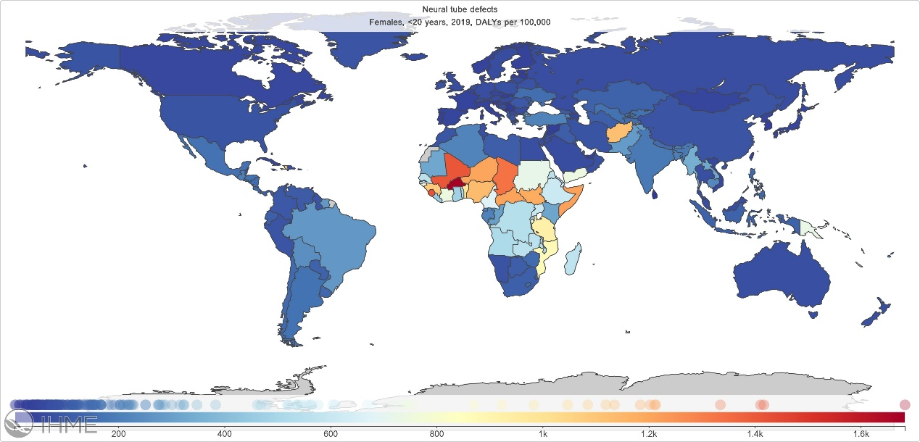
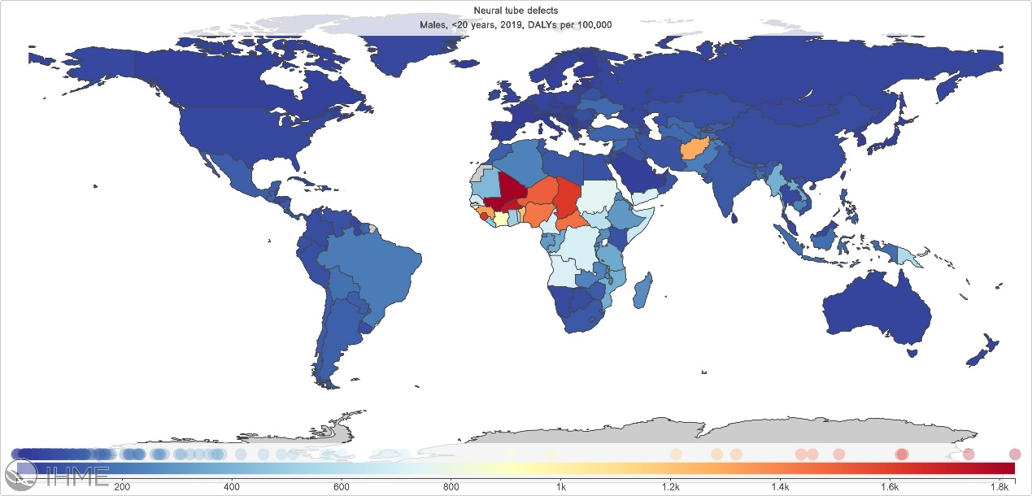

Figure e4. Geographical variations for migraine in 2019 in both sexes, females and males
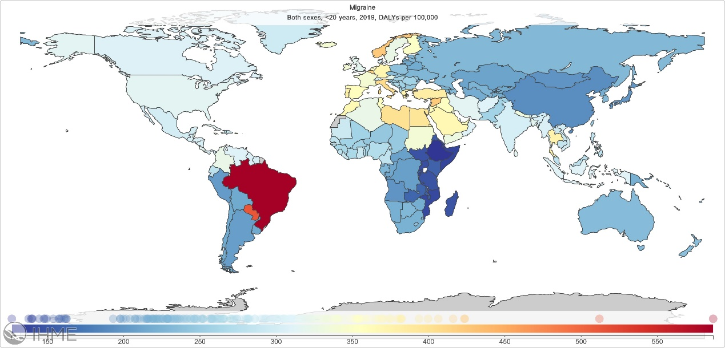
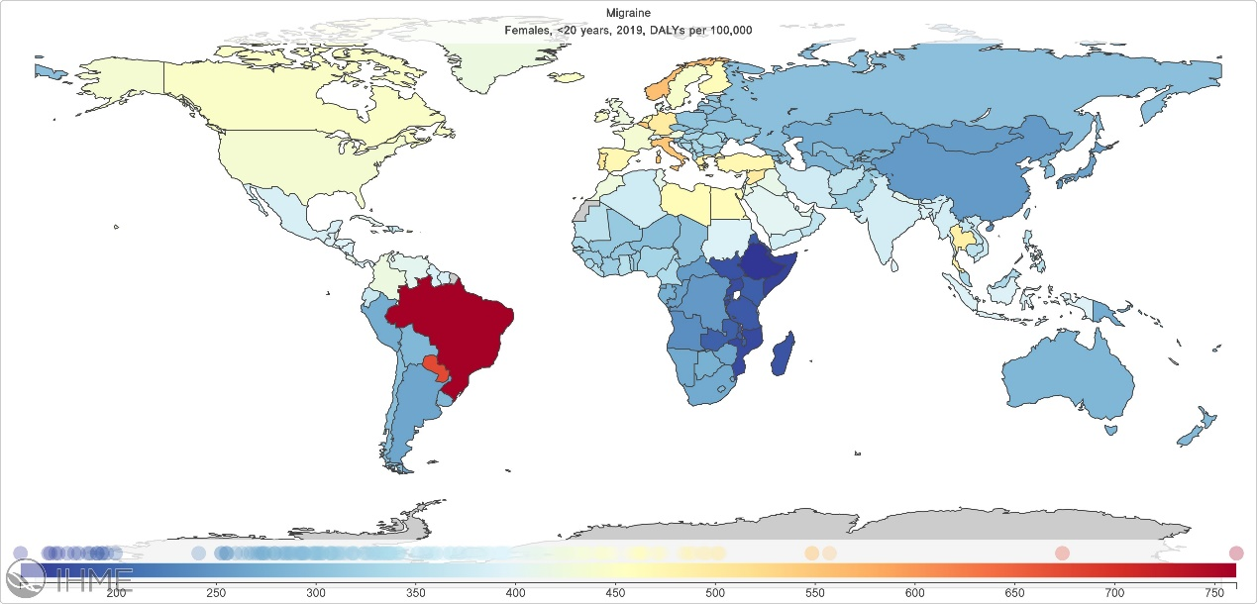
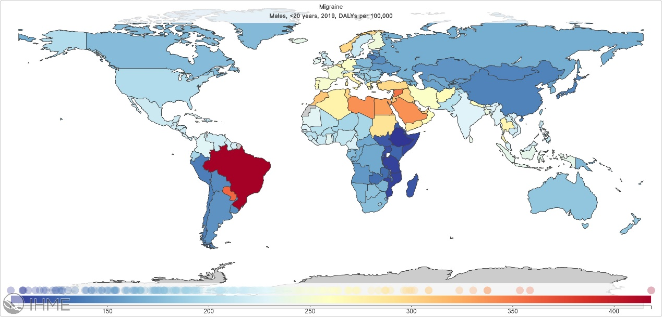
Figure e5. Geographical variations for tension-type headache in 2019 in both sexes, females and males
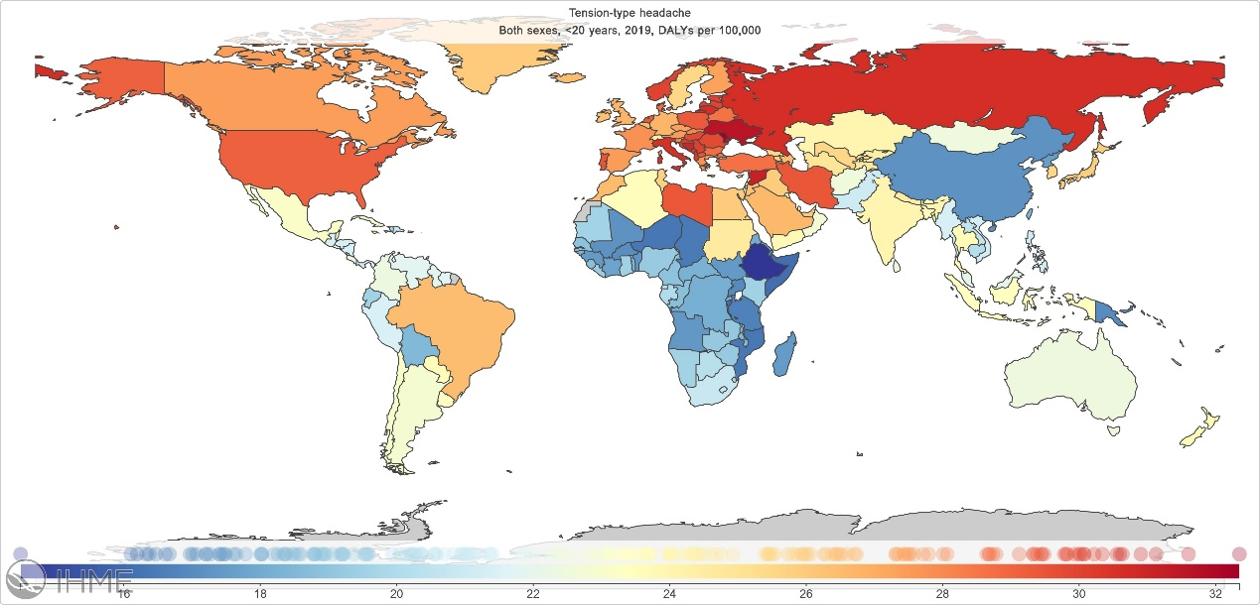
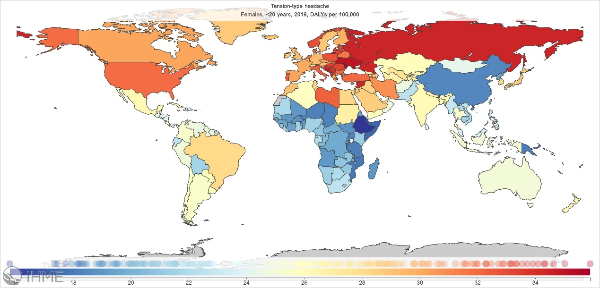
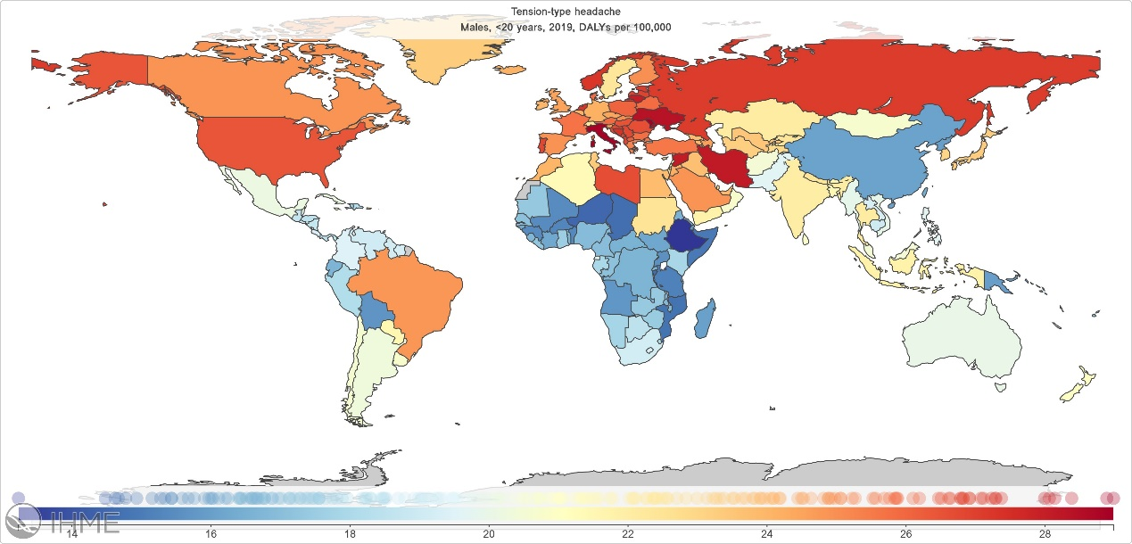

Figure e6. Geographical variations for idiopathic epilepsy in 2019 in both sexes, females and males
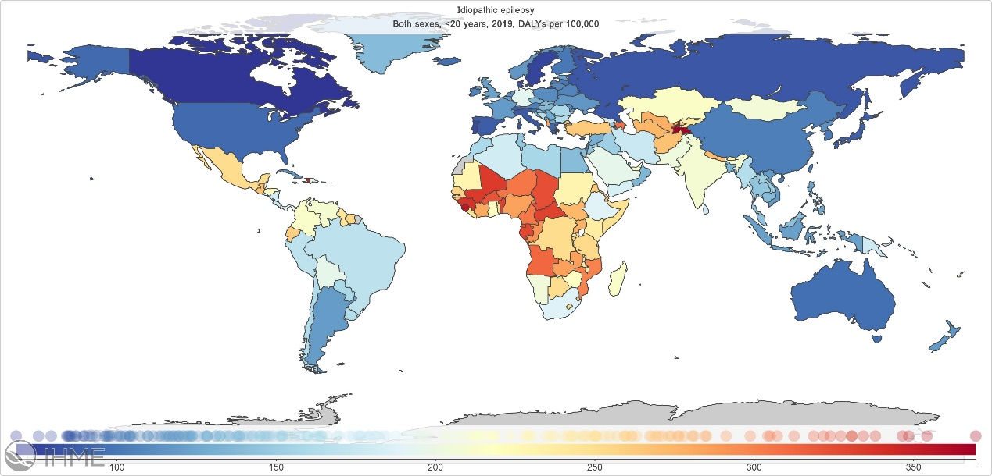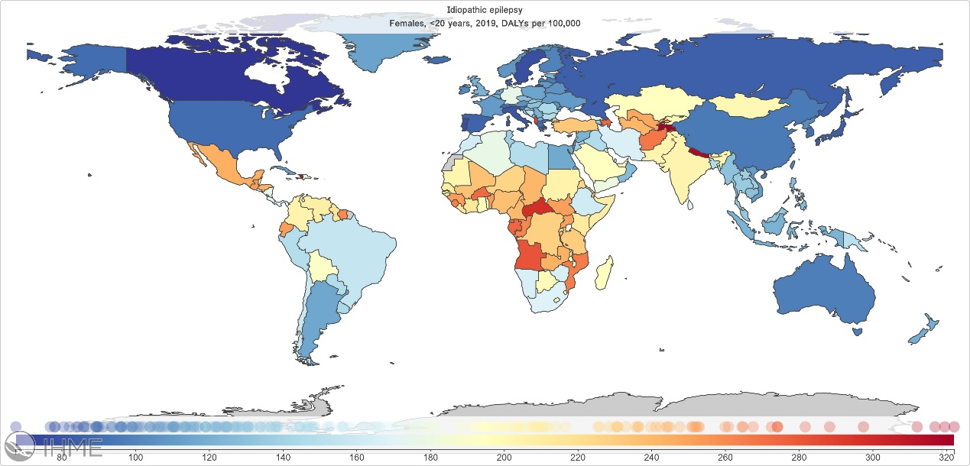
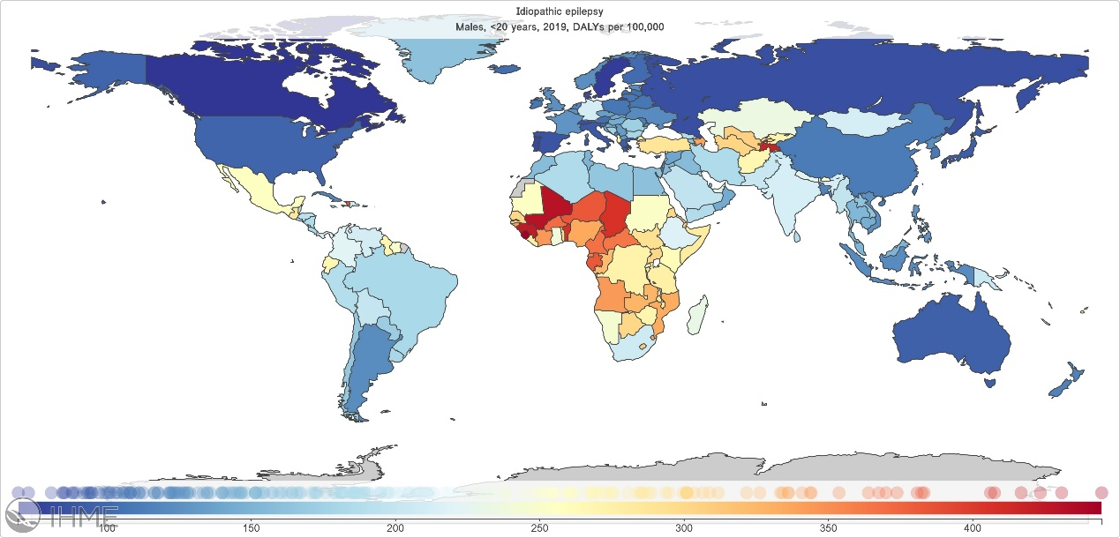
Figure e7. Geographical variations for encephalitis in 2019 in both sexes, females and males
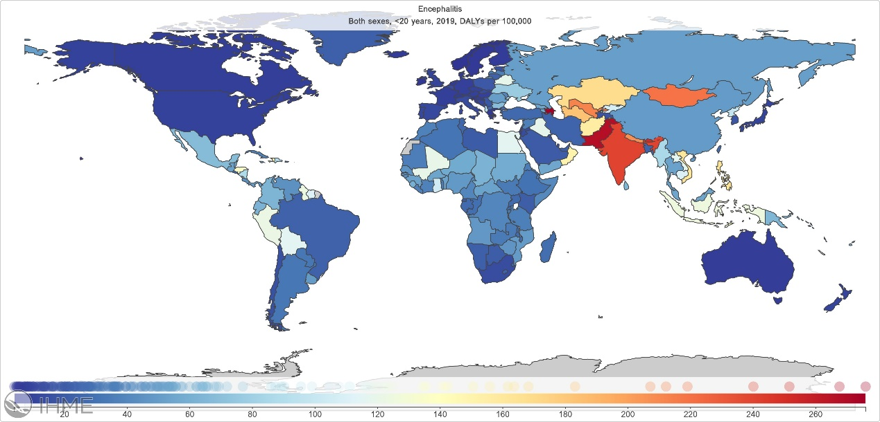
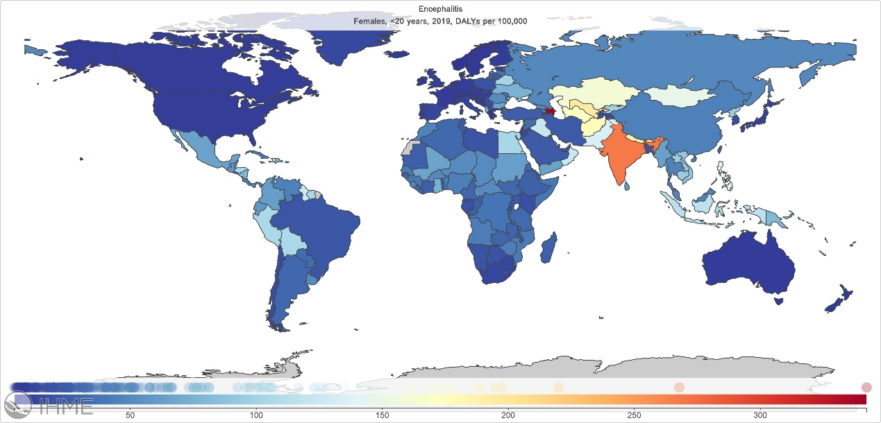
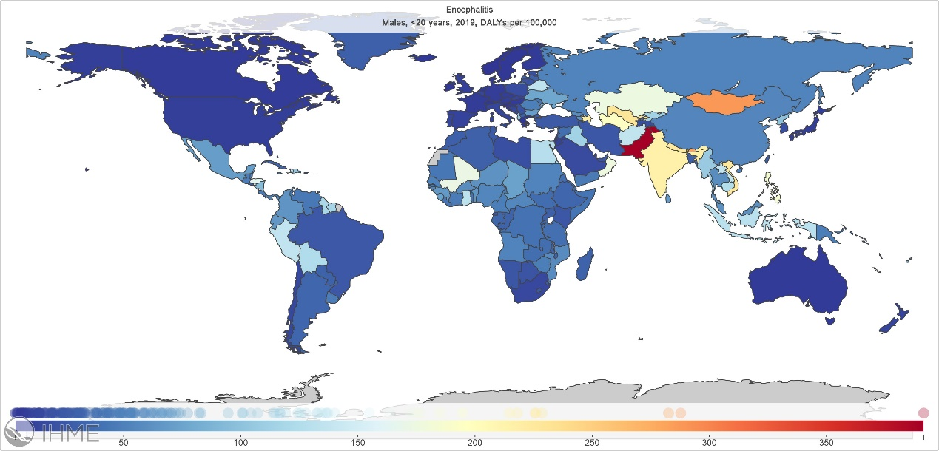

Figure e8. Geographical variations for idiopathic developmental intellectual disability in 2019 in both sexes, females and males
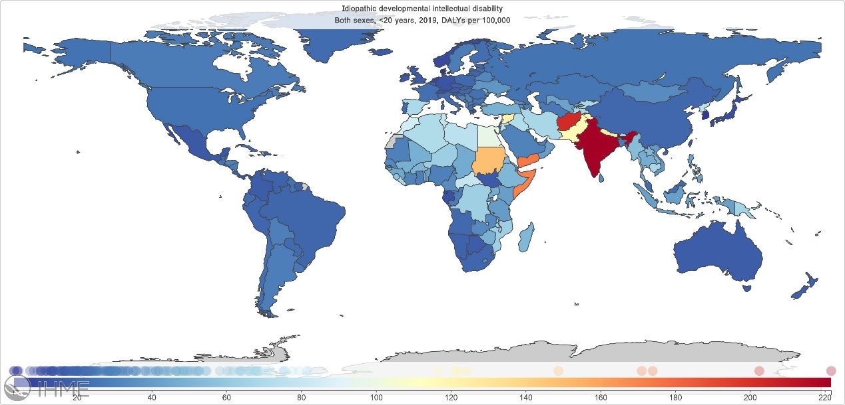
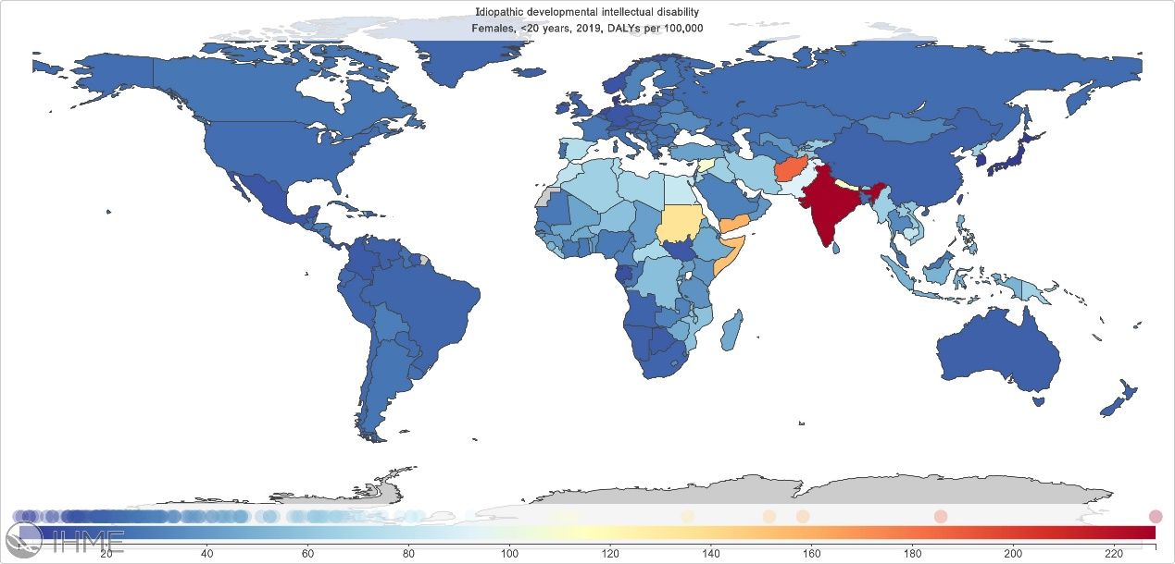
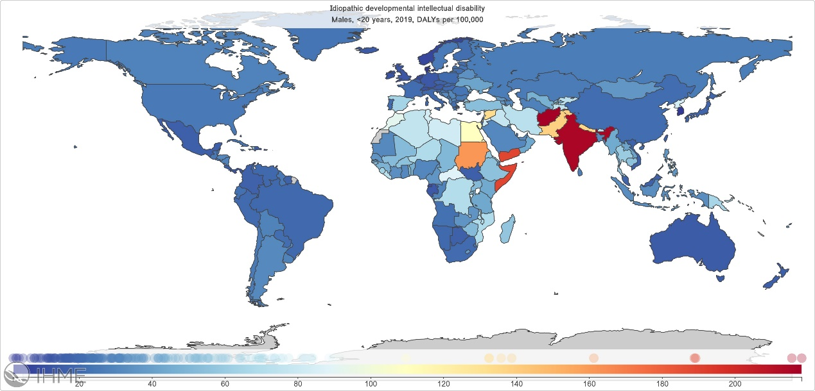
Figure e9. Geographical variations for brain and CNS cancer in 2019 in both sexes, females and males
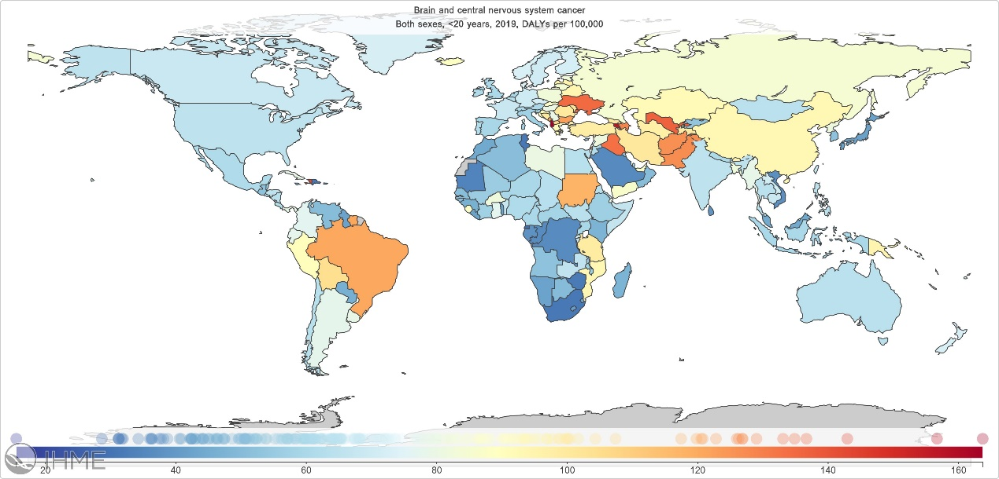
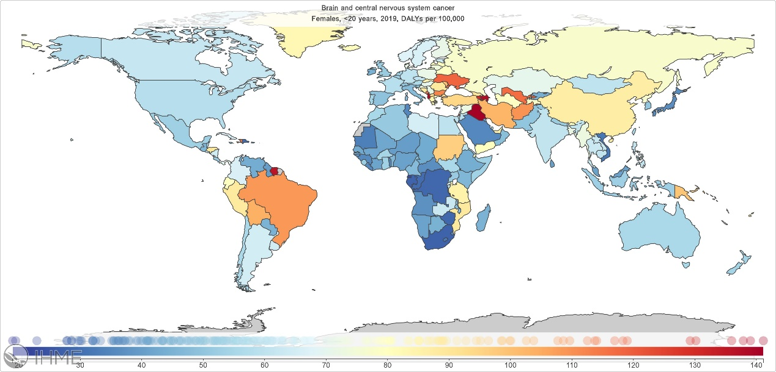
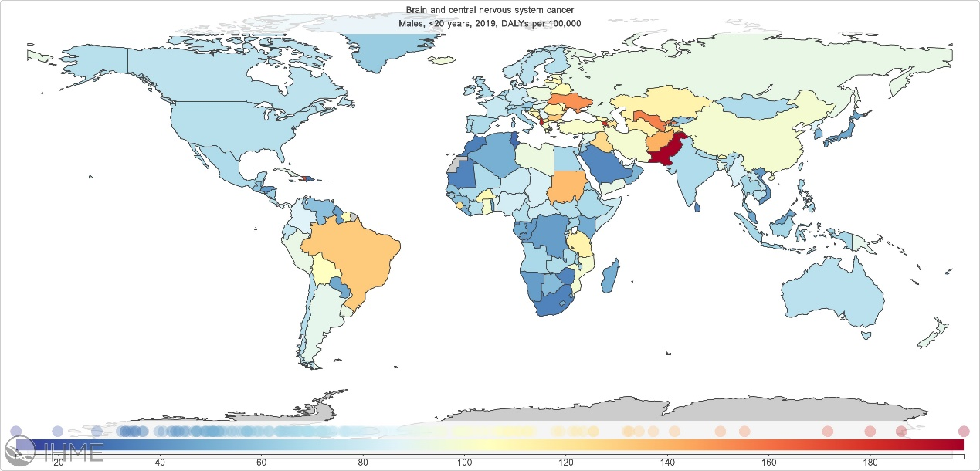

Figure e10. Geographical variations for other neurologic disorders in 2019 in both sexes, females and males
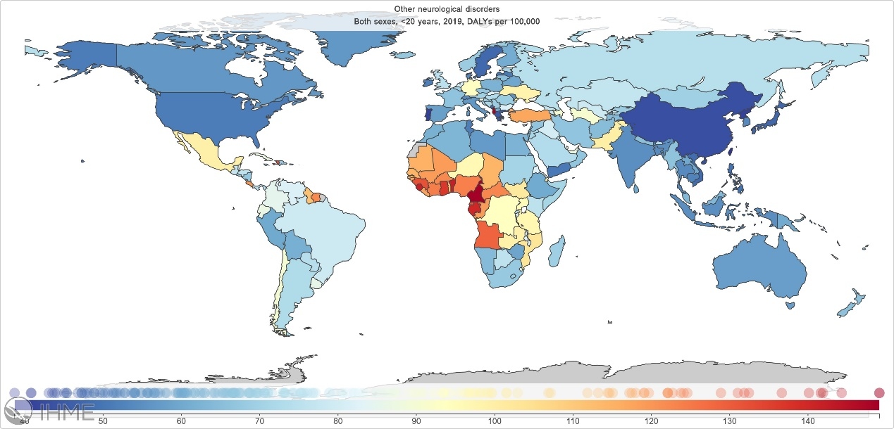
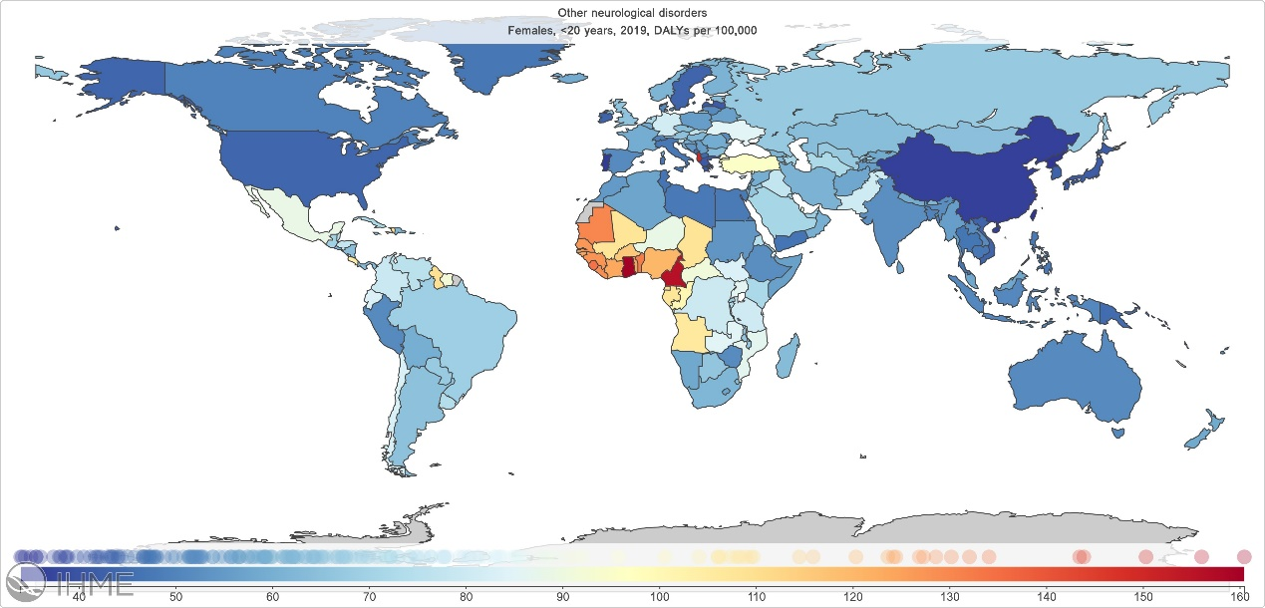
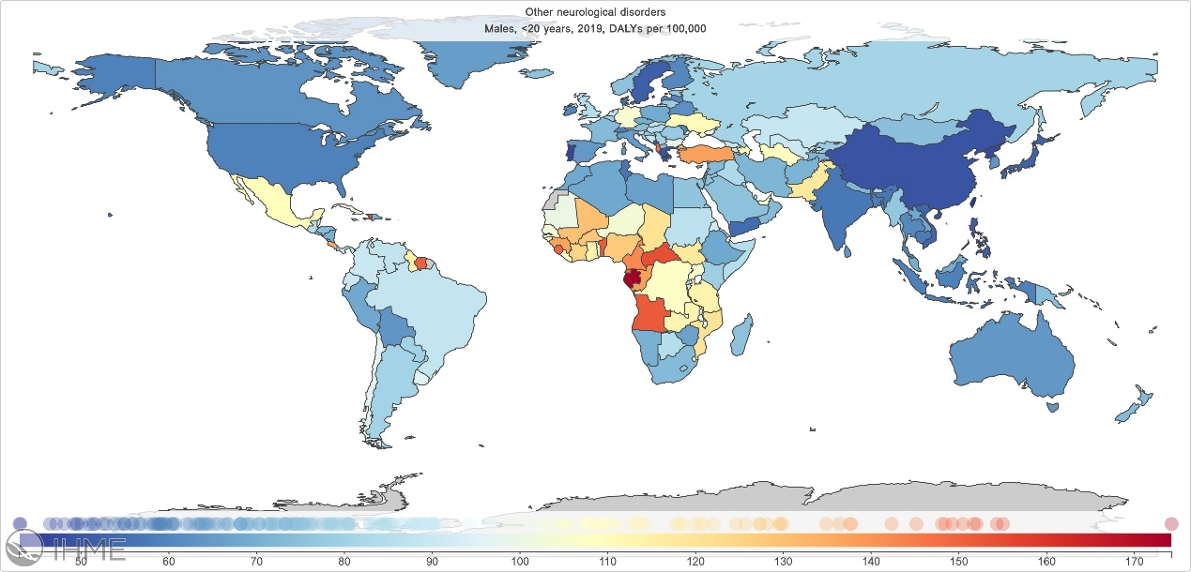
Figure e11. Geographical variations for tetanus in 2019 in both sexes, females and males
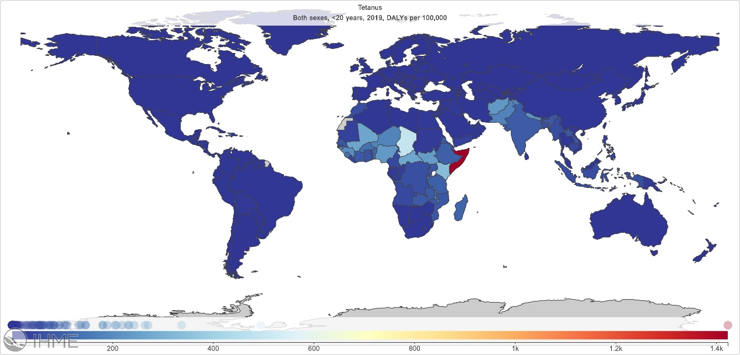
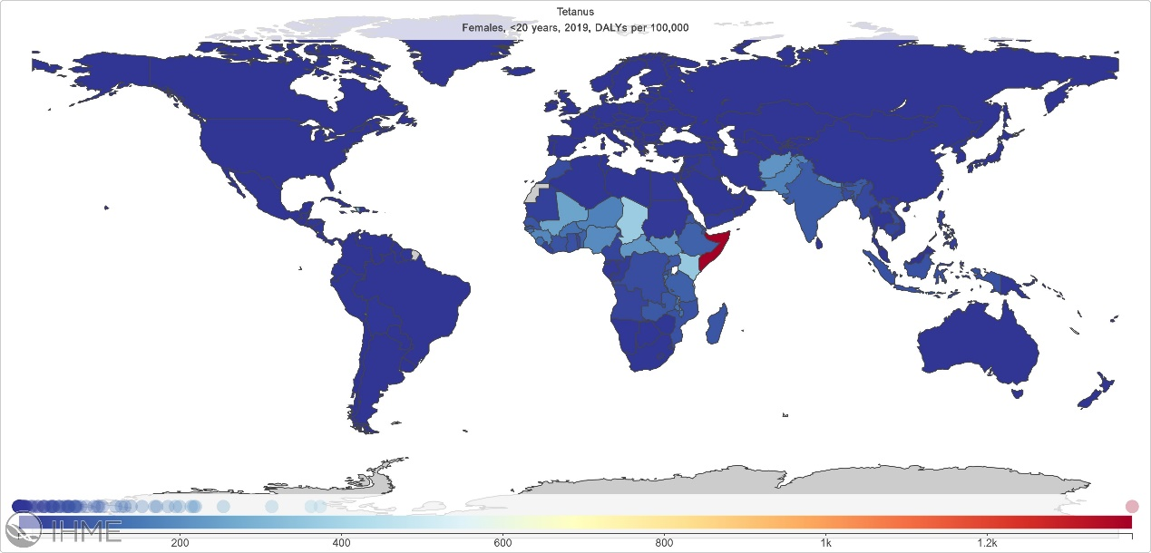
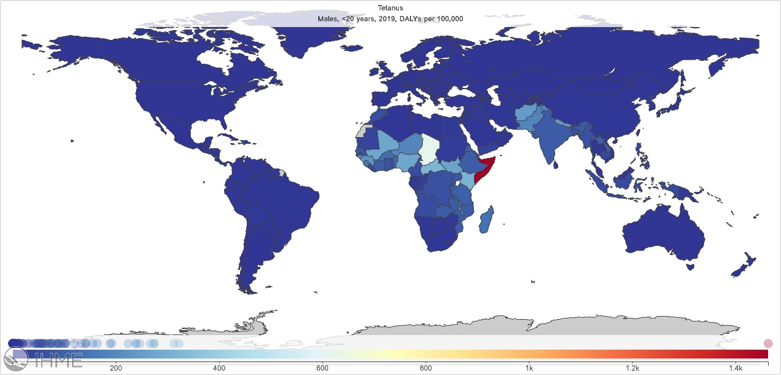

Figure e12. Geographical variations for motor neuron disease in 2019 in both sexes, females and males
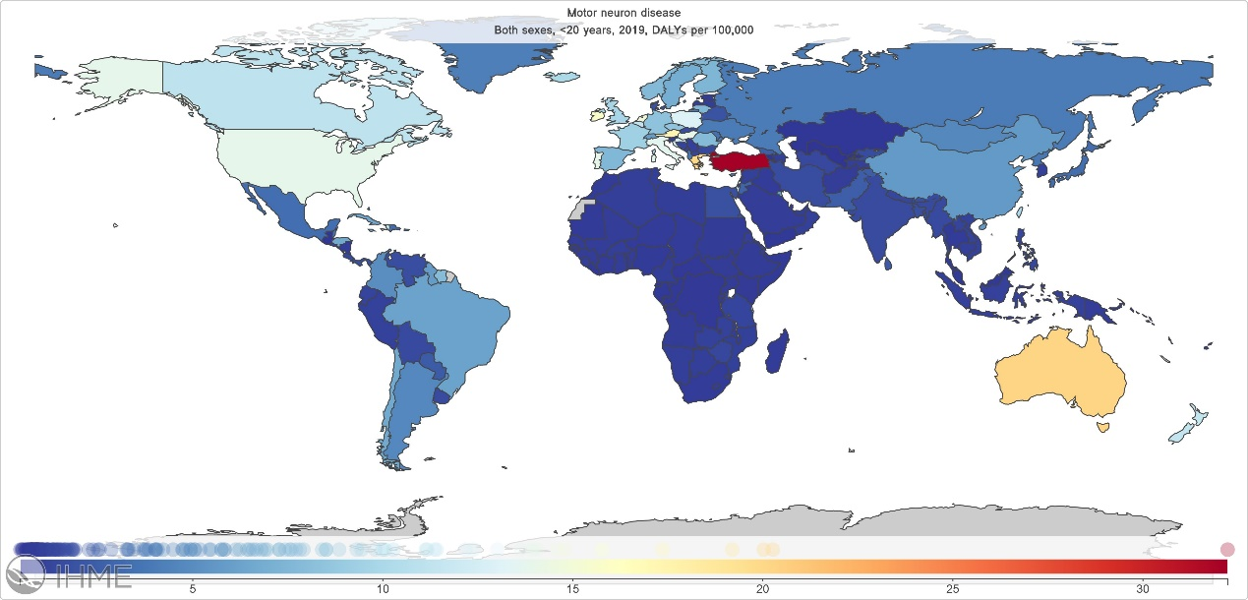
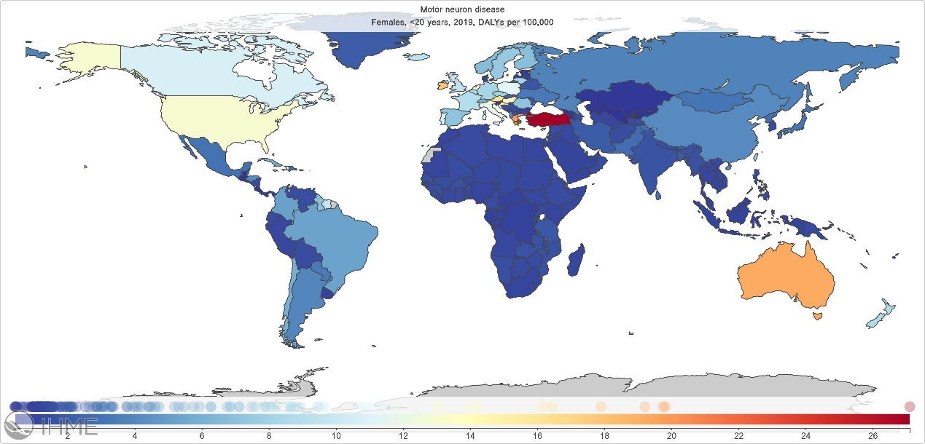
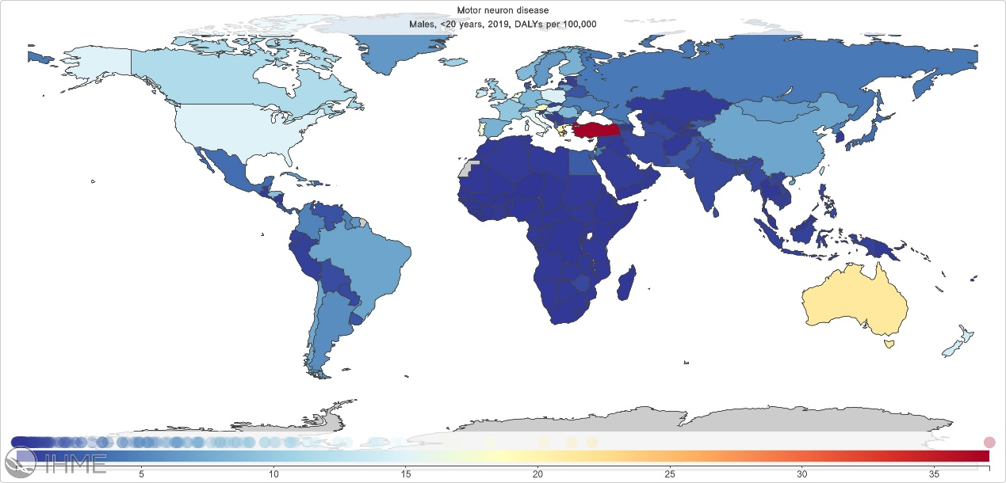

Figure e13. Geographical variations for multiple sclerosis in 2019 in both sexes, females and males
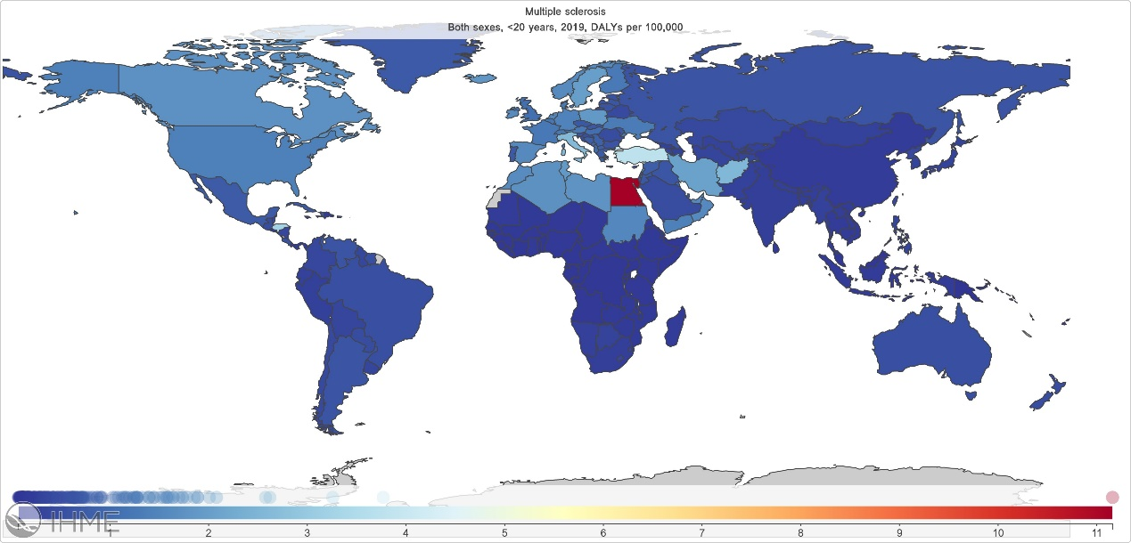
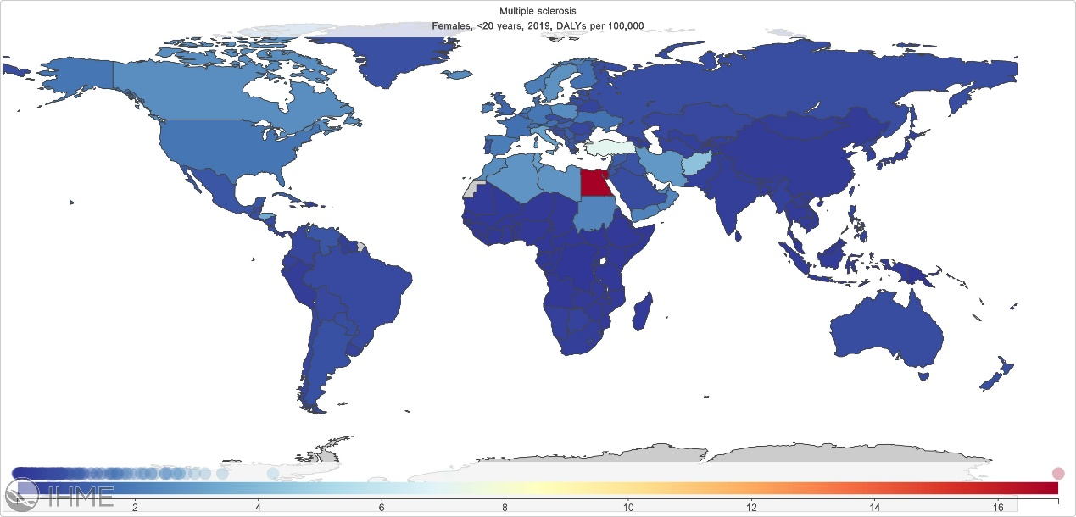
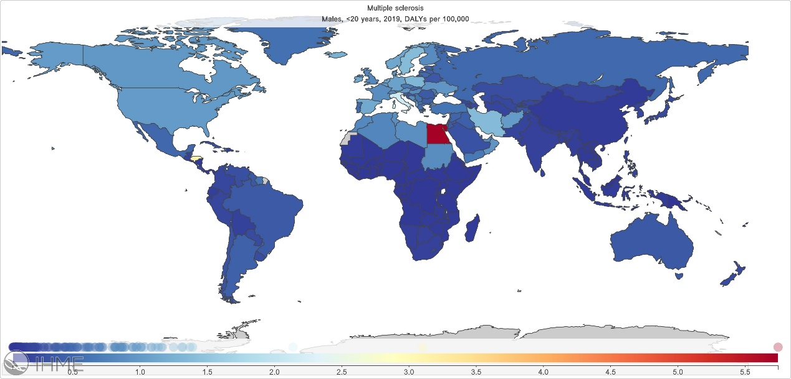
eTable 1: List of International Classification of Diseases (ICD) codes mapped to the Global Burden of pediatric neurologic disorders
Cause | ICD10 | ICD10 Used in Hospital/Claims Analyses
Meningitis | A39-A39.9, A87-A87.9, D86.81, G00-G03.9, G06-G09.9, Z20.811, Z22.31 | A39-A39.9, A87-A87.9, G00-G03.9
Tetanus | A33-A35.0, Z23.5 | A33-A35.0
Encephalitis | A83-A85.2, A85.8-A86.0, B94.1, F07.1, G04-G05.8, Z24.1 | A83-A86.0, B94.1, F07.1, G04-G05.8
Neonatal encephalopathy due to birth asphyxia and trauma | P02-P03.9, P10-P15.9, P20-P21.9, P24-P24.9, P52-P52.9, P90-P91.9 | P21-P21.9, P24-P24.9, P91-P91.9
Neural tube defects | Q00-Q01.9, Q05-Q05.9, Q07.01, Q07.03 | Q00-Q01.9, Q05-Q05.9, Q07.01-Q07.01, Q07.03-Q07.03
Migraine | G43-G43.919 | G43-G43.919, G44.4-G44.41
Tension-type headache | G44.2-G44.229, G44.4-G44.41 | G44.2-G44.229
Idiopathic developmental intellectual disability | F70-F79.9, Z81.0
Idiopathic epilepsy | G40-G41.9, Z82.0
Multiple sclerosis | G35-G35.0 | G35-G35.0
Motor neuron disease |  | G12-G12.9
Brain and central nervous system cancer | C70-C70.1, C70.9-C72.9, Z85.841-Z85.848, Z86.011
Other neurological disorders | F02.2, G10-G10.0, G11-G13.8, G21, G21.2-G24, G24.1-G25.0, G25.2-G25.3, G25.5, G25.8-G26.0, G36-G37.9, G50-G54.1, G54.5-G62, G62.2-G65.2, G70-G71.19, G71.3-G72, G72.1-G73.7, G80-G83.9, G89-G93.6, G93.8-G95.29, G95.8-G96, G96.1, G96.12-G96.9, G98-G99.8, M33-M33.99, M60-M60.19, M60.8-M60.9, M79.7

eTable 2: List of “other neurological disorders” in ICD 10
ICD 10 | Neurological disorder
G10 | Huntington’s disease
G11 | Hereditary ataxia
G12 | Spinal muscular atrophy and related syndromes
G13 | Systemic atrophies primarily affecting central nervous system in diseases classified elsewhere
G23 | Other degenerative diseases of basal ganglia
G24 | Dystonia
G25 | Other extrapyramidal and movement disorders
G26 | Extrapyramidal and movement disorders in diseases classified elsewhere
G36 | Other acute disseminated demyelination
G37 | Other demyelinating diseases of central nervous system
G61 | Inflammatory polyneuropathy
G70 | Myasthenia gravis and other myoneural disorders
G71 | Primary disorders of muscles (including muscular dystrophy and myopathies)
G72 | Other and unspecified myopathies
G73 | Disorders of myoneural junction and muscle in diseases classified elsewhere
G90 | Disorders of autonomic nervous system
G95 | Other and unspecified diseases of spinal cord
M33 | Systemic connective tissue disorders

