Translucent Color Organic Solar Cells: From Power Generating Windowpanes to Aesthetic Art
Baozhong Deng^{1#}, Yi Li^{1#}, Kaiwen Zheng¹, Zhouyi Lu¹, Tao Xu¹*, Shenghao Wang², Xiaoshu Luo³, Bruno Grandidier⁴, Jianhua Zhang¹*, and Furong Zhu⁵*
^{1.} School of Microelectronics, Shanghai University, 200444 Shanghai, China
^{2.} Materials Genome Institute, Shanghai University, 200444 Shanghai, China
^{3.} Shanghai Academy of Fine Arts, Shanghai University, 200444 Shanghai, China
^{4.} Université de Lille, CNRS, Centrale Lille, Université Polytechnique Hauts-de-France, Junia-ISEN, UMR 8520 - IEMN, 59000 Lille, France
^{5.} Department of Physics, Research Centre of Excellence for Organic Electronics and Institute of Advanced Materials, Hong Kong Baptist University, Kowloon Tong, Hong Kong, China,
# These authors contributed equally to this work.
E-mail: xtld@shu.edu.cn, jhzhang@oa.shu.edu.cn, frzhu@hkbu.edu.hk

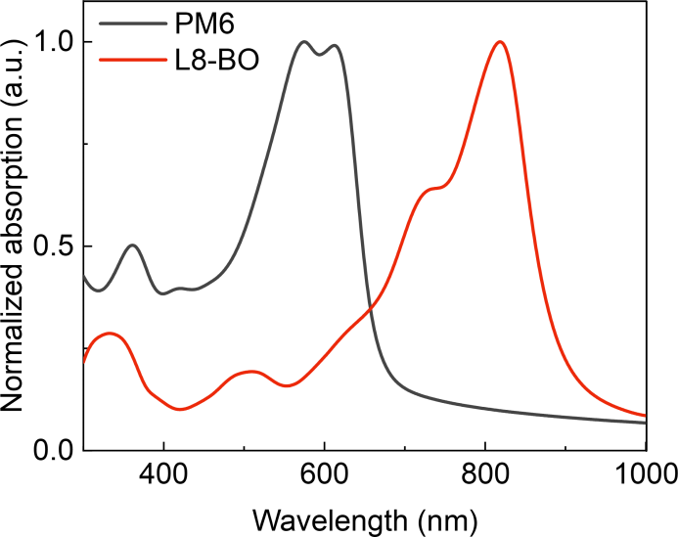
Figure S1. Absorption spectra of PM6 and L8-BO.

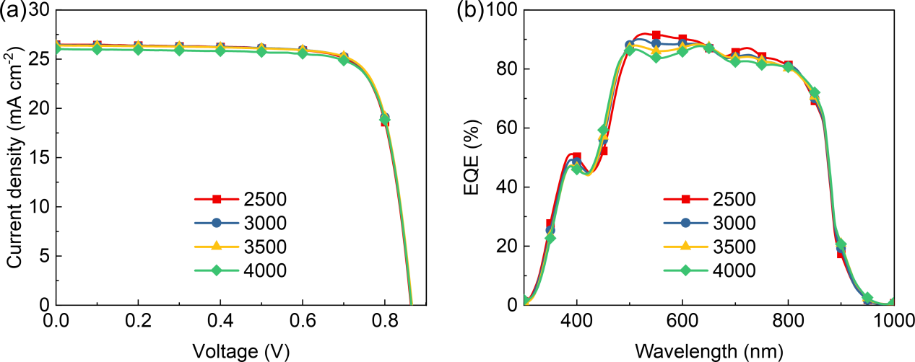
Figure S2. (a) J−V characteristics and (b) EQE spectra of 4.14 mm²-sized PM6:L8-BO opaque OSCs, fabricated using different BHJ active layer thicknesses, prepared at varying spin-coating speeds.

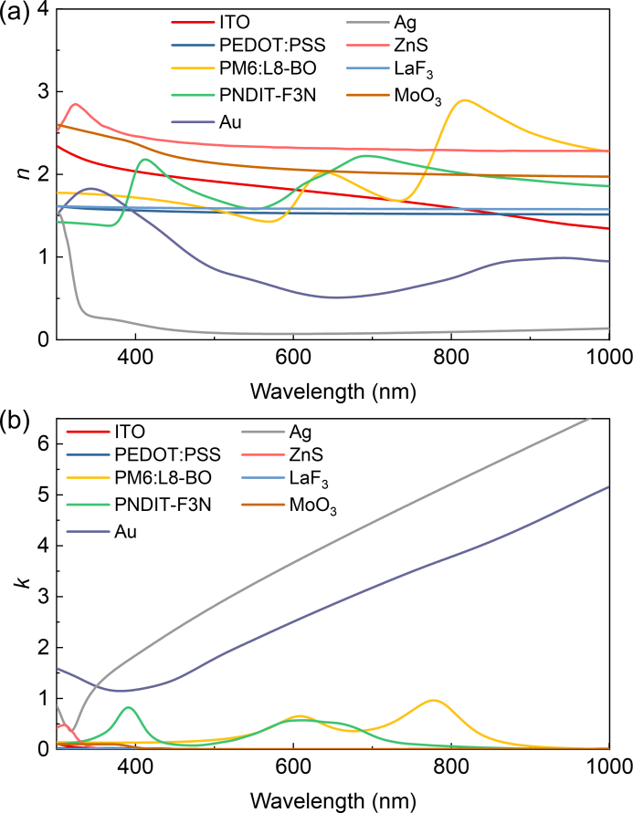
Figure S3. (a) Wavelength-dependent refractive indexes and (b) extinction coefficients of the function layers used in this work.

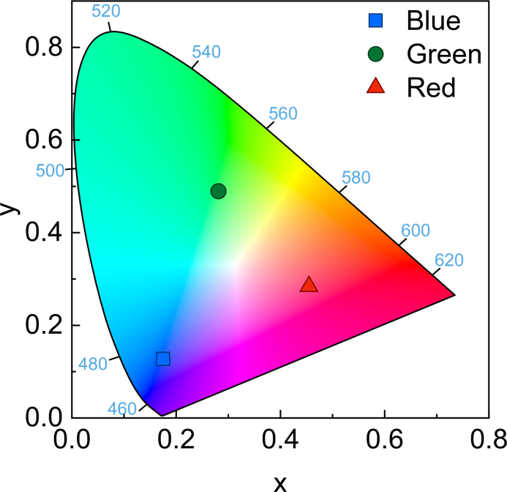
Figure S4. CIE chromaticity coordinates of the blue, green and red ST-OSCs.
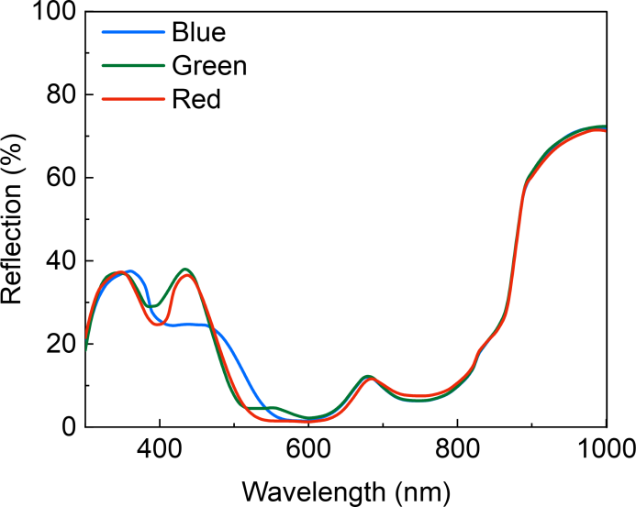
Figure S5. Reflection spectra of the blue, green and red ST-OSCs.

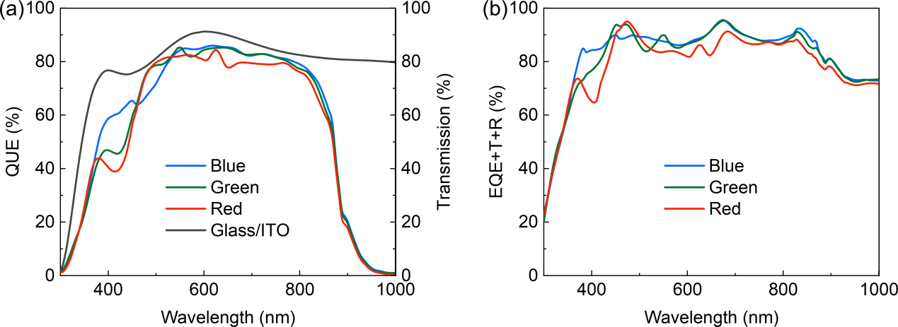
Figure S6. (a) QUE spectra and (b) EQE+T+R spectra obtained for the blue, green, and red ST-OSCs. The transmission spectrum measured for the glass/ITO substrate is also shown for comparison.

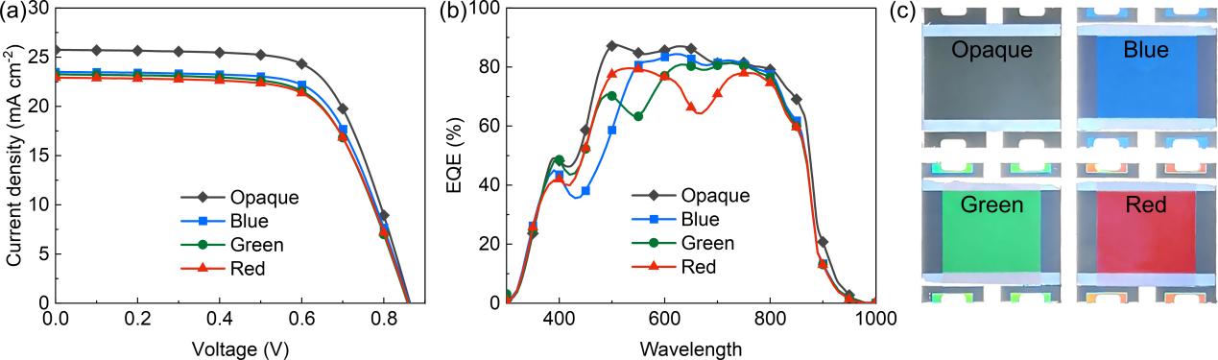
Figure S7. (a) J−V characteristics, (b) EQE spectra and (c) photographs of the 1.0 cm²-sized opaque OSC, blue, green and red ST-OSCs.

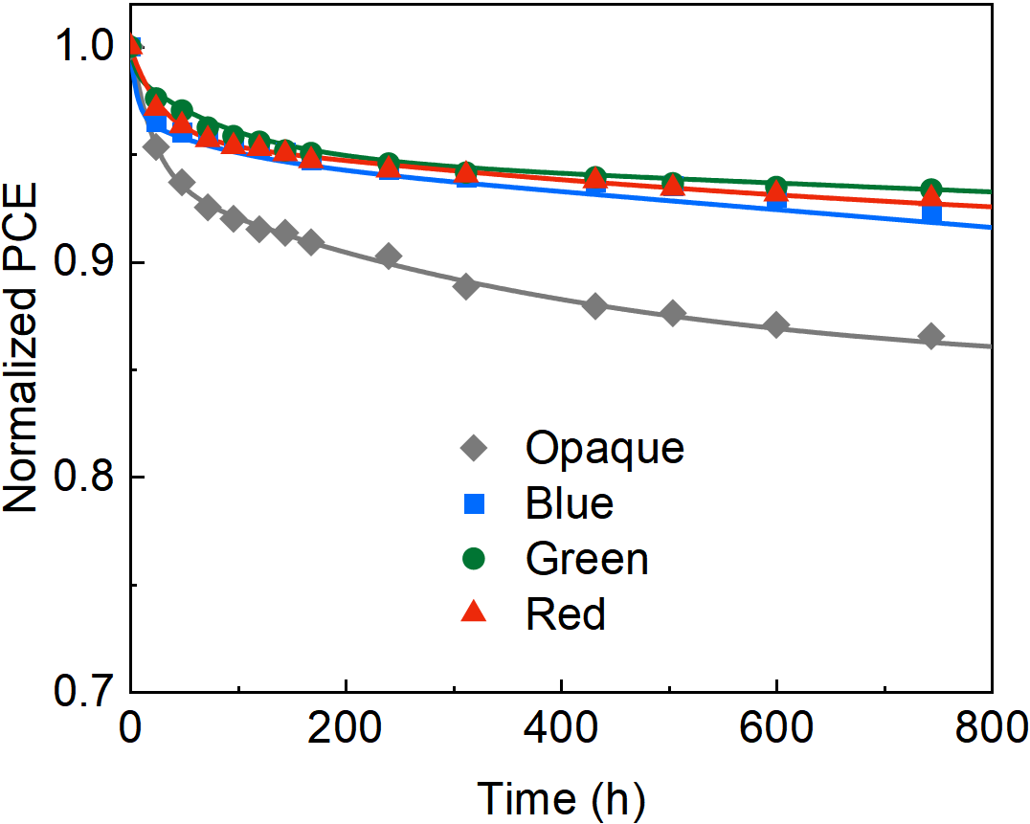
Figure S8. The stability of the control opaque OSC, blue, green, and red ST-OSCs stored in a N₂-purged glove box.

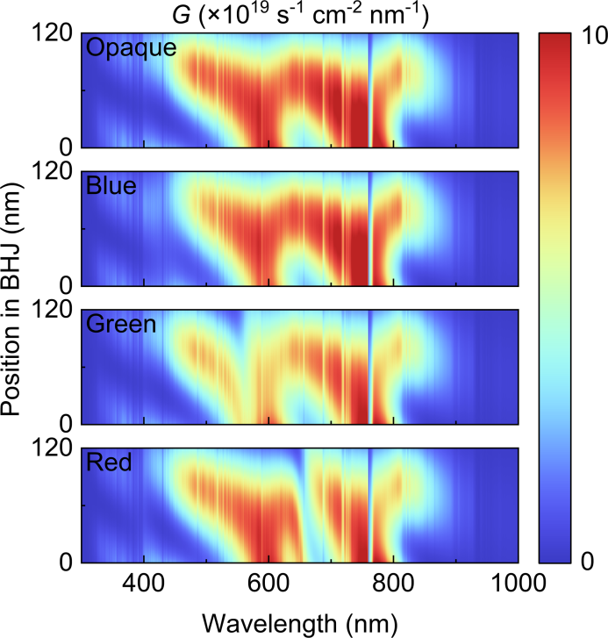
Figure S9. Profiles of the exciton generation in the active layers of the opaque device, blue, green, and red ST-OSCs.

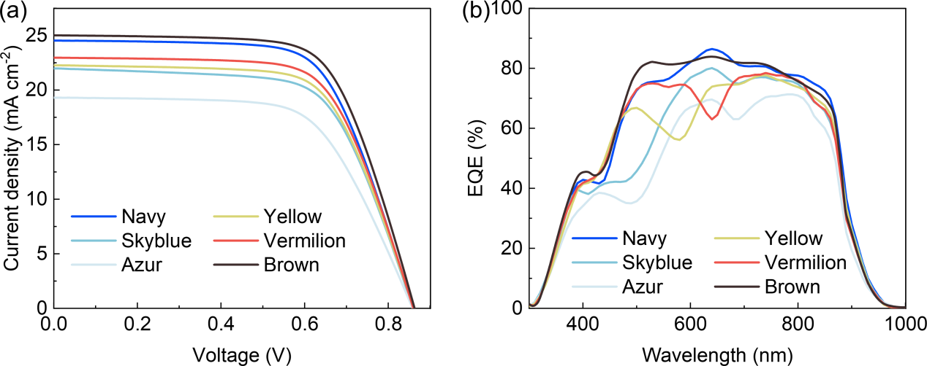
Figure S10. (a) J−V characteristics and (b) EQE spectra measured for the 1.0 cm²-sized navy, sky blue, azure, yellow, vermilion, and brown ST-OSCs.
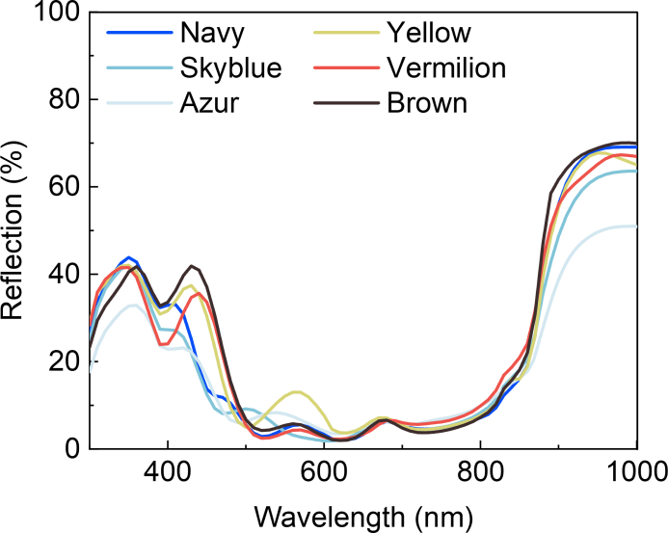
Figure S11. Reflection spectra measured for the navy, sky blue, azure, yellow, vermilion, and brown ST-OSCs.

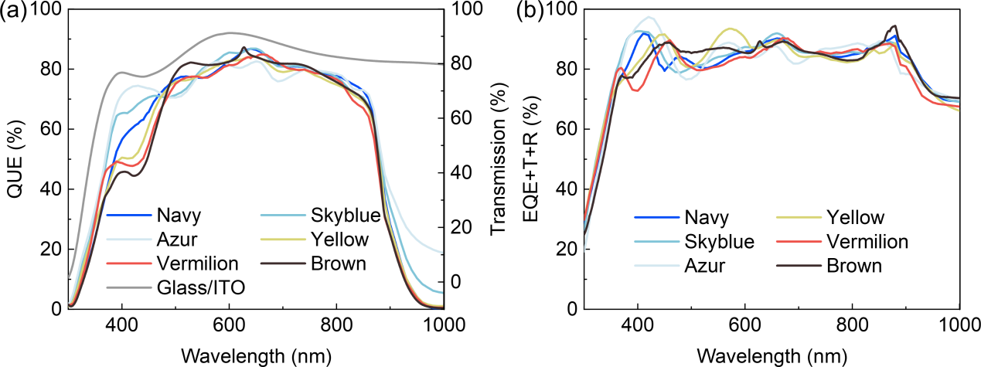
Figure S12. (a) QUE spectra and (b) EQE+T+R spectra obtained for the navy, sky blue, azure, yellow, vermilion, and brown ST-OSCs.

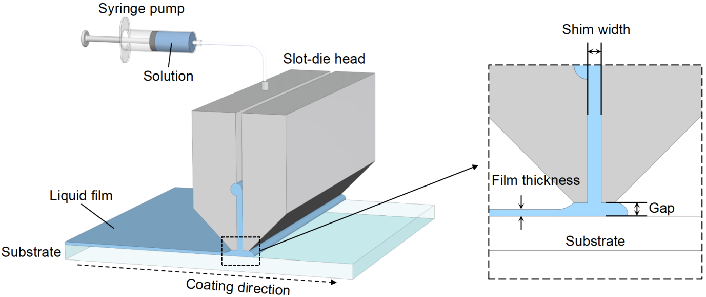
Figure S13. Illustration of the slot-die coating process.

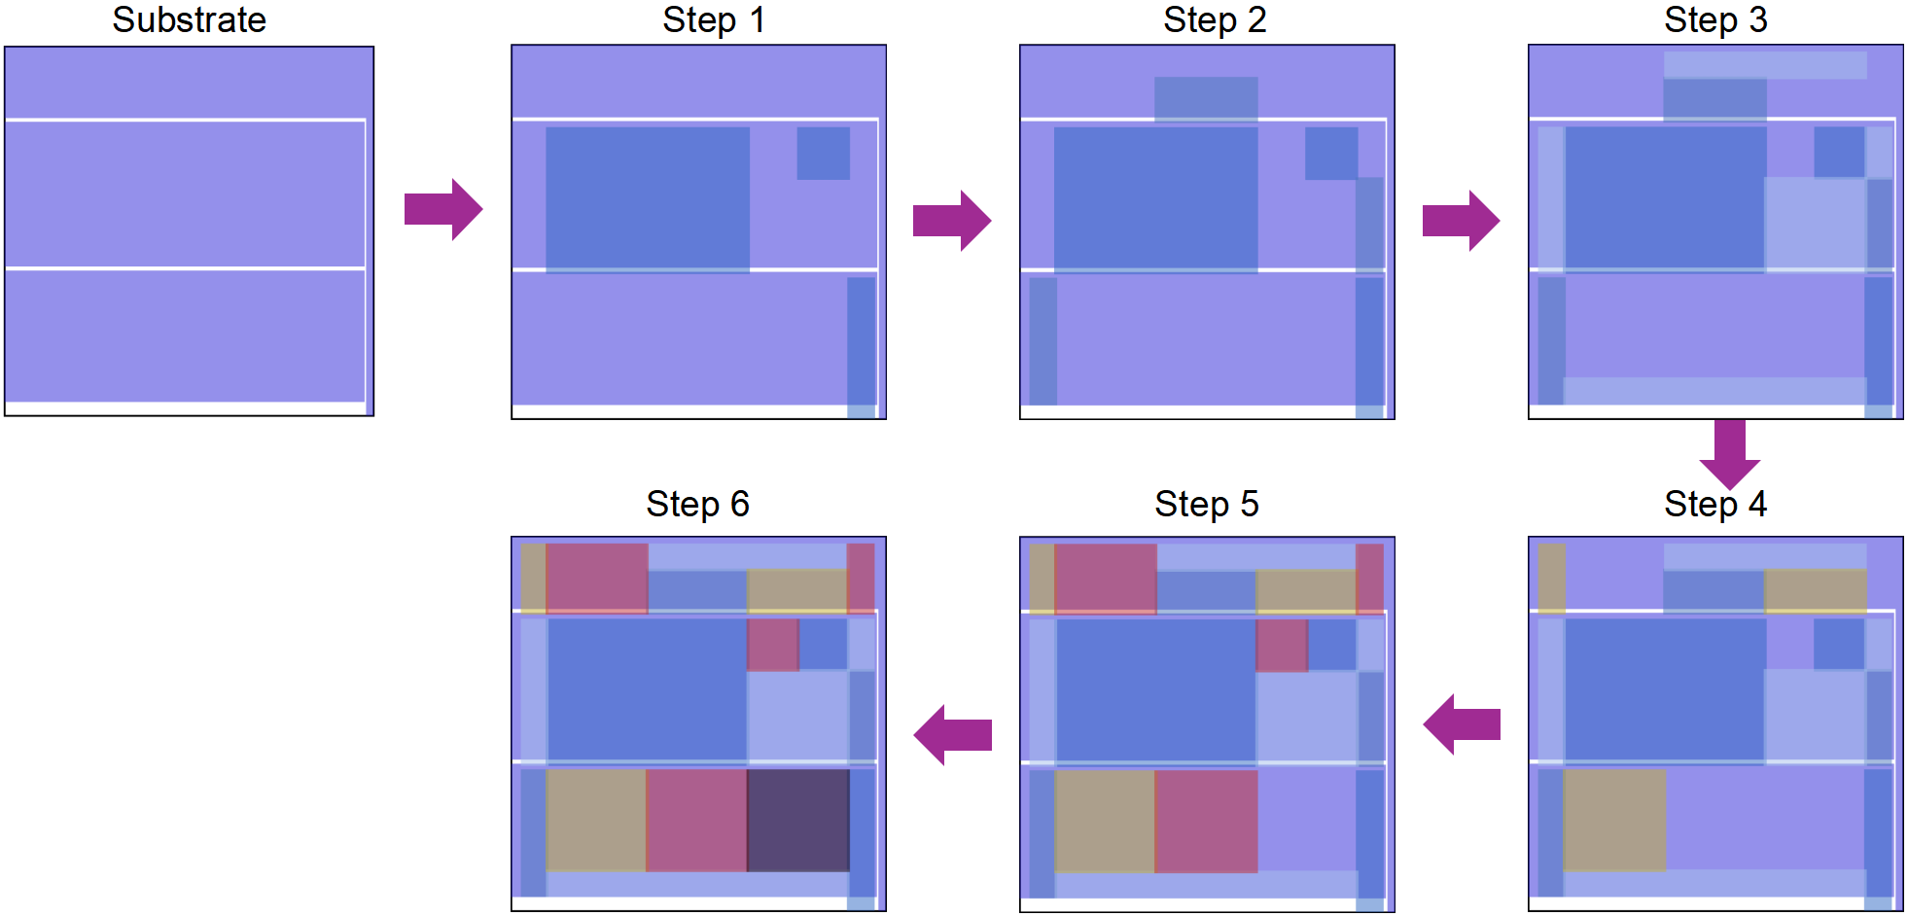
Figure S14. Schematic diagram illustrating the multi-step selective-area evaporation process for fabricating a 100 cm²-sized color ST-OSC module having different microcavity optical coupling layers.

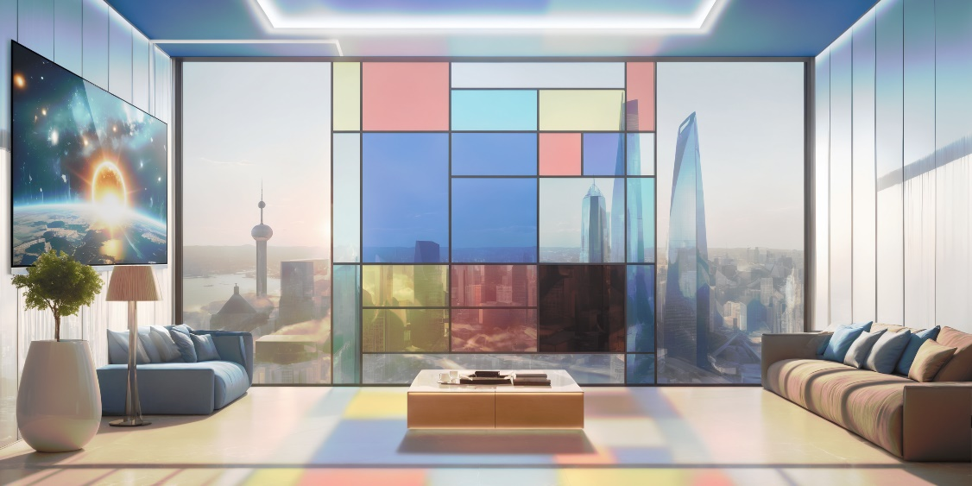
Figure S15. An enabling translucent color BIPV technology: From power generating windowpanes to aesthetic art.

Table S1. Summary of photovoltaic parameters measured for the 4.14 mm²-sized PM6:L8-BO opaque devices, fabricated with BHJ active layer, which was prepared at varying spin-coating speeds. The results were averaged from the measurements of 15 cells.
Rotation speed | V_{OC}  (V) | J_{SC}  (mA/cm²) | J_{cal}  (mA/cm²) | FF  (%) | PCE  (%)
2500 | 0.86±0.01 | 26.49±0.15 | 26.05 | 78.05±0.37 | 17.83±0.16
3000 | 0.86±0.01 | 26.42±0.13 | 25.90 | 78.74±0.23 | 17.97±0.14
3500 | 0.87±0.01 | 26.39±0.24 | 25.80 | 78.95±0.56 | 18.03±0.19
4000 | 0.86±0.01 | 26.00±0.27 | 25.65 | 79.01±0.43 | 17.74±0.23

Table S2. Summary of photovoltaic parameters measured for the large-area opaque device, opaque device, blue, green and red ST-OSCs. The results were averaged from the measurements of 15 cells, with an effective area of 1 cm².
 | V_{OC}  (V) | J_{SC}  (mA/cm²) | J_{cal}  (mA/cm²) | FF  (%) | PCE  (%)
Opaque | 0.86±0.01 | 25.74±0.14 | 25.44 | 66.90±0.48 | 14.87±0.20
Blue | 0.86±0.01 | 23.50±0.22 | 23.22 | 66.76±0.38 | 13.52±0.10
Green | 0.86±0.01 | 23.25±0.16 | 23.02 | 65.48±0.57 | 13.06±0.14
Red | 0.86±0.01 | 22.92±0.10 | 22.42 | 65.74±0.50 | 12.95±0.13

Table S3. Summary of microcavity configuration optimized for making navy, sky blue, azure, yellow, vermilion, and brown ST-OSCs.
Color | Configuration of microcavity optical coupling layers
Navy | Ag(35 nm)/ZnS(40 nm)/Ag(35 nm)
Skyblue | Ag(20 nm)/ZnS(38 nm)/Ag(15 nm)
Azur | Ag(12 nm)/ZnS(35 nm)/Ag(10 nm)
Yellow | Ag(30 nm)/LaF₃(130 nm)/Ag(30 nm)
Vermilion | Ag(35 nm)/MoO₃(104 nm)/Ag(30 nm)
Brown | Ag(60 nm)/MoO₃(106 nm)/Ag(60 nm)

Table S4. Summary of photovoltaic parameters measured for the 1.0 cm²-sized navy, sky blue, azure, yellow, vermilion, and brown ST-OSCs. The results were averaged from the measurements of 15 cells.
Device | V_{OC}  (V) | J_{SC}  (mA/cm²) | J_{cal}  (mA/cm²) | FF  (%) | PCE  (%) | T_{MAX}  (%) | Peak  (nm) | Color coordinates
Navy | 0.859±0.001 | 24.54±0.21 | 24.42 | 66.01±0.22 | 13.91±0.11 | 20.54 | 436 | (0.1611, 0.0824)
Skyblue | 0.859±0.001 | 21.98±0.21 | 21.77 | 65.24±0.14 | 12.31±0.10 | 28.95 | 462 | (0.2195, 0.2627)
Azur | 0.858±0.002 | 19.31±0.15 | 19.04 | 63.66±0.55 | 10.55±0.12 | 37.50 | 404 | (0.2396, 0.2921)
Yellow | 0.860±0.002 | 22.27±0.16 | 22.18 | 66.22±0.40 | 12.69±0.11 | 25.13 | 583 | (0.3860, 0.4251)
Vermilion | 0.860±0.001 | 22.97±0.26 | 22.77 | 66.53±0.34 | 13.14±0.16 | 20.70 | 641 | (0.4775, 0.3301)
Brown | 0.863±0.001 | 25.01±0.19 | 24.65 | 66.99±0.44 | 14.46±0.15 | 3.60 | 628 | (0.5569, 0.2979)

Table S5. A summary of the PCE and T_{max} of the color ST-OSCs with small effective area reported by different groups and in this work.
Reference | Blue ST-OSCs |  | Green ST-OSCs |  | Red ST-OSCs
Reference | PCE  (%) | T_{max}  (%) | PCE  (%) | T_{max}  (%) | PCE  (%) | T_{max}  (%)
Adv. Optical Mater. 2018, 6, 1800051 | 4.54 | 27.7 | 4.46 | 32.1 | 4.31 | 25.7
Adv. Funct. Mater. 2018, 28, 1703398 | 7.8 | 9.4 | 8.1 | 14.5 | 7.2 | 16.6
ACS Appl. Mater. Interfaces. 2019, 11, 18887 | 5.68 | 43 | 5.58 | 36 | 5.48 | 14
ACS Appl. Mater. Interfaces. 2019, 11, 47992 | 8.94 | 16.9 | 8.97 | 24.7 | 8.96 | 24.3
ACS Energy Lett. 2020, 5, 3115 | 14.04 | 31 | 14.6 | 21.8 | 14.28 | 25.2
J. Mater. Chem. C. 2021, 9, 11142 | 13.62 | 15.05 | 13.3 | 9.63 | 13.43 | 5.41
Nano Energy 2021, 80, 105565 | 13.28 | 15.6 | 12.9 | 10.4 | 12.94 | 10.5
Adv. Mater. 2023, 35, 2300360 | 13.3 | 24.9 | 13.3 | 22.2 | 13.4 | 16.6
Adv. Energy Mater. 2023, 13, 2301361 | 15.6 | 13.8 | 15.75 | 21 | 15.7 | 12.9
Adv. Optical Mater. 2024, 12, 2302285 | 13.8 | 37.8 | 13.31 | 28.4 | 13.2 | 27.7
This work | 16.19 | 24.07 | 15.81 | 21.68 | 15.67 | 20.11

