Supplementary Materials for
Shear Strain Control of Multiferroic Magnetic Ordering for Giant Ferromagnetism
Guoqiang Xi^{1†}, Yue-Wen Fang^{2,3†}, Dongxing Zheng^{4†}, Shuai Xu⁵, Hangren Li¹, Jie Tu¹, Fangyuan Zhu⁶, Xudong Liu¹, Xiuqiao Liu¹, Xixiang Zhang⁴, Kuijuan Jin⁵, Jianjun Tian¹, Linxing Zhang^{1*}
¹Institute for Advanced Materials Technology, University of Science and Technology Beijing, Beijing 100083, China
²Fisika Aplikatua Saila, Gipuzkoako Ingeniaritza Eskola, University of the Basque Country (UPV/EHU), Europa Plaza 1, 20018 Donostia/San Sebastián, Spain
³Centro de Física de Materiales (CSIC-UPV/EHU), Manuel de Lardizabal pasealekua 5, 20018 Donostia/San Sebastián, Spain
⁴Physical Science and Engineering Division, King Abdullah University of Science and Technology (KAUST), Thuwal 23955–6900, Saudi Arabia
⁵Beijing National Laboratory for Condensed Matter Physics, Institute of Physics, Chinese Academy of Sciences, Beijing 100190, China
⁶Shanghai Synchrotron Radiation Facility, Shanghai Advanced Research Institute, Chinese Academy of Sciences, Shanghai 201204, China

†These authors contributed equally.
*Correspondence to: linxingzhang@ustb.edu.cn

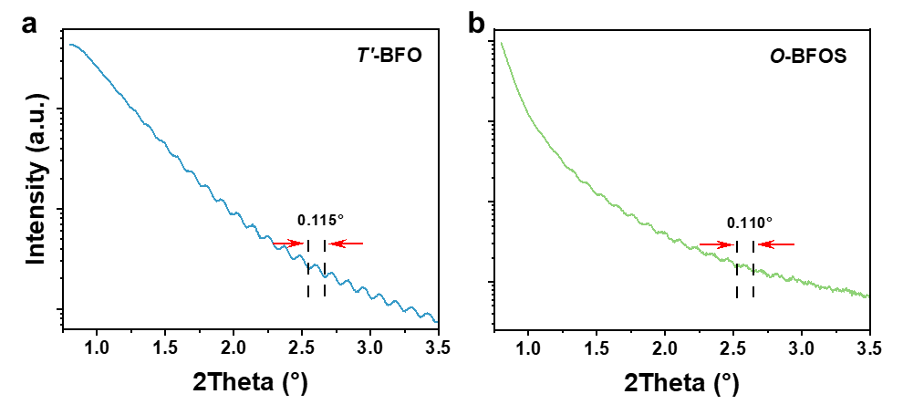
Figure S1 (a, b) Synchrotron X-ray total reflection (XRR) of T’-BFO and O-BFOS thin films.
The film thicknesses were measured using XRR, determining the T’-BFO and O-BFOS film thicknesses to be 78 nm and 80 nm, respectively. The thickness d had been calculated by the equation of d = λ/2sinΔθ, where λ = 1.5466 Å, Δθ is half of the average width of the peak obtained by the XRR measurement.

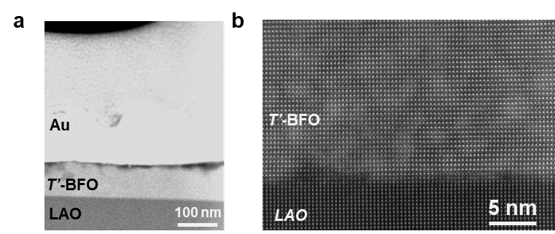
Figure S2 (a) Cross-sectional TEM image of T’-BFO thin film. (b) HAADF-STEM image at the interface between T’-BFO thin film and LAO substrate (a-axis direction).

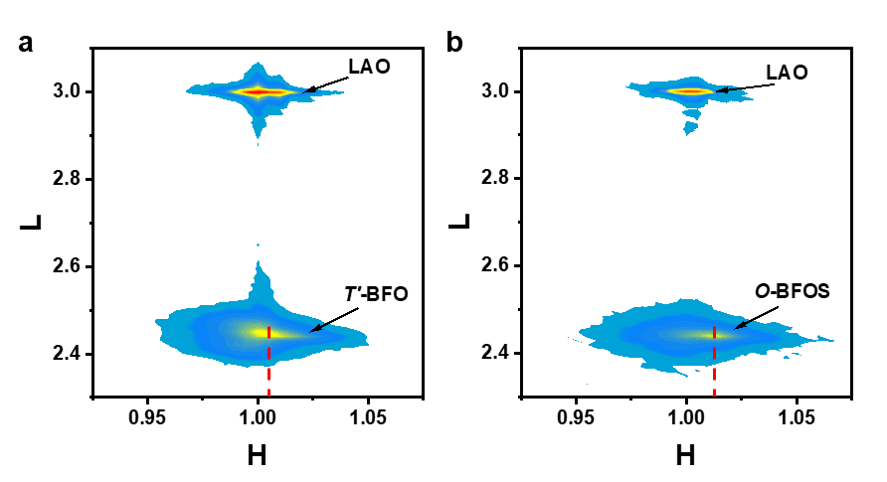
Figure S3 (a, b) (103) plane synchrotron RSM of T’-BFO and O-BFOS thin films.

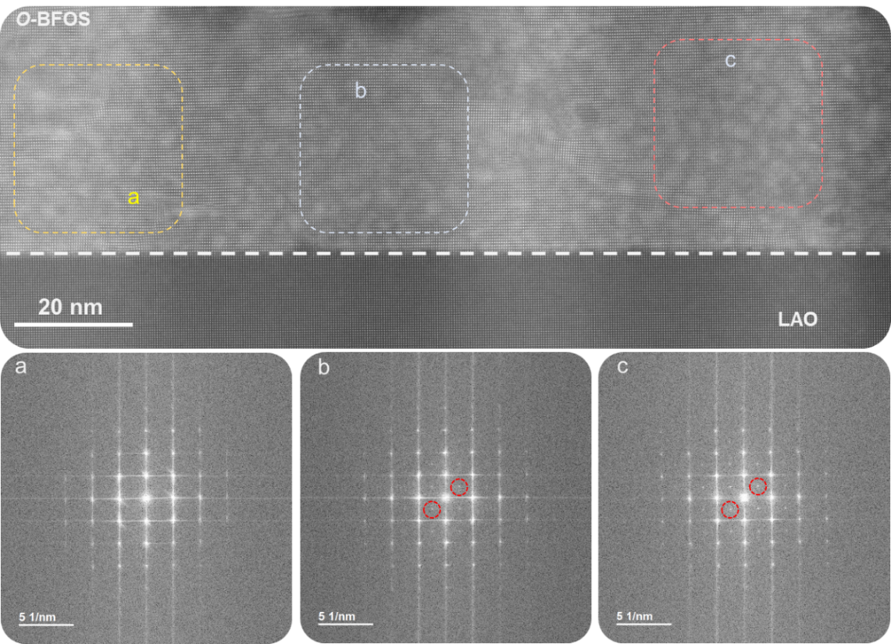
Figure S4 Large-scale cross-section HAADF-STEM of the O-BFOS thin film along the a-axis direction and FFT in a, b, and c regions.

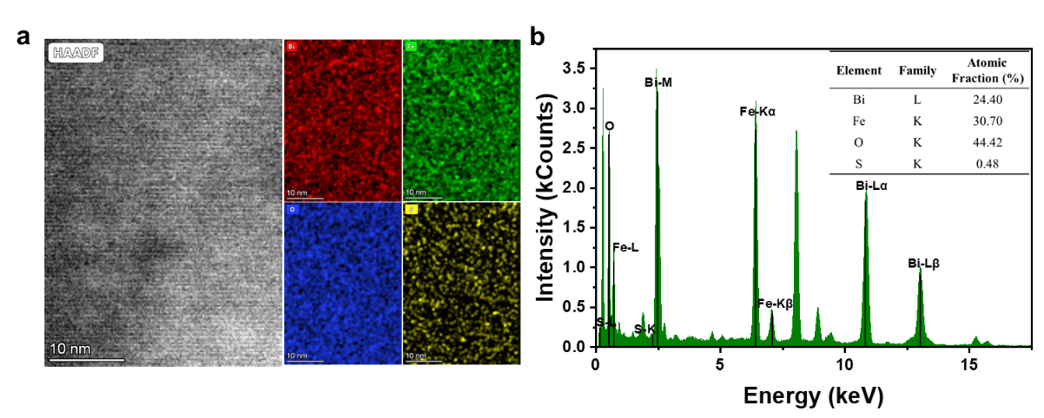
Figure S5 (a) STEM-EDS elemental maps of the O-BFOS thin film. (b) The energy integral of the corresponding element mapping, with the inset representing the proportion of Bi, Fe, O, and S atoms obtained from the integration.

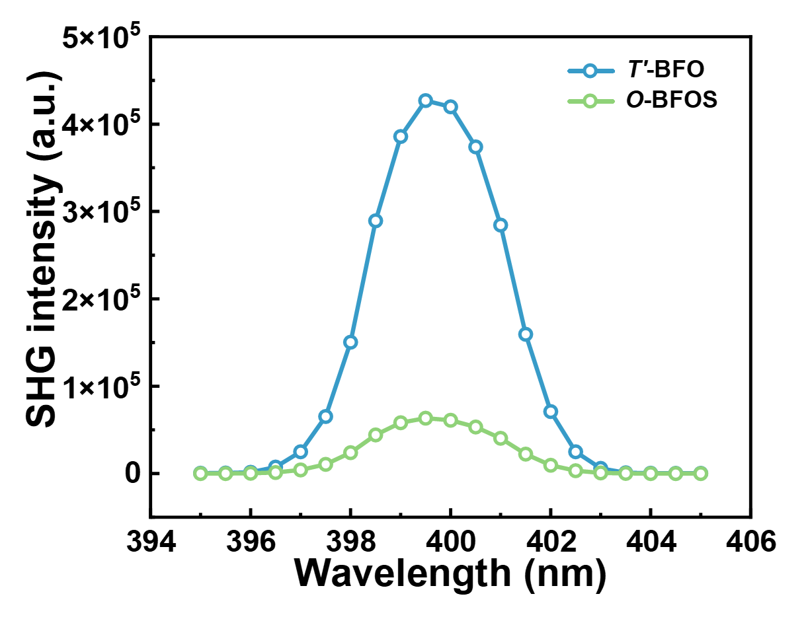
Figure S6 Optical second-harmonic generation (SHG) intensity of T’-BFO and O-BFOS thin films at room temperature.
SHG indicates diminished spatial-inversion symmetry breaking in O-BFOS films, which implies a reduction in ferroelectricity of the film. It is well known that the symmetry of O-phase is higher compared to monoclinic M_{C}-phase, so the ferroelectricity of O-phase O-BFOS films is relatively weaker, which is an important reason for the weakening of SHG signals of O-BFOS films after sulfurization.

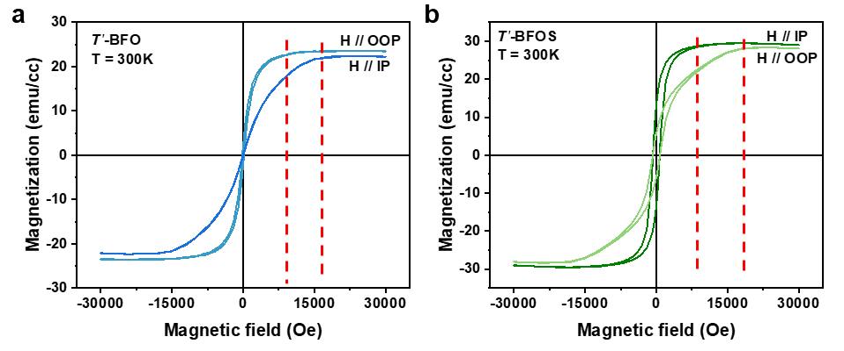
Figure S7 (a, b) Out-of-plane and in-plane magnetic hysteresis loops of T’-BFO films and O-BFOS films at 300 K.

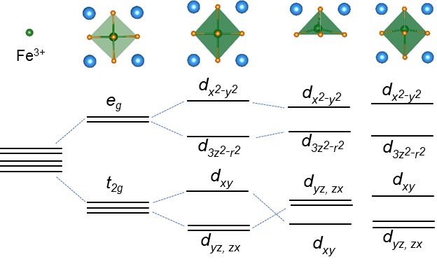
Figure S8 Schematic of Fe 3d orbital in different crystal fields.
According to the crystal field theory, the Fe 3d orbital will split into a low-energy t_{2g} and a high-energy e_{g} orbital when the Fe ion is located at the centra of the FeO₆ octahedron. The lattice is stretched along the c-axis when the film is subjected to clamping stresses from the LAO substrate, the splitting of the t_{2g} and e_{g} orbitals will be further increased when ideally the Fe ions are located at the FeO₆ octahedron. For the T’-BFO film, the c/a can reach to ~1.23 causing Fe ions to offset from the centra of the FeO₆ octahedron due to the LAO substrate clamping stress exceeding 4.5%, resulting in a greatly weakened hybridization of Fe ions with O ions at the bottom of FeO₆ octahedron to form the pyramid-like of the FeO₅ structure. For the O-BFOS film, the lattice distortion induced increases the hybridization of the Fe ions with the O ions by the S ions, the electron loss of Fe ions increases and tends to +3, thus the electron hybridization returns to the FeO₆ octahedral

