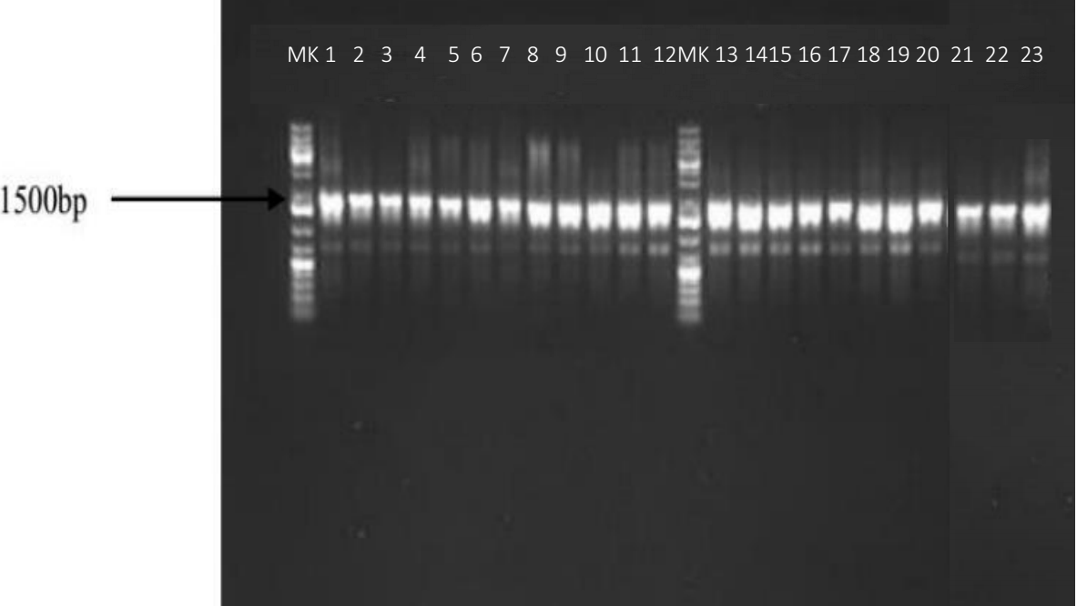

Plate 1. Agarose gel electrophoresis of bacterial DNA isolated from stool samples

