Fig. S1 Composition of endophytic fungi of F. cymosum in different native habitats and different tissue sites. Composition of endophytic fungi of F. cymosum in different native habitats at the level of phylum(A), class(B), and order(C). Composition of endophytic fungi in different tissue parts of F. cymosum at the level of phylum(D), class(E), and order(F). G Sparse plot of 18 sample groups. The abscissa represents the ranking of operational taxonomic units (OTUs), while the ordinate represents the relative percentage of species at the classification level. Similarity ANOSIM analysis of the endophytic fungal community in F. cymosum based on Bray-Curtis distance from different habitats (H) and different tissue sites (I).

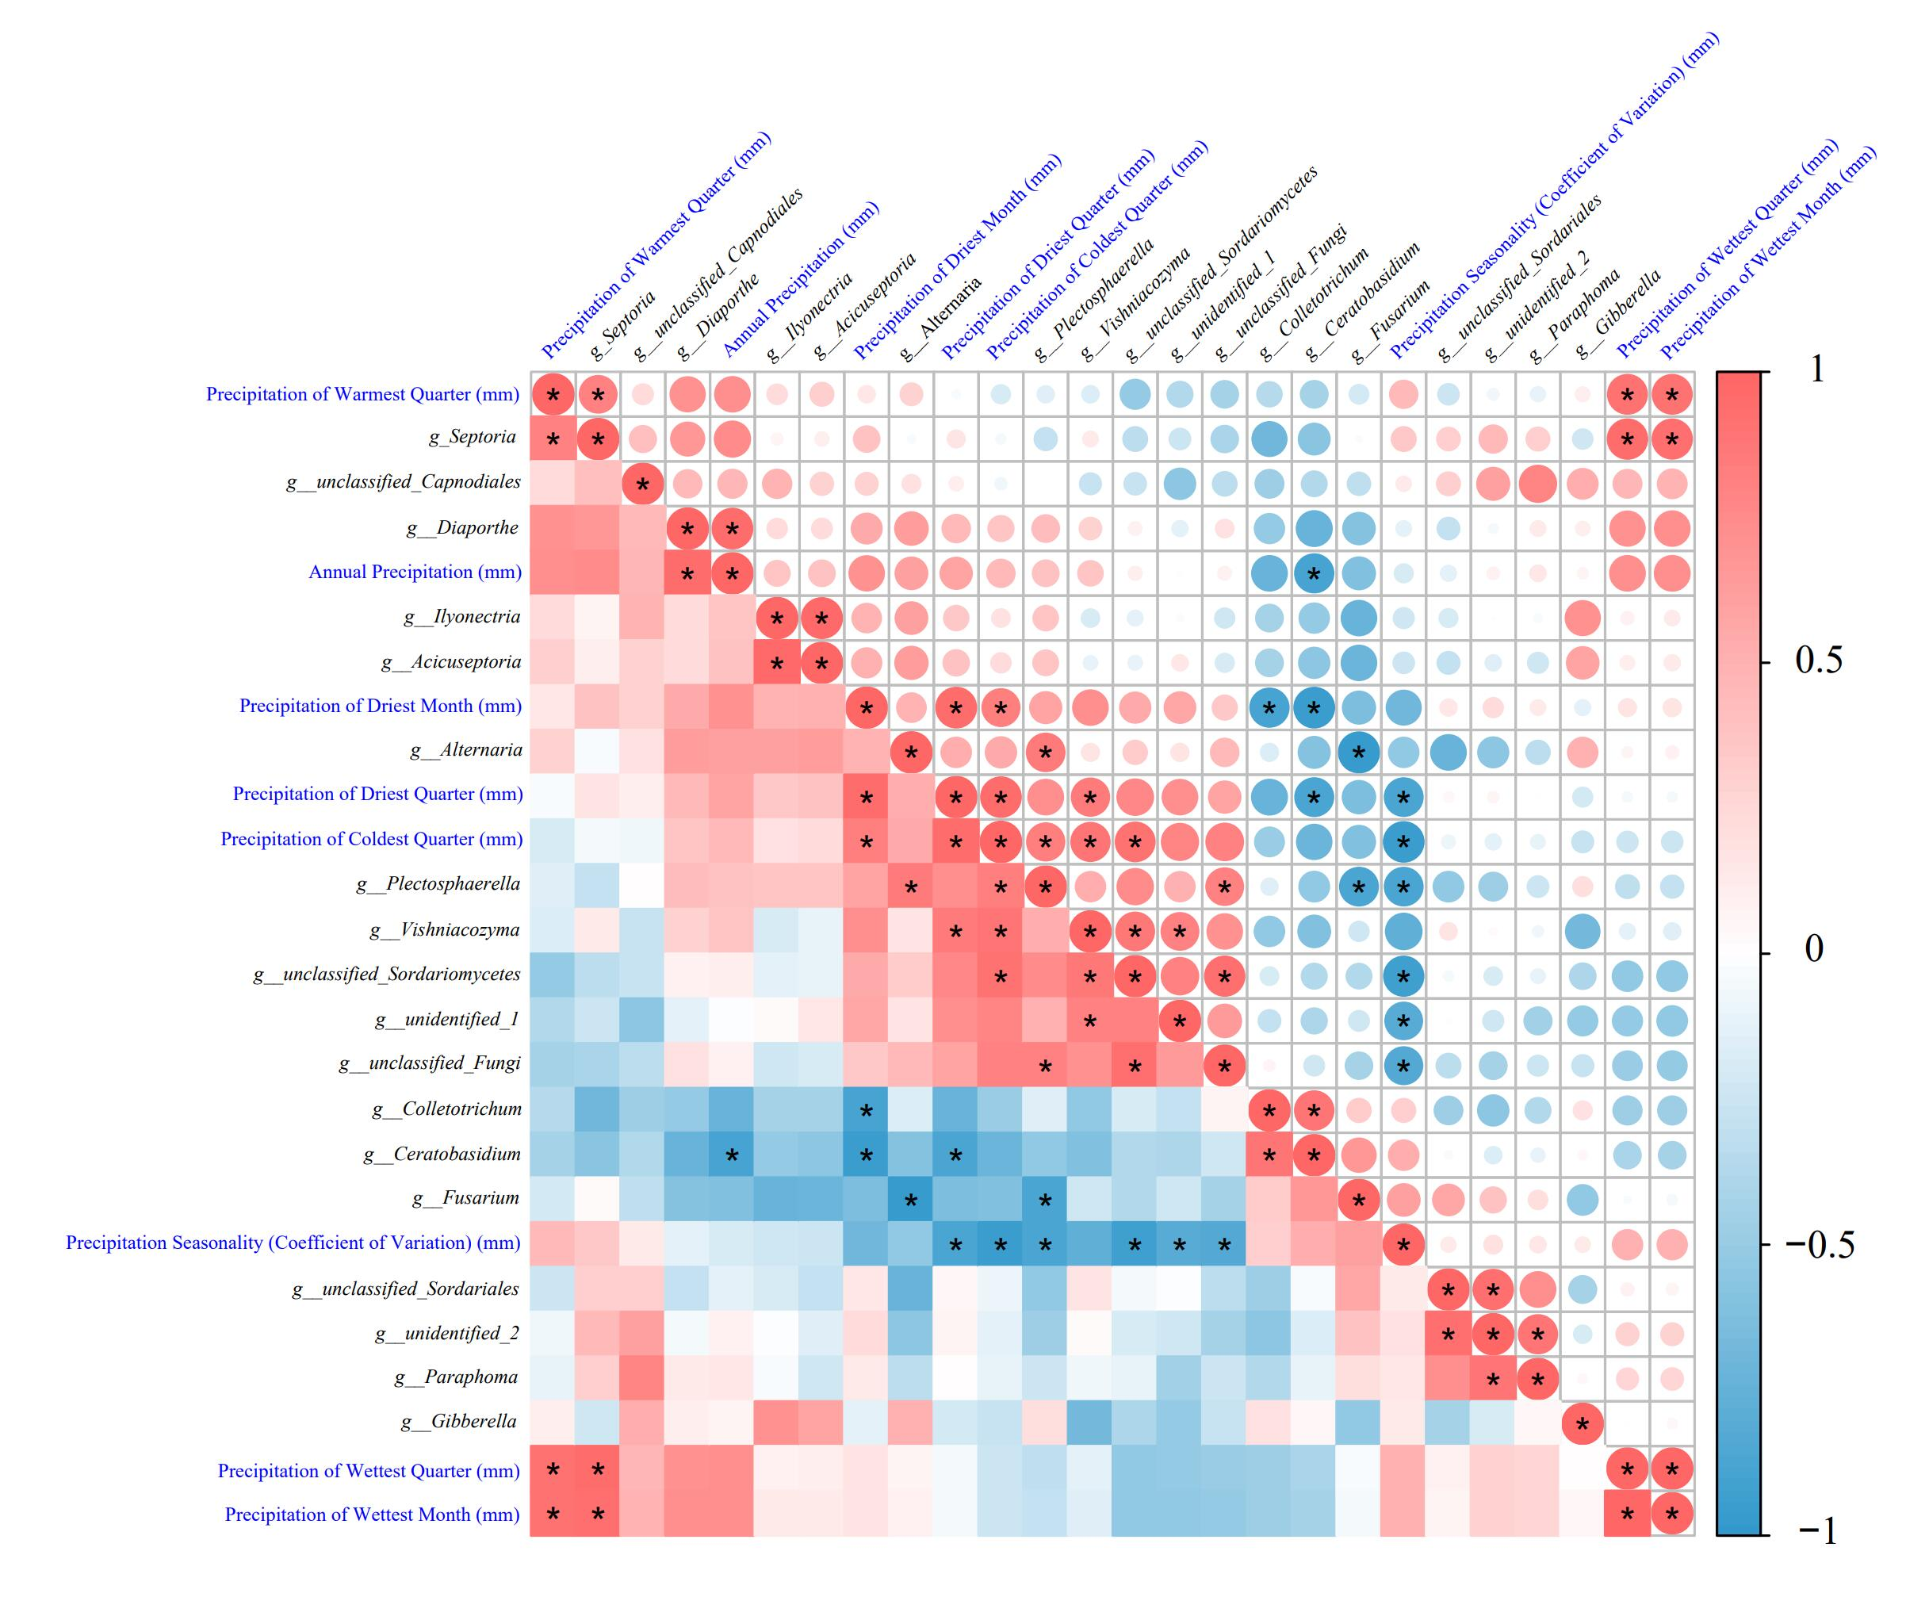

Fig. S2 Pearson correlation analysis of 18 shared genus-level endophytic fungi with eight precipitation-related factors. Where red circles (or squares) indicate a positive correlation and blue circles (or squares) indicate a negative correlation, with larger circles and darker colors indicating greater correlation. * indicates a significant correlation between the two (P<0.05). The horizontal and vertical labels are the names of genus-level fungi in black, and the precipitation correlation factor in blue.

Fig. S3 Morphological images of 37 strains of endophytic fungi obtained by isolation and purification from F. cymosum. Each strain consists of two images of positive and negative plates, with the strain number below the image. Mycelium color, mycelium texture, and colony edge condition can be observed from the plate image.

Fig. S4 Growth curves of 16 target genus level endophytic fungi on normal medium and drought selection medium. Grey represents the normal medium (0% PEG6000), pink represents the selection medium with 8% PEG600 added to simulate drought stress, and red represents the selection medium with 12% PEG600 added to simulate drought stress. The vertical coordinate is the diameter of the colony on the plate (cm), and the horizontal coordinate is the number of days of incubation. The maximum diameter of the plate is 8 cm, and the number of days of incubation in the growth curves is different because of the different growth rates of the colonies. When the colony grows all over the plate or culture until 7 days, stop recording.

Fig. S5 IAA production in the fermentation broth of 16 strains of endophytic fungi at the target genus level. The left graph shows the IAA standard curve. The numbers marked in red are the strains with IAA content higher than 10 mg/L in the fermentation broth so that more attention can be paid to these high IAA-producing fungal strains in the subsequent screening.

Fig. S6 Agronomic traits and physiological indicators of soil-cultivated F. cymosum under normal conditions (or drought conditions) inoculated with or without fungal inoculation, respectively, the changes in plant agronomic traits and physiological indicators. Normal indicates normal conditions of cultivation, and Drought indicates drought stress conditions of cultivation. Agronomic traits were mainly determined as water content in stem (A), leaf water content (B), number of nodes of main stem(C), petiole length (D), leaf width (E), and leaf length (F). Physiological indices were determined as CAT enzyme activity (G), SOD enzyme activity (H), GSH content (I), and soluble sugar content (J). Different letters in the bar graph indicate significant differences (P<0.05).

Fig. S7 15% PEG6000 used in hydroponics to simulate drought stress F. cymosum and under normal conditions (or drought stress), inoculated or not inoculated with the fungus after the changes in physiological indicators of the plant. A Screening of the appropriate concentration of PEG6000.One-week-old F. cymosum was placed in different concentrations of gradient in the PEG6000, to observe the phenotypic changes in the plant and recorded. The first row was recorded at the time point when the leaves of the plants began to lose water (plants showed leaf chlorosis), and the second row was recorded at the time point when the leaves lost water severely (plants showed severe chlorosis). Changes in physiological indexes, CAT enzyme activity (B), and SOD enzyme activity (C) of F. cymosum under normal conditions (0% PEG6000) or drought stress conditions (15% PEG6000), inoculated or not inoculated with fungi. Different letters in the bar graph indicate significant differences (P<0.05).

Fig. S8 GO enrichment analysis of differentially expressed genes in the four experimental comparison groups. Red indicates cellular component (CC), green indicates molecular function (MF), and blue indicates biological process (BP).

Fig. S9 KEGG enrichment analysis results of differentially expressed genes in the three experimental comparison groups. The larger the bubble, the greater the number of enriched genes. The value on the horizontal axis represents the significance level of the enrichment analysis, with larger values indicating higher significance.

Fig. S10 Orthogonal Partial Least Squares Discriminant Analysis (OPLS-DA) showing significant biochemical changes in the four different experimental comparison groups. The horizontal axis T score [1] represents the position of the samples on the first predictive component, which is used to distinguish between different categories of samples. The vertical axis Orthogonal score [1] represents the position of the samples on the first orthogonal component, which describes variations unrelated to the categories. R²Y represents the proportion of the total variation in the response variable (Y) explained by the model. It is an indicator of the goodness of fit of the model, ranging from 0 to 1, with values closer to 1 indicating a stronger explanatory power of the model. Q²Y represents the predictive ability obtained through cross-validation, indicating the accuracy of the model's predictions, with higher values indicating greater accuracy.

Fig. S11 KEGG enrichment pathway analysis of DAMs among the three experimental comparison groups. The x-axis labeled "fold enrichment" represents how many times more frequently a pathway appears in the dataset compared to the expected frequency by chance. The y-axis labeled "P value" represents the statistical significance of the enrichment, with lower values indicating higher statistical significance.

Table S1 Latitude and longitude information and altitude information of six F. cymosum native habitat sites
Code No. | YL | LZ | HL | NH | KM | HZ
Location | Yulong Naxi Autonomous County, Lijiang City, Yunnan Province, China | Gongzun West Road, Bayi District, Linzhi City, Tibet Autonomous Region. | Taima Road, Huili City, Liangshan Yi Autonomous Prefecture, Sichuan Province, China | Shaqiao Township, Nanhua County, Chuxiong Yi Autonomous Prefecture, Yunnan Province, China | Yongding Street, Fumin County, Kunming, Yunnan Province, China | Hezhang County, Bijie City, Guizhou Province, China
Longitude | 99.96 | 94.39 | 102.47 | 101.19 | 102.51 | 104.69
Latitude | 26.87 | 29.59 | 26.75 | 25.28 | 25.33 | 27.02
Altitude (m) | 1824 | 2983 | 1947 | 2127 | 1930 | 2042

Sequencing region name: | Standard fungal ITS1 (b)
Target fragment length: | 250-500bp
Sequencing strategy: | PE250
Upstream primer name: | ITS1F
Downstream primer name: | ITS2
Upstream primer sequence: | CTTGGTCATTTAGAGGAAGTAA
Downstream primer sequence: | GCTGCGTTCTTCATCGATGC

Table S2 Information on ITS primer sequences for high-throughput sequencing.

Table S3 The corresponding meanings of the 19 BIO files.
BIO file name | The corresponding meaning of the BIO file
BIO1 | Annual Mean Temperature (℃)
BIO2 | Mean Diurnal Range (Mean of monthly (max temp - min temp)) (℃)
BIO3 | Isothermality (BIO2/BIO7) (×100)
BIO4 | Temperature Seasonality (standard deviation ×100)
BIO5 | Max Temperature of Warmest Month (℃)
BIO6 | Min Temperature of Coldest Month (℃)
BIO7 | Temperature Annual Range (BIO5-BIO6) (℃)
BIO8 | Mean Temperature of Wettest Quarter (℃)
BIO9 | Mean Temperature of Driest Quarter (℃)
BIO10 | Mean Temperature of Warmest Quarter (℃)
BIO1 | Mean Temperature of Coldest Quarter (℃)
BIO12 | Annual Precipitation (mm)
BIO13 | Precipitation of Wettest Month (mm)
BIO14 | Precipitation of Driest Month (mm)
BIO15 | Precipitation Seasonality (Coefficient of Variation) (mm)
BIO16 | Precipitation of Wettest Quarter (mm)
BIO17 | Precipitation of Driest Quarter (mm)
BIO18 | Precipitation of Warmest Quarter (mm)
BIO19 | Precipitation of Coldest Quarter (mm)

Table S4 Primers used for qRT-qPCR
Gene name | Forward Primer (5′-3′) | Reverse Primer (5′-3′)
DHFR-TS | CTCCTTCCTCCCCCAGATT | AGTTCCTCAACAACACCCC
ADCS | GCAAATAGAGGAAAGGGATA | AGAAGCAGTTCAAGGCATAG
ADCL | CTACTCACCCCTCACCCGTT | TTTTCAGTGCTTAGCCTTAA
GTP-CHI | TTTAGAGAAGGAACAAGAGG | AAGCAAGATTCACAGTAGGA
DHNA | GAAACCTGAAGAGAGAACAC | ATGCGATAAATAGCAGTGTA
DHFS | CGTAATCCAGATAGAGAAGG | AAGCATAACGCAGCACAGAC
Actin | GAGTTATGAGCTTCCTGATG | CCGCCACTCAACACAATGTT
Box | CAAAGCAGGGAAAGAGTCGCAC | AAGAGGAGGAGGGGCTGAAGAAT

Table S5 Chromatographic gradient elution program
Time | A% | B%
0 | 98 | 2
1.5 | 98 | 2
3 | 15 | 85
10 | 0 | 100
10.1 | 98 | 2
11 | 98 | 2
12 | 98 | 2

Sample | Mean ± SD
Sample | Chao 1 | Goods_coverage | Observed_species | Pielou_e | Shannon | Simpson
YL_R | 82.29±8.99 | 0.999531±0.00014 | 73.31±5.63 | 0.58±0.02 | 3.30±0.29 | 0.88±0.029
LZ_R | 92.11±12.77 | 0.999618±0.00009 | 85.40±9.20 | 0.54±0.07 | 3.57±0.65 | 0.84±0.043
HL_R | 498.29±34.96 | 0.998362±0.00094 | 441.83±71.81 | 0.50±0.09 | 4.71±0.51 | 0.85±0.063
NH_R | 75.11±9.95 | 0.999617±0.00009 | 78.23±8.90 | 0.42±0.03 | 2.53±0.26 | 0.73±0.051
KM_R | 46.79±7.81 | 0.999586±0.00033 | 42.50±7.44 | 0.51±0.04 | 2.70±0.26 | 0.79±0.043
HZ_R | 81.46±5.25 | 0.999701±0.00013 | 94.87±5.42 | 0.39±0.08 | 2.79±0.25 | 0.78±0.024
YL_S | 237.23±17.98 | 0.998818±0.00043 | 252.93±22.32 | 0.58±0.04 | 4.38±0.46 | 0.78±0.167
LZ_S | 247.50±39.13 | 0.999004±0.00067 | 173.00±11.54 | 0.50±0.05 | 3.36±0.24 | 0.82±0.046
HL_S | 261.21±20.53 | 0.998966±0.00030 | 244.37±21.86 | 0.62±0.002 | 4.73±0.19 | 0.92±0.006
NH_S | 217.73±16.93 | 0.999134±0.00028 | 210.83±9.11 | 0.54±0.09 | 4.01±0.76 | 0.78±0.077
KM_S | 167.61±13.54 | 0.999285±0.00039 | 157.40±11.76 | 0.63±0.05 | 4.39±0.85 | 0.92±0.029
HZ_S | 149.49±16.70 | 0.999625±0.00012 | 128.30±5.41 | 0.60±0.03 | 4.14±0.20 | 0.89±0.023
YL_L | 132.85±14.78 | 0.999276±0.00007 | 126.86±7.70 | 0.59±0.05 | 3.94±0.49 | 0.86±0.071
LZ_L | 307.11±25.82 | 0.998705±0.00070 | 199.40±7.68 | 0.39±0.04 | 2.88±0.25 | 0.65±0.069
HL_L | 80.78±4.44 | 0.999752±0.00004 | 76.80±2.17 | 0.48±0.01 | 3.03±0.11 | 0.78±0.049
NH_L | 228.58±17.99 | 0.999137±0.00062 | 197.27±7.32 | 0.62±0.02 | 4.53±0.51 | 0.92±0.025
KM_L | 107.89±8.61 | 0.999437±0.00027 | 132.40±9.65 | 0.47±0.04 | 3.18±0.47 | 0.79±0.058
HZ_L | 78.14±5.95 | 0.999796±0.00005 | 72.27±6.19 | 0.45±0.07 | 2.62±0.43 | 0.76±0.054

Table S6 Alpha diversity analysis of endophytic fungi of 18 F. cymosum tissue samples.
Data are the means ± SD. YL, LZ, HL, NH, KM, and HZ, respectively, on behalf of the six F. cymosum habitat names of the abbreviation. R, S, and L, respectively, F. cymosum roots, stems, and leaves of the abbreviation. Chao1 and Observed_species is used to indicate the richness of species in the community, the larger the index value, the higher the richness of the community in the sample. Goods_coverage is used to assess the sequencing on the coverage of the species in the community, Table S1 in the goods_coverage index is greater than 0.99, which indicates that the majority of species in the sample have been detected. Pielou_e index emphasizes the evenness of the community, the higher the index value, the more even the community in the sample. Shannon and Simpson index is used to indicate the diversity of the community, the higher the index value, the higher the diversity of the community in the sample.

Table S7 precipitation information of six F. cymosum native habitat sites
Code No. | YL | LZ | HL | NH | KM | HZ
Precipitation of Coldest Quarter (mm) | 86.00 | 9.00 | 26.00 | 41.00 | 34.00 | 42.00
Precipitation of Warmest Quarter (mm) | 378.00 | 368.00 | 572.00 | 437.00 | 400.00 | 515.00
Precipitation of Driest Quarter (mm) | 59.00 | 9.00 | 26.00 | 41.00 | 34.00 | 42.00
Precipitation of Wettest Quarter (mm) | 378.00 | 368.00 | 572.00 | 437.00 | 481.00 | 515.00
Precipitation Seasonality (Coefficient of Variation) (mm) | 55.44 | 91.53 | 96.57 | 80.08 | 85.77 | 80.42
Precipitation of Driest Month (mm) | 14.00 | 2.00 | 8.00 | 12.00 | 10.00 | 13.00
Precipitation of Wettest Month (mm) | 136.00 | 133.00 | 210.00 | 158.00 | 176.00 | 192.00
Annual Precipitation (mm) | 900.00 | 670.00 | 956.00 | 817.00 | 856.00 | 994.00

Table S8 Molecular biology of 37 species of F. cymosum endophytic fungi identification results
Phylum | Class | Order | Family | Genus | Species | name | Accession no.
Ascomycota | Sordariomycetes | Hypocreales | Nectriaceae | Fusarium | Incarnatum | R1 | OR733585
 |  |  |  |  | sp. | R2 | OR733586
 |  |  |  |  | Equiseti | R3 | OR733588
 |  |  |  |  | Redolens | R5 | OR733632
 |  |  |  |  | Oxysporum | R6 | OR733633
 |  |  |  |  | acuminatum | R7 | OR733661
 |  |  |  |  | graminearum | R8 | OR733662
 |  |  |  |  | Solani | R9 | OR733666
 |  |  |  |  | Commune | S1 | OR733679
 |  |  |  |  | Avenaceum | S2 | OR733678
 |  |  |  |  | longifundum | S3 | OR733727
 |  |  |  |  | tricinctum | L1 | OR731079
 |  |  |  |  | asiaticum | RS1 | OR733675
 |  | Glomerellales | Glomerellaceae | Colletotrichum | truncatum | L4 | OR731085
 |  |  |  |  | sp. | L5 | OR731089
 |  | Diaporthales | Diaporthaceae | Diaporthe | ganjae | L6 | OR731088
 |  |  |  |  | sp. | L7 | OR731092
 |  |  |  |  | novem | L8 | OR731095
 |  |  |  |  | sojae | L9 | OR731135
 |  | Sordariales | Chaetomiaceae | Chaetomium | angustispirale | L2 | OR731082
 | Dothideomycetes | Pleosporales | Pleosporaceae | Alternaria | tenuissima | R13 | OR733668
 |  |  |  |  | angustiovoidea | S4 | OR733684
 |  |  |  |  | sp. | L3 | OR731084
 |  |  |  |  | alternata | SL | OR733689
 |  | Botryosphaeriales | Botryosphaeriaceae | Dothiorella | gregaria | R4 | OR733589
Basidiomycota | Agaricomycetes | Polyporales | Meripilaceae | Rigidoporus | vinctus | RS2 | OR733677
 |  |  | Irpicaceae | Irpex | laceratus | R15 | OR733725
 |  |  | Phanerochaetaceae | Bjerkandera | sp. | R16 | OR734653
 |  |  |  |  | adusta | S6 | OR733686
 |  |  | Cerrenaceae | Cerrena | sp. | S7 | OR733688
 |  | Cantharellales | Ceratobasidiaceae | Ceratobasidium | sp. | R14 | OR733671
 |  | Agaricales | Schizophyllaceae | Schizophyllum | commune | R18 | OR733676
Mucoromycota | Mucoromycetes | Mucorales | Mucoraceae | Mucor | hiemalis | R10 | OR733665
 |  |  |  |  | sp. | R11 | OR733667
 |  |  |  |  | racemosus | R12 | OR733669
Unclassified_gungi |  |  |  |  |  | S5 | OR733685
 |  |  |  |  |  | R17 | OR733674
Total | 4 | 10 | 13 | 13 | 37
Columns 1 to 6 in Table S3 indicate the taxonomic levels of phylum, class, order, family, genus, and species, respectively. Column 7 is the strain number, and column 8 is the sequence accession number obtained by uploading the ITS sequences of the strains to NCBI. 37 species of endophytic fungi were included in 3 phylums, 4 orders, 10 orders, 13 families, and 13 genera.

Table S9 Summary of transcriptome data quality after filtering for each sample

Sample | Total reads | Total giga bases | Q20 rate | Q30 rate | GC content
CK_1 | 46,184,050 | 6.64G | 99.4398% | 97.9921% | 0.463446
CK_2 | 44,816,168 | 6.48G | 99.4106% | 97.9182% | 0.443169
CK_3 | 45,089,216 | 6.5G | 99.4369% | 98.0197% | 0.452488
DCK_1 | 60,464,866 | 8.65G | 99.4515% | 98.0749% | 0.455667
DCK_2 | 49,489,002 | 7.09G | 99.4412% | 98.0476% | 0.46003
DCK_3 | 44,641,626 | 6.39G | 99.3893% | 97.8691% | 0.461683
DR2_1 | 51,644,396 | 7.46G | 99.4255% | 97.9851% | 0.466574
DR2_2 | 43,899,276 | 6.35G | 99.4055% | 97.902% | 0.4614
DR2_3 | 53,570,846 | 7.72G | 99.4851% | 98.153% | 0.46165
R2_1 | 52,268,394 | 7.55G | 99.439% | 98.0158% | 0.451852
R2_2 | 43,039,060 | 6.19G | 99.3848% | 97.8256% | 0.462122
R2_3 | 50,923,126 | 7.35G | 99.4293% | 98.0123% | 0.455083

Table S10 Summary of sequencing reads alignment to the reference genome for each sample
Sample | Read pairs aligned | Total alignments | Aligned to genes | Overall mapping rate | Exonic | Intronic | 5'-3' bias
CK_1 | 18,097,705 | 44,664,433 | 31,689,713 | 0.916 | 31,689,713 (78.39%) | 4,332,744 (10.72%) | 1.23
CK_2 | 17,742,059 | 42,482,786 | 28,635,758 | 0.901 | 28,635,758 (73.65%) | 5,069,941 (13.04%) | 1.34
CK_3 | 18,096,418 | 43,163,691 | 30,162,993 | 0.909 | 30,162,993 (76.61%) | 4,409,607 (11.2%) | 1.31
DCK_1 | 22,675,303 | 57,080,729 | 40,066,983 | 0.894 | 40,066,983 (77.35%) | 5,291,203 (10.21%) | 1.41
DCK_2 | 19,493,565 | 47,621,487 | 33,388,474 | 0.91 | 33,388,474 (77.48%) | 4,721,468 (10.96%) | 1.17
DCK_3 | 17,716,492 | 43,467,482 | 30,575,323 | 0.918 | 30,575,323 (78.15%) | 4,218,856 (10.78%) | 1.17
DR2_1 | 21,503,703 | 50,422,709 | 35,723,413 | 0.923 | 35,723,413 (78.5%) | 5,035,026 (11.06%) | 1.16
DR2_2 | 17,942,520 | 42,295,946 | 29,856,289 | 0.916 | 29,856,289 (77.35%) | 4,414,751 (11.44%) | 1.25
DR2_3 | 21,549,722 | 51,519,209 | 36,623,670 | 0.913 | 36,623,670 (78.13%) | 5,023,008 (10.72%) | 1.18
R2_1 | 21,768,172 | 51,095,517 | 34,051,817 | 0.922 | 34,051,817 (73.81%) | 5,778,079 (12.53%) | 1.3
R2_2 | 16,917,350 | 41,468,993 | 29,439,454 | 0.916 | 29,439,454 (77.87%) | 4,315,800 (11.42%) | 1.15
R2_3 | 20,479,325 | 48,940,377 | 34,512,167 | 0.907 | 34,512,167 (78.28%) | 4,450,846 (10.1%) | 1.08

