Supplementary Data
Supplementary Table S1. Number of surveyed students by province and age
 | Student Age (%)
Province | (5-8) years | (9-12) years | (13-16) years | Total (%)
Southern Highlands | 110 (13.7%) | 242 (30.2%) | 450 (56.1%) | 802 (13.9%)
Enga | 88 (9.7%) | 344 (38.0%) | 474 (52.3%) | 906 (15.7%)
Western Highlands | 225 (16.1%) | 553 (39.6%) | 620 (44.3%) | 1398 (24.2%)
Chimbu | 79 (14.0%) | 251 (44.4%) | 230 (41.1%) | 560 (9.7%)
Eastern Highlands | 159 (15.7%) | 392 (38.8%) | 459 (45.4%) | 1010 (17.5%)
Hela | 71 (10.2%) | 313 (44.8%) | 314 (45%) | 698 (12.1%)
Jiwaka | 43 (10.7%) | 192 (47.9%) | 166 (41.4%) | 401 (6.9%)
Total | 775 (13.4%) | 2287 (39.6%) | 2718 (47.0%) | 5775 (100%)

Supplementary Table S2. General characteristics of households.
variable |  | %
Age <11 years (%) |  | 25.0%
Age ≥40 years (%) |  | 30.5%
Female (%) |  | 54.6%
Literacy of household head (%) |  | 75.9%
Main source of lighting (%) | Solar power | 33.9%
Main source of lighting (%) | Battery lantern | 30.9%
Main source of lighting (%) | Electricity | 21.3%
Main source of drinking water (%) | Surface | 45.6%
Main source of drinking water (%) | Piped | 27.5%
Main source of drinking water (%) | Water tank | 18.2%
Main source of income for the household head (%) | Farming/fishing | 48.4%
Main source of income for the household head (%) | Marketing/ Street selling | 17.8%
Main source of income for the household head (%) | Wage job/ public sector | 15.8%

Supplementary Table S3. Details of positive malaria cases detected in the SMS and RCD surveys.
No. | Date of survey | Survey | Province | Residence | Altitude (m) | Age  (years) | Sex | Travel History | Microscopy result
1 | 20/07/2019 | RCD | Eastern Highlands | Ika | 1656 | 11 | F | Ramu | Pv
2 | 03/10/2019 | SMS | Enga | Konimauda | 2007 | 16 | M | Lae | Pv
3 | 04/10/2019 | RCD | Western Highlands | Kapiapulg | 1529 | 40 | F | Madang | Pf
4 | 16/10/2019 | SMS | Enga | Anji | 1975 | 14 | M | Hagen | Pf
5 | 16/10/2019 | SMS | Enga | Minamb | 2168 | 11 | F | Port Moresby | Pf
6 | 16/10/2019 | SMS | Enga | Minamb | 2034 | 13 | M |  | Pf
7 | 05/11/2019 | SMS | Hela | Ugu | 2337 | 12 | F | Moro | Pf
8 | 07/11/2019 | RCD† | Hela | Margarima | 2079 | 40 | M | Porgera | Pf
9 | 07/11/2019 | RCD† | Hela | Margarima | 2079 | 54 | M | Madang | Pf
10 | 07/11/2019 | RCD† | Hela | Margarima | 2079 | 60 | M | Kutubu | Pf
11 | 07/11/2019 | RCD† | Hela | Margarima | 2079 | 13 | F | Kutubu | Pf
12 | 07/11/2019 | RCD | Hela | Margarima | 2246 | 58 | F | Madang | Pf
13 | 08/11/2019 | SMS | Enga | Par | 1866 | 10 | F |  | Pf

All positive cases were treated with artemether-lumefantrine in case of Pf result, plus primaquine in mixed or non-Pf. †Same house in Margarima Station. ‡ Reported fever in the last two days but measured axillary temperature was normal during the survey.

Supplementary Table S4. Travel history versus malaria result (negative/positive) among students and RCD household members.
Travel history* | No. students |  |  | No. household members
Travel history* | Negatives (%) | Positives (%) | Total | Negatives (%) | Positives (%) | Total
No | 4780 (82.9) | 2  (33.3) | 4782 | 919  (89.2) | 0  (0) | 919
Yes | 986  (17.1) | 4  (66.7) | 990 | 111  (10.8) | 7  (100) | 118
total | 5766  (100) | 6  (100) | 5772 | 1030  (100) | 7  (100) | 1037
* Travel history during the previous month (including within the province, the Highlands Region, or other coastal areas).

Supplementary Table S5. Ownership of bed nets (any net) in house versus malaria results among tested students and household members.

Bed nets in house | No. students† |  |  | No. household members‡
Bed nets in house | Negatives  (%) | Positives  (%) | Total | Negatives (%) | Positives (%) | Total
No | 2551 (44.2) | 5  (83.3) | 2556 | 375  (36.4) | 6  (85.7) | 381
Yes | 3215 (55.8) | 1  (16.7) | 3216 | 655  (63.6) | 1  (14.3) | 656
Total | 5766  (100) | 6  (100) | 5772 | 1030  (100) | 7  (100) | 1037
† Odds ratio=6.3, 95%CI [0.7, 54], p=0.093. ‡ Odds ratio=10.5, 95%CI [1.3, 87.4], p=0.03.

Supplementary Table S6. Bed nets use versus malaria results among SMS students and RCD households*.
Sleeping last night under net* | No. students† |  |  | No. household members‡
Sleeping last night under net* | Negatives (%) | Positives (%) | Total | Negatives (%) | Positives (%) | Total
No | 1033 (32.1) | 1  (100) | 1034 | 244  (37.3) | 1  (100) | 245
Yes | 2181 (67.9) | 0  (0) | 2181 | 411  (62.8) | 0  (0) | 411
Total | 3214  (100) | 1  (100) | 3215 | 655  (100) | 1  (100) | 656
*Only among households reported having any bed nets. † Odds ratio=6.3, 95%CI [0.26, 155.6], p=0.26, not significant). ‡ Odds ratio=5.1, 95%CI [0.21, 124.4], p=0.32, not significant).

Supplementary Table S7. List of HFs within a 1-hour travel radius of the surveyed schools and RCD houses.
No | Health Facility | District | Province
1 | Aiyo CHP | Nipa/Kutubu | Southern Highlands
2 | Kundiawa Hospital | Kundiawa/Gembogl | Chimbu
3 | S.I.L. UC | Obura/Wonenara | Eastern Highlands
4 | Kassam SC | Obura/Wonenara | Eastern Highlands
5 | Yauna SC | Kainantu | Eastern Highlands
6 | Pimaga RH | Nipa/Kutubu | Southern Highlands
7 | Tambul HC | Tambul/Nebilyer | Western Highlands
8 | Sopas UC | Wabag | Enga
9 | Komperi SC | Henganofi | Eastern Highlands
10 | North Goroka UC | Goroka | Eastern Highlands
11 | Hagen Hospital | Mt Hagen | Western Highlands
12 | Nipa DH | Nipa/Kutubu | Southern Highlands
13 | Tinsley HC | Mul/Baiyer | Western Highlands
14 | Goglme SC | Kundiawa/Gembogl | Chimbu
15 | Margarima DH | Komo/Margarima | Hela
16 | Kotna SC | Dei | Western Highlands
17 | Rebiamul UC | Mt Hagen | Western Highlands
18 | Togoba HC | Tambul/Nebilyer | Western Highlands
19 | Wabag HO | Wabag | Enga
20 | Aviamp SC | South Waghi | Jiwaka
21 | Det HC | Nipa/Kutubu | Southern Highlands
22 | Kurki SC | South Waghi | Jiwaka
23 | Yampu HC | Kompiam | Enga
24 | Ketepam SC | South Waghi | Jiwaka
25 | Pabarabuk SC | Tambul/Nebilyer | Western Highlands
26 | Sangurap UC | Wabag | Enga
27 | Unda SC | Wapenamanda | Enga
28 | Tamenda SC | Nipa/Kutubu | Southern Highlands
29 | Pangia HC | Ialibu/Pangia | Southern Highlands
30 | Kungumanda SC | Wapenamanda | Enga
31 | Pumakos SC | Wapenamanda | Enga
32 | Yalis SC | Wapenamanda | Enga
33 | Inu SC | Nipa/Kutubu | Southern Highlands

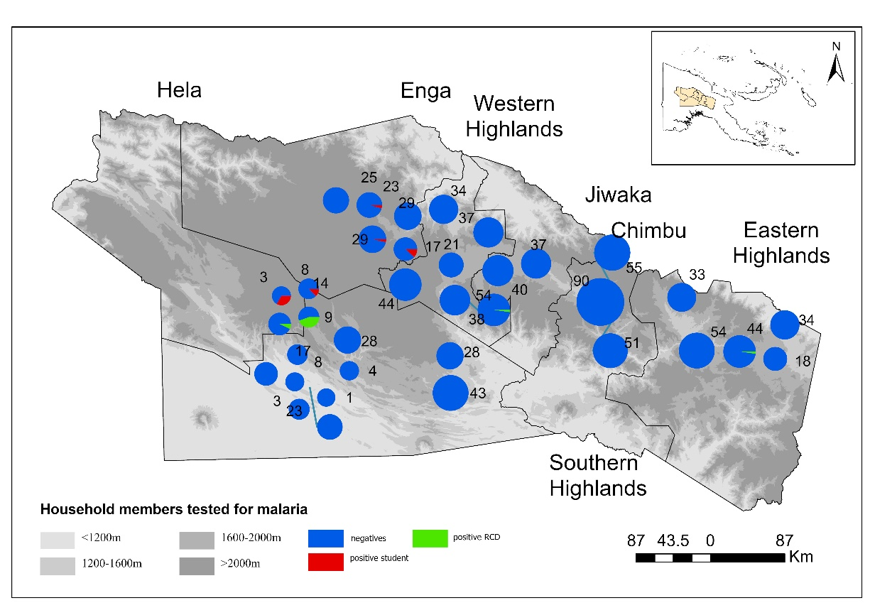
Supplementary Figure S1. Bar chart of household members tested for malaria, aggregated in geospatial clusters with a diameter of 3 km. Totals of negative, positive students and non-students are shown. The chart size is proportional to the totals tested.

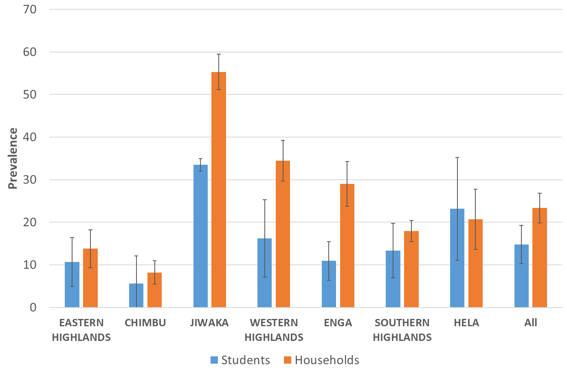
Supplementary Figure S2: Prevalence of anaemia among tested students (N=5,774) and household members (N=1,037) in the Highlands provinces (July-November 2019). Anaemia status is based on haemoglobin thresholds defined by WHO adjusted for altitude (20).

