Comparative of Different Interval Training Methods on Athletes' Oxygen Uptake: A Systematic Review and Meta-analysis

Supplementary material
Table S1 | Study inclusion–exclusion criteria
Table S2 | Summary of participant and study characteristics from all included studies
Table S3 | Summary of the training protocols and outcomes of included studies
Table S4 | Methodological quality of included studies assessed using the Physiotherapy Evidence Database (PEDro) scale
Table S5 | Treatment ranking based on the P-score and SUCRA
Table S6 | Inconsistency between direct and indirect comparisons of interventions
Table S7 | Sensitivity analysis
Table S8 | Primary meta-regression of pairwise meta-analysis
Table S9 | Effect of RST versus CON on athlete oxygen uptake: subgroup and moderation meta-analysis
Table S10 | Effect of HIIT versus CON on athlete oxygen uptake: subgroup and moderation meta-analysis
Table S11 | Effect of HIIT versus MICT on athlete oxygen uptake: subgroup and moderation meta-analysis
Table S12 | Effect of SIT versus CON on athlete oxygen uptake: subgroup and moderation meta-analysis
Table S13 | Effect of SIT versus MICT on athlete oxygen uptake: subgroup and moderation meta-analysis
Table S14 | Effect of HIIT versus SIT on athlete oxygen uptake: subgroup and moderation meta-analysis
Table S15 | Dose‒response effects of training method on oxygen uptake: meta-regression coefficients from the AICc for the linear, quadratic, and cubic models
Figure S1 | PRISMA flow chart
Figure S2 | Funnel plot of network meta-analysis
Figure S3 | Funnel plot of pairwise meta-analysis
Figure S4 | Dose–response effects of RST on oxygen uptake: results of meta-regression analysis for predictors related to an exercise session.
Figure S5 | Dose–response effects of HIIT on oxygen uptake: results of meta-regression analysis for predictors related to an exercise session
Figure S6 | Dose–response effects of SIT on oxygen uptake: results of meta-regression analysis for predictors related to an exercise session.

Table S1. Study inclusion–exclusion criteria
Criteria | Inclusion | Exclusion
1 | Original research article available in any language, including randomised and non-ran-domised, between-groups controlled experimental studies controlled experimental studies | Reviews, surveys, opinion pieces, books, periodicals, editorials, case studies, observational studies, non-academic/non-peer-reviewed text and articles that repeated the results from a different article
2 | Healthy, able-bodied, non-injured athletes, aged 14–35 years, of any gender. Athletes’ domised, controlled experimental studies performance calibre was ‘trained’ or above | Special populations (e.g. clinical, patients), people with a physical or mental disability or people considered to be injured or returning from injury. Non-athletic populations or athletes competing at recreational level. Athletes under the age of 14 or over the age of 35 years
3 | An RST intervention, involving maximal intensity sprints, with a mean work duration of ≤ 10s or equivalent distance, and a rest duration of ≤ 60s  An HIIT intervention, involving high intensity (>85% vVO_{2max}, or >90%HR_{max}), with a mean work duration of 30–300s or equivalent distance  An SIT intervention, involving maximal intensity sprints, with a mean work duration of ≤ 60 s or equivalent distance | Training program did not meet the inclusion criteria
4 | Training was performed as an independent experimental training intervention. Usual training practice was permitted | Studies incorporated combined experimental training interventions that were outside of their usual training practice (e.g., plus plyometric training)
6 | intervention duration of 2–12 weeks (minimum six sessions) | intervention duration of < 2 weeks, < 6 sessions, or > 12 weeks
7 | Studies must have reported ≥ 1 outcome measure (outcome measures are described in | No relevant outcome measures were reported
8 | Training group must have performed the intervention under normal conditions (e.g. usual nutritional intake, normoxia and absence of ergogenic aids). Placebos permitted | Training group was performed under altered or abnormal conditions (e.g., hypoxia, heat stress, and ergogenic aids, different diet)
9 | conventional training groups performed their usual sports training under normal conditions, or performed moderate intensity continue training | Additional training interventions were given to the control groups, outside of their usual training practice or moderate intensity continue training

Table S2. Summary of participant and study characteristics from all included studies
Study | Participants |  |  |  |  |  |  | Experimental approach
Study | Training  methods(N*) | Sport | Level | Age(yrs) | Height(cm) | Weight(kg) |  | Details
Boer et al., 2016 [45] | RST: 17  CON: 13 | FB | TRA | RST: 22 ± 1  CON: 22.2 ± 2.6 | RST: 176 ± 8  CON: 176 ± 7 | RST: 70 ± 7.7  CON: 68.4±6.3 |  | RST performed in addition to regular practice during the pre-season
Bravo et al., 2008 [63] | RST: 13  HIIT: 13 | FB | TRA | RST: 21 ± 5  HIIT: 21 ± 5 | RST: 179 ± 5  HIIT: 179 ± 5 | RST: 71 ± 6  HIIT: 71 ± 6 |  | RST/HIIT substituted in-part for regular practice during the competitive season.
Breil et al., 2010 [37] | HIIT: 13  CON: 8 | AS | NAT | HIIT: 17 ± 1  CON: 17 ± 1 | HIIT: 173 ± 11  CON: 174 ± 9 | HIIT: 66 ± 11  CON: 69 ± 10 |  | HIIT performed in addition to regular practice during the off-season.
Clark et al., 2014 [41] | HIIT₁: 10  HIIT₂: 9  CON: 9 | CYC | TRA | HIIT₁: 33 ± 10  HIIT₂: 33 ± 10  CON: 33 ± 10 | HIIT₁: 178 ± 5  HIIT₂: 178 ± 5  CON: 178 ± 5 | HIIT₁: 74 ± 7  HIIT₂: 74 ± 7  CON: 74 ± 7 |  | HIIT substituted in-part for regular practice during the competitive season.
Diker et al., 2023 [56] | SIT₁: 8  SIT₂: 7  MICT: 8 | FB | TRA | SIT₁: 21 ± 1  SIT₂: 21 ± 1  MICT: 21 ± 1 | SIT₁: 177 ± 5  SIT₂: 177 ± 5  MICT: 173 ± 3 | SIT₁: 71 ± 6  SIT₂: 70 ± 7  MICT: 67 ± 6 |  | SIT performed in addition to regular practice during the post-season.
Driller et al. 2009 [36] | HIIT: 5  CON: 5 | CAN | NAT | HIIT: 19 ± 2  CON: 19 ± 2 | M: 182 ± 5  F: 170 ± 7 | M: 79 ± 5  F: 68 ± 11 |  | HIIT performed in addition to regular practice during the pre-season.
Erylmaz et al., 2018 [50] | RST: 9  CON: 9 | VB | TRA | RST: 21 ± 1  CON: 21 ± 2 | RST: 183 ± 5  CON: 184 ± 4 | RST: 71 ± 7  CON: 76 ± 9 |  | RST performed in addition to regular practice.
Fang et al., 2021 [58] | SIT: 27  MICT: 29 | FB | TRA | SIT: 16 ± 1  MICT: 16 ± 1 | SIT: 176 ± 6  MICT: 179 ± 5 | SIT: 64 ± 7  MICT: 66 ± 6 |  | SIT performed in addition to regular practice.
Fernandez-Fernandez et al., 2012 [18] | HIIT: 11  RST: 12  CON: 9 | TE | NAT | HIIT: 23 ± 5  RST: 21 ± 5  CON: 22 ± 3 | HIIT: 183 ± 7  RSG178 ± 6  CON: 180 ± 5 | HIIT: 80 ± 11  RSG: 74 ± 8  CON: 77 ± 7 |  | RST/ HIIT performed in addition to regular practice.
Gantois et al., 2019 [47] | RST: 9  CON: 8 | BB | NAT | RST: 21 ± 2  CON: 21 ± 2 | RST: 181 ± 8  CON: 21 ± 3 | RST: 74 ± 9  CON: 21 ± 3 |  | RST performed in addition to regular practice during the pre-season.
Gantois et al 2022 [46] | RST: 10  CON: 9 | VB | NAT | RST: 22 ± 3  CON: 21 ± 3 | RST: 181 ± 7  CON: 181 ± 8 | RST: 82 ± 16  CON: 80 ± 15 |  | RST performed in addition to regular practice during the pre-season.
Helgerud et al., 2001 [34] | HIIT: 9  CON: 10 | FB | NAT | HIIT: 18 ± 1  CON: 18 ± 1 | HIIT: 181 ± 6  CON: 181 ± 6 | HIIT: 72.2 ± 11  CON: 72.2 ± 11 |  | HIIT performed in addition to regular practice during the competitive season.
Impellizzeri et al., 2008 [35] | HIIT: 11  CON: 10 | FB | TRA | HIIT: 18 ± 1  CON: 18 ± 1 | HIIT: 178 ± 5  CON: 178 ± 5 | HIIT: 74.5 ± 6.9  CON: 74.5 ± 6.9 |  | HIIT performed in addition to regular practice during the past-season
Kilen, 2014 [40] | SIT: 14  CON: 11 | SWM | NAT | SIT: 20 ± 3  CON: 20 ± 3 | SIT: 180 ± 7  CON: 180 ± 7 | SIT: 72 ± 11  CON: 72 ± 11 |  | SIT performed in addition to regular practice during the competitive season.
Macpherson et al., 2015 [57] | SIT: 14  MICT: 9 | FB | NAT | SIT: 25 ± 4  MICT: 27 ± 6 | SIT: 183 ± 6  MICT: 176 ± 10 | SIT: 77 ± 8  MICT: 72 ± 10 |  | SIT substituted in-part for aerobic practice in regular practice.
Maggioni et al., 2018 [48] | RST: 12  CON: 12 | BB | NAT | RST: 19 ± 1  CON: 19 ± 1 | RST: 182 ± 7  CON: 182 ± 7 | RST: 74 ± 10  CON: 74 ± 10 |  | RST performed during the competitive season.
Meckel et al., 2012 [60] | SIT: 11  HIIT: 13 | FB | TRA | SIT: 15 ± 1  HIIT: 15 ± 1 | SIT: 167 ± 6  HIIT: 167 ± 6 | SIT: 57 ± 7  HIIT: 57 ± 7 |  | SIT performed in addition to regular practice during the pre-season
Menz et al., 2015 [38] | SIT: 14 (35.8%)  MICT: 13 (23.1%) | FB | TRA | SIT: 27 ± 3  MICT: 24 ± 2 | SIT: 173 ± 7  MICT: 176 ± 8 | SIT: 69 ± 8  MICT: 70 ± 9 |  | SIT performed in addition to regular practice.
Mitranun et al., 2018 [44] | SIT: 15  CON: 15 | FB  RUG | TRA | SIT: 20 ± 1  CON: 21 ± 1 | SIT: 173 ± 6  CON: 176 ± 6 | SIT: 70 ± 7  CON: 73 ± 9 |  | SIT performed in addition to regular practice.
Ouergui et al., 2020 [49] | RST: 12  CON: 12 | TKD | NAT | RST: 16 ± 1  CON: 16 ± 1 | RST: 166 ± 7  CON: 162 ± 10 | RST: 57 ± 7  CON: 57 ± 13 |  | RST performed in addition to regular practice.
Papandreou et al., 2020 [43] | SIT: 8  MICT: 8  CON: 8 | CAN | NAT | SIT: 18 ± 4  MICT: 18 ± 4  CON: 18 ± 4 | SIT: 170 ± 8  MICT: 173 ± 7  CON: 173 ± 10 | SIT: 66 ± 8  MICT: 69 ± 12  CON: 70 ± 13 |  | SIT performed in addition to regular practice.
Pierros et al., 2023 [61] | HIIT: 16  SIT: 13 | FB | TRA | HIIT: 20 ± 2  SIT: 24 ± 5 | HIIT: 180 ± 10  SIT: 180 ± 10 | HIIT: 72 ± 5  SIT: 74 ± 5 |  | HIIT/SIT performed in addition to regular practice.
Qu et al., 2019 [39] | SIT: 5  HIIT: 5  CON: 5 | CYC | NAT | SIT: 22 ± 3  HIIT: 22 ± 3  CON: 23 ± 4 | SIT: 179 ± 4  HIIT: 180 ± 3  CON: 178 ± 4 | SIT: 68 ± 7  HIIT: 70 ± 4  CON: 70 ± 4 |  | SIT/HIIT performed in addition to regular practice.
Quezada-Muñoz et al., 2021 [33] | SIT: 10 (100%)  MICT: 10 (100%) | HOC | NAT | SIT: 24 ± 3  MICT: 22 ± 2 | SIT: 160 ± 5  MICT: 163 ± 7 | SIT: 62 ± 6  MICT: 68 ± 17 |  | SIT performed in addition to regular practice.
Rago et al., 2022 [59] | SIT: 11  MICT: 11 | END | NAT | SIT: 22 ± 2  MICT: 22 ± 2 | SIT: 185 ± 5  MICT: 182 ± 8 | SIT: 77 ± 5  MICT: 73 ± 6 |  | SIT performed in addition to regular practice.
Ronnestad et al., 2021 [62] | SIT: 9  HIIT: 7 | IHOC | NAT | SIT: 17 ± 1  HIIT: 17 ± 1 | SIT: 182 ± 3  HIIT: 185 ± 3 | SIT: 78 ± 7  HIIT: 85 ± 9 |  | SIT/HIIT performed in addition to regular practice.
Sarkar et al., 2021 [53] | HIIT: 20  MICT: 20 | END | TRA | HIIT: 17 ± 1  MICT: 17 ± 1 | HIIT: 170 ± 4  MICT: 168 ± 5 | HIIT: 59 ± 5  MICT: 59 ± 5 |  | HIIT performed in addition to regular practice.
Sheykhlouvand et al., 2016 [52 | HIIT: 7  SIT: 7  MICT: 7 | CAN | INT | HIIT: 24 ± 3  SIT: 24 ± 3  MICT: 24 ± 3 | HIIT: 181 ± 4  SIT: 181 ± 4  MICT: 181 ± 4 | HIIT: 85 ± 6  SIT: 85 ± 6  MICT: 85 ± 6 |  | SIT/HIIT performed in addition to regular practice.
Sheykhlouvand et al., 2018 [42] | SIT: 8  CON: 8 | CAN | NAT | SIT: 28 ± 2  CON: 28 ± 2 | SIT: 166 ± 5  CON: 166 ± 5 | SIT: 63 ± 9  CON: 63 ± 9 |  | SIT performed in addition to regular practice.
Sheykhlouvand et al., 2022 [51] | HIIT: 8  MICT: 8 | CAN | NAT | HIIT: 27 ± 4  MICT: 27 ± 4 | HIIT: 180 ± 2  MICT: 180 ± 2 | HIIT: 83 ± 5  MICT: 83 ± 5 |  | HIIT performed in addition to regular practice.
Sperlich et al., 2011 [54] | HIIT: 9  MIMICT: 8 | FB | TRA | HIIT: 14 ± 0  MICT: 14 ± 0 | HIIT: 160 ± 9  MICT: 160 ± 9 | HIIT: 160 ± 9  MICT: 160 ± 9 |  | HIIT performed in addition to regular practice during the winter preparation period
Yang et al., 2017 [55] | HIIT: 7  MICT: 7 | CAN | TRA | HIIT: 18 ± 2  MICT: 19 ± 2 | HIIT: 169 ± 4  MICT: 176 ± 7 | HIIT: 67 ± 8  MICT: 75 ± 8 |  | HIIT performed in addition to regular practice during the pre-season.
Note: VB=volleyball; BB=basketball; CYC=cycling; SWM=swim; RUG=rugby; FB=football; CAN=canoe; HOC=hockey; ROW=rowing; AS=alpine skiing; TKD=taekwondo; TE=tennis; IHOC=ice hockey; END=endurance program; TRA, trained/developmental athletes; INT = international/elite athletes; NAT = national/highly trained athletes;
CON = conventional training groups

Table S3. Summary of the training protocols and outcomes of included studies
Study | Training methods | Training protocol |  |  |  |  |  |  |  |  |  |  | Outcomes (post - pre)
Study | Training methods | Dur.  (wks） | Freq.  (d/w) | Warm-up | Intensity | Training  mode | Sets | Group  rest | Reps | Work  distance/  duration | Inter  rep rest |  | Test  (Measure) | Intervention  (mean±SD) | Comparison  (mean±SD)
Boer et al., 2016 [45] | RST | 6 | 3 | 600s | All out | RUN | 3 | 240s  P | 6 | 40m | 10s  A |  | VO_{2peak}  (Direct) | 2.1±6.65 | -2.2±5.27
Bravo et al., 2008 [63] | RST | 7 | 2 | NR | All out | RUN | 3 | 240s  P | 6 | 40m | 20m  P |  | VO_{2max}  (Direct) | 2.8±3.55
Bravo et al., 2008 [63] | HIIT | 7 | 2 | NR | 90~95%  HR_{max} | RUN | 1 | NA | 4 | 240s | 180s  A |  | VO_{2max}  (Direct) | 3.5±3.15
Breil et al., 2010 [37] | HIIT | 2 | 5~6 | 480s | 100%  HR_{max} | CYC | 1 | NA | 4 | 240s | 180s  A |  | VO_{2max}  (Direct) | 3.2±4.87 | 1.5±6.68
Clark et al., 2014 [41] | SIT | 1 | 7 | 900s | All out | CYC | 1 | NA | 25 | 5, 10, 20s | 25, 50, 100s  A |  | VO_{2peak}  (Direct) | 3.5±6.2 | 0.6±6.3
Clark et al., 2014 [41] | SIT | 1 | 7 | 900s | All out | CYC | 1 | NA | 10 | 15, 30, 45s | 75, 150, 225s  A |  | VO_{2peak}  (Direct) | 2.3±4.8 | 0.6±6.3
Diker et al., 2023 [56] | SIT | 6 | 2 | 900s | All out | RUN | 1 | NA | 6~10 | 30s | 150s |  | VO_{2max}  (Direct) | 7.7±4.95 | 5.7±7.66
Diker et al., 2023 [56] | SIT | 6 | 2 | 900s | All out | RUN | 1 | NA | 6~10 | 30s | 30s |  | VO_{2max}  (Direct) | 8.1±4.2 | 5.7±7.66
Driller et al. 2009 [36] | HIIT | 4 | 2 | NR | 90%  PkPO | PAD | 1 | NA | 8 | 150s | 300s  A |  | VO_{2peak}  (Direct) | 3.8±7.6 | -0.6±7.56
Erylmaz et al., 2018 [50] | RST | 6 | 3 | NR | All out | RUN | 1~3 | 240s  P | 3~5 | 20m | 20s  A |  | VO_{2max}  (Direct) | 3.4±3.12 | 0.2±4
Fang et al., 2021 [58] | SIT | 4 | 3 | 600s | All out | CYC | 1 | 600s  A | 6 | 30s | 120s  A |  | VO_{2peak}  (Direct) | 7.6±7.13 | 4.1±8.25
Fernandez-Fernandez et al., 2012 [18] | HIIT | 6 | 3 | NR | 90~95%  HR_{max} | RUN | 3 | 680s  A | 3 | 90s | 68.5s  NR |  | VO_{2peak}  (Direct) | 2.8±3.58 | -0.1±3.85
Fernandez-Fernandez et al., 2012 [18] | RST | 6 | 3 | NR | All out | RUN | 3 | 480s  A | 10 | 5s | 15s  P |  | VO_{2peak}  (Direct) | 3±4.35 | -0.1±3.85
Gantois et al., 2019 [47] | RST | 6 | 3~4 | 600s | All out | RUN | 2 | 180s  A | 6 | 30m | 20s  P |  | VO_{2max}  (Direct) | 1.01±5.12 | -1.95±3.79
Gantois et al 2022 [46] | RST | 6 | 3 | 900s | All out | RUN | 2 | 300s  A | 6 | 30m | 20s  A |  | VO_{2max}  (Direct) | 1.91±4.64 | -0.97±5.55
Helgerud et al., 2001 [34] | HIIT | 8 | 2 | NR | 90~95%  HR_{max} | RUN | 1 | NA | 4 | 240s | 180s  A |  | VO_{2max}  (Direct) | 6.2±4.23 | 1.1±4.35
Impellizzeri et al., 2008 [35] | HIIT | 4 | 2~3 | NR | 90~95%  HR_{max} | RUN | 1 | NA | 4 | 240s | 180s  A |  | VO_{2max}  (Direct) | 2.5±2.92 | -0.6±1.51
Kilen, 2014 [40] | SIT | 12 | NR | NR | All out | SWM | 1 | NA | 6-10 | 10-30s | 120-240s  NR |  | VO_{2max}  (Direct) | -0.2±0.95 | 0±0.7
Macpherson et al., 2015 [57] | SIT | 2 | 3 | NR | All out | RUN | 1 | NA | 4~6 | 30s | 240s  A |  | VO_{2max}  (Direct) | 3±9.65 | -0.1±13.53
Maggioni et al., 2018 [48] | RST | 8 | 3 | 1200s | All out | RUN | 3 | 180s  P | 6 | 40m | 20s  P |  | VO_{2max}  (Direct) | 1.8±6.61 | -2.5±3.63
Meckel et al., 2012 [60] | SIT | 7 | 4 | NR | All out | RUN | 4~6 | 240s  A | 4 | 50m | 120s  A |  | VO_{2max}  (Yo-Yo) | 2.9±4.71
Meckel et al., 2012 [60] | HIIT | 7 | 4 | NR | 90~95%  HR_{max}  85%MS | RUN | 1 | NA | 4~6 | 200m | 300s  A |  | VO_{2max}  (Yo-Yo) | 4.3±5.3
Menz et al., 2015 [38] | SIT | 3 | 3~4 | 900s | 90~95%  HR_{max} | RUN | 1 | NA | 4 | 240s | 240s  A |  | VO_{2max}  (Direct) | 2.2±7.31 | 1±7.71
Mitranun et al., 2018 [44] | SIT | 10 | 3 | 300s | 170%  VO_{2max} | CYC | 1 | NA | 10 | 30s | 30s  NR |  | VO_{2peak}  (Direct) | 3.8±4.43 | 1.5±4.87
Ouergui et al., 2020 [49] | RST | 4 | 2 | 900s | All out | RUN | 3 | 180s  NR | 10 | 35m | 10s  P |  | VO_{2max}  (Yo-Yo) | 4.1±3.18 | 1.2±3.36
Papandreou et al., 2020 [43] | SIT | 8 | 3 | 300s | 120%  VO_{2max} | PAD | 4 | NR | 8 | 30s | 60s  P |  | VO_{2max}  (Direct) | 2.02±5.37 | -0.66±6.56
Pierros et al., 2023 [61] | HIIT | 4 | 3 | 1000s | 85~100%  vV̇O_{2max} | RUN | 1~2 | NR | 4~6 | 240~300s | 180s  NR |  | VO_{2max}  (Yo-Yo) | 4.86±3.42
Pierros et al., 2023 [61] | SIT | 4 | 3 | 1000s | 95~105%  vV̇O_{2max} | RUN | 1~2 | NR | 1~10 | 10-120s | 20~120s  NR |  | VO_{2max}  (Yo-Yo) | -1.17±4.09
Qu et al., 2019 [39] | SIT | 3 | 2 | NR | All out | CYC | 1 | NA | 8~12 | 30s | 180s  A |  | VO_{2max}  (Direct) | 6.2±7.53 | 1.8±3.52
Qu et al., 2019 [39] | HIIT | 3 | 2 | NR | 90~100%  HR_{max} | CYC | 1 | NA | 8~10 | 240s | 240s  A |  | VO_{2max}  (Direct) | 3.8±9.47 | 1.8±3.52
Qu et al., 2019 [39] | HIIT | 8 | 2 | NR | All out | HSE | 1 | NA | 7 | 60s | 60s  NR |  | VO_{2max}  (Yo-Yo) | 2.7±5.64 | 1.88±5.18
Rago et al., 2022 [59] | SIT | 10 | 3 | 900s | 95%  ME | RUN | 1 | NA | 6~12 | 30s | 180s  NR |  | VO_{2max}  (Direct) | 1.74±3.11 | 0.54±3.51
Ronnestad et al., 2021 [62] | SIT | 9 | 3 | 900s | All out | CYC | 3 | 180s  A | 13 | 30s | 15s  A |  | VO_{2max}  (Direct) | 2±4.16
Ronnestad et al., 2021 [62] | HIIT | 9 | 3 | 900s | All out | CYC | 1 | NA | 4 | 300s | 150s  A |  | VO_{2max}  (Direct) | -0.6±4.51
Sarkar et al., 2021 [53] | HIIT | 8 | 6 | 900s | 90~95%  HR_{max} | RUN | 3 | NR | 5~8 | 120s | 120s  A |  | VO_{2max}  (Direct) | 6.96±4.71 | 0.61±3.59
Sheykhlouvand et al., 2016 [52] | HIIT | 3 | 3 | NR | 100%  VO_{2peak} | PAD | 1 | NA | 6~9 | 60s | 180s  NR |  | VO_{2peak}  (Direct) | 2.64±4.16 | 0.86±5.86
Sheykhlouvand et al., 2016 [52] | SIT | 3 | 3 | NR | 100~130%  VO_{2peak} | PAD | 1 | NA | 6 | 60s | 180s  NR |  | VO_{2peak}  (Direct) | 2.91±4.19 | 0.86±5.86
Sheykhlouvand et al., 2018 [42] | SIT | 4 | 3 | 600s | All out | PAD | 3~6 | 180s  A | 5 | 5s | 10s  A |  | VO_{2peak}  (Direct) | 2.8±3.5 | 0.6±3.92
Sheykhlouvand et al., 2022 [51] | HIIT | 8 | 3 | NR | 100%  VO_{2peak} | PAD | 1 | NA | 6 | 60~75%Tmax | 60~75%  Tmax  NR |  | VO_{2peak}  (Direct) | 5.96±3.79 | 2.36±2.48
Sperlich et al., 2011 [54] | HIIT | 5 | 2~3 | 600s | 90~95%  HR_{max} | RUN | 1 | NA | 4~15 | 30-240s | 30~240s  NR |  | VO_{2max}  (Direct) | 3.8±4.8 | 1.1±4.03
Yang et al., 2017 [55] | HIIT | 4 | 3 | 180s | 90%  VO_{2peak} | PAD | 1 | NA | 7 | 120s | 60s  NR |  | VO_{2peak}  (Direct) | 3.3±6.62 | 3.4±3.55
Note: A, active rest; P, passive rest; NR, not report; PkPO, final workload; MS, maximal speed; ME, maximal efforts; RUN, running; CYC, cycling; PAD, paddling; SWM, swimming; HSE, HIIT special exercise

Table S4. Methodological quality of included studies assessed using the Physiotherapy Evidence Database (PEDro) scale
 | Study | Year | Eligibility  criteria | Random  allocation | Concealed  allocation | Similar  baseline | Participant  blinding | Investigator  blinding | Assessor  blinding | Completness  of follow-up | Intention  to treat | Between-group  comparisons | Point measures  and variability | Total score
1 | Boer et al., 2016 [45] | 2016 | No | 1 | 0 | 1 | 0 | 0 | 0 | 1 | 1 | 1 | 1 | 6
2 | Bravo et al., 2008 [63] | 2008 | Yes | 1 | 0 | 1 | 0 | 0 | 0 | 1 | 1 | 1 | 1 | 6
3 | Breil et al., 2010 [37] | 2010 | Yes | 0 | 0 | 1 | 0 | 0 | 0 | 1 | 1 | 1 | 1 | 5
4 | Clark et al., 2014 [41] | 2014 | Yes | 0 | 0 | 1 | 0 | 0 | 0 | 1 | 1 | 1 | 1 | 5
5 | Diker et al., 2023 [56] | 2023 | Yes | 1 | 0 | 1 | 0 | 0 | 0 | 1 | 0 | 1 | 1 | 5
6 | Driller et al. 2009 [36] | 2009 | Yes | 1 | 1 | 1 | 0 | 0 | 0 | 1 | 1 | 1 | 1 | 7
7 | Erylmaz et al., 2018 [50] | 2018 | Yes | 1 | 0 | 1 | 0 | 0 | 0 | 1 | 1 | 1 | 1 | 6
8 | Fang et al., 2021 [58] | 2021 | No | 0 | 0 | 1 | 0 | 0 | 0 | 1 | 1 | 1 | 1 | 5
9 | Fernandez-Fernandez et al., 2012 [18] | 2012 | Yes | 1 | 0 | 1 | 0 | 0 | 0 | 1 | 1 | 1 | 1 | 6
10 | Gantois et al., 2019 [47] | 2019 | Yes | 1 | 1 | 1 | 0 | 0 | 0 | 1 | 1 | 1 | 1 | 7
11 | Gantois et al 2022 [46] | 2022 | Yes | 1 | 0 | 1 | 0 | 0 | 0 | 1 | 1 | 1 | 1 | 6
12 | Helgerud et al., 2001 [34] | 2001 | Yes | 1 | 0 | 1 | 0 | 0 | 0 | 1 | 1 | 1 | 1 | 6
13 | Impellizzeri et al., 2008 [35] | 2008 | Yes | 1 | 0 | 0 | 0 | 0 | 0 | 1 | 1 | 1 | 1 | 5
14 | Kilen, 2014 [40] | 2014 | Yes | 1 | 0 | 1 | 0 | 0 | 0 | 1 | 1 | 1 | 1 | 6
15 | Macpherson et al., 2015 [57] | 2015 | Yes | 0 | 0 | 1 | 0 | 0 | 0 | 1 | 1 | 1 | 1 | 5
16 | Maggioni et al., 2018 [48] | 2018 | Yes | 1 | 1 | 1 | 0 | 0 | 0 | 1 | 1 | 1 | 1 | 7
17 | Meckel et al., 2012 [60] | 2012 | Yes | 1 | 0 | 1 | 0 | 0 | 0 | 1 | 1 | 1 | 1 | 6
18 | Menz et al., 2015 [38] | 2015 | Yes | 1 | 0 | 0 | 0 | 0 | 0 | 1 | 1 | 1 | 1 | 5
19 | Mitranun et al., 2018 [44] | 2018 | Yes | 1 | 0 | 0 | 0 | 0 | 0 | 1 | 1 | 1 | 1 | 5
20 | Ouergui et al., 2020 [49] | 2020 | No | 1 | 0 | 0 | 0 | 0 | 0 | 1 | 1 | 1 | 1 | 5
21 | Papandreou et al., 2020 [43] | 2020 | Yes | 1 | 0 | 0 | 0 | 0 | 0 | 1 | 1 | 1 | 1 | 5
22 | Pierros et al., 2023 [61] | 2023 | Yes | 0 | 0 | 0 | 0 | 0 | 0 | 1 | 1 | 1 | 1 | 4
23 | Qu et al., 2019 [39] | 2019 | Yes | 1 | 1 | 1 | 0 | 0 | 0 | 0 | 1 | 1 | 1 | 6
24 | Quezada-Muñoz et al., 2021 [33] | 2021 | Yes | 1 | 0 | 0 | 0 | 0 | 0 | 1 | 1 | 1 | 1 | 5
25 | Rago et al., 2022 [59] | 2022 | Yes | 1 | 1 | 1 | 0 | 0 | 0 | 1 | 1 | 1 | 1 | 7
26 | Ronnestad et al., 2021 [62] | 2021 | Yes | 0 | 0 | 1 | 0 | 0 | 0 | 1 | 1 | 1 | 1 | 5
27 | Sarkar et al., 2021 [53] | 2021 | Yes | 1 | 0 | 0 | 0 | 0 | 0 | 1 | 1 | 1 | 1 | 5
28 | Sheykhlouvand et al., 2016 [52 | 2022 | Yes | 1 | 0 | 0 | 0 | 0 | 0 | 1 | 1 | 1 | 1 | 5
29 | Sheykhlouvand et al., 2018 [42] | 2016 | Yes | 1 | 0 | 0 | 0 | 0 | 0 | 1 | 1 | 1 | 1 | 5
30 | Sheykhlouvand et al., 2022 [51] | 2018 | Yes | 1 | 0 | 1 | 0 | 0 | 0 | 1 | 1 | 1 | 1 | 6
31 | Sperlich et al., 2011 [54] | 2011 | Yes | 0 | 0 | 1 | 0 | 0 | 0 | 1 | 1 | 1 | 1 | 5
32 | Yang et al., 2017 [55] | 2017 | Yes | 0 | 0 | 1 | 0 | 0 | 0 | 1 | 1 | 1 | 1 | 5

Table S5. Treatment ranking based on the P-score and SUCRA
Treatment | P-score (common) | P-score (random) | SUCRA (common) | SUCRA (random)
RST | 0.903 | 0.903 | 0.654 | 0.907
HIIT | 0.842 | 0.842 | 0.595 | 0.840
SIT | 0.498 | 0.498 | 0.497 | 0.495
CON | 0.214 | 0.214 | 0.463 | 0.218
CT | 0.044 | 0.044 | 0.292 | 0.040

Table S6. Inconsistency between direct and indirect comparisons in NMA
Comparison | Number of studies | NMA | Direct  Comparison | Indirect  Comparison | Difference between  Direct & Indirect  Comparison | p value
HIIT – CON | 8 | 0.65 | 0.54 | 0.83 | -0.29 | 0.28
MICT – CON | 1 | -0.16 | -0.04 | -0.18 | 0.14 | 0.79
RST – CON | 7 | 0.71 | 0.76 | 0.44 | 0.32 | 0.44
SIT – CON | 7 | 0.27 | 0.34 | 0.14 | 0.20 | 0.50
HIIT – MICT | 5 | 0.81 | 0.87 | 0.74 | 0.13 | 0.67
HIIT – RST | 2 | -0.06 | 0.09 | -0.15 | 0.24 | 0.51
HIIT – SIT | 5 | 0.38 | 0.34 | 0.41 | -0.07 | 0.81
MICT – RST | 0 | -0.87 | NA | -0.87 | NA | NA
MICT – SIT | 7 | -0.43 | -0.39 | -0.55 | 0.16 | 0.63
RST – SIT | 0 | 0.44 | NA | 0.44 | NA | NA
Note: NA, not available; NMA, network meta-analysis

Table S7. Sensitivity analyses in NMA
Reasons for exclusion | N | RST-HIIT | RST-SIT | RST-CON | RST-MICT | HIIT-SIT | HIIT-CON | HIIT-MICT | SIT-CON | SIT-MICT | CON-MICT | Heterogeneity  / Inconsistency:
All included | 34 | 0.06  [-0.30; 0.41] | 0.44  [ 0.05; 0.83] | 0.71  [ 0.40; 1.01] | 0.87  [ 0.44; 1.30] | 0.38  [ 0.10; 0.65] | 0.65  [ 0.39; 0.90] | 0.81  [ 0.50; 1.11] | 0.27  [-0.01; 0.55] | 0.43  [ 0.16; 0.70] | 0.16  [-0.17; 0.50] | τ² = 0; τ = 0;  I² = 0%, 95% CI [0.0, 38.3%]
Fair in PEDro | 15 | -0.01  [0.45; 0.42] | 0.38  [-0.17; 0.93] | 0.70  [ 0.36; 1.04] | 0.75  [-0.10; 1.60] | 0.39  [-0.12; 0.91] | 0.71  [ 0.31; 1.12] | 0.76  [-0.06; 1.59] | 0.32  [-0.16; 0.80] | 0.37  [-0.28; 1.02] | 0.05  [-0.76; 0.86] | τ² = 0; τ = 0;  I² = 0%, 95% CI [0.0, 56.6%]
Non-random | 25 | 0.05  [-0.32; 0.41] | 0.42  [-0.01; 0.86] | 0.71  [ 0.41; 1.01] | 0.98  [ 0.49; 1.47] | 0.38  [ 0.03; 0.73] | 0.66  [ 0.38; 0.95] | 0.94  [ 0.55; 1.33] | 0.29  [-0.05; 0.62] | 0.56  [ 0.19; 0.93] | 0.27  [-0.14; 0.69] | τ² = 0; τ = 0;  I² = 0%, 95% CI [0.0, 43.2%]
Indirect measure  in outcomes | 30 | 0.05  [-0.32; 0.43] | 0.30  [-0.12; 0.71] | 0.67  [ 0.34; 1.00] | 0.78  [ 0.34; 1.23] | 0.24  [-0.08; 0.56] | 0.62  [ 0.34; 0.89] | 0.73  [ 0.40; 1.05] | 0.37  [ 0.08; 0.67] | 0.48  [ 0.21; 0.76] | 0.11  [-0.23; 0.45] | τ² = 0; τ = 0;  I² = 0%, 95% CI [0.0, 40.2%]
Mean _{age} < 18 | 23 | 0.07  [-0.32; 0.46] | 0.50  [ 0.06; 0.94 | 0.67  [ 0.34; 0.99] | 0.85  [ 0.30; 1.40] | 0.43  [ 0.06; 0.80] | 0.60  [ 0.28; 0.91] | 0.78  [ 0.30; 1.26] | 0.17  [-0.16; 0.49] | 0.35  [-0.04; 0.74] | 0.19  [-0.29; 0.66] | τ² = 0; τ = 0;  I² = 0%, 95% CI [0.0, 45.4%]
TRA  athletes | 20 | 0.26  [-0.21; 0.74] | 0.32  [-0.21; 0.85] | 0.71  [ 0.33; 1.09] | 0.73  [ 0.17; 1.30] | 0.06  [-0.34; 0.46] | 0.45  [ 0.11; 0.79] | 0.47  [ 0.07; 0.88] | 0.39  [-0.01; 0.78] | 0.41  [ 0.02; 0.81] | 0.03  [-0.42; 0.48] | τ² = 0; τ = 0;  I² = 0%, 95% CI [0.0; 47.0%]
INT/ NAT  athletes | 14 | -0.17  [-0.78; 0.43] | 0.58  [-0.10; 1.25] | 0.77  [ 0.19; 1.34] | 1.08  [ 0.31; 1.85] | 0.74  [ 0.29; 1.20] | 0.93  [ 0.48; 1.39] | 1.25  [ 0.70; 1.80] | 0.19  [-0.26; 0.64] | 0.51  [ 0.05; 0.97] | 0.32  [-0.28; 0.92] | τ² = 0.05; τ = 0.23; I² = 23.9%, 95% CI [0.0, 62.1%]
Note: Results are shown with items excluded; NMA, network meta-analysis; TRA, trained/developmental athletes; INT = international/elite athletes; NAT = national/highly trained athletes

Table S8. Primary meta-regression of pairwise meta-analysis
Comparison | N | Coefficient [95% CI] | SE | p value
RST – CON | 7
Mean _{age} |  | -0.15 [-1.07, 0.76] | -0.15 | 0.74
Regimen (weeks) |  | -0.02 [-0.31, 0.28] | -0.02 | 0.90
Athlete |  | -0.04 [-0.77, 0.69] | -0.04 | 0.91
Outcome measure |  | 0.15 [-0.76, 1.07] | 0.15 | 0.74
HIIT – SIT | 5
Mean _{age} |  | 0.00 [-0.26, 0.27] | 0.00 | 0.98
Regimen (weeks) |  | -0.11 [-0.45, 0.23] | -0.11 | 0.52
Athlete |  | -0.63 [-1.55, 0.30] | -0.63 | 0.18
Outcome measure |  | 1.21 [0.03, 2.39] | 1.21 | 0.04
HIIT – CON | 8
Mean _{age} |  | -0.3 [-0.71, 0.11] | 0.21 | 0.15
Regimen (weeks) |  | 0.13 [-0.43, 0.69] | 0.29 | 0.64
Athlete |  | -0.02 [-0.76, 0.72] | 0.38 | 0.96
Outcome measure |  | -0.43 [-1.41, 0.54] | 0.5 | 0.38
HIIT – MICT | 5
Mean _{age} |  | -0.22 [-0.88, 0.44] | 0.34 | 0.52
Regimen (weeks) |  | 1.05 [0.22, 1.88] | 1.05 | 0.01
Athlete |  | -0.07 [-1.40, 1.26] | -0.07 | 0.92
Outcome measure |  | /
SIT – CON | 7
Mean _{age} |  | 0.15 [-0.55, 0.85] | 0.15 | 0.67
Regimen (weeks) |  | -0.10 [-0.49, 0.30] | -0.10 | 0.64
Athlete |  | -0.17 [-0.86, 0.52] | -0.17 | 0.63
Outcome measure |  | /
SIT – MICT | 7
Mean _{age} |  | -0.07 [-0.49, 0.35] | -0.07 | 0.74
Regimen (weeks) |  | 0.05 [-0.46, 0.57] | 0.05 | 0.84
Athlete |  | -0.04 [-0.53, 0.45] | -0.04 | 0.89
Outcome measure |  | /
Note: Outcome measure, direct or indirect (Yo-Yo) measurement in VO_{2max}/ VO_{2peak}

Table S9. The effect of RST versus CON on athlete oxygen uptake: subgroup and moderation meta- analyses
 | SMD | 95%CI† | p_{d}‡ | I²(%)§ | p_{f}¶ | p_{h}** | p_{m}††
Age
19~23 | 0.7 | 0.34, 1.06 | < 0.01 | 0 | 0.812 | 0.998 | 0.74
<18 | 0.86 | 0.02, 1.69 | 0.045 | 0 | / | 0.812 | 0.74
Training regimen
>6 | 0.78 | -0.05, 1.61 | 0.066 | 0 | / | 0.203 | 0.89
3~6 | 0.72 | 0.35, 1.08 | <0 .01 | 0 | 0.712 | 0.996 | 0.89
Days per week
3d/Week | 0.7 | 0.34, 1.06 | < 0.001 | 0 | 0.812 | 0.998 | 0.74
2d/Week | 0.86 | 0.02, 1.69 | 0.045 | 0 | / | / | 0.74
Work‒recovery ratio
1:2 | 0.86 | 0.02, 1.69 | 0.045 | 0 | / | / | 0.78
1:3 | 0.70 | 0.11, 1.30 | 0.02 | 0 | / | 0.969 | 0.78
1:4 | 0.70 | 0.24, 1.16 | <0.01 | 0 | 0.79 | 0.966 | 0.78
Team sport
Nonteam | 0.70 | 0.18, 1.40 | 0.01 | 0 | / | / | 0.8
Team | 0.70 | 0.30, 1.09 | < 0.01 | 0 | 0.836 | 0.992 | 0.8
Note: †, 95% CI for pooled mean difference; ‡, p value for pooled mean difference; §, I² measure of heterogeneity between studies expressed as percentage; ¶, p value from the test of heterogeneity; **, p value for funnel plot asymmetry; ††, p value for the test of moderation effect.

Table S10. The effect of HIIT versus CON on athlete oxygen uptake: subgroup and moderation meta-analysis
 | SMD | 95%CI† | p_{d}‡ | I²(%)§ | p_{f}¶ | p_{h}** | p_{m}††
Age
>23 | 0.15 | -0.38, 0.68 | 0.256 | 0 | / | 0.983 | 0.15
19~23 | 0.73 | 0.20, 1.27 | <0.01 | 0 | 0.261 | 0.72 | 0.15
<18 | 0.72 | -0.12, 1.55 | 0.093 | 43.8 | / | 0.182 | 0.15
Training methods
Cycling | 0.28 | -0.44, 1 | 0.45 | 0 | / | 0.96 | 0.74
Running | 0.72 | 0.20, 1.25 | 0.007 | 34.5 | 0.063 | 0.232 | 0.74
Paddling | 0.52 | -0.74, 1.78 | 0.415 | / | / | / | 0.74
Others | 0.15 | -0.73, 1.02 | 0.746 | / | / | / | 0.74
Training regimen
>6 | 0.62 | -0.35, 1.59 | 0.212 | 54.5 | / | 0.138 | 0.64
3~6 | 0.54 | 0.11, 0.98 | 0.015 | 10.4 | 0.679 | 0.484 | 0.64
<3 | 0.29 | -0.59, 1.18 | 0.519 | / | / | / | 0.64
Days per week
>3d/Week | 0.29 | -0.18, 0.87 | 0.519 | / | / | / | 0.80
3d/Week | 0.62 | 0.02, 1.23 | 0.044 | 85.7 | 0.264 | 0.198 | 0.80
2d/Week | 0.52 | -0.01, 1.05 | 0.053 | 67.3 | 0.994 | 0.49 | 0.80
Work‒recovery ratio
<1 | 0.82 | 0.36, 1.27] | <0.001 | 0 | 0.502 | 0.511 | 0.14
1 | 0.17 | -0.32, 0.66 | 0.501 | 0 | 0.392 | 0.989 | 0.14
>1 | 0.52 | [-0.01, 1.05 | 0.415 | / | / | 0.436 | 0.14
Team sport
Nonteam | 0.47 | -0.05, 0.99 | 0.074 | 0 | 0.781 | 0.886 | 0.14
Team | 0.79 | 0.13, 1.46 | 0.02 | 37.5 | 0.615 | 0.205 | 0.14
Note: †, 95%CI for pooled mean difference; ‡, p value for pooled mean difference; §, I² measure of heterogeneity between studies expressed as percentage; ¶, p value from the test of heterogeneity; **, p value for funnel plot asymmetry; ††, p value for the test of moderation effect

Table S11. The effect of HIIT versus MICT on athlete oxygen uptake: subgroup and moderation meta-analysis
 | SMD | 95%CI† | p_{d}‡ | I²(%)§ | p_{f}¶ | p_{h}** | p_{m}††
Age
>23 | 1.1 | 0.21, 1.98 | 0.015 | 55 | / | / | 0.52
19~23 | -0.02 | -1.07, 1.03 | 0.974 | 0 | / | / | 0.52
<18 | 0.7 | -0.05, 1.44 | 0.066 | 55 | / | / | 0.52
Training methods
Running | 1.1 | 0.21, 1.98 | 0.015 | 55 | / | 0.135 | 0.21
Paddling | 0.46 | -0.17, 1.09 | 0.152 | 6.5 | 0.809 | 0.344 | 0.21
Training regimen
>6 | 1.36 | 0.77, 1.94 | <0.001 | 0 | / | 0.509 | 0.01
3~6 | 0.31 | -0.28, 0.90 | 0.304 | 0 | 0.424 | 0.718 | 0.01
Days per week
3d/Week | 0.49 | -0.02, 1.01 | 0.061; | 0 | 0.84 | 0.537 | 0.02
2d/Week | 1.49 | 0.79, 2.19 | <0.001 | 0 | / | / | 0.02
Work‒recovery ratio
<1 | -0.02 | -1.07，1.03 | 0.974; | 0 | / | / | 0.74
1 | 1.12 | 0.56, 1.69 | <0.001 | 19.1 | 0.401 | 0.323 | 0.74
>1 | 0.33 | -0.73, 1.38 | 0.542 | 0 | / | / | 0.74
Team sport
Nonteam | 0.78 | 0.07, 1.49 | 0.031 | 55.4 | 0.167 | 0.076 | 0.80
Team | 0.57 | -0.40, 1.55 | 0.246; | 0 | / | / | 0.80
Note: †, 95%CI for pooled mean difference; ‡, p value for pooled mean difference; §, I² measure of heterogeneity between studies expressed as percentage; ¶, p value from the test of heterogeneity; **, p value for funnel plot asymmetry; ††, p value for the test of moderation effect

Table S12. The effect of SIT versus CON on athlete oxygen uptake: subgroup and moderation meta-analysis
 | SMD | 95%CI† | p_{d}‡ | I²(%)§ | p_{f}¶ | p_{h}** | p_{m}††
Age
>23 | 0.27 | -0.17, 0.71 | 0.227 | 0 | 0.606 | 0.926 | 0.67
19~23 | 0.42 | -0.12, 0.97 | 0.127 | 0 | 0.529 | 0.509 | 0.67
Training methods
Swimming | -0.23 | -1.02, 0.56 | 0.574; | 0 | / | / | 0.27
Paddling | 0.49 | -0.21, 1.19 | 0.172 | 0 | / | 0.848 | 0.27
Cycling | 0.45 | 0.00, 0.90 | 0.051 | 0 | 0.618 | 0.97 | 0.27
Training regimen
>6 | 0.22 | -0.26, 0.70 | 0.376 | 3.7 | 0.964 | 0.39 | 0.67
3~6 | 0.56 | -0.44, 1.56 | 0.272: | 0 | / | 1 | 0.67
<3 | 0.37 | -0.28, 1.02 | 0.268 | 0 | / | 0.816 | 0.67
Days per week
>3d/Week | 0.37 | -0.28, 1.02 | 0.268; | 0 | / | 0.816 | 0.48
3d/Week | 0.49 | -0.02.0.99 | 0.059 | 0 | 0.922 | 0.981 | 0.48
2d/Week | 0.08 | -0.76, 0.92 | 0.851 | 28.1 | / | 0.238 | 0.48
Work‒recovery ratio
>1 | 0.48 | -0.25, 1.21 | 0.194 | 0 | / | / | 0.47
1:02 | 0.49 | -0.21, 1.19 | 0.172 | 0 | / | 0.848 | 0.47
<1:3 | 0.2 | -0.27, 0.67 | 0.398 | 0 | 0.177 | 0.58 | 0.47
Team sport
Nonteam | 0.29 | -0.10, 0.68 | 0.144 | 0 | 0.784 | 0.043 | 0.65
Team | 0.48 | -0.25 ,1.21 | 0.194 | 0 | / | / | 0.65
Note: †, 95%CI for pooled mean difference; ‡, p value for pooled mean difference; §, I² measure of heterogeneity between studies expressed as percentage; ¶, p value from the test of heterogeneity; **, p value for funnel plot asymmetry; ††, p value for the test of moderation effect

Table S13. The effect of SIT versus MICT on athlete oxygen uptake: subgroup and moderation meta-analysis
 | SMD | 95%CI† | p_{d}‡ | I²(%)§ | p_{f}¶ | p_{h}** | p_{m}††
Age
>23 | 0.31 | -0.35, 0.97 | 0.359 | 0 | / | 0.87 | 0.74
19~23 | 0.36 | -0.11, 0.84 | 0.133 | 0 | 0.802 | 0.996 | 0.74
<18 | 0.45 | -0.08, 0.98 | 0.099 | 0 | / | /
Training methods
Cycling | 0.45 | -0.08, 0.98 | 0.099 | 0 | / | / | 0.9
Running | 0.31 | -0.14, 0.77 | 0.177: | 0 | 0.691 | 0.998 | 0.9
Paddling | 0.42 | -0.30, 1.15 | 0.251 | 0 | / | 0.903 | 0.9
Training regimen
>6 | 0.4 | -0.24, 1.04 | 0.225 | 0 | / | 0.858 | 0.67
3~6 | 0.4 | -0.02, 0.83 | 0.063 | 0 | 0.236 | 0.96 | 0.67
<3 | 0.26 | -0.58, 1.11 | 0.537 | 0 | / | / | 0.67
Days per week
>3d/Week | 0.35 | -0.49, 1.19 | 0.418 | 0 | / | / | 0.94
3d/Week | 0.4 | 0.02.0.78 | 0.038 | 0 | 0.613 | 0.985 | 0.94
2d/Week | 0.32 | -0.38, 1.03 | 0.37 | 0 | / | 0.928 | 0.94
Work‒recovery ratio
<1:3 | 0.47 | -0.53, 1.46 | 0.357 | 0 | / | / | 0.86
1:2 | 0.37 | 0.04, 0.70 | 0.027 | 0 | 0.1 | 0.999 | 0.86
Team sport
Nonteam | 0.39 | -0.16, 0.94 | 0.162 | 0 | 0.634 | 0.983 | 0.96
Team | 0.37 | -0.00, 0.75 | 0.053 | 0. | 0.177 | 0.983 | 0.96
Note: †, 95%CI for pooled mean difference; ‡, p value for pooled mean difference; §, I² measure of heterogeneity between studies expressed as percentage; ¶, p value from the test of heterogeneity; **, p value for funnel plot asymmetry; ††, p value for the test of moderation effect

Table S14. The effect of HIIT versus SIT on athlete oxygen uptake: subgroup and moderation meta-analysis
 | SMD | 95%CI† | p_{d}‡ | I²(%)§ | p_{f}¶ | p_{h}** | p_{m}††
Age
>23 | -0.09 | -0.91, 0.72 | 0.91 | 0 | / | / | 0.78
19~23 | 0.72 | -1.06, 2.50 | 0.429 | 82.40 | / | 0.017 | 0.78
<18 | -0.06 | -1.11, 0.99 | 0.066 | 38.30 | / | 0.203 | 0.78
Training methods
cycling | -0.44 | -1.23, 0.34 | 0.266 | 0 | / | 0.698 | 0.54
Paddling | -0.06 | -1.11, 0.99 | 0.91 | / | / | / | 0.54
running | 0.91 | -0.36, 2.19] | 0.16 | 79.3 |  | 0.028 | 0.54
Training regimen
>6 | -0.09 | -0.91, 0.72 | 0.82 | 38.3 | / | 0.203 | 0.45
3~6 | 0.48 | -0.70, 1.66 | 0.425 | 74.50 | 0.232 | 0.014 | 0.45
Days per week
>3d/Week | 0.27 | -0.54, 1.07 | 0.515 | 0 | / | / | 0.96
3d/Week | 0.22 | -0.78, 1.22 | 0.671 | 73.9 | 0.212 | 0.004 | 0.96
Work‒recovery ratio of HIIT
<1 | 0.15 | -0.49, 0.79 | 0.655 | 0 | / | 0.626 | 0.65
1 | -0.25 | -1.50, 0.99 | 0.69 | 0 | 0.212 | / | 0.65
>1 | 0.52 | -1.58, 2.62 | 0.627 | 90.30 | / | 0.001 | 0.65
Work‒recovery ratio of SIT
>1 | -0.57 | 1.58, 0.44 | 0.268 | 0 | / | / | 0.94
1:2 | 1.57 | 0.73, 2.41 | <0.001 | 0 | / | / | 0.94
1:3 | 0.06 | -0.51, 0.63 | 0.829 | 0 | 0.053 | 0.759 | 0.94
Team sport
Nonteam | -0.14 | -0.94, 0.66 | 0.731 | 0 | / | / | 0.48
Team | 0.45 | -0.76, 1.65 | 0.470 | 82.30 | 0.562 | 0.004 | 0.48
Note: †, 95%CI for pooled mean difference; ‡, p value for pooled mean difference; §, I² measure of heterogeneity between studies expressed as percentage; ¶, p value from the test of heterogeneity; **, p value for funnel plot asymmetry; ††, p value for the test of moderation effect

Table S15. Dose‒response effects of training method on oxygen uptake: meta-regression coefficients from the AICc for the linear, quadratic, and cubic models
 | b₀* | 95%CI† | b₁‡ | 95% CI§ | p∥ | AICc¶ | AICc₂** | AICc₃††
RST
Age | 1.84 | -1.42, 5.10 | -0.06 | -0.22, 0.10 | 0.45 | 23.85 | 53.66 | 74.84
Training regimen | 1.31 | -0.43, 3.05 | -0.12 | -0.40, 0.16 | 0.40 | 23.76 | 53.36 | 71.41
Days per week | -0.14 | -1.61, 1.34 | 0.26 | -0.26, 0.77 | 0.33 | 23.40 | 52.54 | 52.54
Repetitions per session | 0.73 | -0.11, 1.57 | -0.01 | -0.06, 0.04 | 0.71 | 24.15 | 52.80 | 74.44
Interval duration | 1.19 | -0.51, 2.88 | -0.02 | -0.06, 0.03 | 0.48 | 74.44 | 53.41 | 74.70
Duration of recovery | 1.10 | -0.08, 2.29 | -0.03 | -0.10, 0.04 | 0.37 | 23.63 | 53.34 | 53.34
Work‒recovery ratio | 0.40 | -0.40, 1.20 | 0.61 | -1.88, 3.10 | 0.63 | 23.63 | 53.31 | 53.31
HIIT
Age | 0.86 | -0.67, 2.38 | -0.01 | -0.09, 0.06 | 0.70 | 35.84 | 39.06 | 43.79
Training regimen | 0.48 | -0.33, 1.28 | 0.02 | -0.12, 0.15 | 0.82 | 35.88 | 37.78 | 42.82
Days per week | 0.89 | 0.14, 1.64 | -0.16 | -0.50, 0.18 | 0.36 | 35.15 | 38.52 | 43.63
Repetitions per session | 0.51 | -0.06, 1.08 | 0.01 | -0.05, 0.06 | 0.77 | 35.01 | 38.44 | 44.48
Interval duration | 0.34 | -0.38, 1.06 | 0 | 0.00, 0.01 | 0.48 | 33.20 | 37.17 | 41.25
Duration of recovery | 0.65 | -0.17, 1.47 | 0 | 0.00, 0.00 | 0.84 | 33.58 | 36.36 | 42.80
Work‒recovery ratio | 0.44 | -0.39, 1.26 | 0.12 | -0.56, 0.80 | 0.73 | 33.50 | 36.82 | 43.71
SIT
Age | -0.22 | -1.39, 0.94 | 0.02 | -0.03, 0.07 | 0.47 | 32.39 | 36.23 | 41.80
Training regimen | 0.22 | -0.35, 0.79 | -0.01 | -0.09, 0.08 | 0.91 | 32.88 | 36.66 | 41.50
Days per week | 0.09 | -0.64, 0.83 | 0.03 | -0.17, 0.23 | 0.78 | 32.73 | 36.33 | 42.42
Warm-up duration | 1.01 | -0.06, 2.08 | 0.01 | -0.00, 0.01 | 0.87 | 26.85 | 34.33 | 72.27
Repetitions per session | 0.44 | 0.10, 0.78 | -0.01 | -0.03, -0.01 | 0.03 | 29.19 | 33.22 | 33.43
Interval duration | -0.18 | -0.95, 0.59 | 0.0461 | -0.01, 0.09 | 0.13 | 30.67 | 29.49 | 34.85
Interval duration ^ 2 | -0.18 | -0.95, 0.59 | -0.01 | -0.01, -0.00 | 0.01 |  | /
Duration of recovery | 0.25 | -0.29, 0.80 | -0.01 | -0.01, 0.01 | 0.78 | 34.85 | 35.31 | 39.90
Work‒recovery ratio | 0.16 | -0.24, 0.56 | 0.07 | -0.54, 0.68 | 0.83 | 32.74 | 36.01 | 41.91
Note: *, Intercept; † , 95% CI for b₀; ‡, Unstandardised regression coefficient; §, 95% CI for b₁; ∥, p value for b₁; ¶, Bias-corrected AICc for the linear model; **, Bias-corrected AICc for the quadratic polynomial model; ††, Bias-corrected AICc for the cubic polynomial model.

Figure S1 PRISMA flow chart

Figure S2. Funnel plot of network meta-analysis
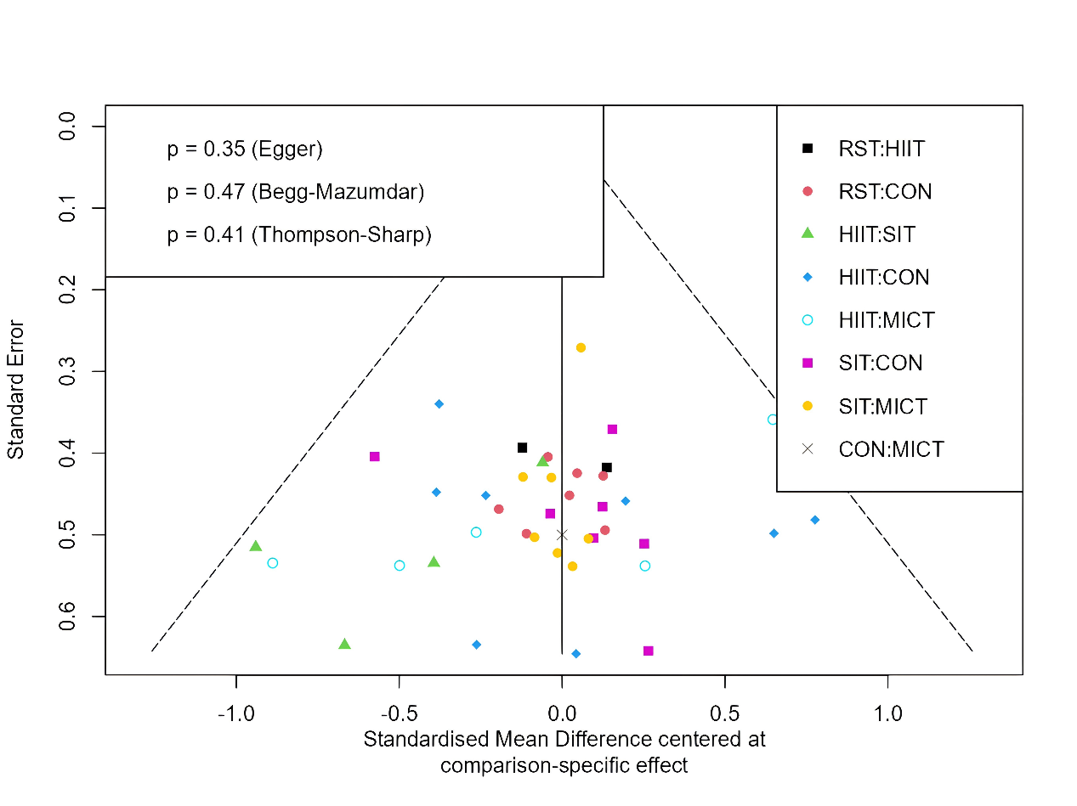

Figure S3. Funnel plot of pairwise meta-analysis
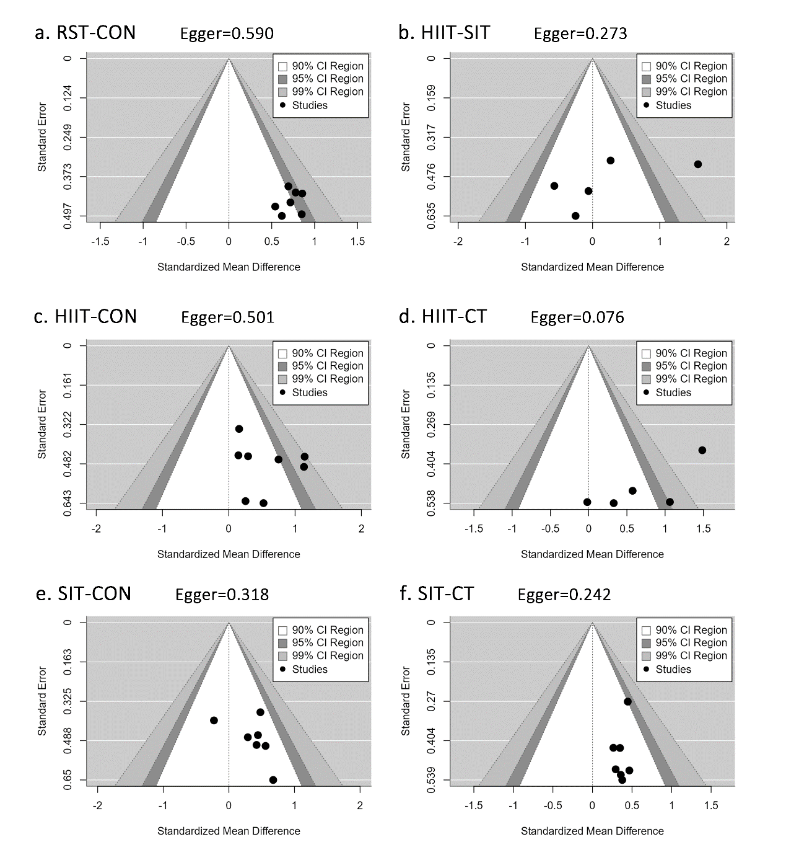

Figure S4. Dose–response effects of RST on oxygen uptake: results of meta- regression analysis for predictors related to an exercise session
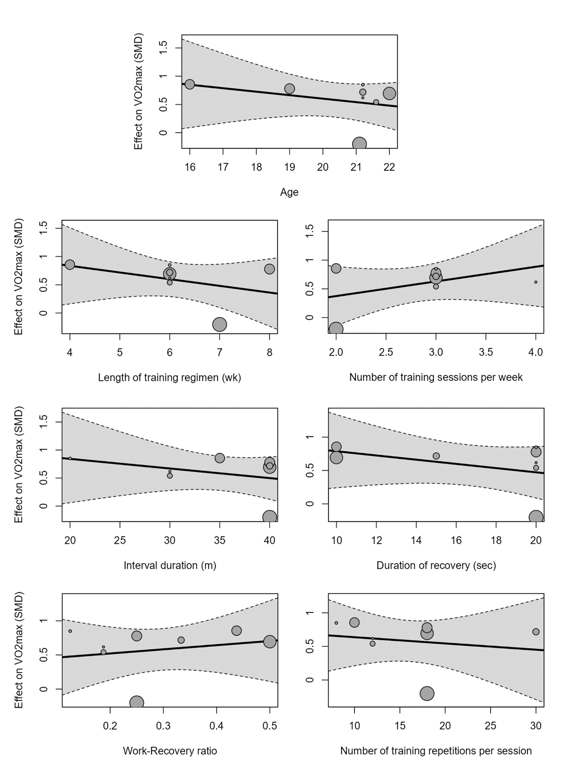
Note: The effects are presented as SMD. The circle sizes are proportional to the precision of effect(s) observed in each study.

Figure s5. Dose–response effects of HIIT on oxygen uptake: results of meta- regression analysis for predictors related to an exercise session
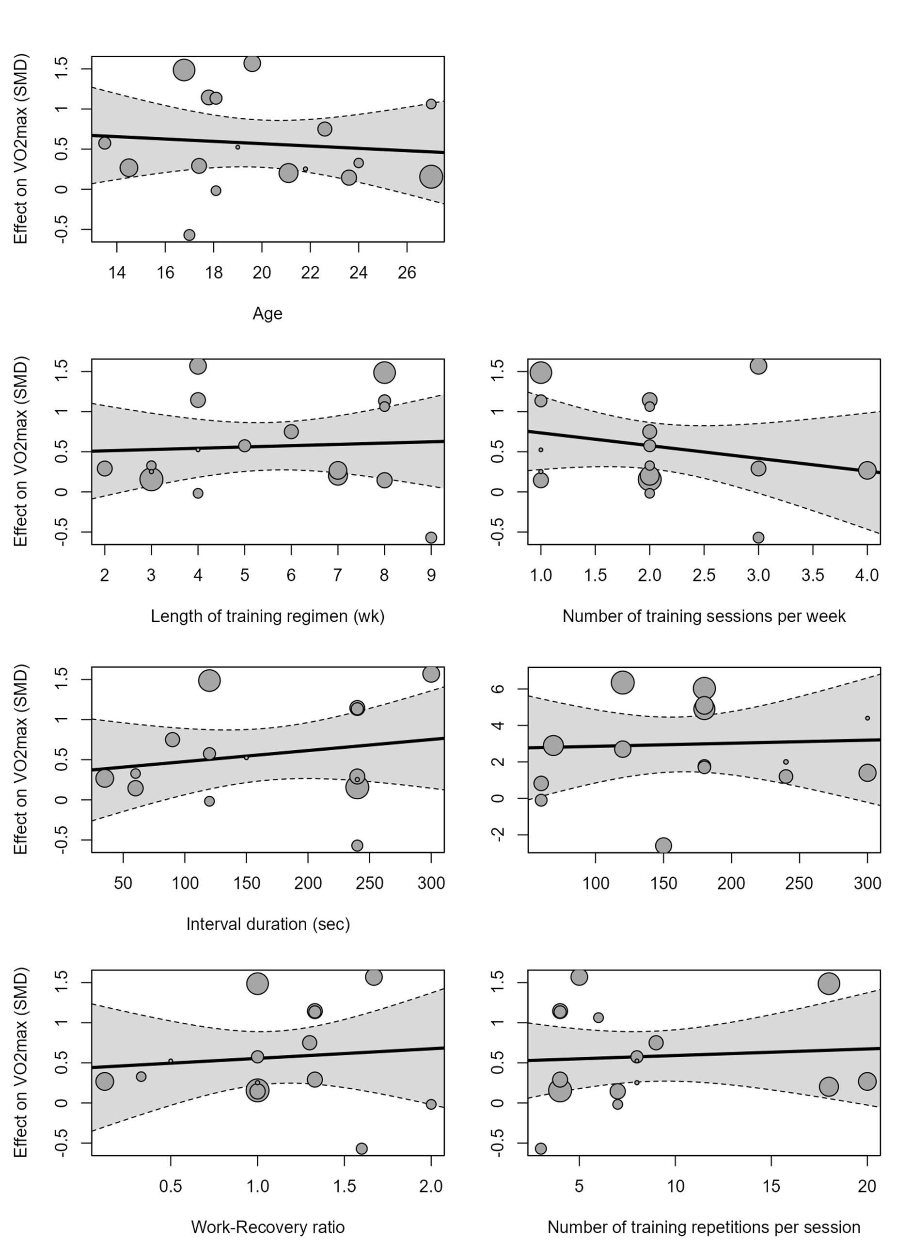
Note: The effects are presented as SMD. The circle sizes are proportional to the precision of effect(s) observed in each study.

Figure S6. Dose–response effects of SIT on oxygen uptake: results of meta- regression analysis for predictors related to an exercise session
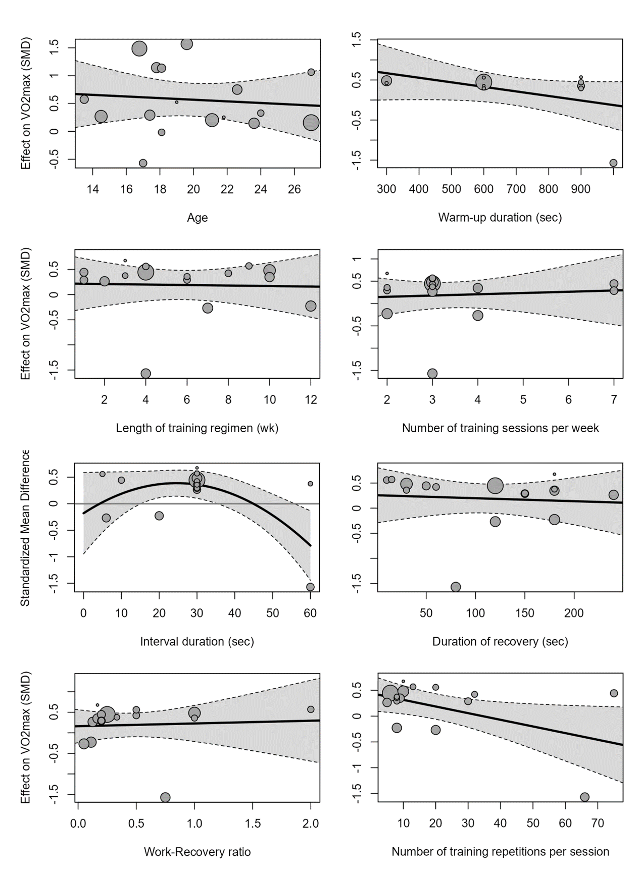
Note: The effects are presented as SMD. The circle sizes are proportional to the precision of effect(s) observed in each study.

