SUPPLEMENTARY MATERIALS FOR
Continuous liquid supply multi-material DLP 3D printing
Jiawei Sun, Wangjun Xiong, Lidian Zhang, Yanlin Song*, Lei Wu*
*Correspondence to: wulei1989@iccas.ac.cn; ylsong@iccas.ac.cn
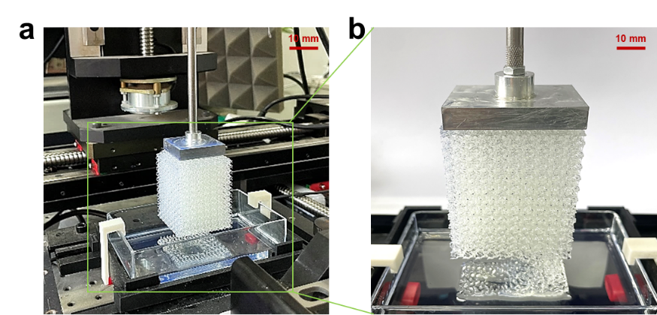
Supplementary Figure 1 Optical captures of the fractured printed gyroid structure through vat polymerization at printing speed of 150 μm/s and printing height of 6 cm. b is enlarged a. Due to continuous high speed printing induced exothermic curing, over polymerization occurs with printing strucutre sticking to the curing surface, making it impossible for further printing .

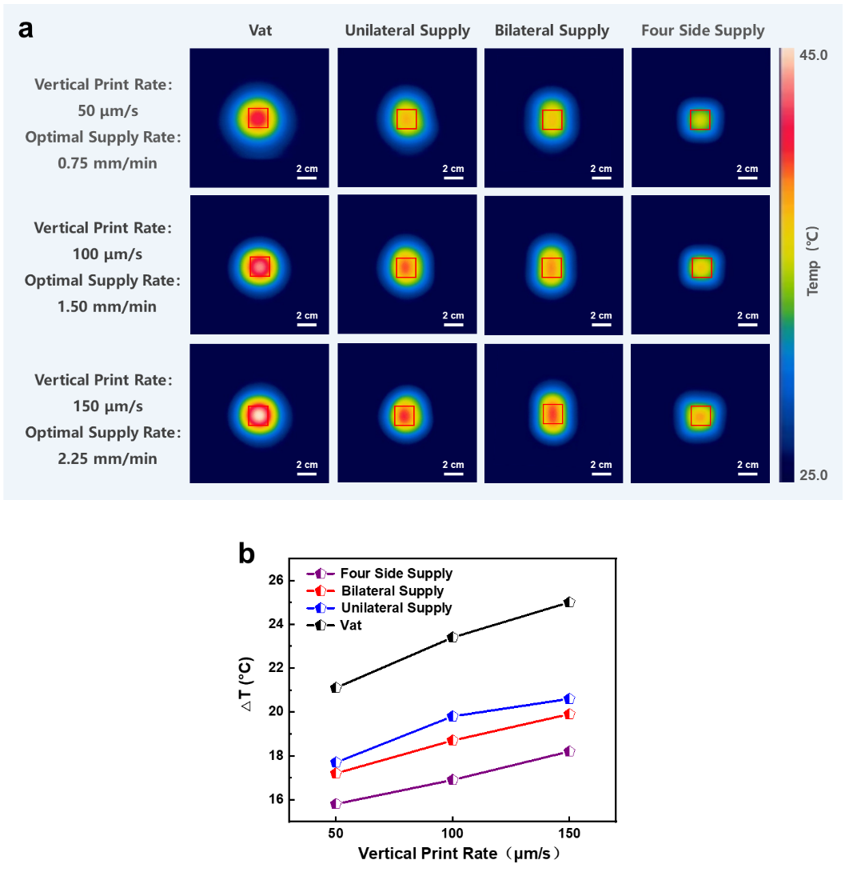
Supplementary Figure 2 Effect of supply quantity on temperature difference during printing process. a IR images captured by the bottom IR camera at the vertical print rate of 50 μm/s, 100 μm/s, 150 μm/s under vat polymerization, unilateral supply, bilateral supply and four side supply condition, respectively, when the printing process is just finished (structure size, 2 cm ×2 cm ×8 cm; optical resolution, 25 μm; ambient temperature 20 ℃). b Temperature difference of curing interface versus print rate curve corresponding to the IR images in a. Black, blue, red and purple lines indicate the vat polymerization, unilateral supply, bilateral supply and four side supply condition, respectively. It can be found that ΔT gradually increases with vertical print rate, and decreases with the increase of supply quantity.
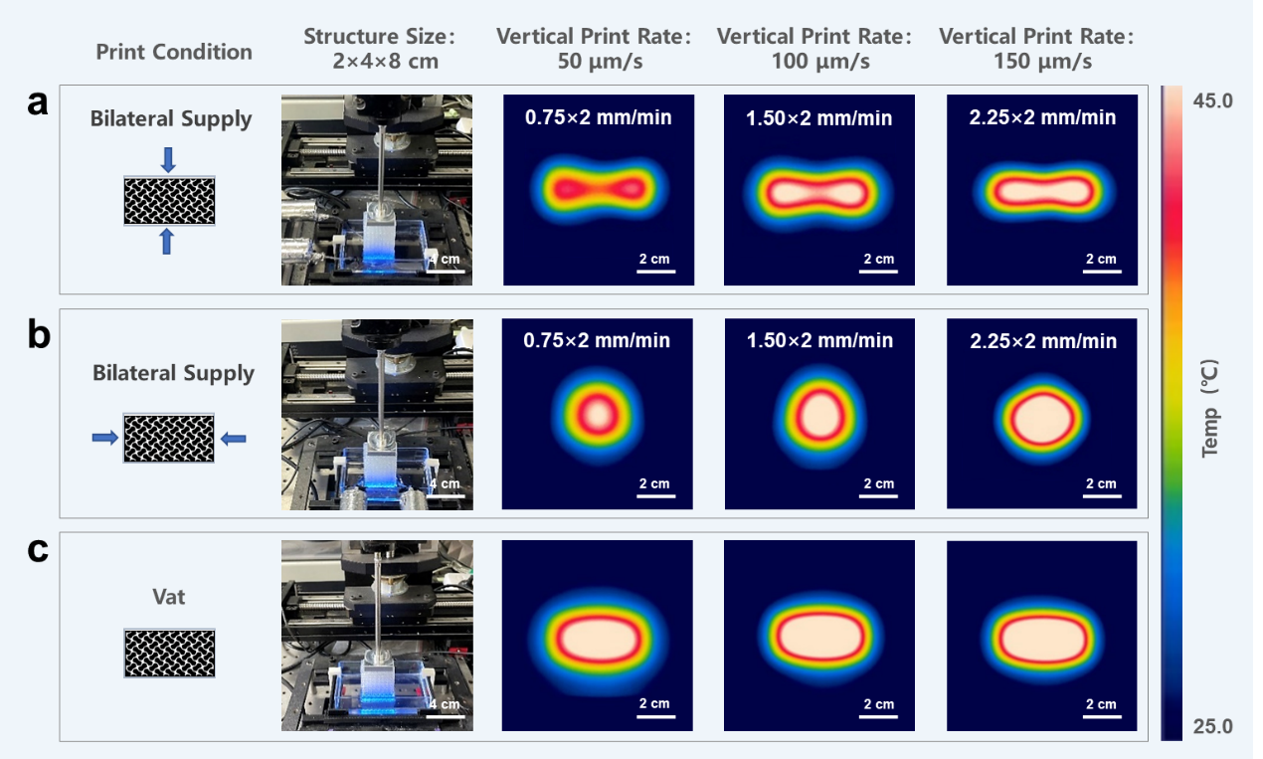
Supplementary Figure 3 Effect of supply distribution on temperature difference during printing process. Optical captures and IR images captured by the bottom IR camera at the vertical print rate of 50 μm/s, 100 μm/s, 150 μm/s under bilateral supply with supply position close to the center of the structure (a), bilateral supply with supply position away from the center of the structure (b) and vat polymerization condition (c), respectively, when the printing process is just finished (structure size, 2 cm ×4 cm ×8 cm; optical resolution, 25 μm; ambient temperature 20 ℃). It can be found that the closer the supply distribution is to the center of the structure, the more obvious the reduction of interface temperature is, and the temperature differences are all much lower than that of the vat polymerization condition.

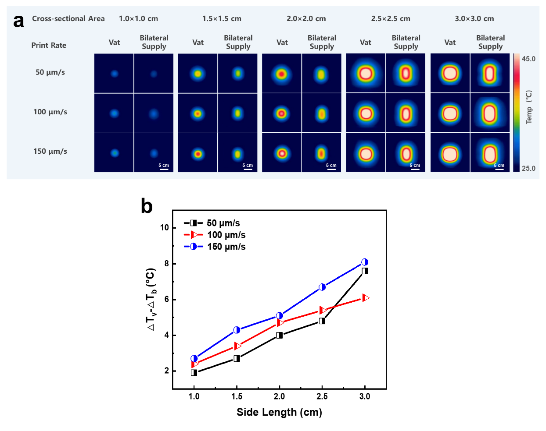
Supplementary Figure 4 Effect of cross-section size on temperature difference during printing process. a IR images captured by the bottom IR camera at the vertical print rate of 50 μm/s, 100 μm/s, 150 μm/s under vat polymerization and bilateral supply condition, respectively, when the printing process is just finished (optical resolution, 25 μm; ambient temperature 20 ℃). b The difference between the temperature difference under vat polymerization condition (△T_{v}) and the temperature difference under bilateral supply condition (△T_{b}) changes with the length of the cross-section of the structure. Black, blue and red lines indicate the vertical print rate of 50 μm/s, 100 μm/s, 150 μm/s, respectively. It can be found that △T_{v} -△T_{b} gradually increases with the side length and print rate, indicates that the supply printing strategy is conducive to high-speed printing of large-size structures.

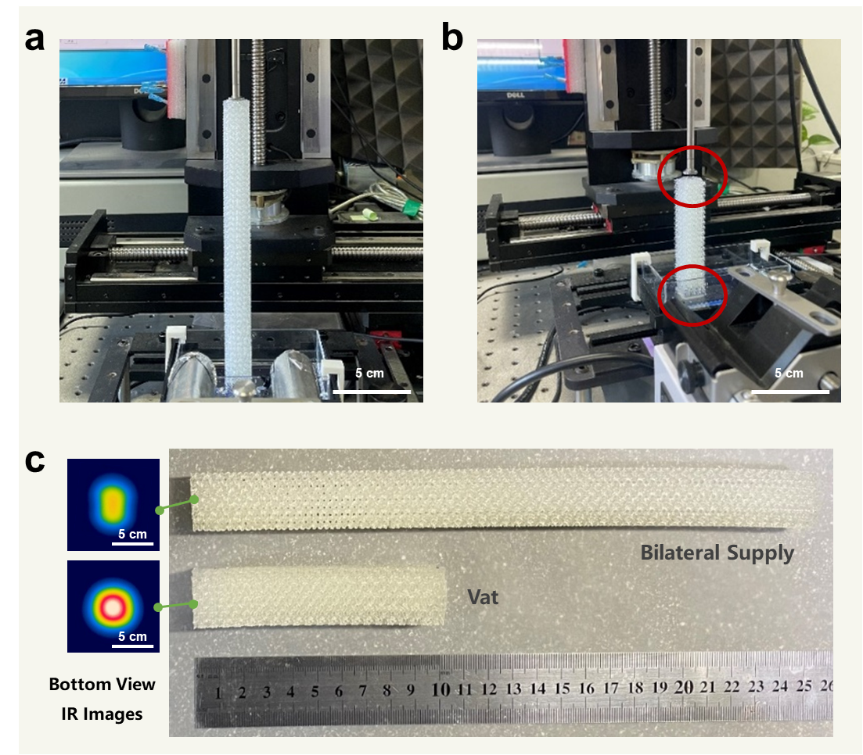
Supplementary Figure 5 Optical captures of continuously print gyroid structure at the vertical print rate of 100 μm/s under bilateral supply (a) and vat polymerization (b) condition, respectively (cross-sectional size, 2 cm ×2 cm; optical resolution, 25 μm; ambient temperature 20 ℃). c Corresponding printing results under bilateral supply and vat polymerization condition and corresponding IR images captured by the bottom IR camera when the printing process is just finished. For the printable height, the interface temperature gradually increases under vat polymerization condition, and finally the structure sticks to the curing interface at about 10 cm. While printing under bilateral supply condition, the curing interface temperature gradually rises at the beginning, then remains stable, enables continuous printing.
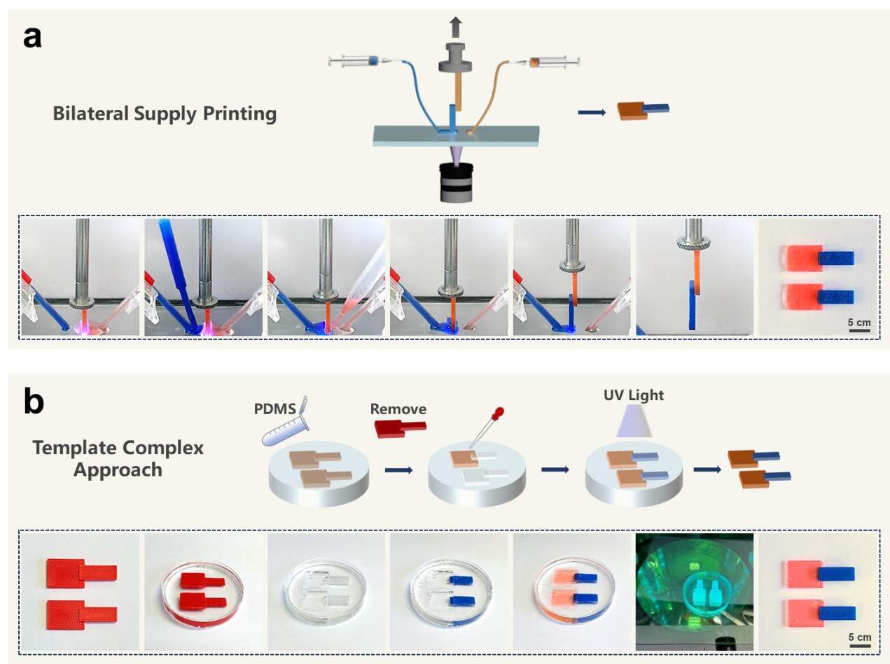
Supplementary Figure 6 Schematic and time-sequence optical images of the preparation of interfacial mechanical property test samples prepared by bilateral supply printing (a) and template replication approach (b). The bilateral supply printing method can realize one-step printing while template replication approach needs to prepare the die at first, then solidify the two materials respectively, and finally release the sample, which requires cumbersome printing process.
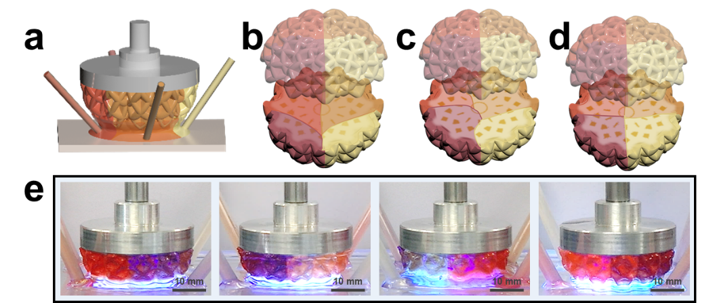
Supplementary Figure 7 Preparation of four-material porous pumpkin structure with controlled outer appearance and inner material distribution. a Scheme of the preparation configuration of the four-material porous pumpkin structure. b-d Schemes of the four-material pumpkin structure displaying the outer appearance of the four-material pumpkin structures with non-uniform (b, c) and uniform (d) inner distributions. e Optical captures of the printing process from different views, showing a clear interface between corresponding two adjacent materials.

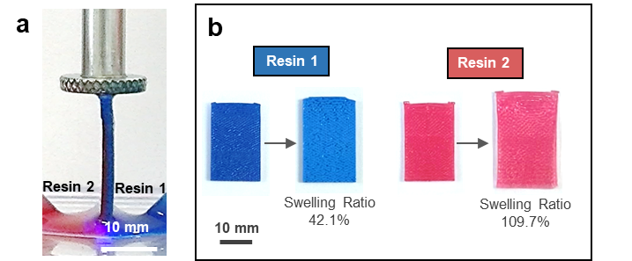
Supplementary Figure 8 a Optical capture of two-material laminated structure printing process (vertical printing speed, 20 μm/s). b Optical image of single material structure before and after swelling with anhydrous ethanol for 30 min. Resin 1 and 2 are commercial castable wax resin and commercial elastic resin dyed with red ink, respectively.

Captions for supplementary movies
Movie S1. IR Temperature distribution video of the gyroid structure printing process under vat polymerization, bilateral supply, four side supply condition.
Movie S2. Printing process of bi-material lamellar structure curved interface.
Movie S3. Tensile test along the interface direction for the samples prepared by bilateral supply printing and replication approach.
Movie S4. Printing process of four-material porous pumpkin structure.
Movie S5. Real time monitoring of the 3D material distribution defined trajectories of magnetic-responsive fishes.

