The result of the two sensitivity analysis scenario aside from the leave-one-out analysis.
First Author |  | Year | Case | Sample | Pooled Prevalence | 95%CI | I²
 | Scenario 1: Including studies with unspecified serological test.
Hassana |  | 2021 | 129 | 158 | 45,87% | 39,35% - 52,53% | 95,7%
Maharani |  | 2024 | 127 | 793
Munir |  | 2014 | 9 | 23
Purnami |  | 2020 | 16 | 35
Rachmawati |  | 2019 | 6 | 79
 | Scenario 2: Excluding studies that only assessed IgM
Fatmawati |  | 2021 | 4 | 25 | 48,70% | 42,37% - 55,07% | 94,2%
Nadayang |  | 2020 | 2 | 33
Wulandari |  | 2019 | 1 | 20

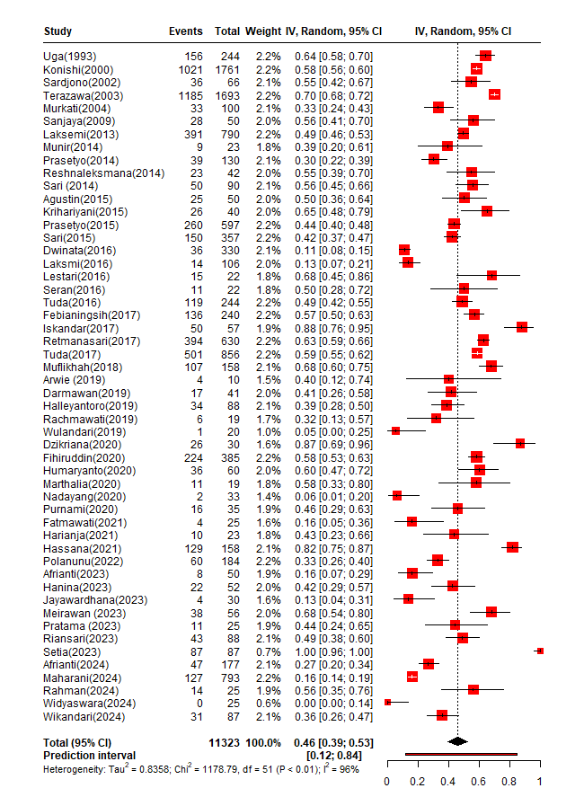
Forest plot depicting the result for sensitivity analysis; scenario 1.

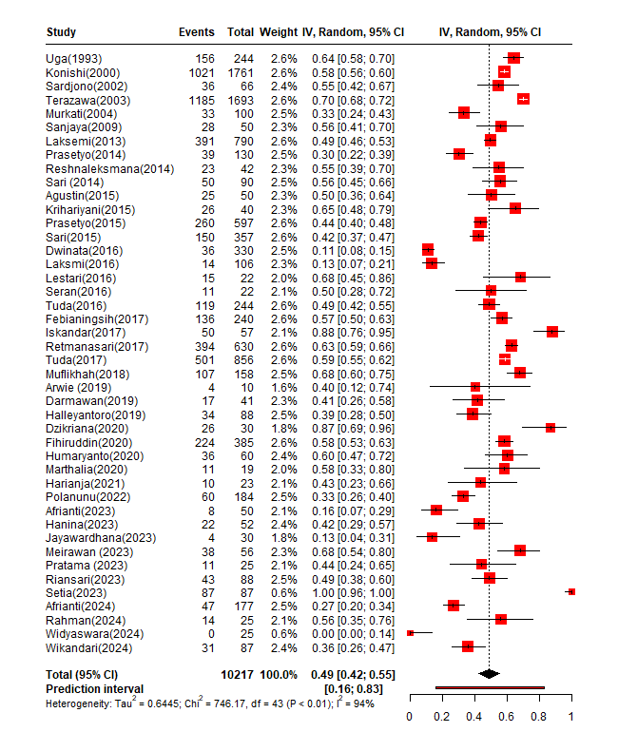
Forest plot depicting the result for sensitivity analysis; scenario 2.

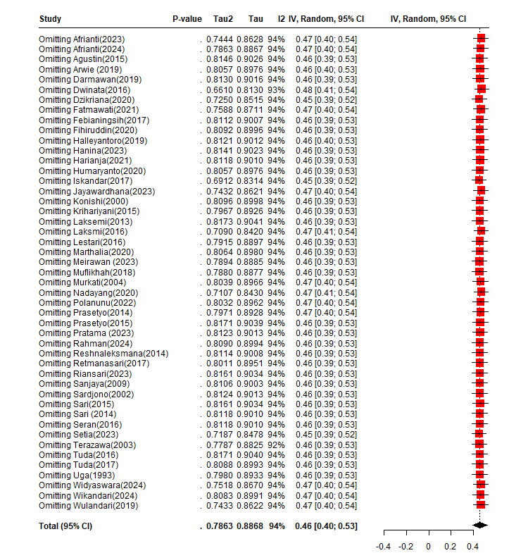
Forest plot depicting the result of leave-one-out analysis.

