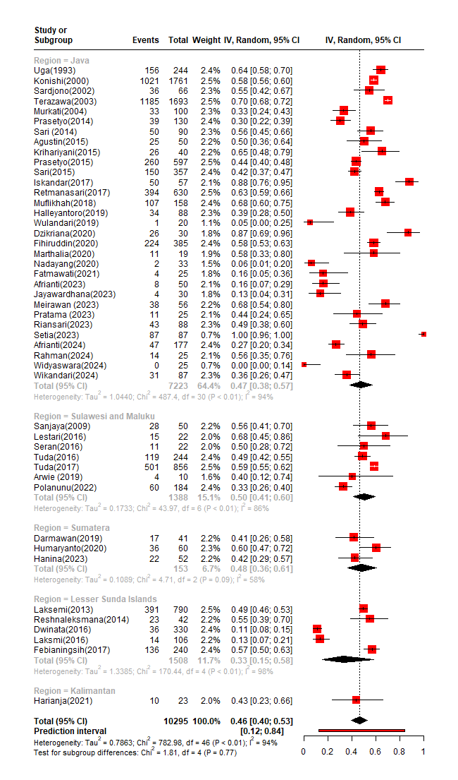
Forest plot showing the pooled seroprevalence of toxoplasmosis based on geographical region.

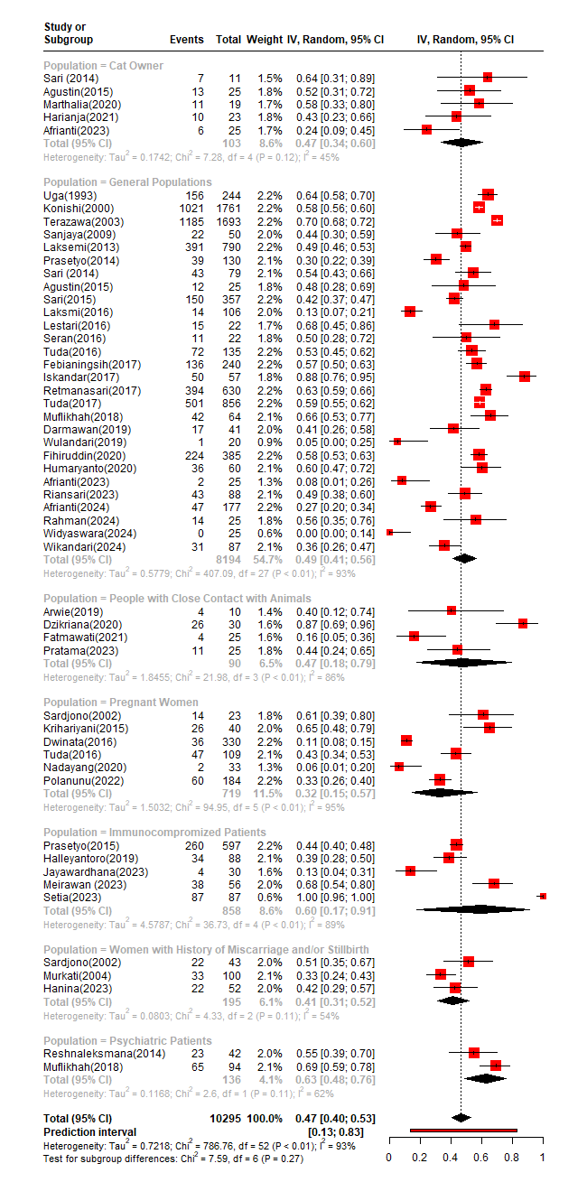
Forest plot showing the pooled seroprevalence of toxoplasmosis based on study population.

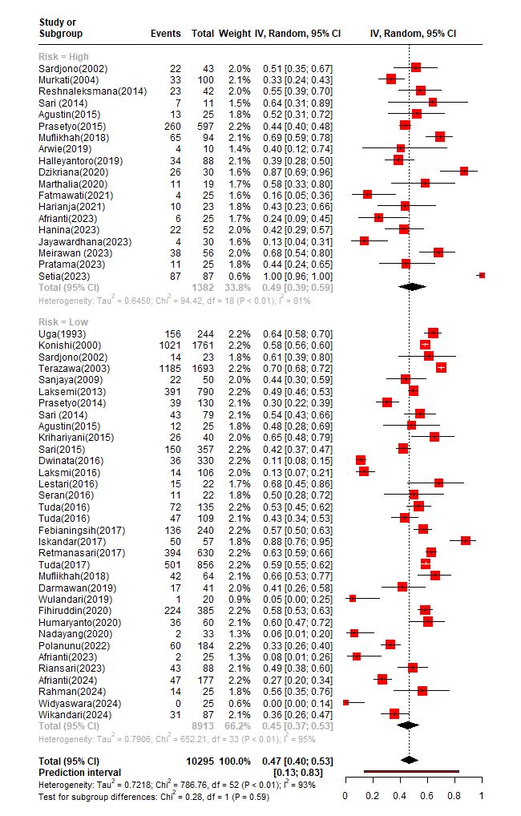
Forest plot showing the pooled seroprevalence of toxoplasmosis based on population risk level.

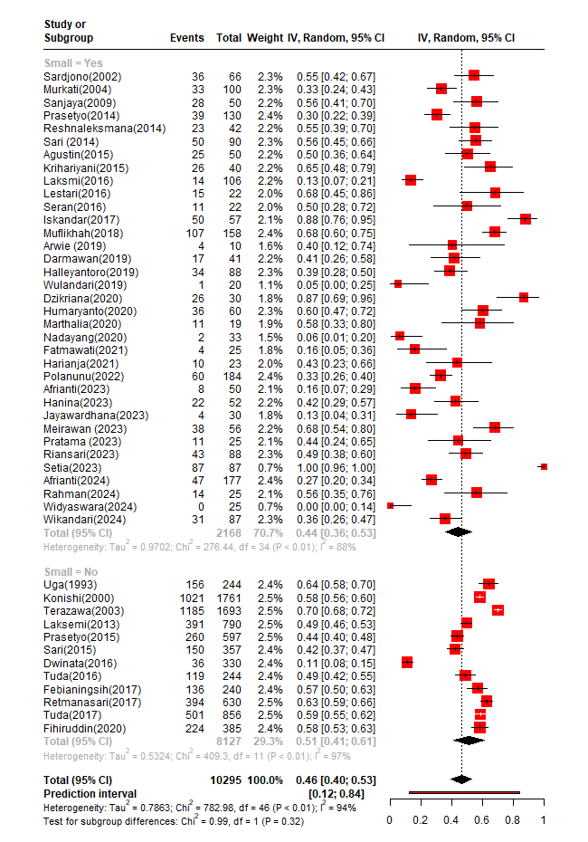
Forest plot showing the pooled seroprevalence of toxoplasmosis based on sample size.

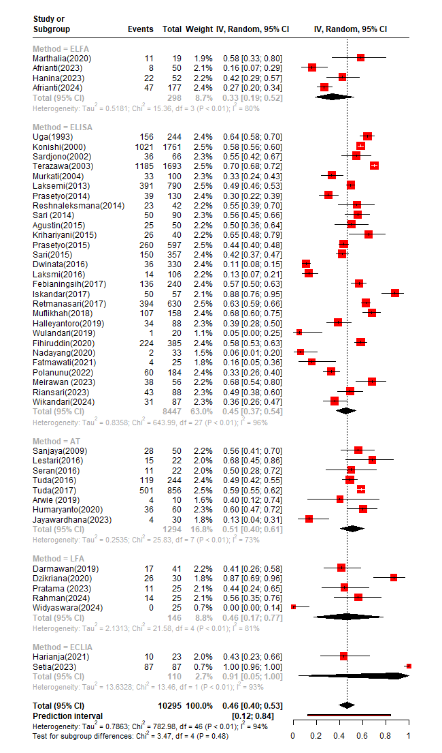
Forest plot showing the pooled seroprevalence of toxoplasmosis based on detection method.

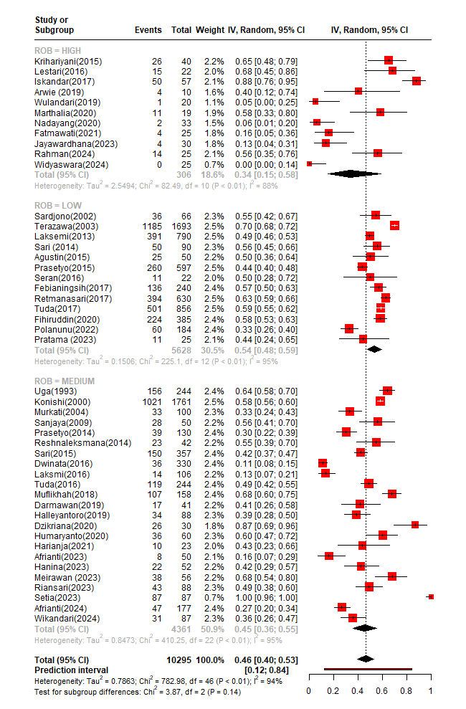
Forest plot showing the pooled seroprevalence of toxoplasmosis based on risk-of-bias (ROB) assessment result.

