The Holistic Model of Leukaemia Survivorship Care: derived from a qualitative exploration of leukaemia survivorship
Kirsten S¹, Laidsaar-Powell R¹, Shaw JM¹, Dhillon, HM¹.
Journal Name: Journal of Cancer Survivorship
Affiliations
- Psycho-Oncology Cooperative Research Group, School of Psychology, Faculty of Science, The University of Sydney, NSW, Australia
ORCID IDs:
Kirsten S 0009-0000-5733-2055
Laidsaar-Powell R 0000-0002-3462-5645
Shaw JM 0000-0002-9543-7066
Dhillon HM 0000-0003-4039-5169

Corresponding author: Haryana Dhillon,
Psycho-Oncology Cooperative Research Group,
School of Psychology, Faculty of Science,
The University of Sydney NSW 2006, Australia
Haryana.dhillon@sydney.edu.au

Supplementary File 3: Consolidated Criteria for Reporting Qualitative Research (COREQ)
This document contains the completed COREQ checklist, which is used to assess the methodological rigour and transparency of qualitative research.

Completed COREQ Checklist
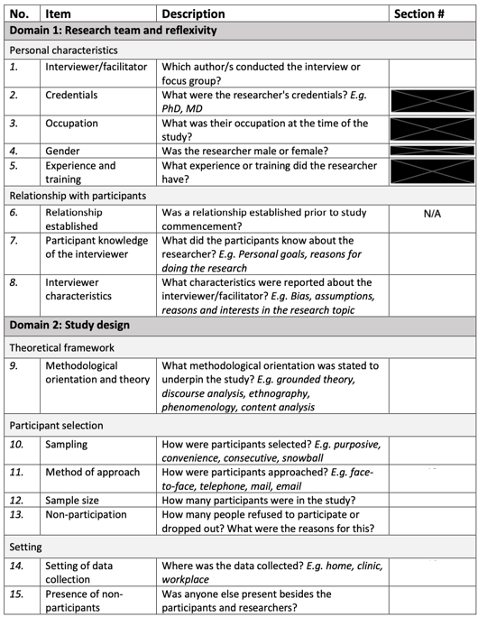
N/A
p. 8
p. 6-7
p. 6-7
p. 8
p. 6
p. 6
p. 6
N/A
p. 6
p. 19
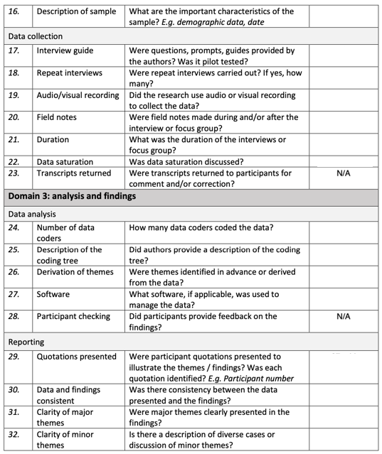
N/A
N/A
p. 8-15
p. 8-15
p. 8-15
p. 8-15
p. 6-7
p. 7
p. 20
p. 7, 19
p. 6
p. 8
N/A
p. 6
N/A
p. 7
p. 8

